**SonarLint & SonarQube**

**SonarLint :**

* SonarLint is an IDE extension that helps you detect and fix quality issues as you write code.
* Like a spell checker, SonarLint squiggles flaws so that they can be fixed before committing code. Its Working on **IDE** like Eclipse , VisualStudio Code , etc ,….
* In Eclipse , Install SonarLint , Help 🡪 Eclipse Marketplace 🡪 Search **SonarLint** and install it.

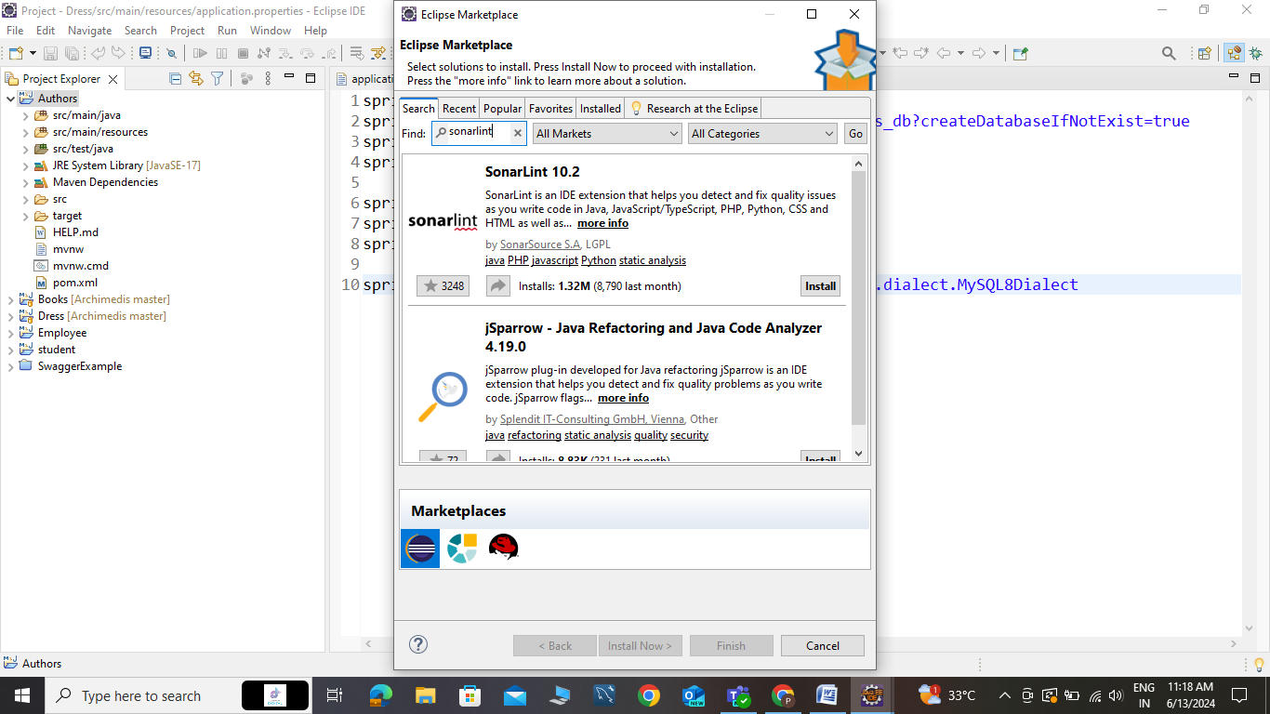

* Once the installation is complete, Eclipse will prompt you to restart.
* Click "Restart Now" to restart Eclipse.
* Check SonarLint was present or not . So Window 🡪Preference 🡪Search **SonarLint**.

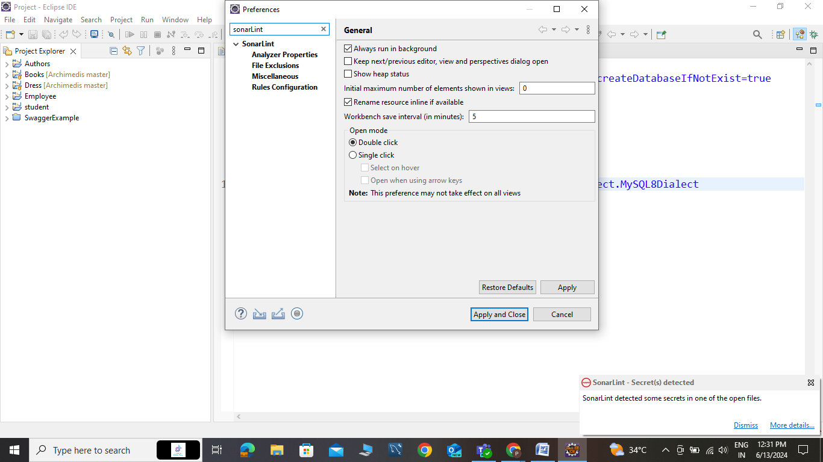

* If check **SonarLint** process , so Right Click any project like I am doing Spring Boot .

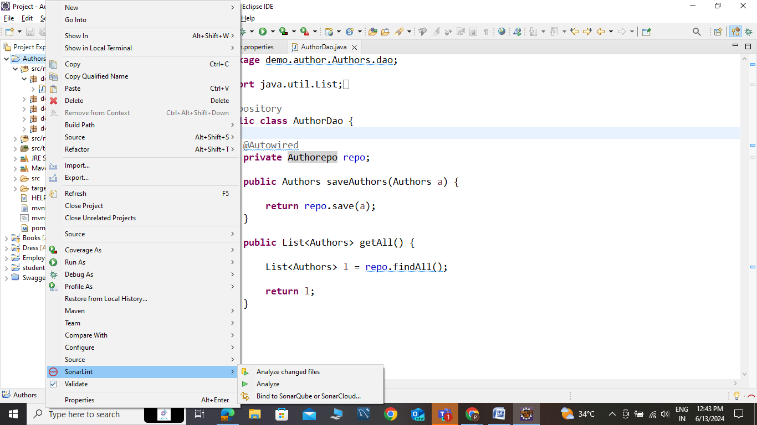

* Click SonarLint and Analyze your project .

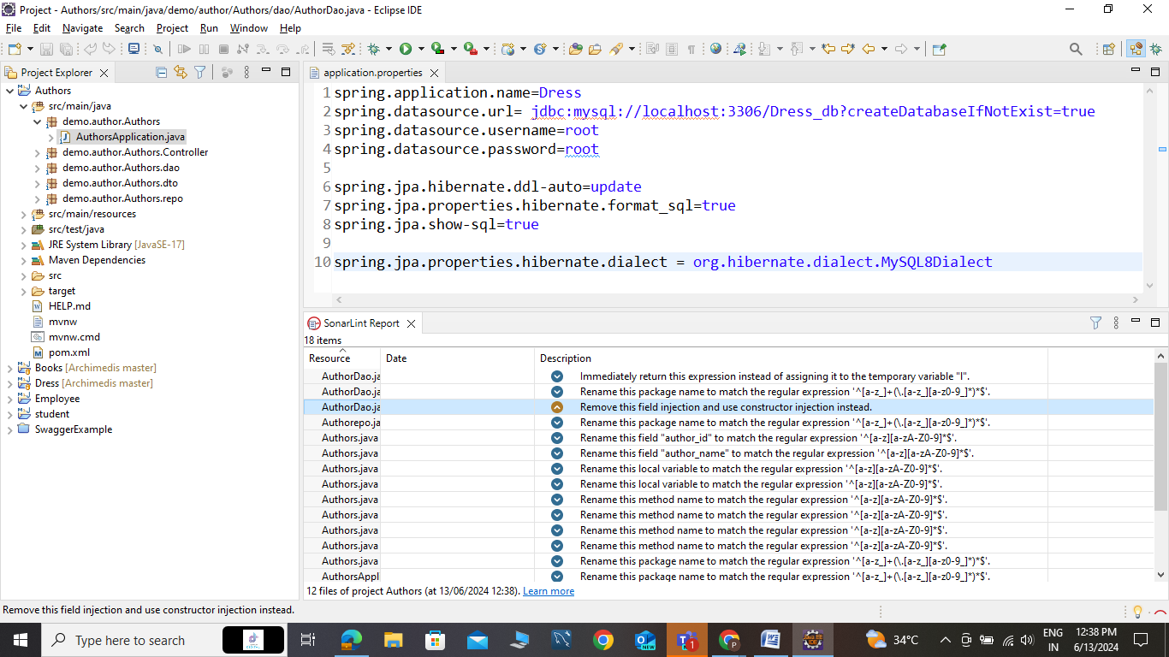

* Eclipse showing SonarLint Report (like above picture) , then Developers are correcting that mistakes.

**SonarQube :**

* **SonarQube** is a platform for continuous code quality inspection. It conducts static code analysis to detect bugs, code smells, and security vulnerabilities, ensuring high-quality, secure software.
* Integrating seamlessly into the development pipeline, it provides immediate feedback to developers, enabling early issue detection and resolution.
* And you set the path in Environment Variable . Variable name 🡪 SONAR_HOME . Path 🡪 your path of sonarqube installation folder . (like C:\SonarQube\sonarqube-10.5.1.90531\lib )

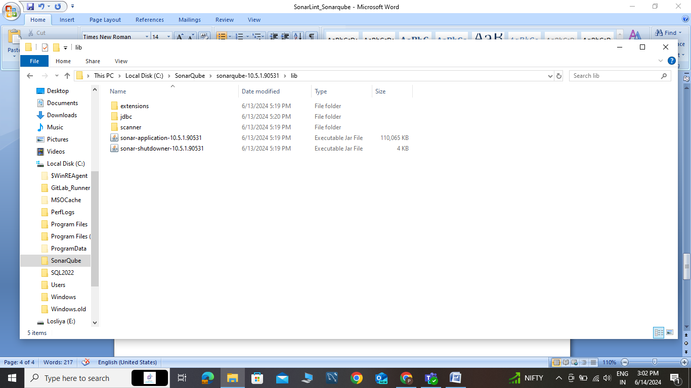

* After you add path into environment variable.
* You will go that folders , sonarqube-10.5.1.90531🡪bin🡪windows-x86-64 , after inside this folder you can open command prompt ,

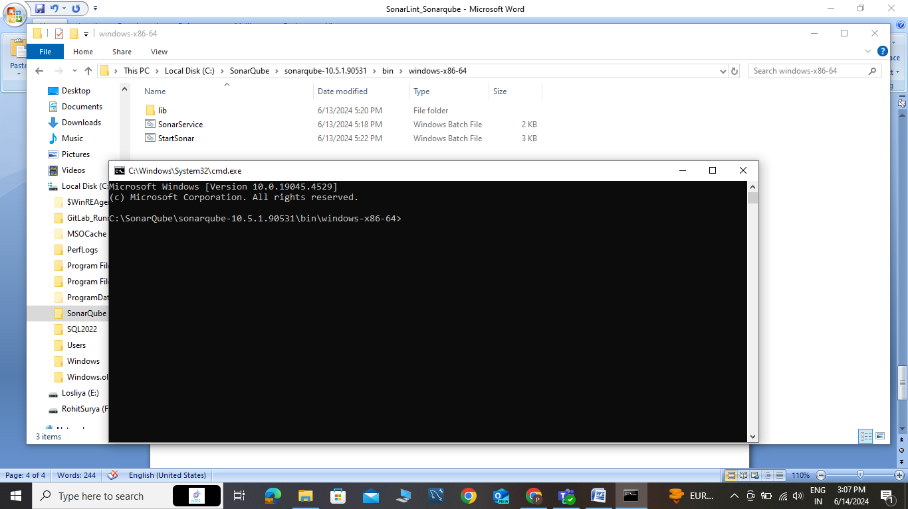

* After open the cmd , you will run StartSonar.bat file .

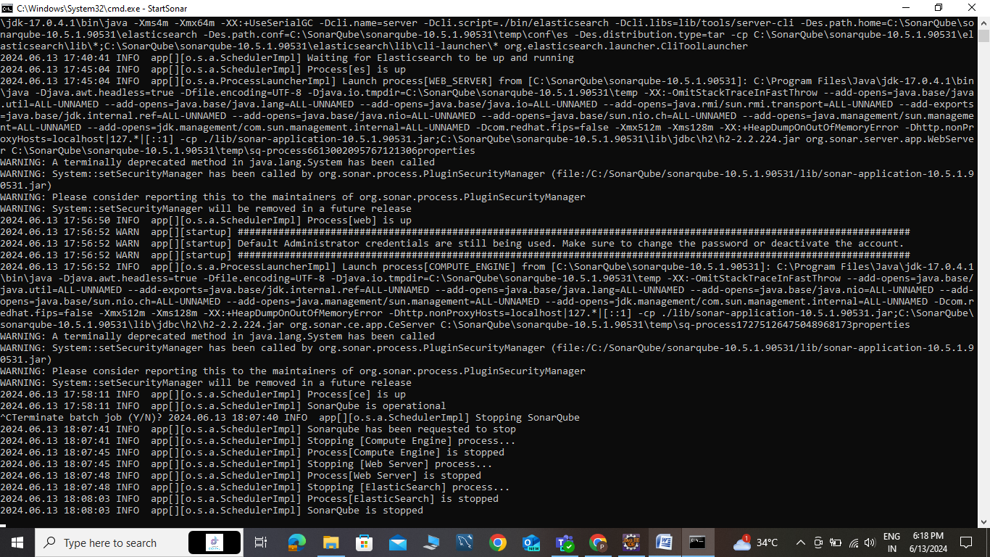

* Next step , Running successfully then you will gonna any browser . and you will localhost:9000 (default port of SonarQube was 9000) .
* Then the port open , **the page was SonarQube login page** , username 🡪 admin , password 🡪 admin .

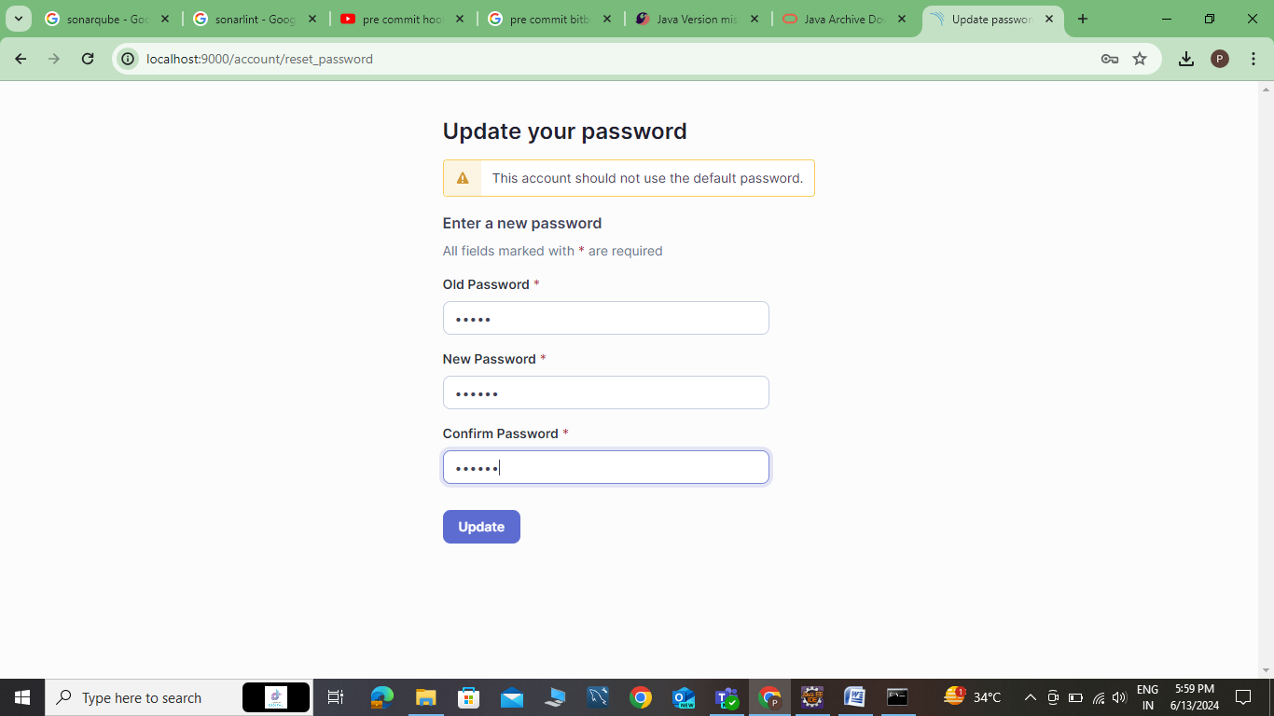

* After successfully open login , the above page was open then you will update the password .

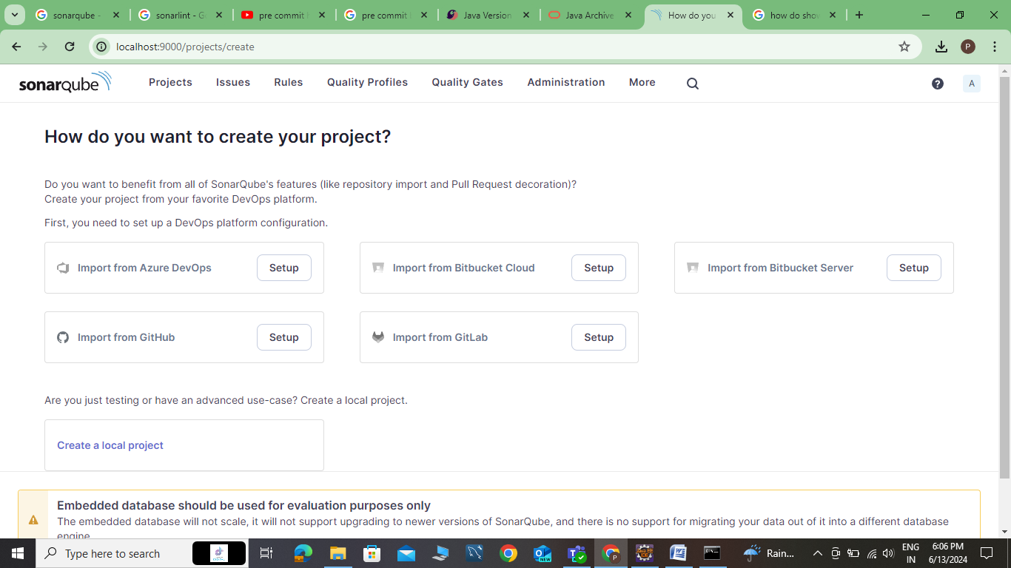

* Then you successfully SonarQube login .