**SPRING BOOT SWAGGER**

Creating a dress application using springboot using rest api which is also accessible through swagger

**Main application**

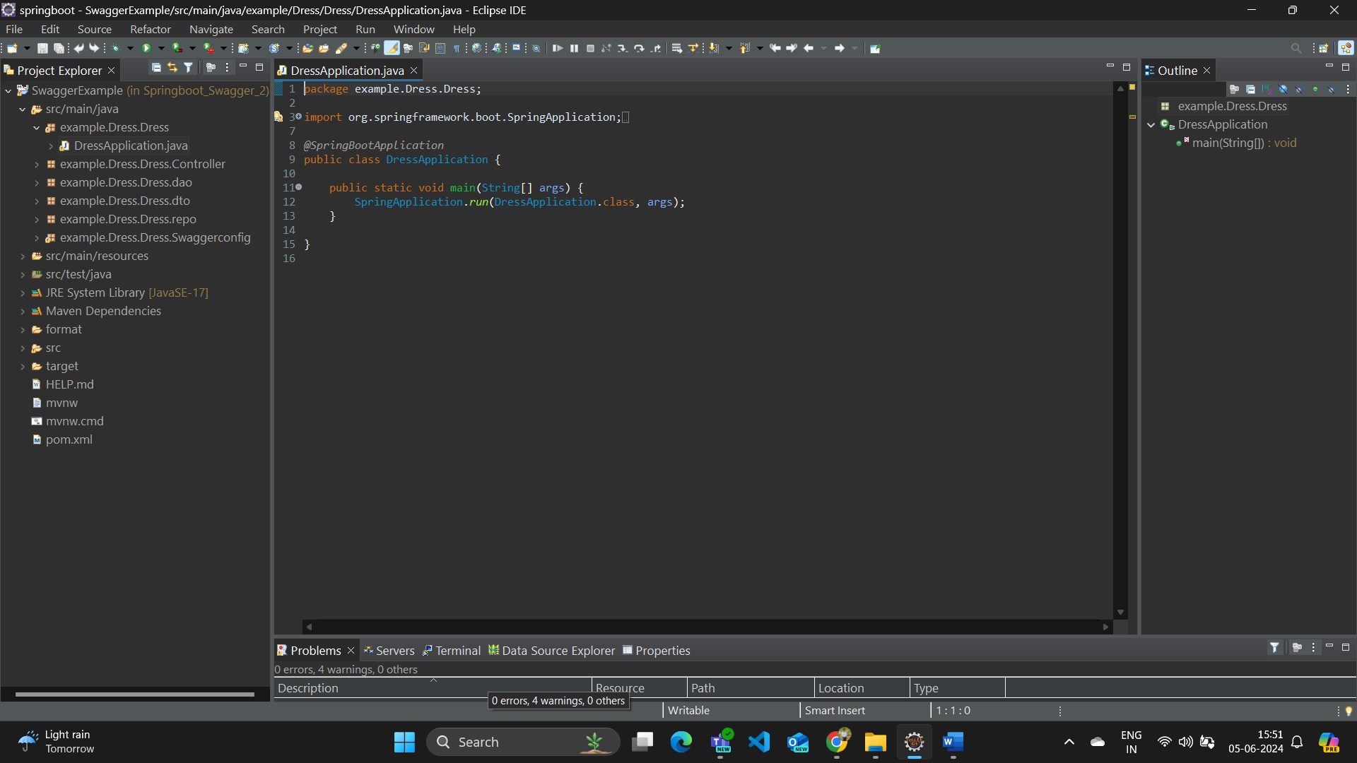

**Controller class for dress application**

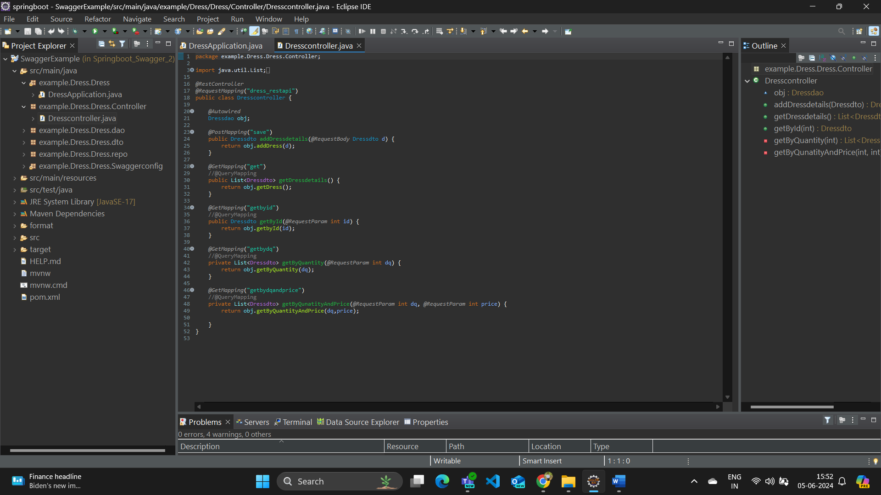

**Dao class for dress application**

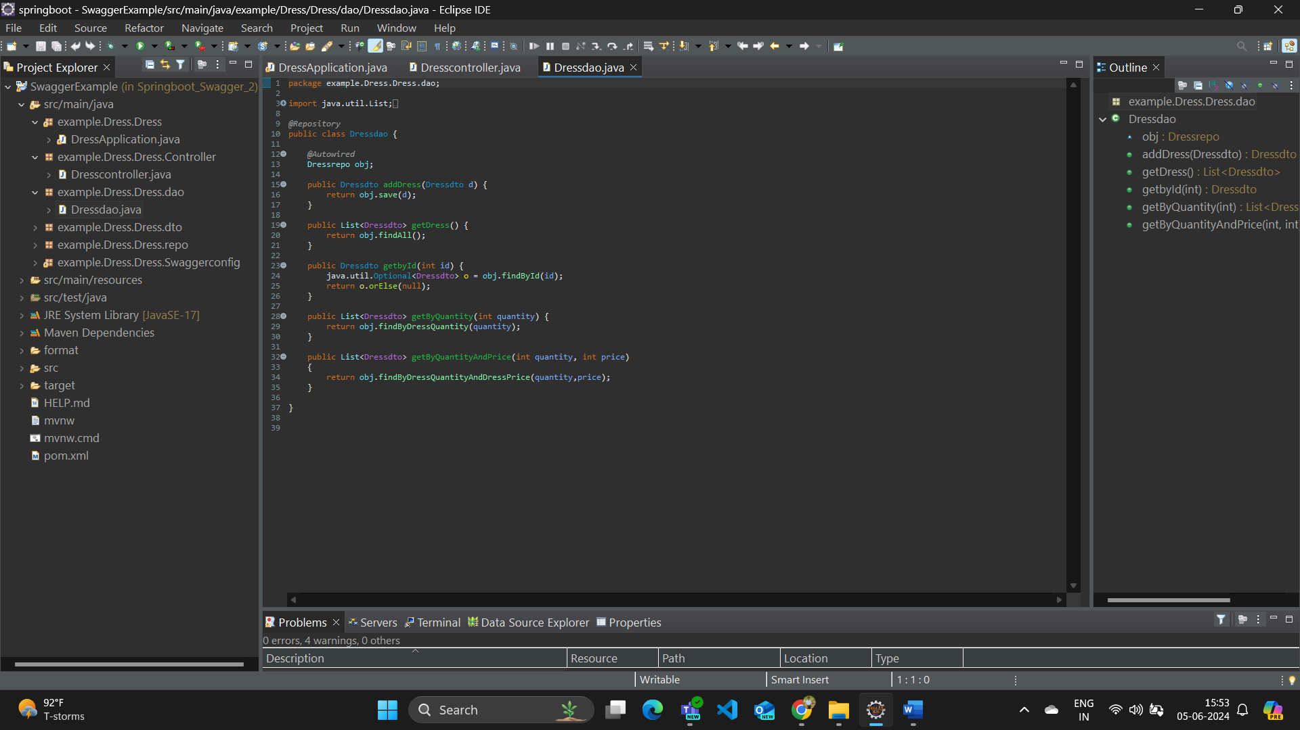

**Dto classes for dress and brand**

**Brand dto**

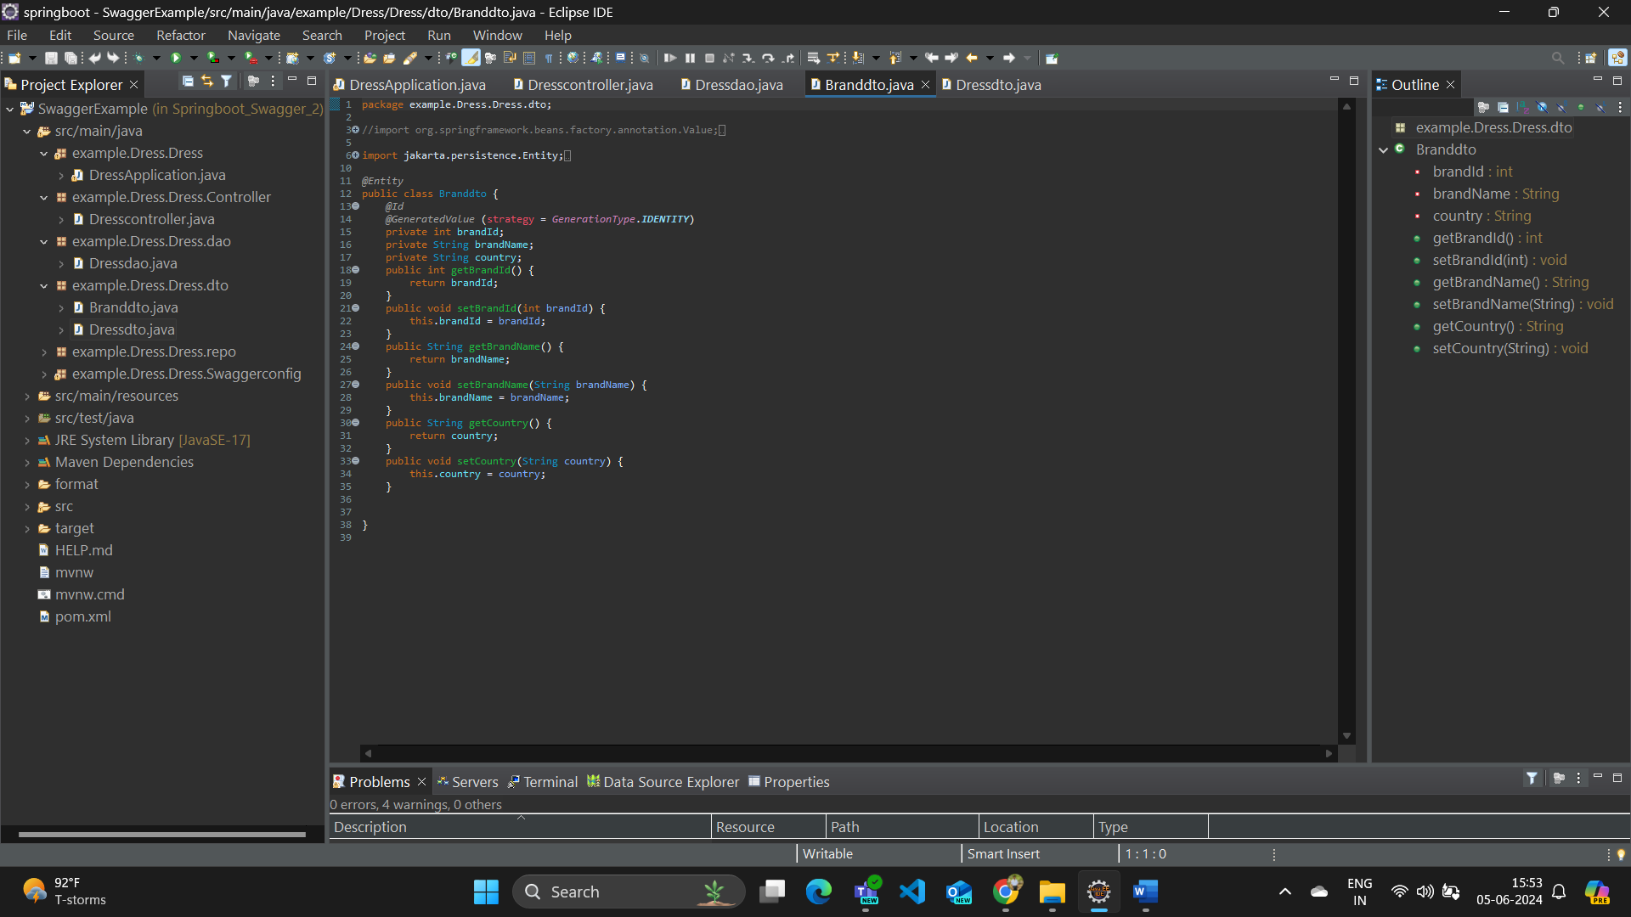

**Dress dto**

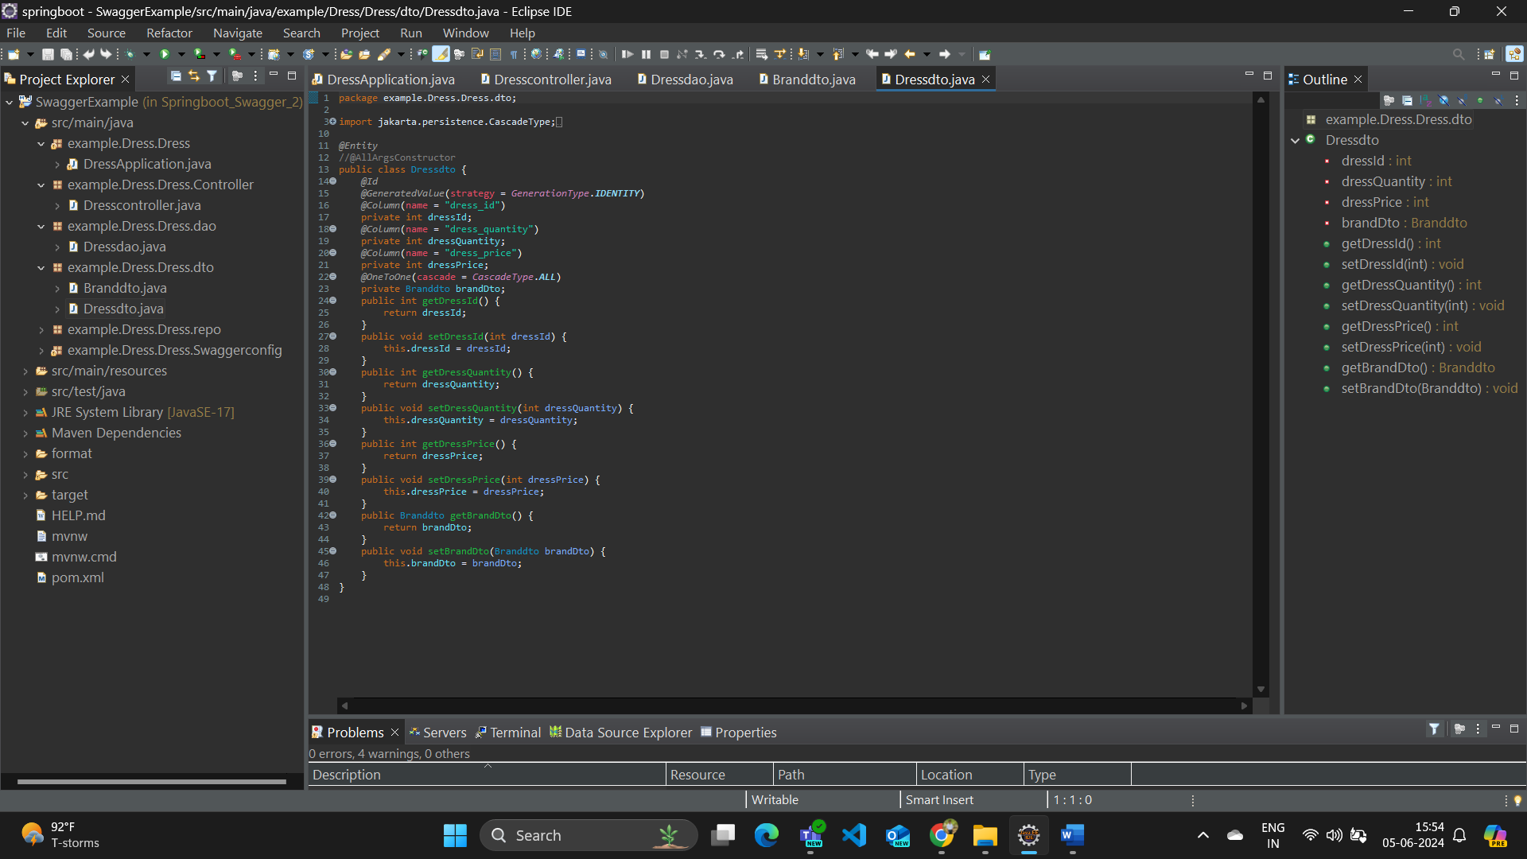

**Repo fies for brand and dress**

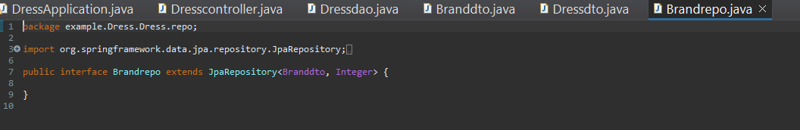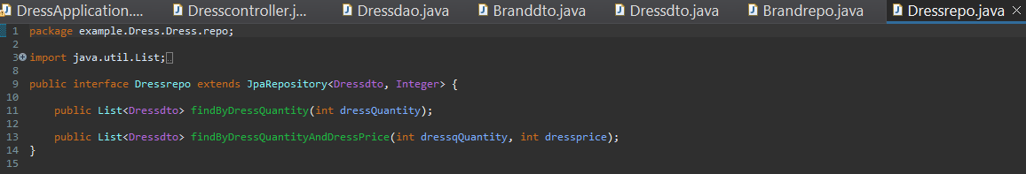

**Swagger configuration file for dress application**

* It can be done in two methods
  + OpenApiConfiguration
    - Swagger 3 with spring boot 3
  + WebmvcEndpointsConfiguration
    - Swagger 3 with spring boot 3

**WebmvcEndpointsconfiguration**

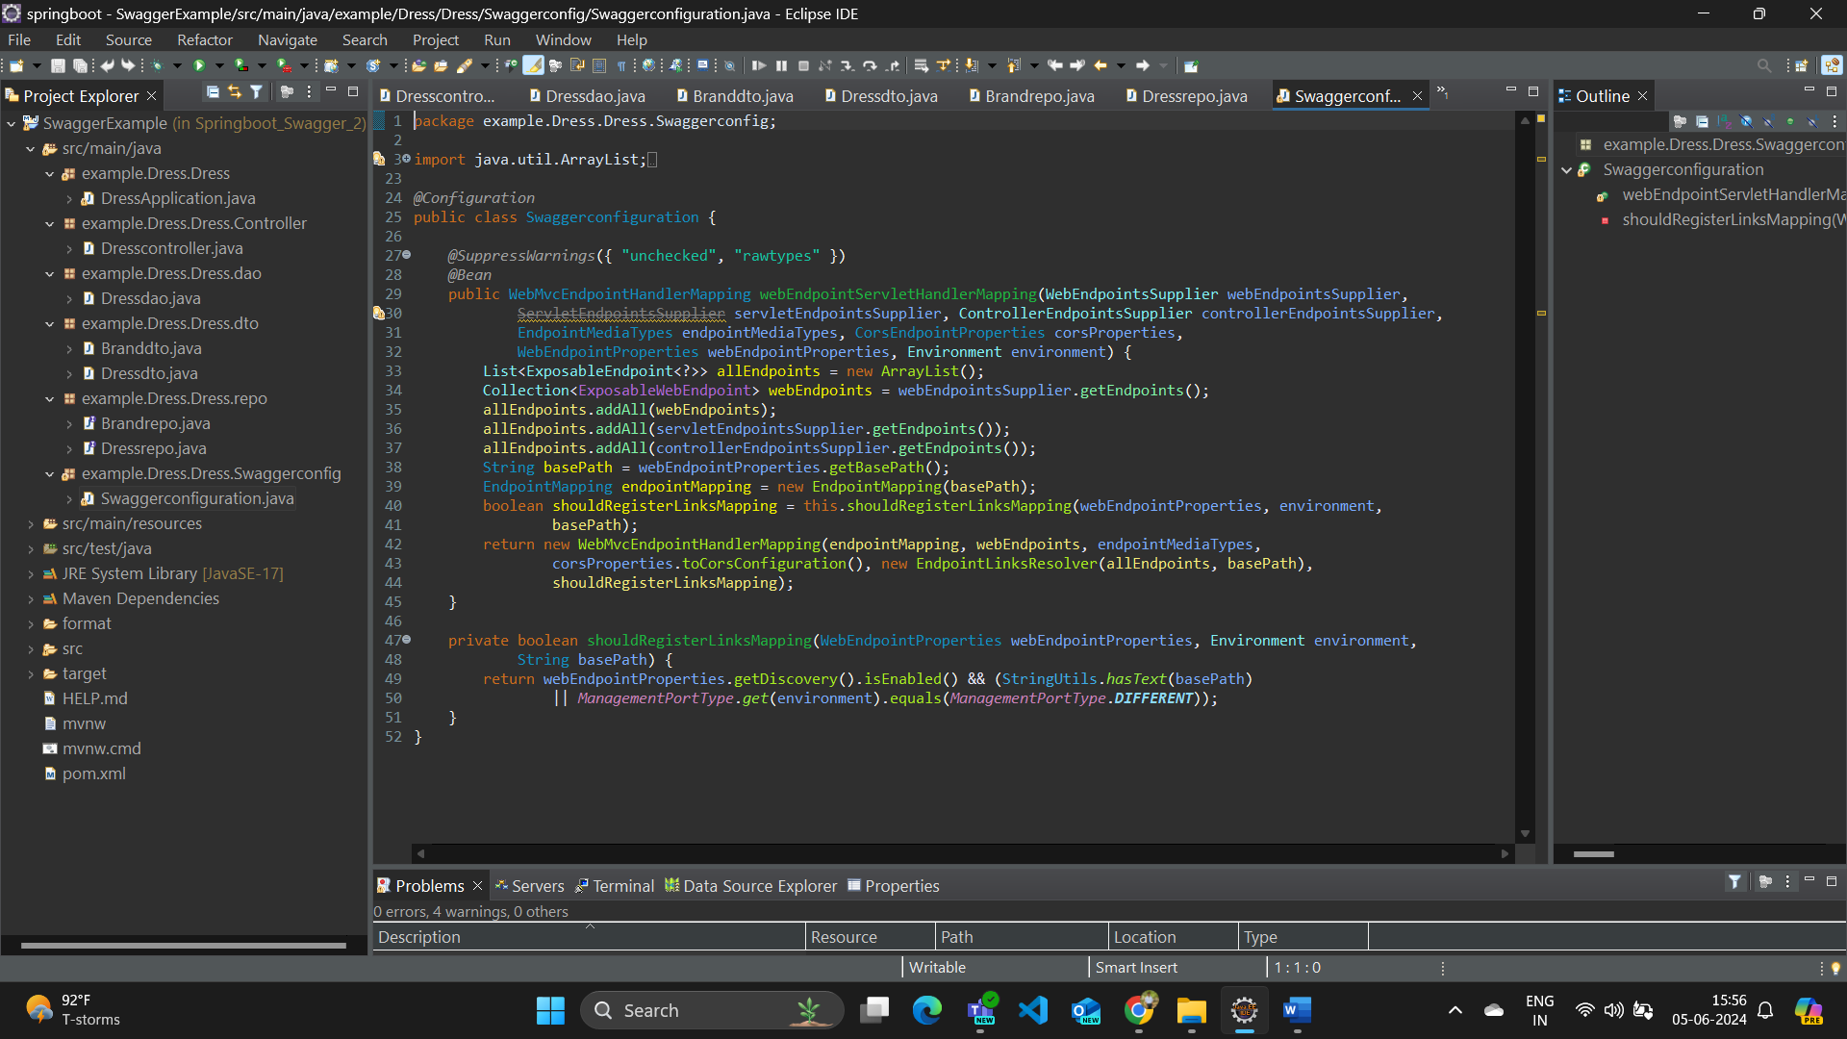

**OpenApiConfiguration**

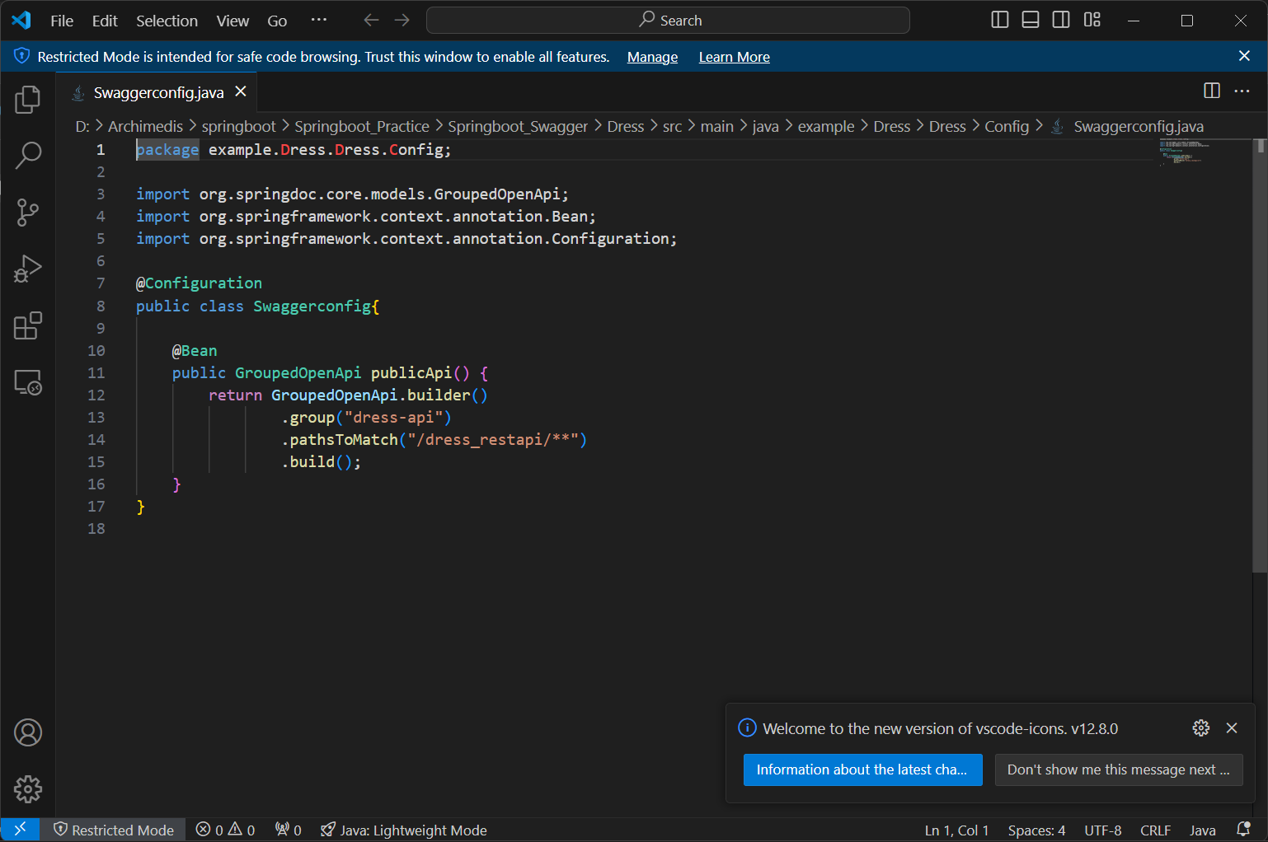

**Pom file for dress application**

<?xml version="1.0" encoding="UTF-8"?>

<project xmlns="http://maven.apache.org/POM/4.0.0"

xmlns:xsi="http://www.w3.org/2001/XMLSchema-instance"

xsi:schemaLocation="http://maven.apache.org/POM/4.0.0 http://maven.apache.org/xsd/maven-4.0.0.xsd">

<modelVersion>4.0.0</modelVersion>

<parent>

<groupId>org.springframework.boot</groupId>

<artifactId>spring-boot-starter-parent</artifactId>

<version>3.3.0</version>

<relativePath /> <!-- lookup parent from repository -->

</parent>

<groupId>com.example.swagger</groupId>

<artifactId>SwaggerExample</artifactId>

<version>0.0.1-SNAPSHOT</version>

<name>SwaggerExample</name>

<description>Demo project for Spring Boot</description>

<properties>

<java.version>17</java.version>

</properties>

<dependencies>

<dependency>

<groupId>org.springframework.boot</groupId>

<artifactId>spring-boot-starter-data-jpa</artifactId>

</dependency>

<!-- Replace Springfox with Springdoc OpenAPI dependencies -->

<!--

https://mvnrepository.com/artifact/org.springdoc/springdoc-openapi-ui -->

<dependency>

<groupId>org.springdoc</groupId>

<artifactId>springdoc-openapi-starter-common</artifactId>

<version>2.1.0</version> <!-- Update to the compatible version -->

</dependency>

<dependency>

<groupId>org.springframework.boot</groupId>

<artifactId>spring-boot-starter-actuator</artifactId>

</dependency>

<dependency>

<groupId>org.springdoc</groupId>

<artifactId>springdoc-openapi-starter-webmvc-ui</artifactId>

<version>2.1.0</version>

</dependency>

<dependency>

<groupId>org.springframework.boot</groupId>

<artifactId>spring-boot-starter-web</artifactId>

</dependency>

<dependency>

<groupId>com.mysql</groupId>

<artifactId>mysql-connector-j</artifactId>

<scope>runtime</scope>

</dependency>

<dependency>

<groupId>org.springframework.boot</groupId>

<artifactId>spring-boot-starter-test</artifactId>

<scope>test</scope>

</dependency>

<dependency>

<groupId>javax.servlet</groupId>

<artifactId>javax.servlet-api</artifactId>

<version>4.0.1</version> <!-- or the appropriate version for your

project -->

<scope>provided</scope>

</dependency>

<dependency>

<groupId>com.h2database</groupId>

<artifactId>h2</artifactId>

<scope>runtime</scope>

</dependency>

<!--

https://mvnrepository.com/artifact/org.springdoc/springdoc-openapi-common -->

<dependency>

<groupId>org.springdoc</groupId>

<artifactId>springdoc-openapi-common</artifactId>

<version>1.6.9</version>

</dependency>

</dependencies>

<build>

<plugins>

<plugin>

<groupId>org.springframework.boot</groupId>

<artifactId>spring-boot-maven-plugin</artifactId>

</plugin>

</plugins>

</build>

</project>

Here is the swagger interface where we can hit the endpoints in the dress application

