**Git Install**

Download Git : <https://git-scm.com/download/win>

Machine generated alternative text:
Downloads 
File 
Home 
Share 
View 
pasumark > 
Manage 
Application Tools 
Downloads 
Name 
Today (1) 
Quick access 
Desktop 
Documents 
Downloads 
e] Pictures 
Music 
Videos 
OneDrive - Automatic Data I 
pasumark on NAD25CG021( 
Git-2.28.O-64-bit.exe 
v Yesterday (2) 
node-v12.18.3-x64.msi 
VSCodeUserSetup-x64-1.47.3.exe 
v Last week (1) 
O webex.exe 
Search Downloads 
Date modified 
8/12/2020 5:02 PM 
8/11/2020 12:04 PM 
8/11/2020 10:15 AM 
8/5/2020 10:06 AM 
Type 
Application 
Windows Installe... 
Application 
Application 
x 
Size 
49,91: 
56,16" 
468; 
3D Objects 
Desktop 
I rnantc 
4 items 1 item selected 
48.7 MB 

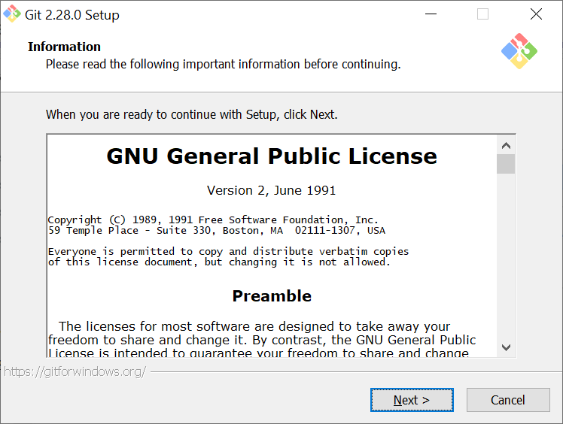

C:\Program Files\Git

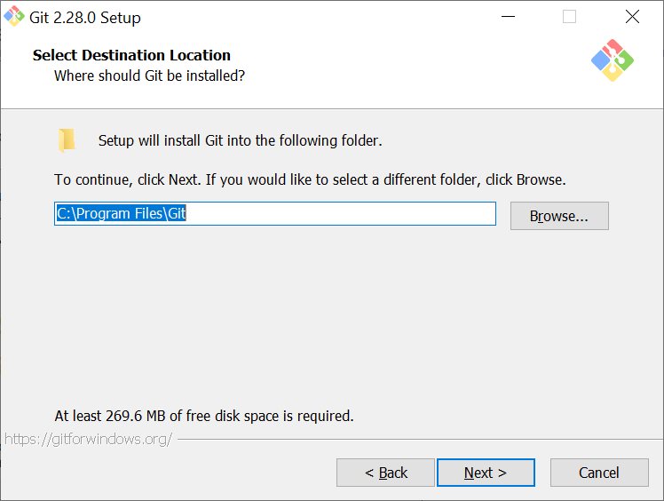

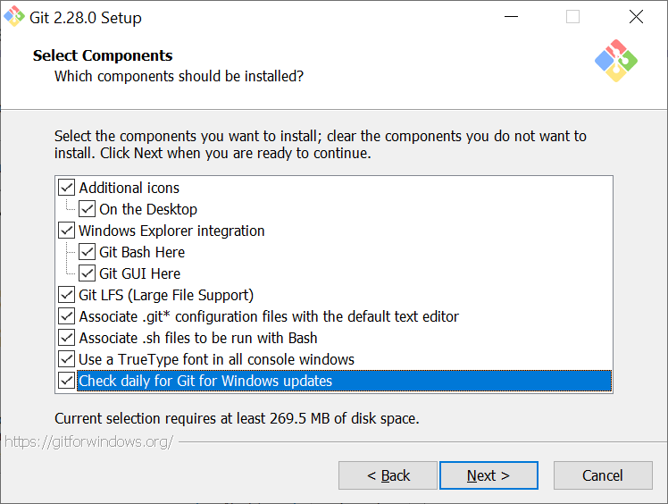

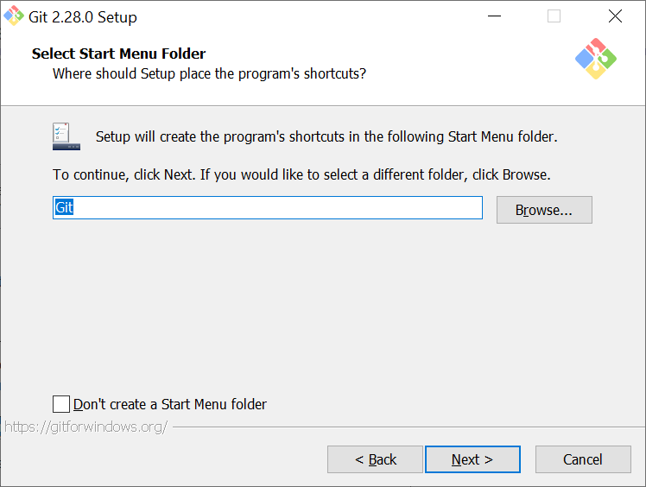

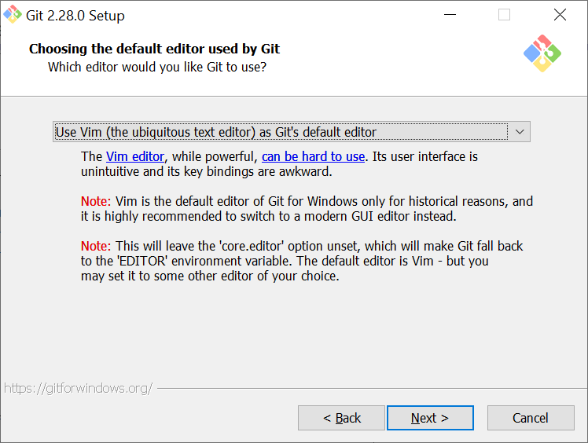

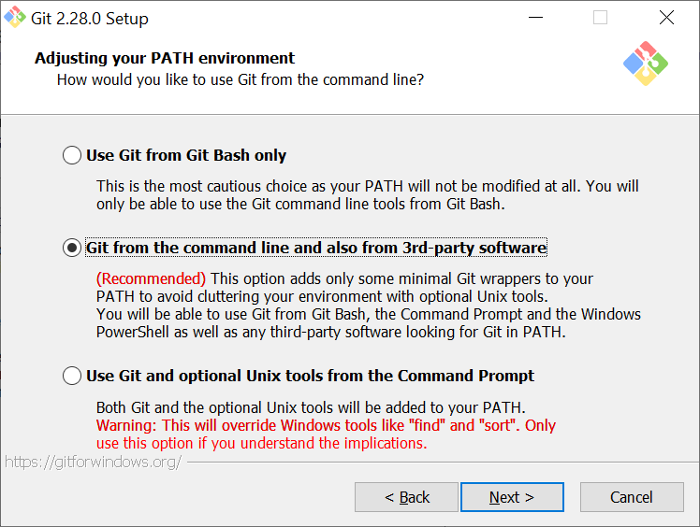

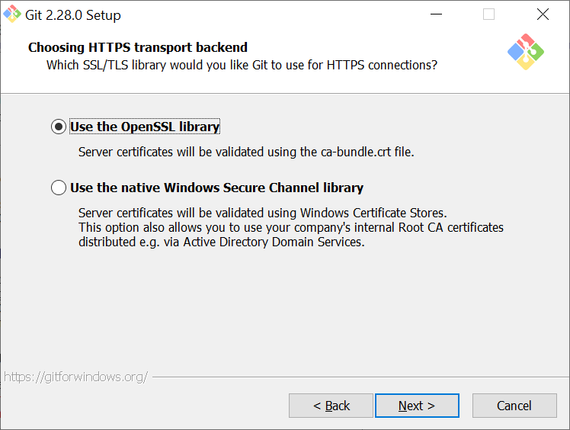

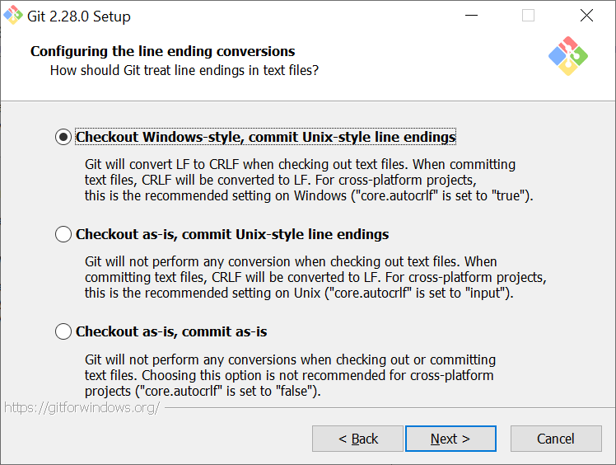

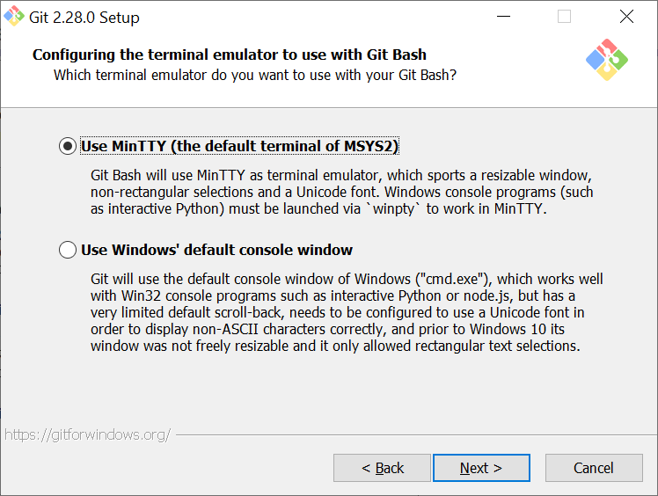

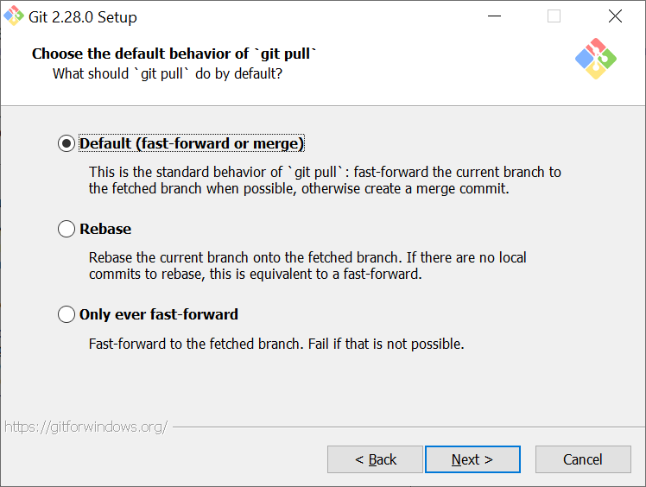

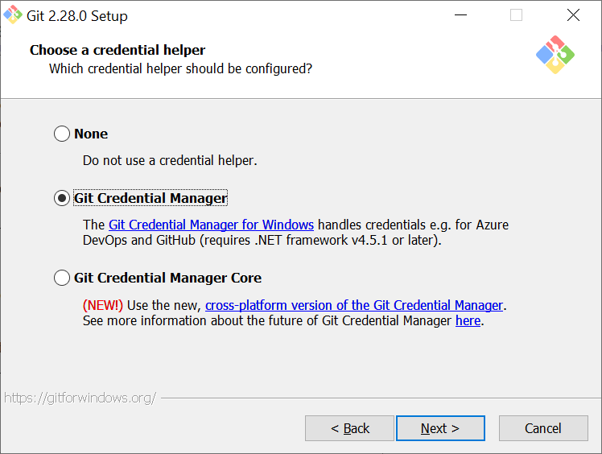

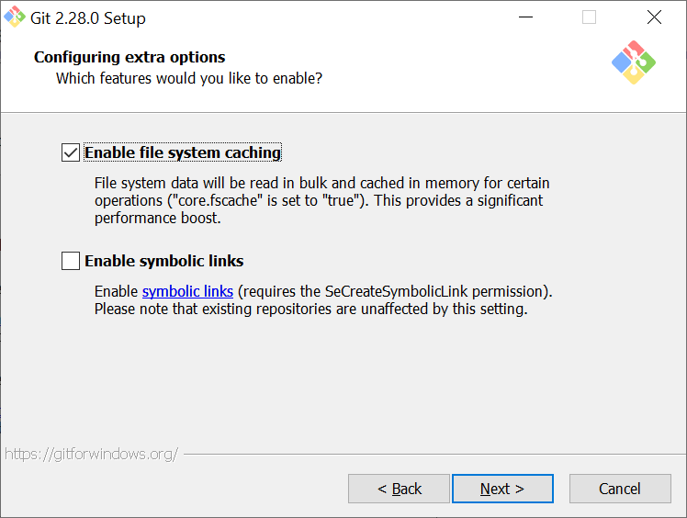

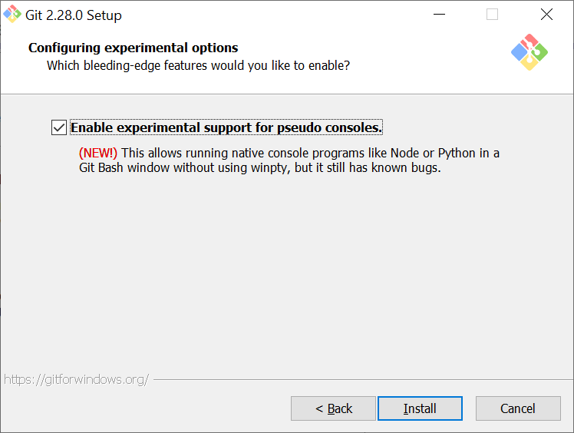

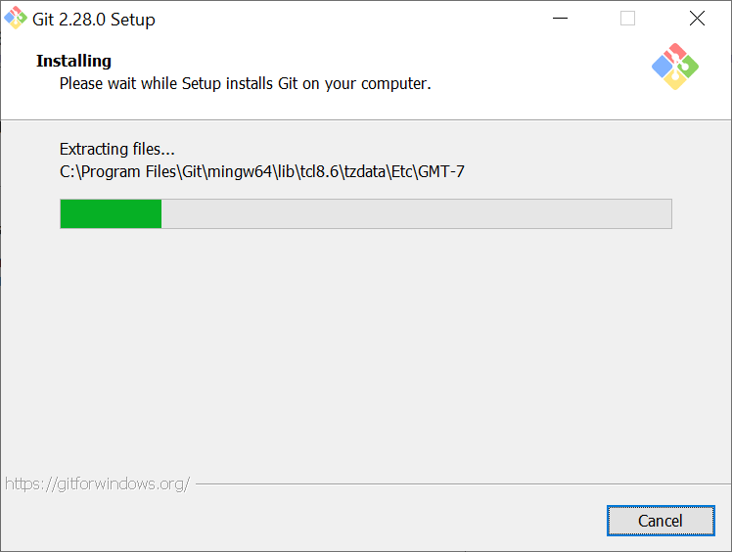

Machine generated alternative text:
Git 2.28.O setup 
>< 
Completing the Git Setup Wizard 
Setup has finished installing Git on your computer. The 
application may be launched by selecting the installed 
shortcuts. 
Click Finish to exit Setup. 
Z] Launch Git Bash 
Z] View Release Notes 
Next > 

Git Successfully Installed

Machine generated alternative text:
MINGW64:/c/Users/pasumark 
pasumark@NAD25CG021C2GV MINGW64 - 
S git --version 
git version 2.28.O.windows.1 
pasumark@NAD25CG021C2GV MINGW64 - 

**GitHub :** [**https://github.com/KPasumarthy/KPNodejsWebApp**](https://github.com/KPasumarthy/KPNodejsWebApp)

