# **Python : KPPythonApp**

**KPPythonApp**

**Install VSCode**

* Install VSCode for creating 'KPPythonApp'

**Install Python**

* Install Python from the <https://www.python.org/downloads/>
* 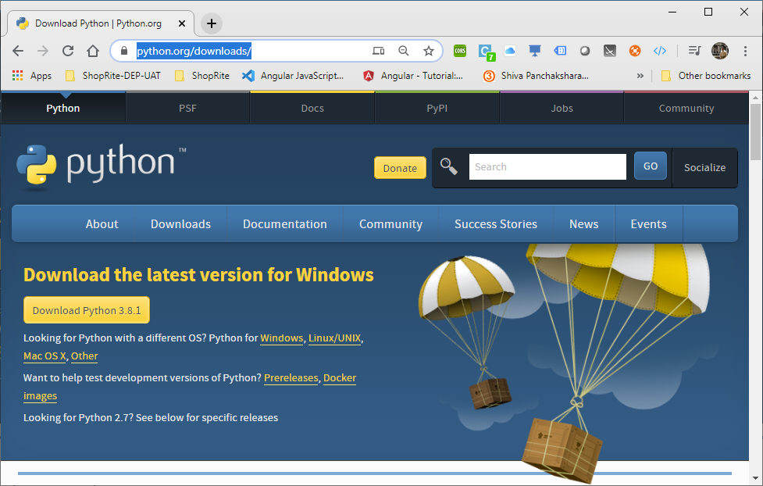

* 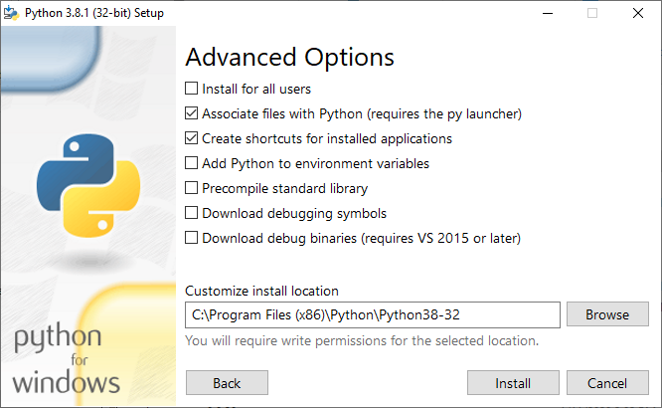
* Install Python from inside VSCode.
* 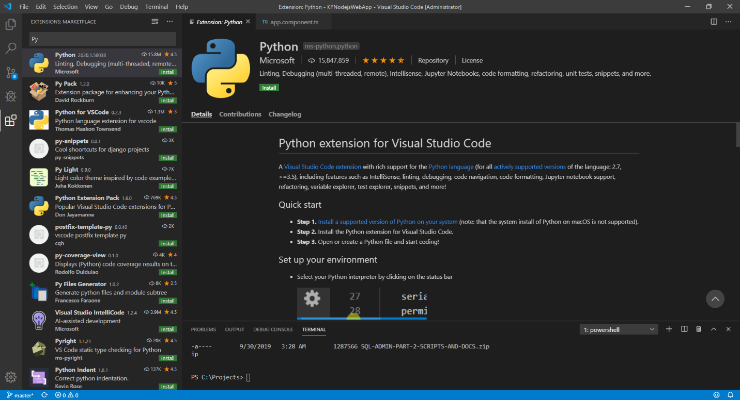
* Python Installation Directory :

"C:/Program Files (x86)/Python/Python38-32/python.exe"

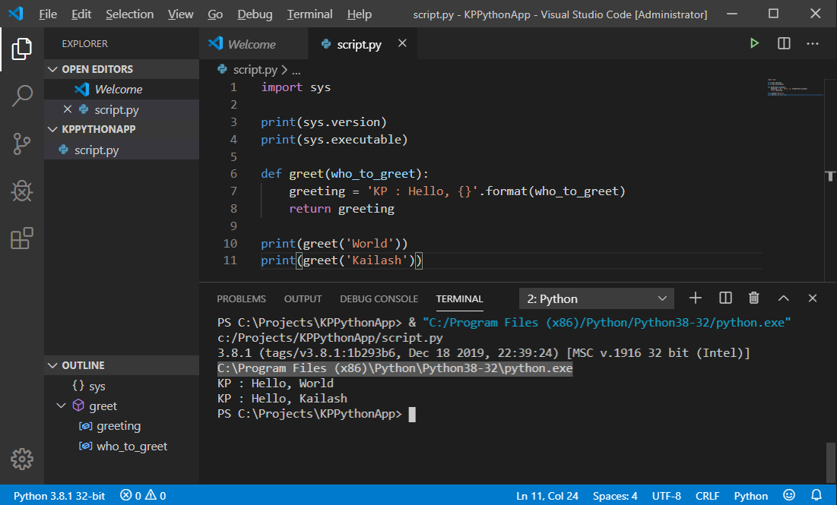

* Global Settings : C:\Users\admin\AppData\Roaming\Code\User\settings.json
* Python Install Virtual Environment : & "C:/Program Files (x86)/Python/Python38-32/python.exe" -m venv venv
* 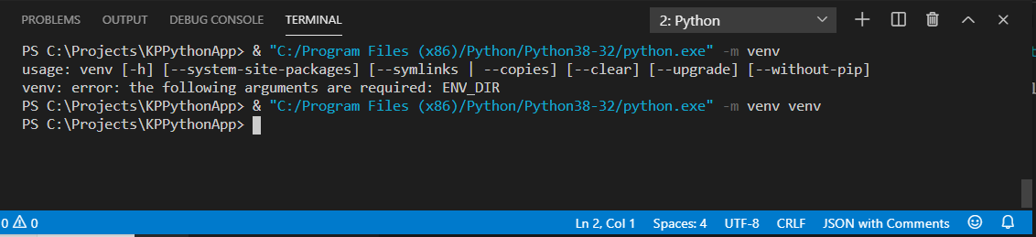
* Python : Requests Library - API Http Get Request

url = "<http://kpmvcwebapis.com/api/Persons/27>"

headers = { 'content-type': 'application/json',

            'accept':'text/html,application/xhtml+xml,application/xml; q=0.9,*/*;q=0.8',

            'accept-Encoding': 'gzip, deflate',

            'accept-language' : 'en-US, en; q=0.5',

            'Connection':'Keep-Alive'}

response = requests.get(url,  headers=headers)

* 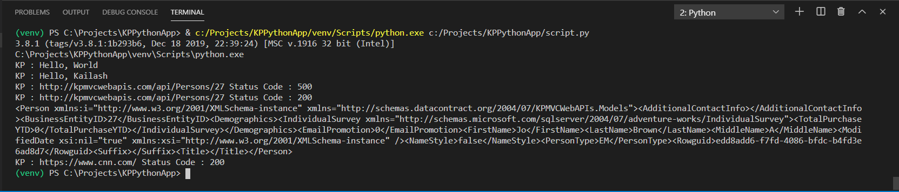

**GitHub : Git & Initialize on Git-Hub**

* GitHub : Initialize Git and GitHub
* GitHub : <https://github.com/KPasumarthy/KPPythonApp>
* 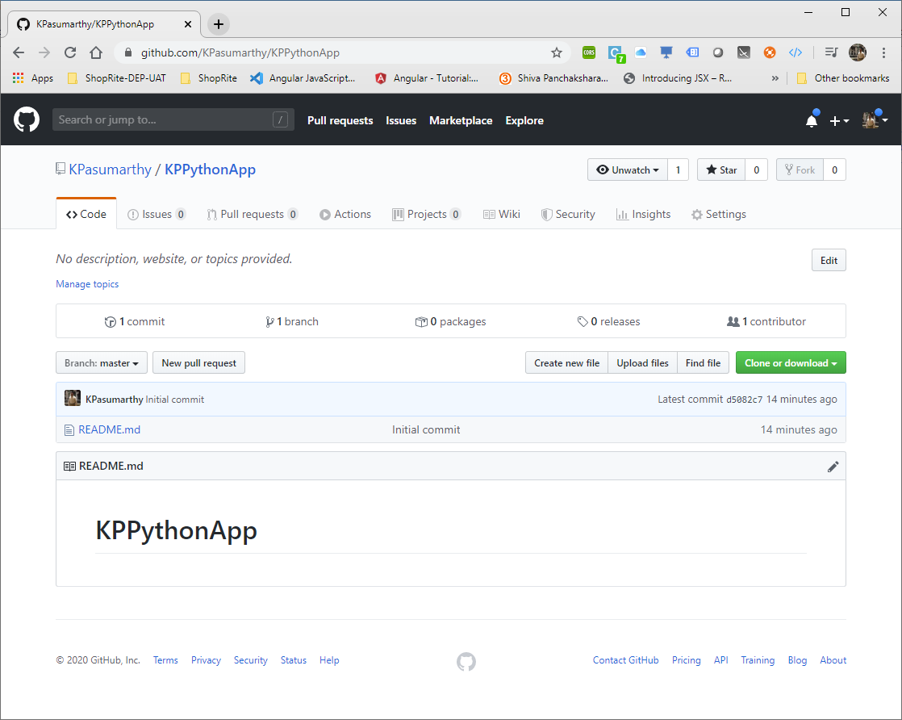
* Initialize git locally with the following commands
  + git init
  + git clone <https://github.com/KPasumarthy/KPPythonApp>

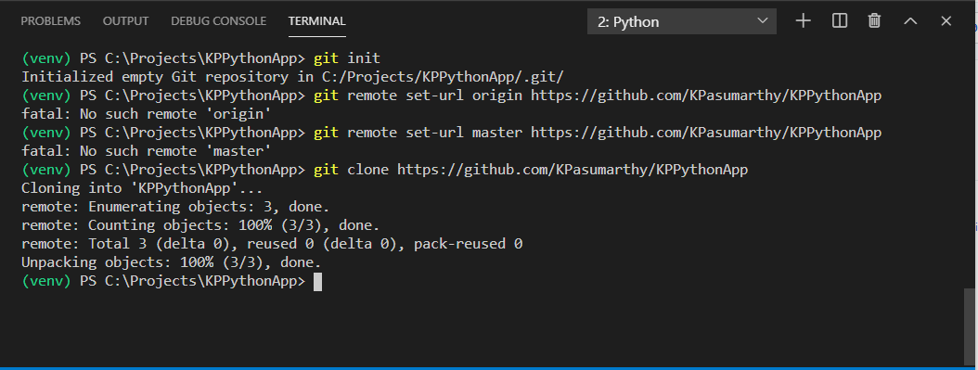

* git add .
* git commit -a "KP : Initial Commit Python App"
* git push

**Set Python Path & Commands :**

* C:\>set PATH=C:\Program Files (x86)\Python\Python38-32;%PATH%
* C:\>set PYTHONPATH=%PYTHONPATH%;C:\Program Files (x86)\Python\Python38-32\Lib
* C:\>python

* **Associate 'py' with Python Files**

assoc .py=Python.File

* **Redirect all Python files to the new executable:**

ftype Python.File=C:\Program Files (x86)\Python\Python38-32\pythonw.exe "%1" %*

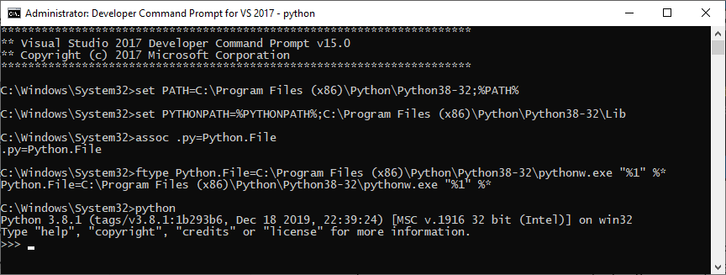

**Python Path & MySQL :**

* Install Python MySQL Connector : python -m pip install mysql-connector

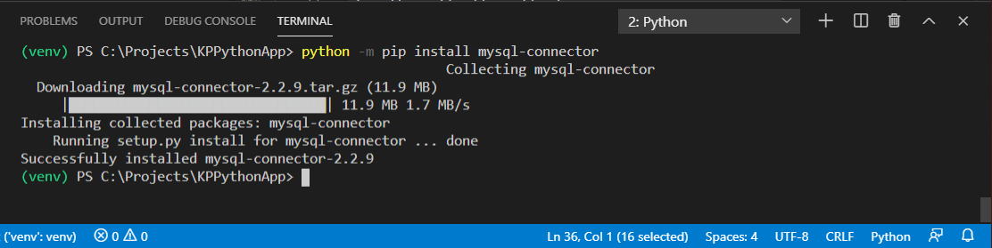

* pip install mysql-connector-python
* 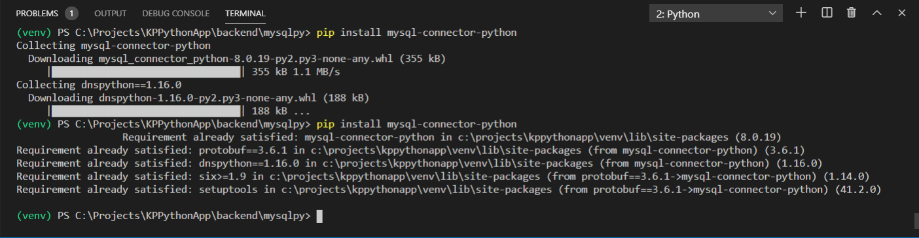

**Python Literature & Documentation**

* <https://docs.python.org/3/index.html>
* Important reason to include ‘__init__.py’ file is to make the python modules inside sub-directories visible …
* <https://stackoverflow.com/questions/1260792/import-a-file-from-a-subdirectory>
* <https://www.w3schools.com/python/python_mysql_getstarted.asp>