Names:
Kaitlynn Perkins
Ian Day
Nathan Trout
Evan Manson
Thomas Wise

- Choose 10 items from the list of product requirements. These should be the features that you intend to implement and deliver as part of your release at the end of the semester.
  - User account management
  - The system shall let users open and run CTF challenge files so they can actually participate in the learning experience
  - Instructors and admins can add challenges
  - Different user views
  - Login system
  - Event Leaderboards
  - Account deletion
  - Input validation
  - Authentication
  - Account and access management
- Identify salient non-functional characteristics of the product
  - Scalability
    - The application should be designed for scalability through cloud hosting and infrastructure so it can support a large number of users at once
  - Security and Privacy
    - We want to have data protection so that everything is secure
    - We also want to have access and authentication rules for sign-in.
  - Load Balancing
    - The system should use load balancers so traffic can be distributed efficiently as the app grows
- Develop architectural design
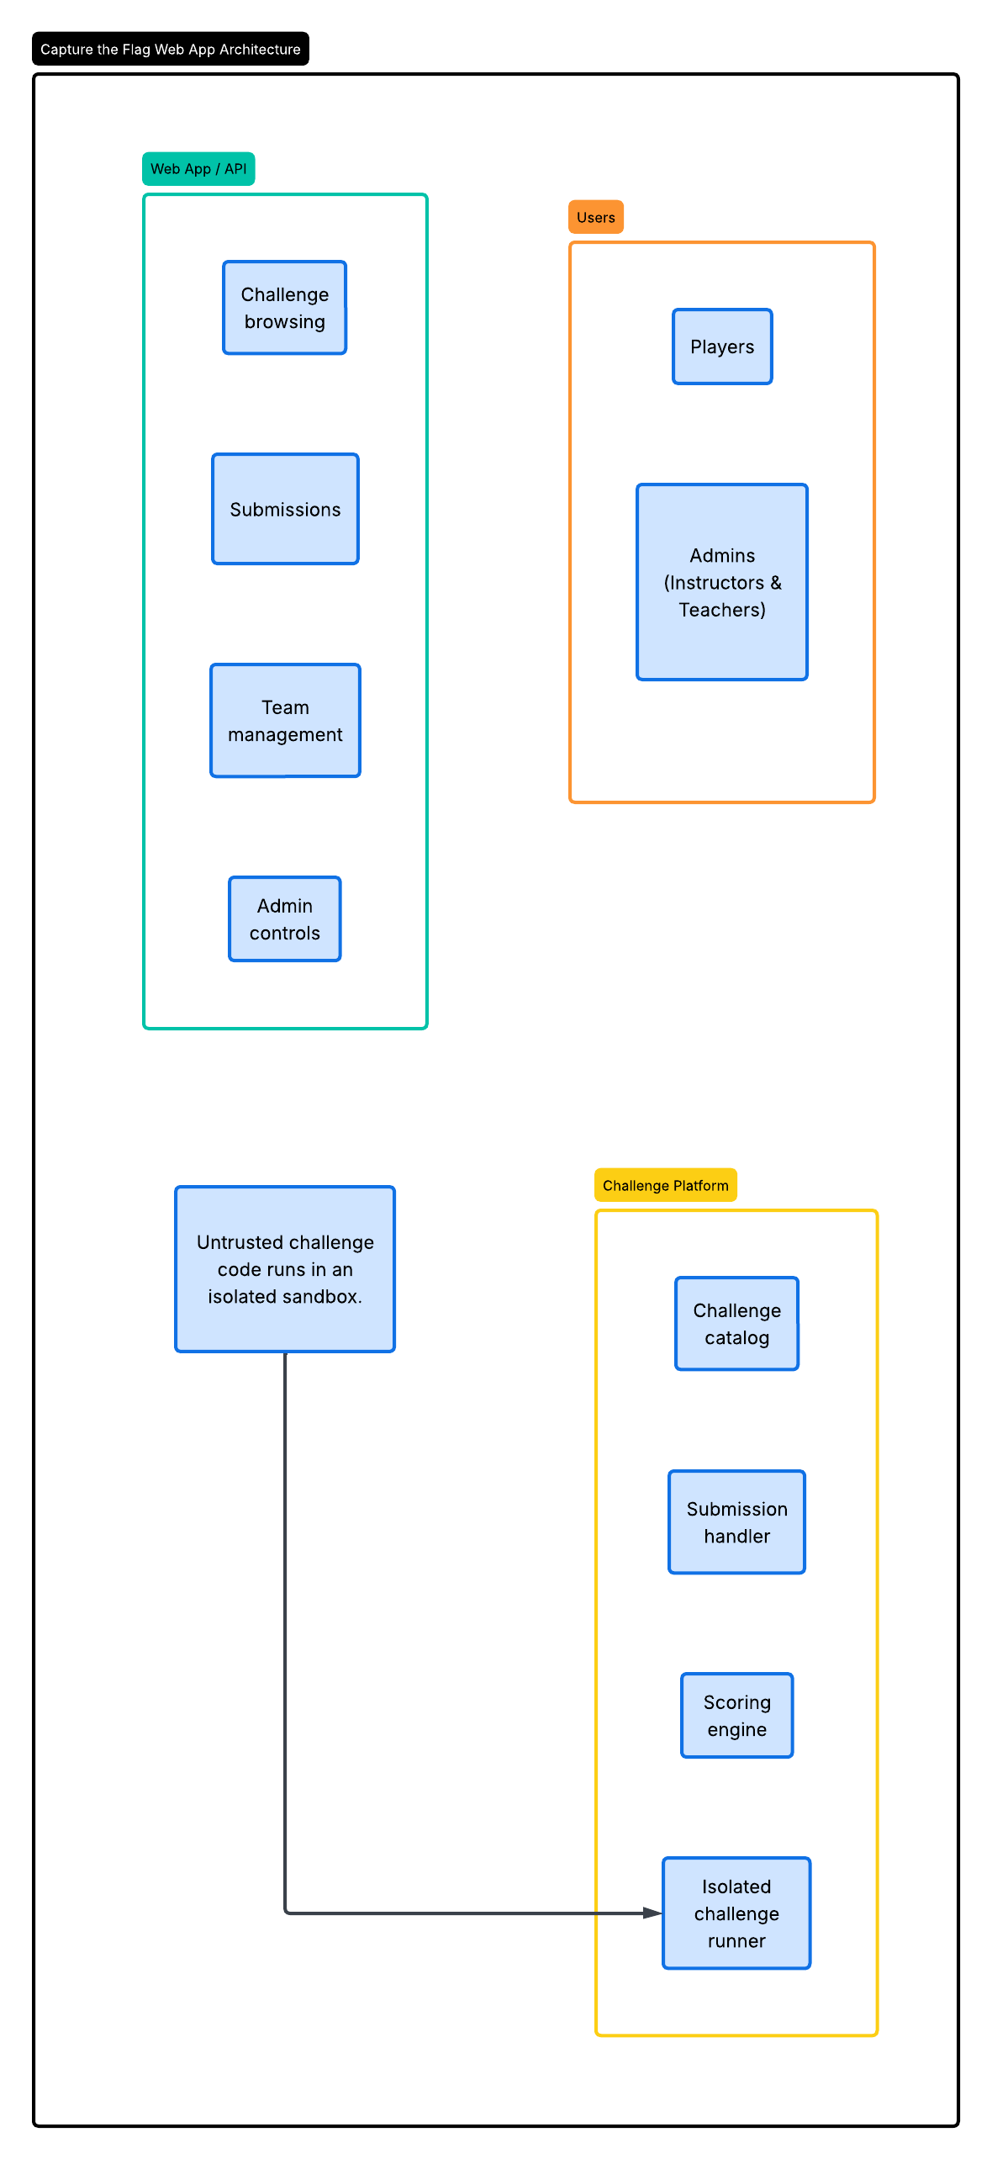
- Develop the data model

- Design User interfaces (UI); Optionally, design wireframes(on paper / on Figma / other tool)
- Choose technology stack for implementation
- Identify services and API endpoints

