CMPE2000 Lab 1 Checkoffs **Student Name: Kaiden Pitcher-Lumley**

**Instructions:** Fill in the sheet below. Put an X under checkoff for the items that are complete as written. Add comments where instructed or required to explain how your solution meets the requirement. The instructor will perform an in-class checkoff once the sheet is complete, and may review your site further (outside of class) to finalize the lab mark.

**Website Address:**

**https://kpitcherlumley.github.io/KPitcherLumleypersonal.github.io/personalpage/personallanding.html**

|  |  |  |
| --- | --- | --- |
| Requirement | Comments | Checkoff |
| Which resources did you use for your research? Answer the following questions based on your research.  * https://www.namecheap.com/guru-guides/what-to-put-on-a-personal-website/  * https://www.themuse.com/advice/6-things-you-should-put-on-your-personal-websiteand-6-things-to-aavoid-at-all-costs  * https://collegeinfogeek.com/essential-componenets-of-personal-websites/  *  * | | |
| What privacy considerations guide your website?  * No Passwords on the site  * Only info that is needed  *  *  * | | |
| What items will you be including on your website?  * Links to social sites  * Images  * Work Examples  * Useful info (ex. Name)  * | | |
| What items will you NOT include on your website?  * Blogs because I suck at writing  * Clip ART!!!  *  *  * | | |
| **SUBMIT YOUR WEBSITE DESIGN TO THE DROPBOX in addition to this document** | | |
| Indicate how you met the Lab’s requirements by filling in the requested information below: | | |
| Uses GitHub Webspace | Yes and it was a pain to figure out |  |
| Use appropriate HTML5 Tags (Header, Section, Aside, Nav, etc) | Pretty sure |  |
| No deprecated tags used anywhere | None used at all |  |
| All pages interlinked | Yes and they have back to previous page links for the non main page |  |
| One or more pages use CSS Grid (specify pages) | Pretty sure all pages use the grid |  |
| Mobile first topology used | yes |  |
| All pages use the same style.css | yes |  |
| Pages have a common theme | Yes maybe a little over board |  |
| If any styling was done outside of one external stylesheet, indicate # of occurrences and explain why: |  |  |
| Provide a listing of all the HTML tags you used throughout your site | -header, h1, nav, img, a, figure, footer, br, h5, script, article, h2, p, ul, li,  H3, section, body |  |
| List the font specification from your site: | Headers -  font-family: 'Silkscreen', cursive, monospace;  Other - font-family: 'Chakra Petch', sans-serif, monospace; |  |
| Creative Contributions | | |
| What are some of the creative parts of your site that you’d like me to notice/be aware of? | The images are 98% ones ive taken  The placeholder sites in projects use very basic JS | |
| Are there any websites that influenced you/gave you ideas on how to design your site that you didn’t mention in your research? | No | |
| Any other comments? | No–––­­­ |  |

Once sheet is complete, sign up on the whiteboard for instructor checkoff. Mark will not be finalized in class.

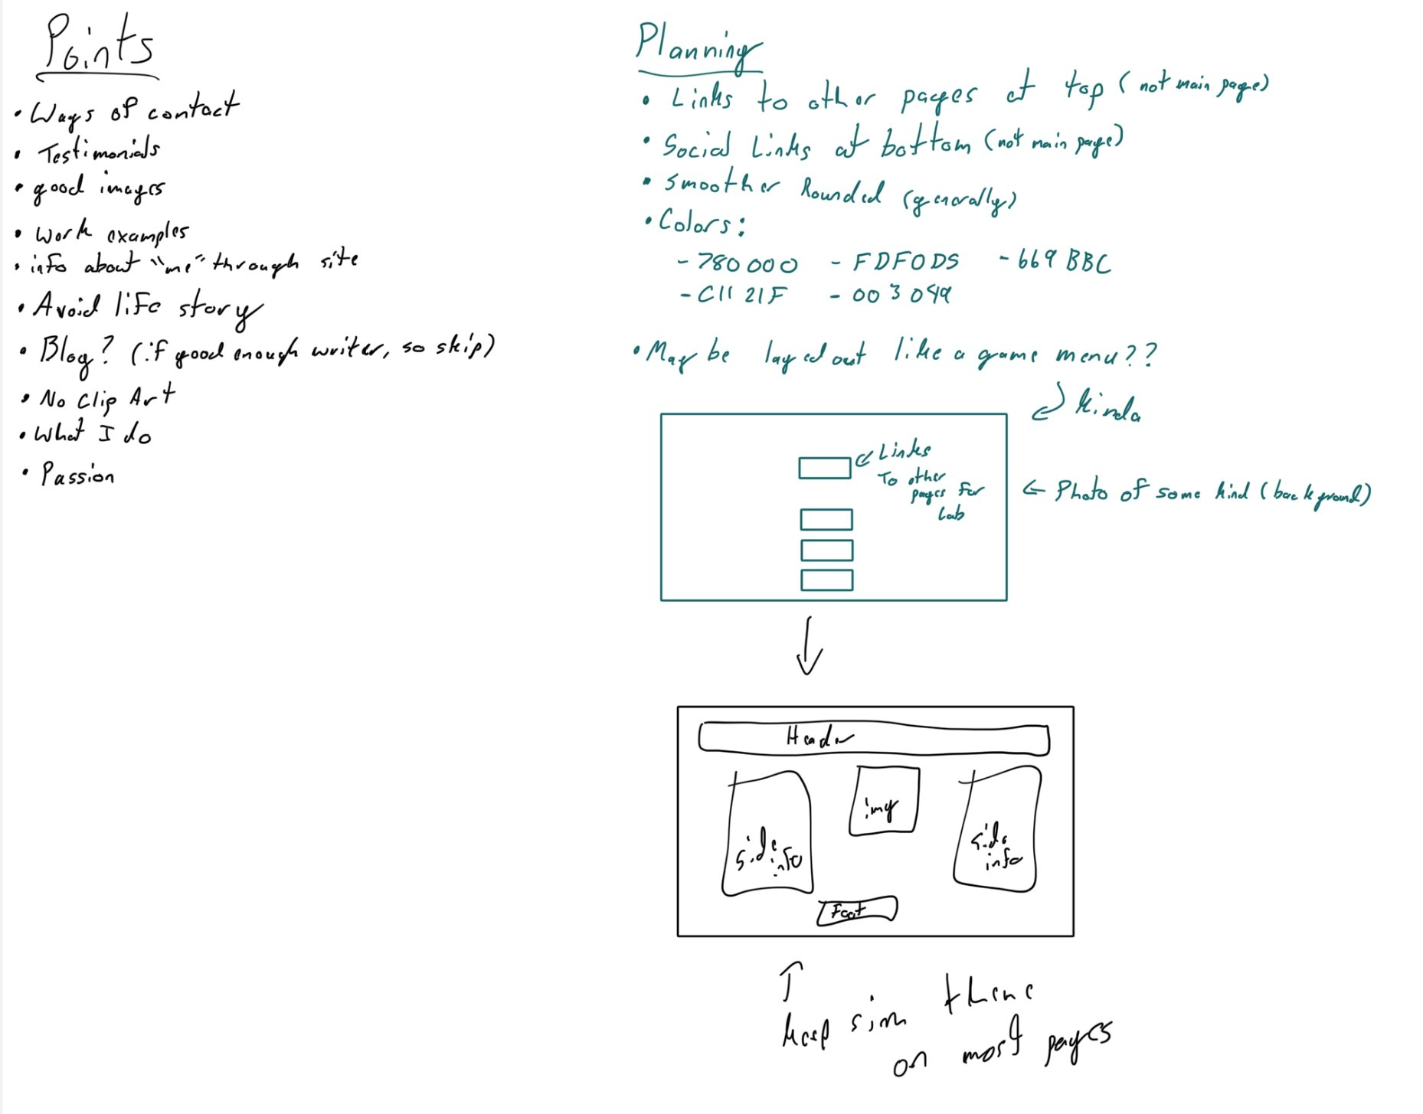

**Instructor checkoff:** _____________ **Final Grade: ________________**