Q. Docker container

[devops-commontrack-mocktest/question5 at main · KPkm25/devops-commontrack-mocktest](https://github.com/KPkm25/devops-commontrack-mocktest/tree/main/question5)

1. Cloning the Github Repository using the following command

Git clone git@hgithub.com:devops-experience/k8s-helloworld.git

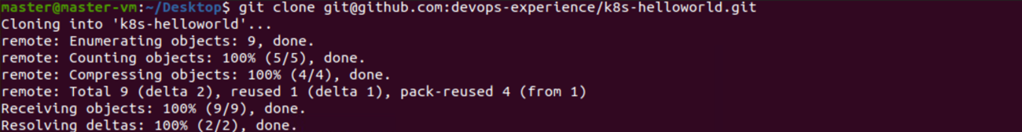

2. Creating the Dockerfile using the following command

Cd k8s-helloworld

Nano Dockerfile

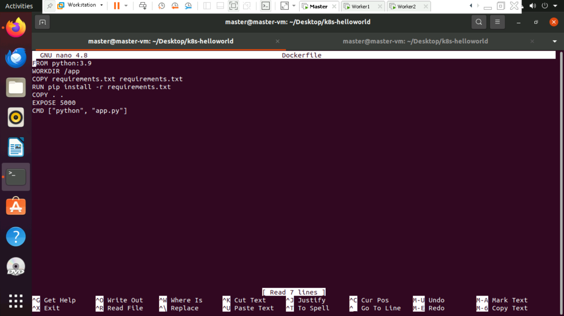

3. Building the Docker image using the following command

Docker build -t kpkm25/k8s-helloworld

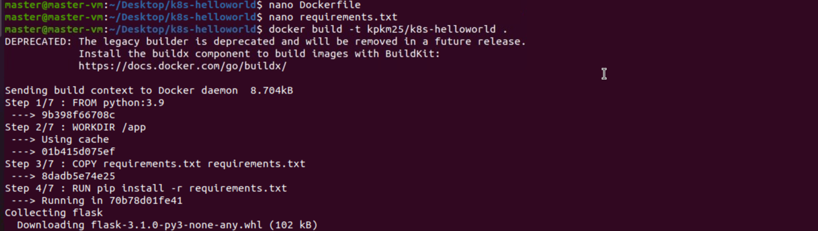

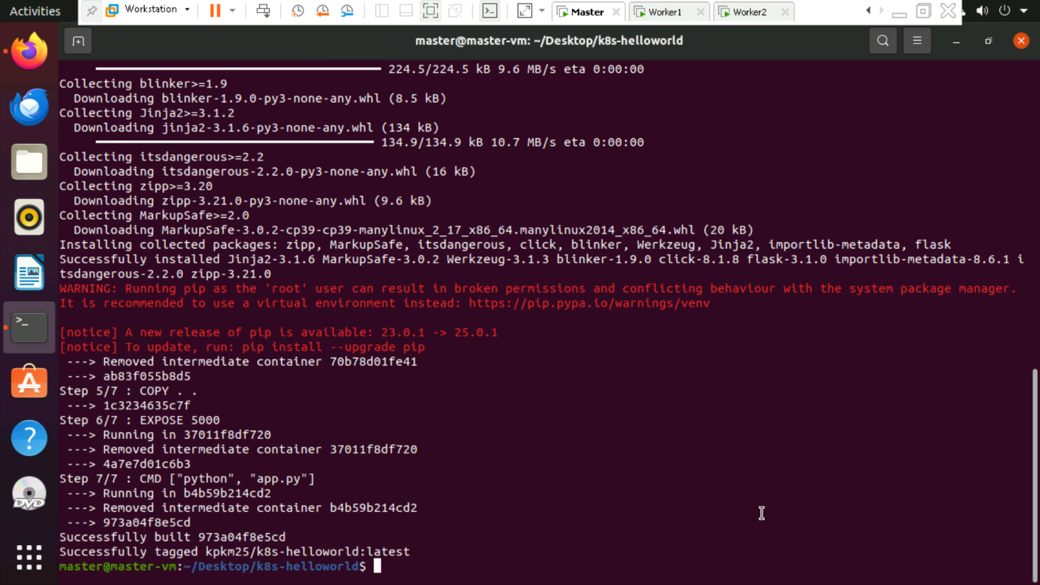

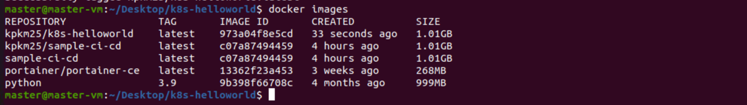

4. Running the container on port 5000 using the following command

Docker run -p 5000:5000 kpkm25/k8s-helloworld

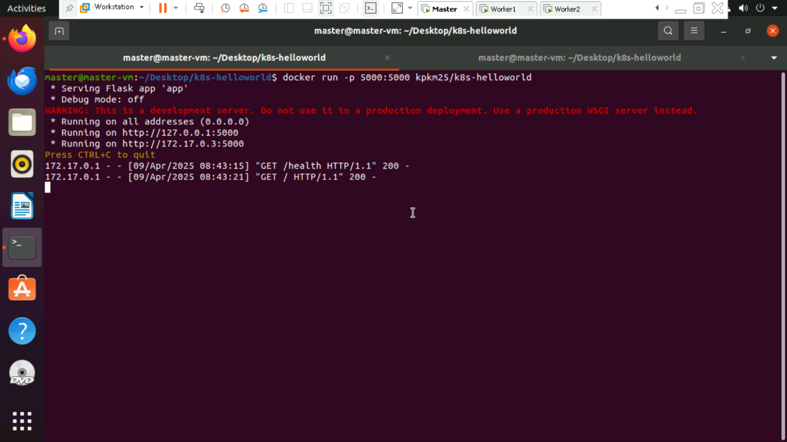

5. Testing the API endpoints using the following curl commands:

Curl <http://127.0.0.1:5000>

Curl 127.0.0.1:5000/health

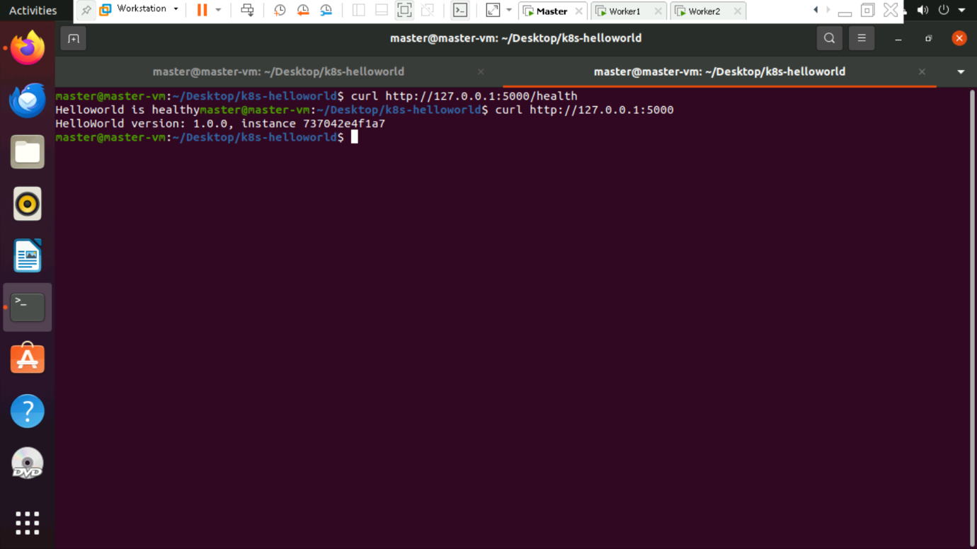

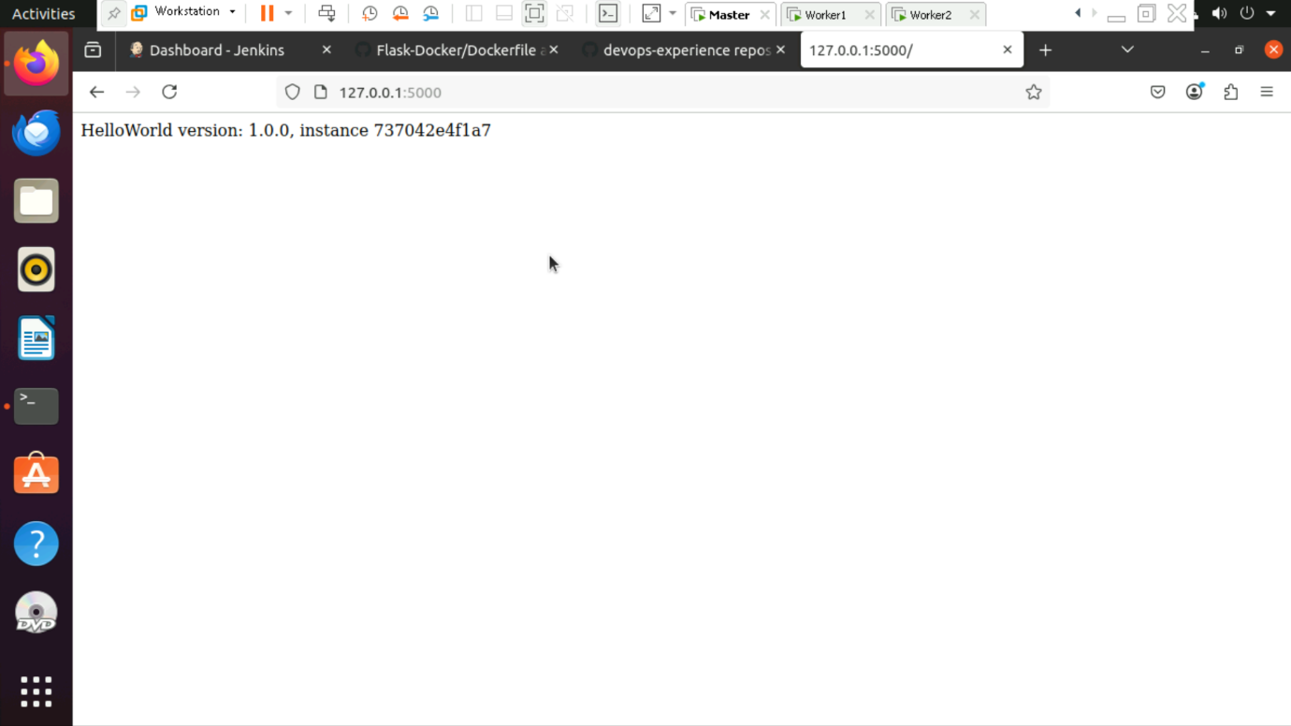

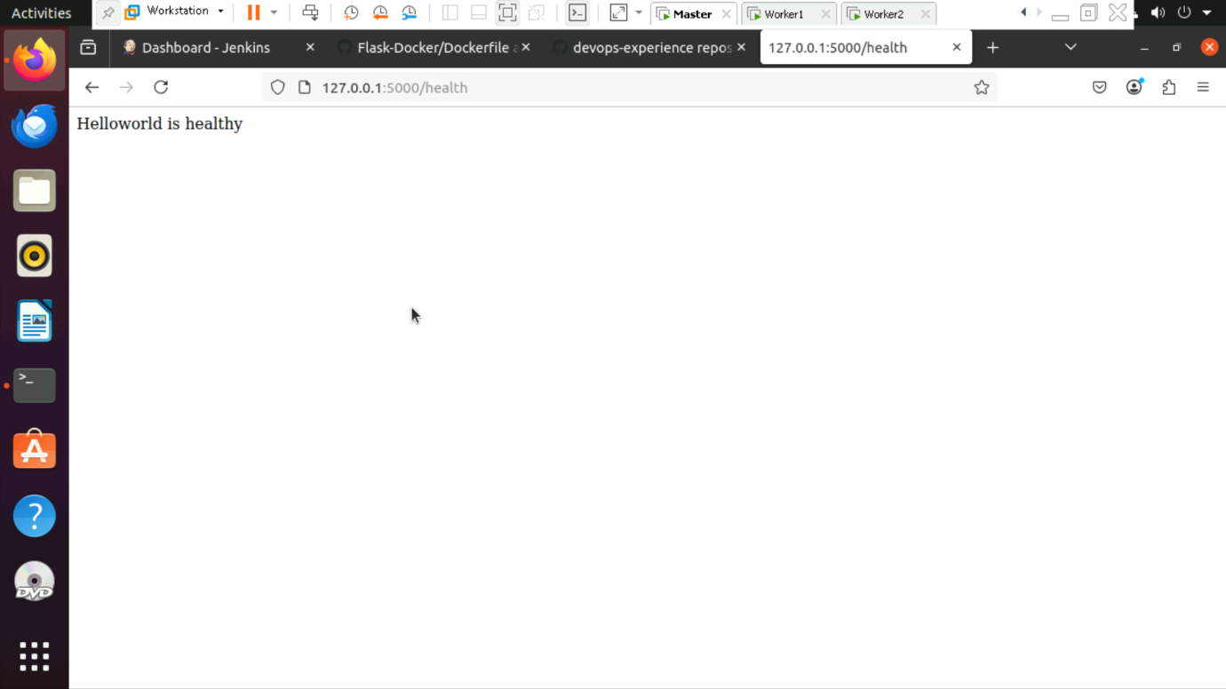

6. To view the container ID, run the following command

Docker ps

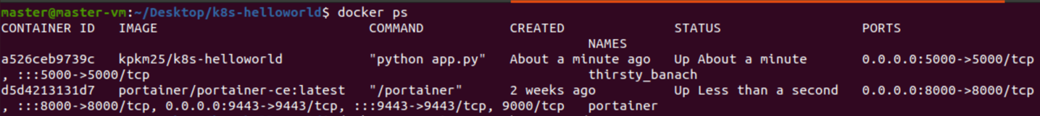

7. To view the working directory we have to go inside the container using the following command

Docker exec -it <container_id> pwd

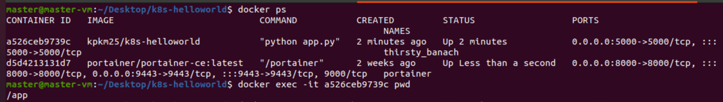

8. To view the read-write layer directory on the host, run the following command

Docker inspect <container_id> --format ‘{{.GraphDriver.Data.UpperDir}}’

