GRC Control Automation Prototype Architecture

DISCLAIMER: This project is a fictional portfolio prototype designed to demonstrate GRC Engineering principles and access review control automation. It is NOT a production security system.

1. System Overview
The Privileged Access Review Control Engine automates point-in-time compliance checks into a continuous, audit-ready control. It ingests identity, account, and entitlement state, runs automated YAML-defined detection rules, flags violations, and generates cryptographically verifiable audit evidence.

2. Architecture Diagram :
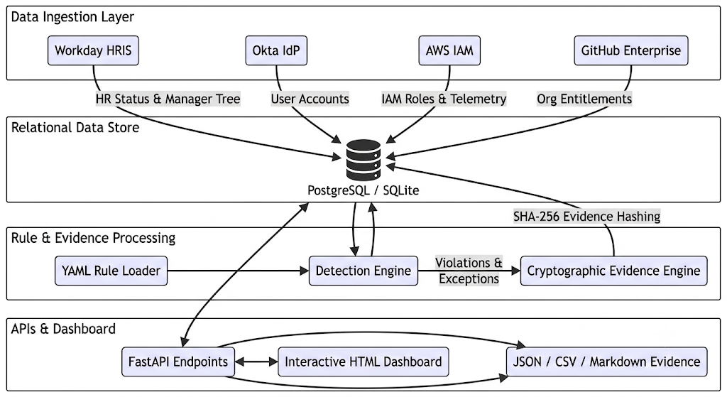

3. Automation Scope Analysis

What Is Automated?
- Data Correlation: Automatic mapping of native account usernames to canonical identity emails across AWS, Okta, and GitHub.
- Rule Evaluation: Continuous detection of terminated users, unowned accounts, dormant access, role mismatches, and unapproved grants.
- Severity & SLA Assignment: Automated classification of violation severity and due-date calculation.
- Audit Evidence Generation: Automated creation of tamper-evident JSON, CSV, and Markdown audit packages stamped with SHA-256 hashes.

What Remains Manual?
- Business Justification Approval: Human managers must review contextual needs before approving access exceptions.
- Risk Acceptance Decisions: Formal sign-off on high-risk findings requires human CISO / GRC Lead authorization.
- Executive Overrides: Policy threshold overrides require manual GRC review.

What Could Go Wrong?
- Stale Source Sync: If HRIS sync lags, terminated user detection might be delayed.
- Rule Misconfiguration: Overly broad rules could trigger false positive alert fatigue.
- Credential Rotation: API authentication tokens to cloud providers could expire, causing scan drops.

