1. Double Click to start installation



Follow the steps to successfully install Yardi Tools

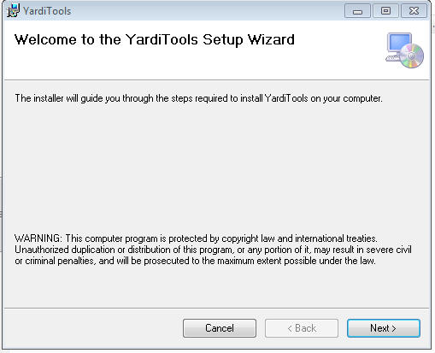

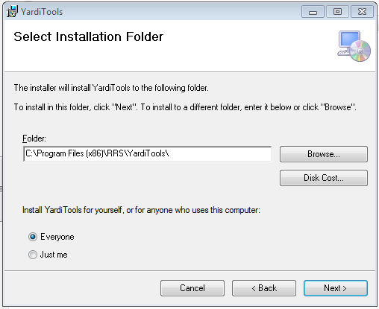

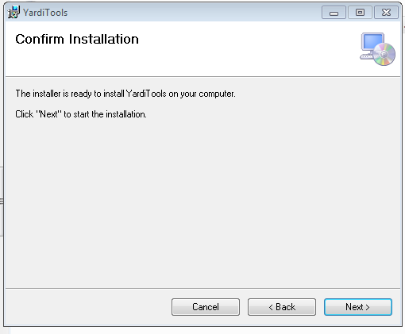

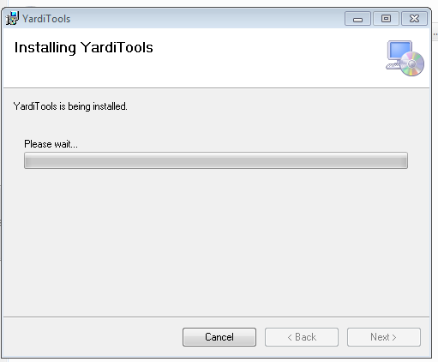

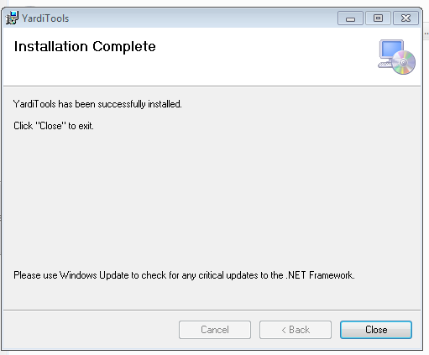

The files will be instaled in the following default directory:

Note : If you have added clients and set file locations, please save a copy of the files clients.xml and config.xml. If you reinstall Yardi tools in the future, it will overwrite these files.

Go ahead and create shortcuts for YardiDashboard.exe

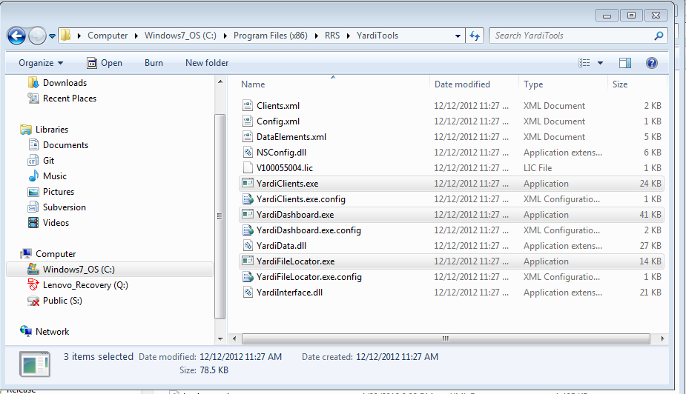

If you want to reinstall Yardi tools, please go to the screen below and uninstall Yardi Tools first.

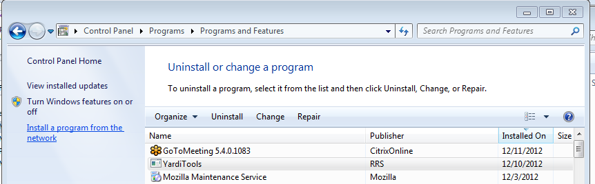

The File Locator tool allows you to choose where you want to store your files.

RAW xml file are the complete file downloaded from Yardi. They are saved for reference.

Collections extracts are were the csv files are stored

Collections Extracts (false) are where the files with collection status is false.

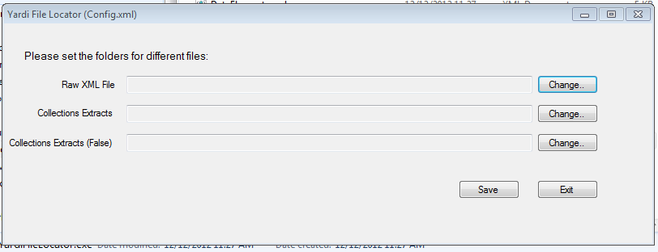

If you run YardiDashboard, it will give the following message and launch the file locator.

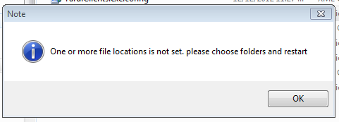

Yardi Client Maintenance tool

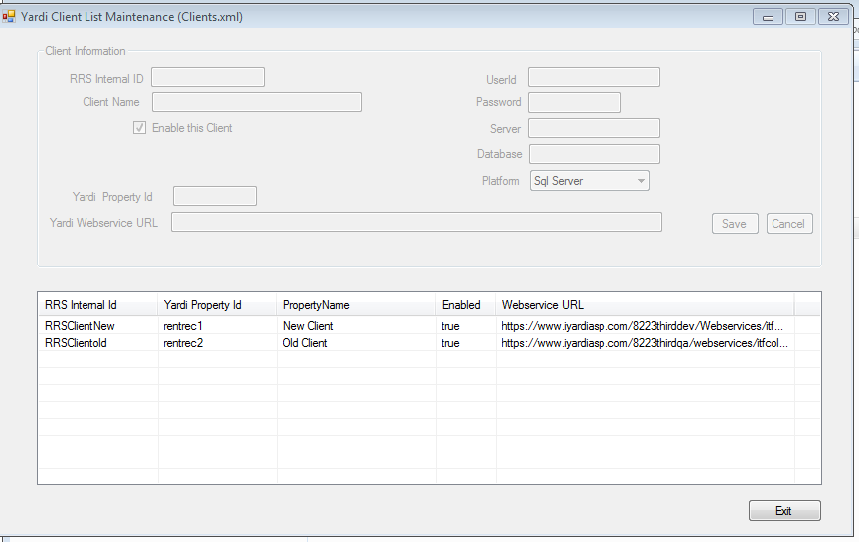

Right click on the list to add, edit , delete entries.