Day1_assignment

Create local repo as DeveloperA and create 3 files demo1, demo2, demo3

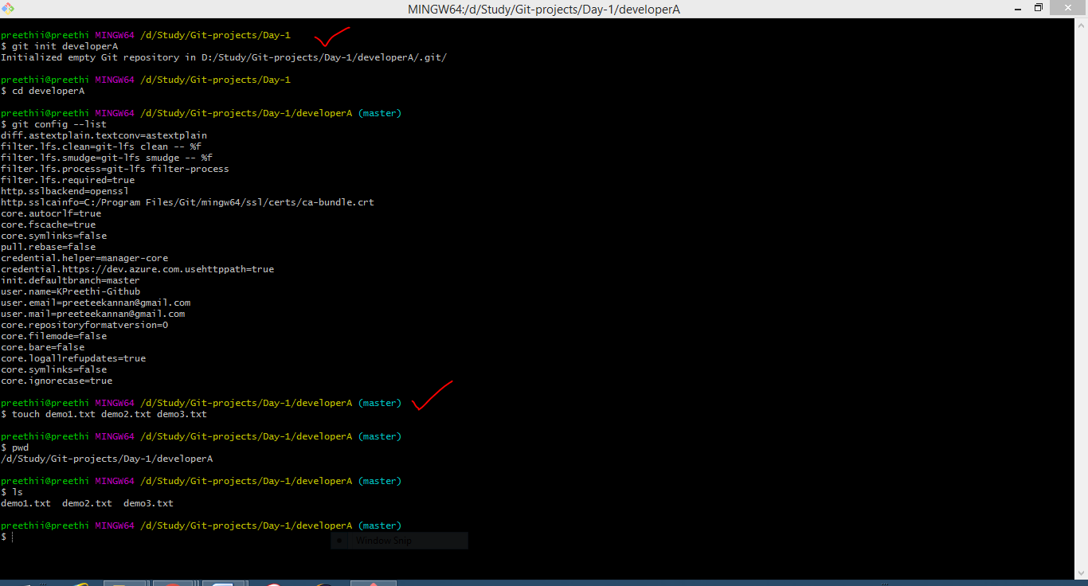

Add all the files into the staging area & commit into the local repo

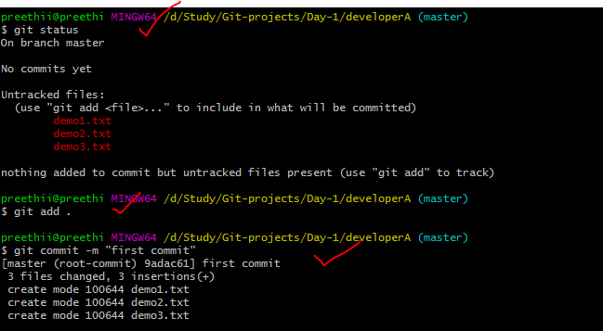

Created a remote repo (https://github.com/KPreethi-Github/**DevOps-Bootcamp**.git) & add the remote repo with local repo

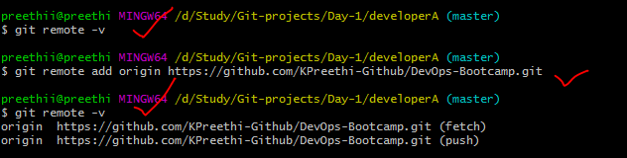

Push the code from local repo to remote repo

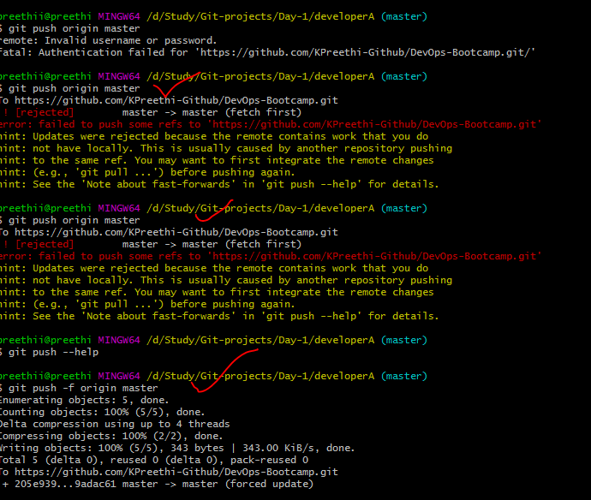

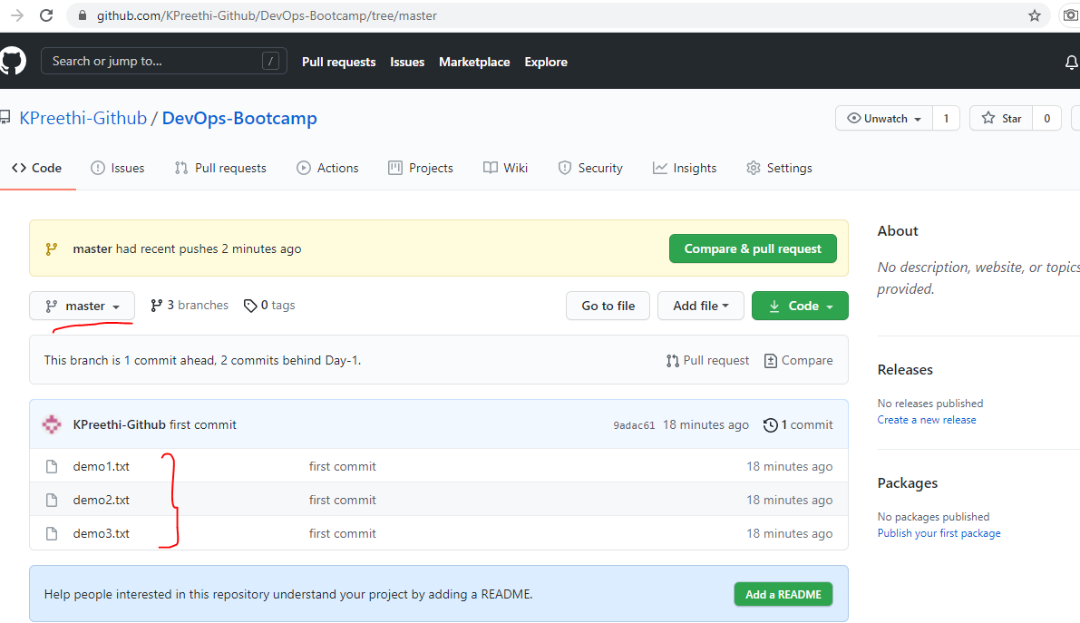

Clone the remote repo to the another folder developer

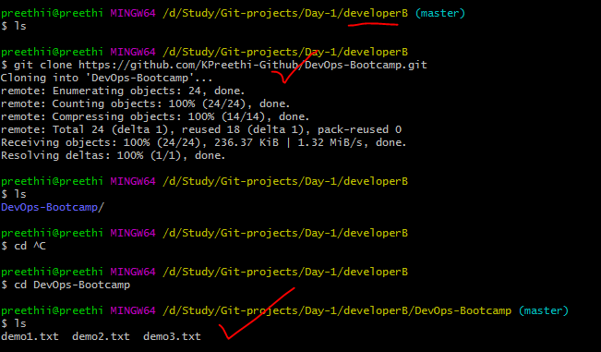

Make and commit the changes via developerB & synchronize the changes in developerA

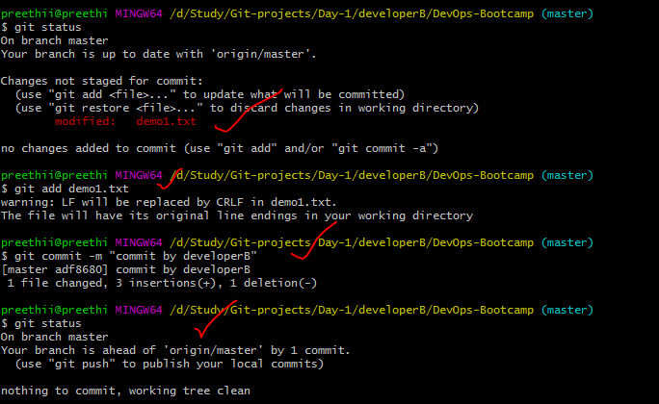

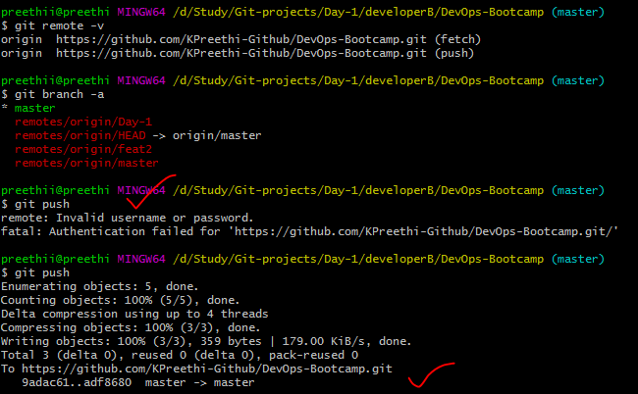

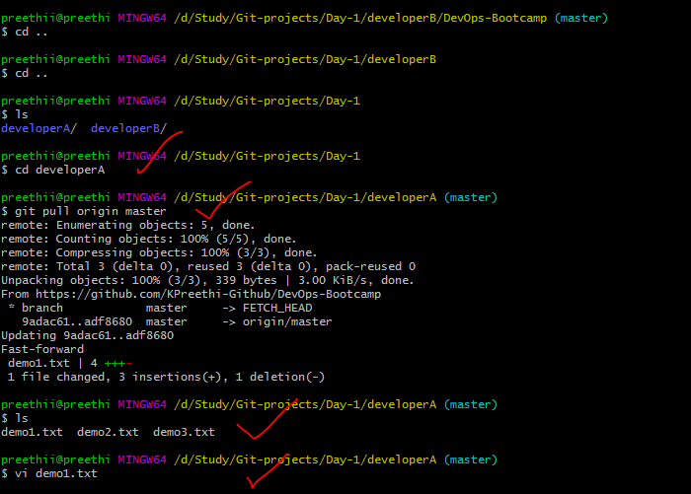

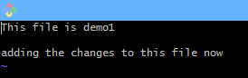

Create a feature branch & change the file

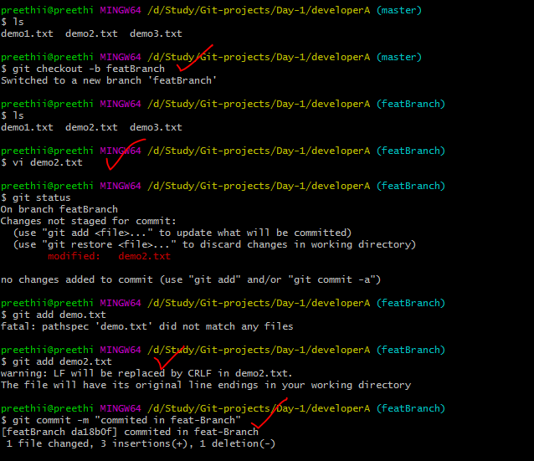

Merge back the created branch with the master branch

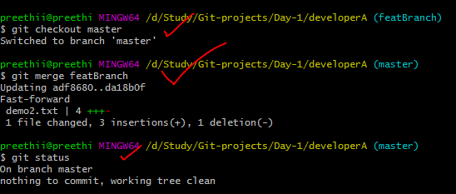

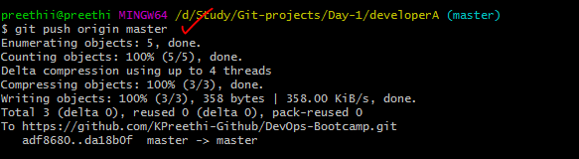

Delete the feature branch after merging

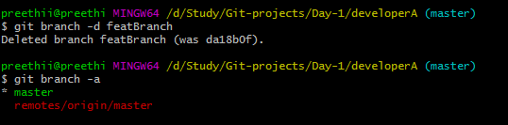

preethii@preethi MINGW64 /d/Study/Git-projects/Day-1

$ git init developerA

Initialized empty Git repository in D:/Study/Git-projects/Day-1/developerA/.git/

preethii@preethi MINGW64 /d/Study/Git-projects/Day-1

$ cd developerA

preethii@preethi MINGW64 /d/Study/Git-projects/Day-1/developerA (master)

$ git config --list

diff.astextplain.textconv=astextplain

filter.lfs.clean=git-lfs clean -- %f

filter.lfs.smudge=git-lfs smudge -- %f

filter.lfs.process=git-lfs filter-process

filter.lfs.required=true

http.sslbackend=openssl

http.sslcainfo=C:/Program Files/Git/mingw64/ssl/certs/ca-bundle.crt

core.autocrlf=true

core.fscache=true

core.symlinks=false

pull.rebase=false

credential.helper=manager-core

credential.https://dev.azure.com.usehttppath=true

init.defaultbranch=master

user.name=KPreethi-Github

user.email=preeteekannan@gmail.com

user.mail=preeteekannan@gmail.com

core.repositoryformatversion=0

core.filemode=false

core.bare=false

core.logallrefupdates=true

core.symlinks=false

core.ignorecase=true

preethii@preethi MINGW64 /d/Study/Git-projects/Day-1/developerA (master)

$ touch demo1.txt demo2.txt demo3.txt

preethii@preethi MINGW64 /d/Study/Git-projects/Day-1/developerA (master)

$ pwd

/d/Study/Git-projects/Day-1/developerA

preethii@preethi MINGW64 /d/Study/Git-projects/Day-1/developerA (master)

$ ls

demo1.txt demo2.txt demo3.txt

preethii@preethi MINGW64 /d/Study/Git-projects/Day-1/developerA (master)

$ git config --global --unset user.mail

preethii@preethi MINGW64 /d/Study/Git-projects/Day-1/developerA (master)

$ git config --list

diff.astextplain.textconv=astextplain

filter.lfs.clean=git-lfs clean -- %f

filter.lfs.smudge=git-lfs smudge -- %f

filter.lfs.process=git-lfs filter-process

filter.lfs.required=true

http.sslbackend=openssl

http.sslcainfo=C:/Program Files/Git/mingw64/ssl/certs/ca-bundle.crt

core.autocrlf=true

core.fscache=true

core.symlinks=false

pull.rebase=false

credential.helper=manager-core

credential.https://dev.azure.com.usehttppath=true

init.defaultbranch=master

user.name=KPreethi-Github

user.email=preeteekannan@gmail.com

core.repositoryformatversion=0

core.filemode=false

core.bare=false

core.logallrefupdates=true

core.symlinks=false

core.ignorecase=true

preethii@preethi MINGW64 /d/Study/Git-projects/Day-1/developerA (master)

$ git log

fatal: your current branch 'master' does not have any commits yet

preethii@preethi MINGW64 /d/Study/Git-projects/Day-1/developerA (master)

$ git status

On branch master

No commits yet

Untracked files:

(use "git add <file>..." to include in what will be committed)

demo1.txt

demo2.txt

demo3.txt

nothing added to commit but untracked files present (use "git add" to track)

preethii@preethi MINGW64 /d/Study/Git-projects/Day-1/developerA (master)

$ git add .

preethii@preethi MINGW64 /d/Study/Git-projects/Day-1/developerA (master)

$ git reset

preethii@preethi MINGW64 /d/Study/Git-projects/Day-1/developerA (master)

$ git status

On branch master

No commits yet

Untracked files:

(use "git add <file>..." to include in what will be committed)

demo1.txt

demo2.txt

demo3.txt

nothing added to commit but untracked files present (use "git add" to track)

preethii@preethi MINGW64 /d/Study/Git-projects/Day-1/developerA (master)

$ git add .

preethii@preethi MINGW64 /d/Study/Git-projects/Day-1/developerA (master)

$ git commit -m "first commit"

[master (root-commit) 9adac61] first commit

3 files changed, 3 insertions(+)

create mode 100644 demo1.txt

create mode 100644 demo2.txt

create mode 100644 demo3.txt

preethii@preethi MINGW64 /d/Study/Git-projects/Day-1/developerA (master)

$ git remote -v

preethii@preethi MINGW64 /d/Study/Git-projects/Day-1/developerA (master)

$ git remote add origin https://github.com/KPreethi-Github/DevOps-Bootcamp.git

preethii@preethi MINGW64 /d/Study/Git-projects/Day-1/developerA (master)

$ git remote -v

origin https://github.com/KPreethi-Github/DevOps-Bootcamp.git (fetch)

origin https://github.com/KPreethi-Github/DevOps-Bootcamp.git (push)

preethii@preethi MINGW64 /d/Study/Git-projects/Day-1/developerA (master)

$ git push origin master

remote: Invalid username or password.

fatal: Authentication failed for 'https://github.com/KPreethi-Github/DevOps-Bootcamp.git/'

preethii@preethi MINGW64 /d/Study/Git-projects/Day-1/developerA (master)

$ git push origin master

To https://github.com/KPreethi-Github/DevOps-Bootcamp.git

! [rejected] master -> master (fetch first)

error: failed to push some refs to 'https://github.com/KPreethi-Github/DevOps-Bootcamp.git'

hint: Updates were rejected because the remote contains work that you do

hint: not have locally. This is usually caused by another repository pushing

hint: to the same ref. You may want to first integrate the remote changes

hint: (e.g., 'git pull ...') before pushing again.

hint: See the 'Note about fast-forwards' in 'git push --help' for details.

preethii@preethi MINGW64 /d/Study/Git-projects/Day-1/developerA (master)

$ git push origin master

To https://github.com/KPreethi-Github/DevOps-Bootcamp.git

! [rejected] master -> master (fetch first)

error: failed to push some refs to 'https://github.com/KPreethi-Github/DevOps-Bootcamp.git'

hint: Updates were rejected because the remote contains work that you do

hint: not have locally. This is usually caused by another repository pushing

hint: to the same ref. You may want to first integrate the remote changes

hint: (e.g., 'git pull ...') before pushing again.

hint: See the 'Note about fast-forwards' in 'git push --help' for details.

preethii@preethi MINGW64 /d/Study/Git-projects/Day-1/developerA (master)

$ git push --help

preethii@preethi MINGW64 /d/Study/Git-projects/Day-1/developerA (master)

$ git push -f origin master

Enumerating objects: 5, done.

Counting objects: 100% (5/5), done.

Delta compression using up to 4 threads

Compressing objects: 100% (2/2), done.

Writing objects: 100% (5/5), 343 bytes | 343.00 KiB/s, done.

Total 5 (delta 0), reused 0 (delta 0), pack-reused 0

To https://github.com/KPreethi-Github/DevOps-Bootcamp.git

+ 205e939...9adac61 master -> master (forced update)

preethii@preethi MINGW64 /d/Study/Git-projects/Day-1/developerA (master)

$ cd ..

preethii@preethi MINGW64 /d/Study/Git-projects/Day-1

$ mkdir developerB

preethii@preethi MINGW64 /d/Study/Git-projects/Day-1

$ cd developerB

preethii@preethi MINGW64 /d/Study/Git-projects/Day-1/developerB

$ git clone https://github.com/KPreethi-Github/DevOps-Bootcamp.git

Cloning into 'DevOps-Bootcamp'...

remote: Enumerating objects: 24, done.

remote: Counting objects: 100% (24/24), done.

remote: Compressing objects: 100% (14/14), done.

remote: Total 24 (delta 1), reused 18 (delta 1), pack-reused 0

Receiving objects: 100% (24/24), 236.37 KiB | 687.00 KiB/s, done.

Resolving deltas: 100% (1/1), done.

preethii@preethi MINGW64 /d/Study/Git-projects/Day-1/developerB

$ git branch -r

fatal: not a git repository (or any of the parent directories): .git

preethii@preethi MINGW64 /d/Study/Git-projects/Day-1/developerB

$ git branch -a

fatal: not a git repository (or any of the parent directories): .git

preethii@preethi MINGW64 /d/Study/Git-projects/Day-1/developerB

$ cd ..

preethii@preethi MINGW64 /d/Study/Git-projects/Day-1

$ git branch -a

fatal: not a git repository (or any of the parent directories): .git

preethii@preethi MINGW64 /d/Study/Git-projects/Day-1

$ ls

developerA/ developerB/

preethii@preethi MINGW64 /d/Study/Git-projects/Day-1

$ cd developerA

preethii@preethi MINGW64 /d/Study/Git-projects/Day-1/developerA (master)

$ ls

demo1.txt demo2.txt demo3.txt

preethii@preethi MINGW64 /d/Study/Git-projects/Day-1/developerA (master)

$ git branch -a

* master

remotes/origin/master

preethii@preethi MINGW64 /d/Study/Git-projects/Day-1/developerA (master)

$ cd ..

preethii@preethi MINGW64 /d/Study/Git-projects/Day-1

$ cd developerB

preethii@preethi MINGW64 /d/Study/Git-projects/Day-1/developerB

$ ls

preethii@preethi MINGW64 /d/Study/Git-projects/Day-1/developerB

$ git init

Initialized empty Git repository in D:/Study/Git-projects/Day-1/developerB/.git/

preethii@preethi MINGW64 /d/Study/Git-projects/Day-1/developerB (master)

$ ls

preethii@preethi MINGW64 /d/Study/Git-projects/Day-1/developerB (master)

$ ls -al

total 4

drwxr-xr-x 1 preethii 197121 0 May 26 06:35 ./

drwxr-xr-x 1 preethii 197121 0 May 26 06:21 ../

drwxr-xr-x 1 preethii 197121 0 May 26 06:35 .git/

preethii@preethi MINGW64 /d/Study/Git-projects/Day-1/developerB (master)

$ git branch -a

preethii@preethi MINGW64 /d/Study/Git-projects/Day-1/developerB (master)

$ remote -v

bash: remote: command not found

preethii@preethi MINGW64 /d/Study/Git-projects/Day-1/developerB (master)

$ git remote -v

preethii@preethi MINGW64 /d/Study/Git-projects/Day-1/developerB (master)

$ git remote add origin https://github.com/KPreethi-Github/DevOps-Bootcamp.git

preethii@preethi MINGW64 /d/Study/Git-projects/Day-1/developerB (master)

$ git remote -v

origin https://github.com/KPreethi-Github/DevOps-Bootcamp.git (fetch)

origin https://github.com/KPreethi-Github/DevOps-Bootcamp.git (push)

preethii@preethi MINGW64 /d/Study/Git-projects/Day-1/developerB (master)

$ git branch -a

preethii@preethi MINGW64 /d/Study/Git-projects/Day-1/developerB (master)

$ git clone https://github.com/KPreethi-Github/DevOps-Bootcamp.git

Cloning into 'DevOps-Bootcamp'...

remote: Enumerating objects: 24, done.

remote: Counting objects: 100% (24/24), done.

remote: Compressing objects: 100% (14/14), done.

remote: Total 24 (delta 1), reused 18 (delta 1), pack-reused 0

Receiving objects: 100% (24/24), 236.37 KiB | 1.41 MiB/s, done.

Resolving deltas: 100% (1/1), done.

preethii@preethi MINGW64 /d/Study/Git-projects/Day-1/developerB (master)

$ git branch -a

preethii@preethi MINGW64 /d/Study/Git-projects/Day-1/developerB (master)

$ git branch -r

preethii@preethi MINGW64 /d/Study/Git-projects/Day-1/developerB (master)

$ ls

preethii@preethi MINGW64 /d/Study/Git-projects/Day-1/developerB (master)

$ git clone https://github.com/KPreethi-Github/DevOps-Bootcamp.git

Cloning into 'DevOps-Bootcamp'...

remote: Enumerating objects: 24, done.

remote: Counting objects: 100% (24/24), done.

remote: Compressing objects: 100% (14/14), done.

remote: Total 24 (delta 1), reused 18 (delta 1), pack-reused 0

Receiving objects: 100% (24/24), 236.37 KiB | 1.31 MiB/s, done.

Resolving deltas: 100% (1/1), done.

preethii@preethi MINGW64 /d/Study/Git-projects/Day-1/developerB (master)

$ ls

preethii@preethi MINGW64 /d/Study/Git-projects/Day-1/developerB

$ git clone https://github.com/KPreethi-Github/DevOps-Bootcamp.git

Cloning into 'DevOps-Bootcamp'...

remote: Enumerating objects: 24, done.

remote: Counting objects: 100% (24/24), done.

remote: Compressing objects: 100% (14/14), done.

remote: Total 24 (delta 1), reused 18 (delta 1), pack-reused 0

Receiving objects: 100% (24/24), 236.37 KiB | 1.32 MiB/s, done.

Resolving deltas: 100% (1/1), done.

preethii@preethi MINGW64 /d/Study/Git-projects/Day-1/developerB

$ ls

DevOps-Bootcamp/

preethii@preethi MINGW64 /d/Study/Git-projects/Day-1/developerB

$ cd ^C

preethii@preethi MINGW64 /d/Study/Git-projects/Day-1/developerB

$ cd DevOps-Bootcamp

preethii@preethi MINGW64 /d/Study/Git-projects/Day-1/developerB/DevOps-Bootcamp (master)

$ ls

demo1.txt demo2.txt demo3.txt

preethii@preethi MINGW64 /d/Study/Git-projects/Day-1/developerB/DevOps-Bootcamp (master)

$ vi demo1.txt

preethii@preethi MINGW64 /d/Study/Git-projects/Day-1/developerB/DevOps-Bootcamp (master)

$ git status

On branch master

Your branch is up to date with 'origin/master'.

Changes not staged for commit:

(use "git add <file>..." to update what will be committed)

(use "git restore <file>..." to discard changes in working directory)

modified: demo1.txt

no changes added to commit (use "git add" and/or "git commit -a")

preethii@preethi MINGW64 /d/Study/Git-projects/Day-1/developerB/DevOps-Bootcamp (master)

$ git status

On branch master

Your branch is up to date with 'origin/master'.

Changes not staged for commit:

(use "git add <file>..." to update what will be committed)

(use "git restore <file>..." to discard changes in working directory)

modified: demo1.txt

no changes added to commit (use "git add" and/or "git commit -a")

preethii@preethi MINGW64 /d/Study/Git-projects/Day-1/developerB/DevOps-Bootcamp (master)

$ git add demo1.txt

warning: LF will be replaced by CRLF in demo1.txt.

The file will have its original line endings in your working directory

preethii@preethi MINGW64 /d/Study/Git-projects/Day-1/developerB/DevOps-Bootcamp (master)

$ git commit -m "commit by developerB"

[master adf8680] commit by developerB

1 file changed, 3 insertions(+), 1 deletion(-)

preethii@preethi MINGW64 /d/Study/Git-projects/Day-1/developerB/DevOps-Bootcamp (master)

$ git status

On branch master

Your branch is ahead of 'origin/master' by 1 commit.

(use "git push" to publish your local commits)

nothing to commit, working tree clean

preethii@preethi MINGW64 /d/Study/Git-projects/Day-1/developerB/DevOps-Bootcamp (master)

$ git remote -a

error: unknown switch `a'

usage: git remote [-v | --verbose]

or: git remote add [-t <branch>] [-m <master>] [-f] [--tags | --no-tags] [--mirror=<fetch|push>] <name> <url>

or: git remote rename <old> <new>

or: git remote remove <name>

or: git remote set-head <name> (-a | --auto | -d | --delete | <branch>)

or: git remote [-v | --verbose] show [-n] <name>

or: git remote prune [-n | --dry-run] <name>

or: git remote [-v | --verbose] update [-p | --prune] [(<group> | <remote>)...]

or: git remote set-branches [--add] <name> <branch>...

or: git remote get-url [--push] [--all] <name>

or: git remote set-url [--push] <name> <newurl> [<oldurl>]

or: git remote set-url --add <name> <newurl>

or: git remote set-url --delete <name> <url>

-v, --verbose be verbose; must be placed before a subcommand

preethii@preethi MINGW64 /d/Study/Git-projects/Day-1/developerB/DevOps-Bootcamp (master)

$ git remote -v

origin https://github.com/KPreethi-Github/DevOps-Bootcamp.git (fetch)

origin https://github.com/KPreethi-Github/DevOps-Bootcamp.git (push)

preethii@preethi MINGW64 /d/Study/Git-projects/Day-1/developerB/DevOps-Bootcamp (master)

$ git branch -a

* master

remotes/origin/Day-1

remotes/origin/HEAD -> origin/master

remotes/origin/feat2

remotes/origin/master

preethii@preethi MINGW64 /d/Study/Git-projects/Day-1/developerB/DevOps-Bootcamp (master)

$ git push

remote: Invalid username or password.

fatal: Authentication failed for 'https://github.com/KPreethi-Github/DevOps-Bootcamp.git/'

preethii@preethi MINGW64 /d/Study/Git-projects/Day-1/developerB/DevOps-Bootcamp (master)

$ git push

Enumerating objects: 5, done.

Counting objects: 100% (5/5), done.

Delta compression using up to 4 threads

Compressing objects: 100% (3/3), done.

Writing objects: 100% (3/3), 359 bytes | 179.00 KiB/s, done.

Total 3 (delta 0), reused 0 (delta 0), pack-reused 0

To https://github.com/KPreethi-Github/DevOps-Bootcamp.git

9adac61..adf8680 master -> master

preethii@preethi MINGW64 /d/Study/Git-projects/Day-1/developerB/DevOps-Bootcamp (master)

$ cd ..

preethii@preethi MINGW64 /d/Study/Git-projects/Day-1/developerB

$ cd ..

preethii@preethi MINGW64 /d/Study/Git-projects/Day-1

$ ls

developerA/ developerB/

preethii@preethi MINGW64 /d/Study/Git-projects/Day-1

$ cd developerA

preethii@preethi MINGW64 /d/Study/Git-projects/Day-1/developerA (master)

$ git pull origin master

remote: Enumerating objects: 5, done.

remote: Counting objects: 100% (5/5), done.

remote: Compressing objects: 100% (3/3), done.

remote: Total 3 (delta 0), reused 3 (delta 0), pack-reused 0

Unpacking objects: 100% (3/3), 339 bytes | 3.00 KiB/s, done.

From https://github.com/KPreethi-Github/DevOps-Bootcamp

* branch master -> FETCH_HEAD

9adac61..adf8680 master -> origin/master

Updating 9adac61..adf8680

Fast-forward

demo1.txt | 4 +++-

1 file changed, 3 insertions(+), 1 deletion(-)

preethii@preethi MINGW64 /d/Study/Git-projects/Day-1/developerA (master)

$ ls

demo1.txt demo2.txt demo3.txt

preethii@preethi MINGW64 /d/Study/Git-projects/Day-1/developerA (master)

$ vi demo1.txt

preethii@preethi MINGW64 /d/Study/Git-projects/Day-1/developerA (master)

$ vi demo1.txt

preethii@preethi MINGW64 /d/Study/Git-projects/Day-1/developerA (master)

$ ls

demo1.txt demo2.txt demo3.txt

preethii@preethi MINGW64 /d/Study/Git-projects/Day-1/developerA (master)

$ git checkout -b featBranch

Switched to a new branch 'featBranch'

preethii@preethi MINGW64 /d/Study/Git-projects/Day-1/developerA (featBranch)

$ ls

demo1.txt demo2.txt demo3.txt

preethii@preethi MINGW64 /d/Study/Git-projects/Day-1/developerA (featBranch)

$ vi demo2.txt

preethii@preethi MINGW64 /d/Study/Git-projects/Day-1/developerA (featBranch)

$ git status

On branch featBranch

Changes not staged for commit:

(use "git add <file>..." to update what will be committed)

(use "git restore <file>..." to discard changes in working directory)

modified: demo2.txt

no changes added to commit (use "git add" and/or "git commit -a")

preethii@preethi MINGW64 /d/Study/Git-projects/Day-1/developerA (featBranch)

$ git add demo.txt

fatal: pathspec 'demo.txt' did not match any files

preethii@preethi MINGW64 /d/Study/Git-projects/Day-1/developerA (featBranch)

$ git add demo2.txt

warning: LF will be replaced by CRLF in demo2.txt.

The file will have its original line endings in your working directory

preethii@preethi MINGW64 /d/Study/Git-projects/Day-1/developerA (featBranch)

$ git commit -m "commited in feat-Branch"

[featBranch da18b0f] commited in feat-Branch

1 file changed, 3 insertions(+), 1 deletion(-)

preethii@preethi MINGW64 /d/Study/Git-projects/Day-1/developerA (featBranch)

$ git checkout master

Switched to branch 'master'

preethii@preethi MINGW64 /d/Study/Git-projects/Day-1/developerA (master)

$ git merge featBranch

Updating adf8680..da18b0f

Fast-forward

demo2.txt | 4 +++-

1 file changed, 3 insertions(+), 1 deletion(-)

preethii@preethi MINGW64 /d/Study/Git-projects/Day-1/developerA (master)

$ git status

On branch master

nothing to commit, working tree clean

preethii@preethi MINGW64 /d/Study/Git-projects/Day-1/developerA (master)

$ git branch -a

featBranch

* master

remotes/origin/master

preethii@preethi MINGW64 /d/Study/Git-projects/Day-1/developerA (master)

$ git push origin master

remote: Invalid username or password.

fatal: Authentication failed for 'https://github.com/KPreethi-Github/DevOps-Bootcamp.git/'

preethii@preethi MINGW64 /d/Study/Git-projects/Day-1/developerA (master)

$ git push origin master

Enumerating objects: 5, done.

Counting objects: 100% (5/5), done.

Delta compression using up to 4 threads

Compressing objects: 100% (3/3), done.

Writing objects: 100% (3/3), 358 bytes | 358.00 KiB/s, done.

Total 3 (delta 0), reused 0 (delta 0), pack-reused 0

To https://github.com/KPreethi-Github/DevOps-Bootcamp.git

adf8680..da18b0f master -> master

preethii@preethi MINGW64 /d/Study/Git-projects/Day-1/developerA (master)

$ git branch -d featBranch

Deleted branch featBranch (was da18b0f).

preethii@preethi MINGW64 /d/Study/Git-projects/Day-1/developerA (master)

$ git branch -a

* master

remotes/origin/master

preethii@preethi MINGW64 /d/Study/Git-projects/Day-1/developerA (master)

$