Assignment – Day 3 – DOCKER

Install git in the Centos7 GCP-instance

sudo yum install git

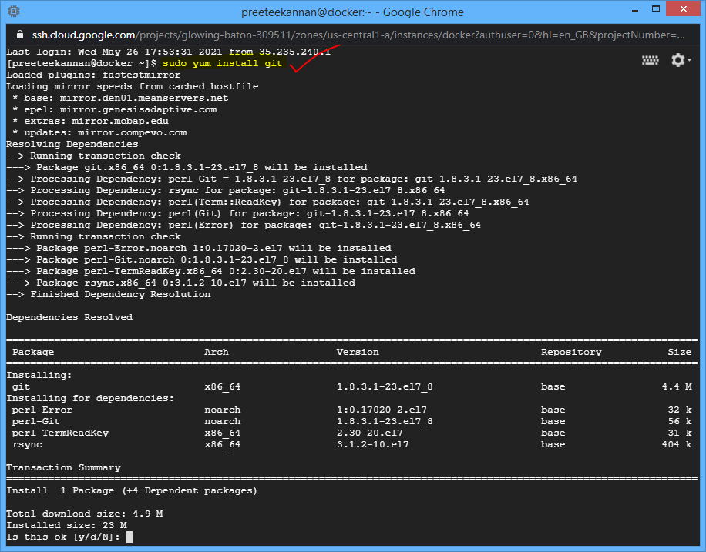

Git --version

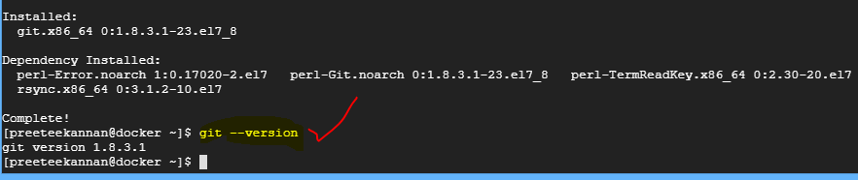

Clone the web app – repository

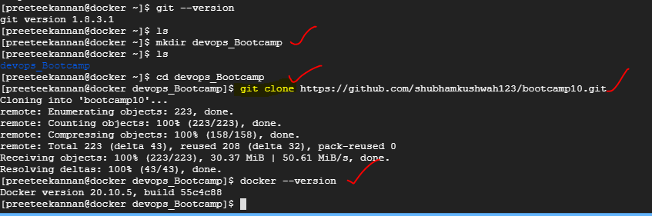

Connect to Dockerhub as sudo user

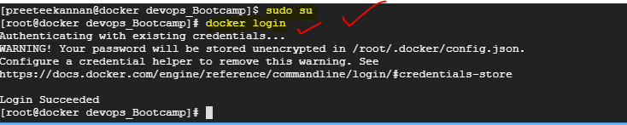

Edited the Dockerfile

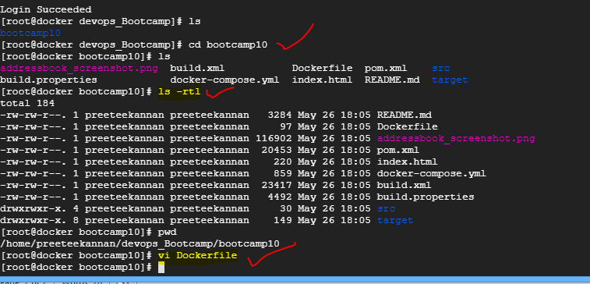

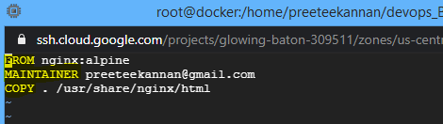

Building the docker image

**docker build –t kpreethi/my-docker-image:1.0 .**

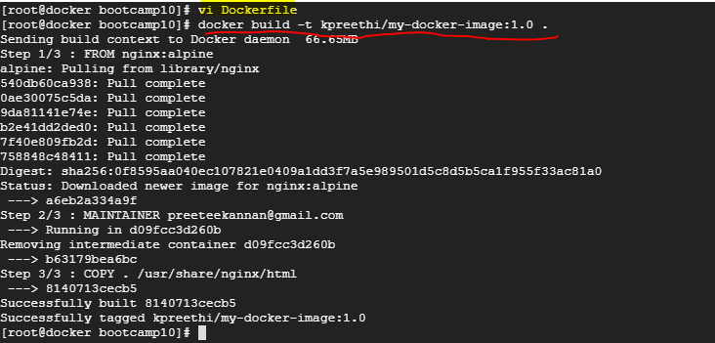

**docker ps 🡪** list all containers that are up and running

**docker ps –a 🡪** to show all the running and exited containers

**docker images 🡪** lists all the locally stored docker images

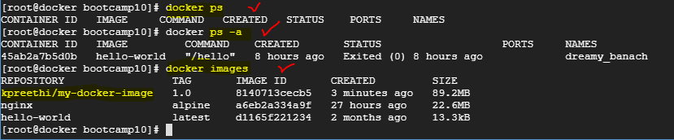

**Run the docker image**

docker run –d –p 80:80 kpreethi/my-docker-image:1.0



Static web page should appear

Push the docker image 🡪 **docker image push kpreethi/my-docker-image:1.0**

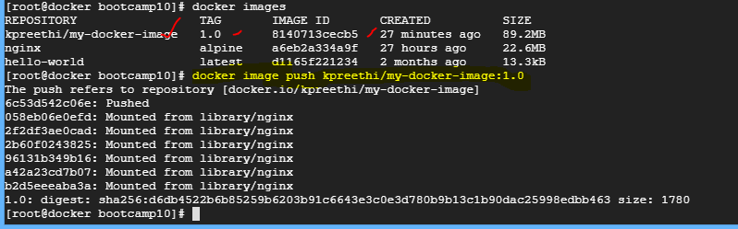

Image is pushed to the Dockerhub

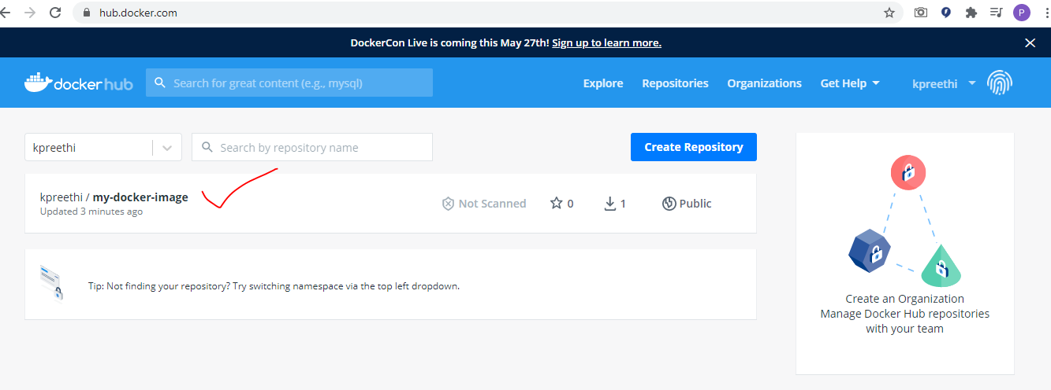

To pull the image from the hub, we create another VM

sudo apt install

sudo apt install docker.io

sudo su 🡪 to work as a super user

docker login

docker pull kpreethi/my-docker-image:1.0

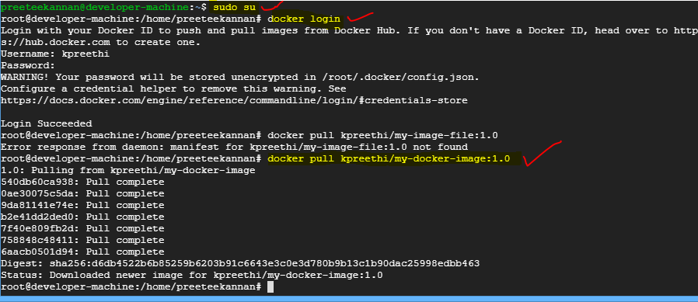

docker run –d –p 9090:80 kpreethi/my-docker-image:1.0



Web page must appear here….

**Docker compose**

Write a yml file (in the instance-1) to run the application container along with a mysql database container