Step-1:

Create a local repository ‘developer A’

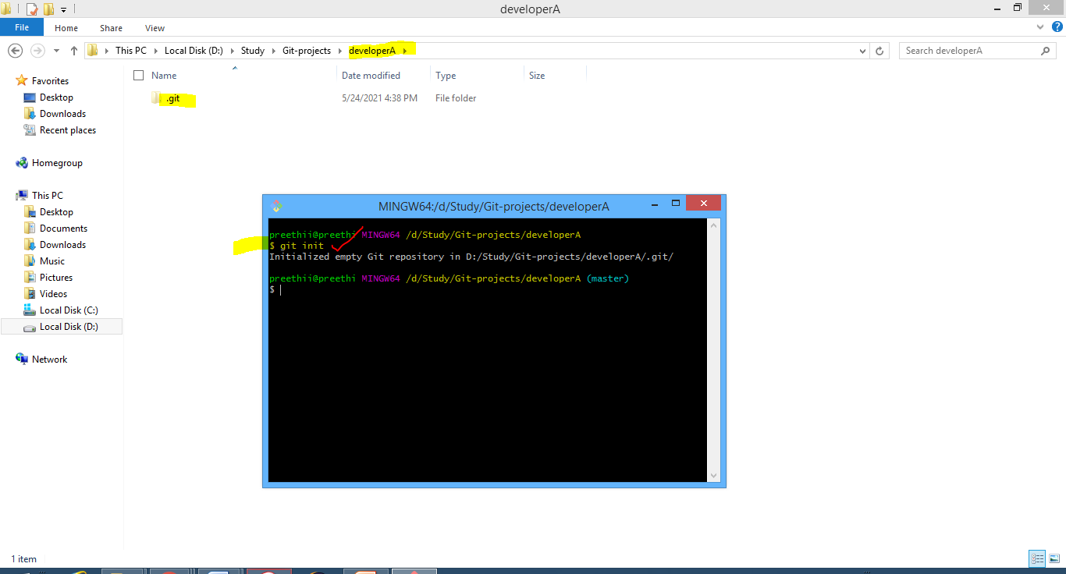

Step-2:

In the local repo, Create 3 files – demo1, demo2, demo3

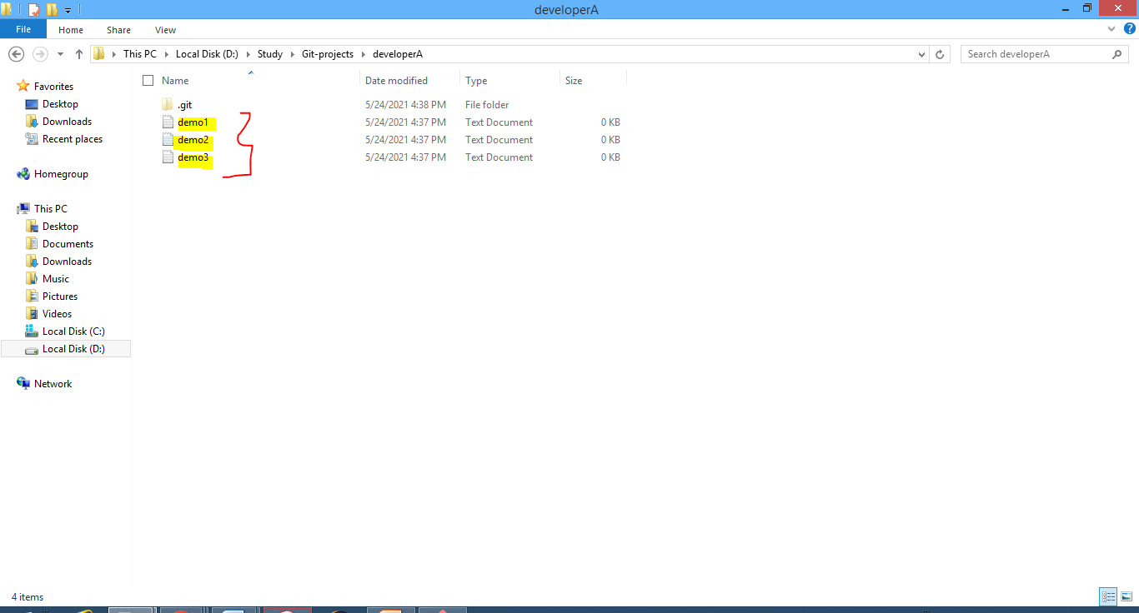

Step-3:

Add and commit files to the local repository

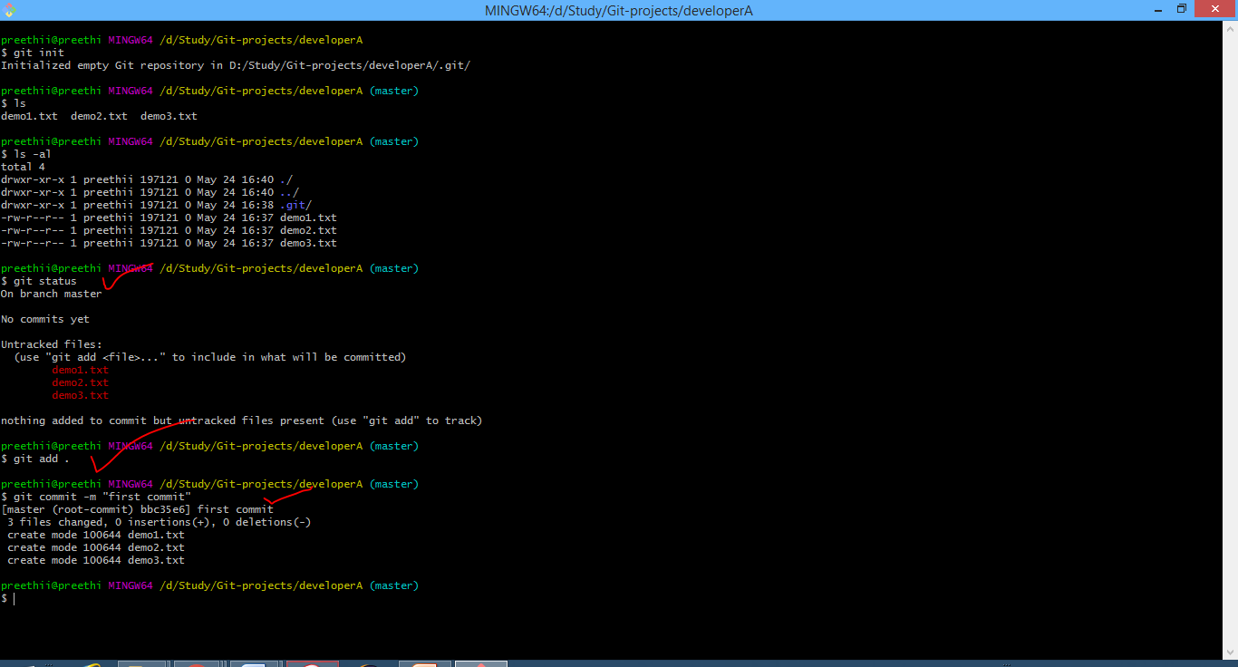

Step-4:

Add a remote repository to the local repository

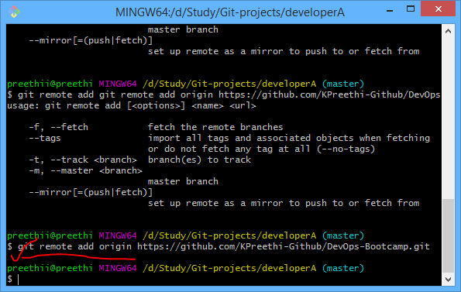

Step-5:

Push the changes to the remote repository to the local repository

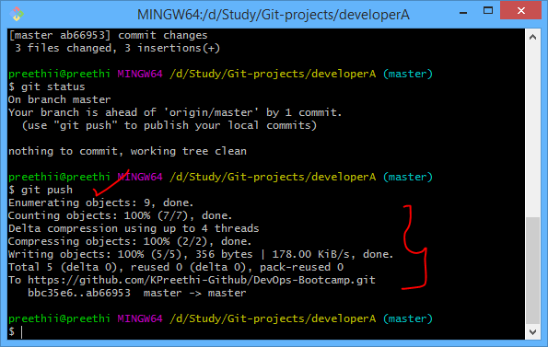

Step-6

Clone the repo into the folder – developerB

