INTERNSHIP PROJECT REPORT
SALES DATA ANALYSIS
DASHBOARD
Exploratory Analysis • Business Insights • Interactive Visualization

PROJECT DETAILS | INFORMATION
Prepared by | Priyanshu Kumar
Project | Sales Data Analysis Dashboard
Primary technologies | Python, Pandas, Plotly and Streamlit
GitHub repository | https://github.com/KPriyanshu775/Sales-Data-Analysis
Report purpose | Documentation of an internship project implementation

Prepared as a technical project report

Abstract
This report documents the development of a Sales Data Analysis Dashboard using Python. The project analyzes a structured retail sales workbook containing 10,194 records and 21 columns. The workflow includes data inspection, summary calculations, regional and category comparisons, monthly trend analysis, product and customer profitability analysis, discount-level comparisons, and an interactive Streamlit dashboard. Pandas is used for data preparation and aggregation, Plotly for interactive charts, and Streamlit for the browser-based user interface. The dashboard provides filters for region, category and order-date range, along with key performance indicators, charts, business insights and filtered CSV export. The work is descriptive and diagnostic; it does not claim predictive forecasting or causal proof.

Executive Summary
The analysis calculated total sales of $2,326,534.35, total profit of $292,296.81, 38,654 units sold, 5,111 unique orders and 804 unique customer IDs. The overall profit margin was 12.56%. The West region led sales and profit in the regional comparison. Technology was the most profitable category. The Tables, Bookcases and Supplies sub-categories recorded negative profit in the base analysis. At customer level, Sean Miller had the highest sales, while Tamara Chand had the highest profit. A Streamlit dashboard makes these views explorable through interactive filters.
Measure | Base analysis result
Records / columns | 10,194 / 21
Total sales | $2,326,534.35
Total profit | $292,296.81
Total quantity sold | 38,654
Unique orders | 5,111
Unique customers | 804
Overall profit margin | 12.56%

Contents
- 1. Project Introduction
- 2. Problem Definition and Objectives
- 3. Dataset Overview and Preparation
- 4. Tools and Technologies
- 5. Methodology and Implementation
- 6. Analytical Results and Findings
- 7. Dashboard Design and Features
- 8. Testing and Validation
- 9. How to Run and Use the Dashboard
- 10. Limitations and Future Enhancements
- 11. Conclusion
- 12. References and Project Files

1. Project Introduction
Retail sales data can contain information about orders, customers, products, categories, regions, dates, discounts, quantities, sales and profit. Reviewing these fields separately can make it difficult to understand overall performance or locate areas of loss. This project organizes the analysis into repeatable Python scripts and presents selected results through an interactive dashboard.

1.1 Project Overview
The project reads a Superstore-style Excel workbook, performs data understanding and grouped analysis, generates charts and CSV outputs, and provides a Streamlit application for interactive exploration. The application runs locally and opens in a web browser.

1.2 Intended Users
The dashboard is intended for a user who wants to review sales and profitability patterns without manually writing data queries. It is suitable for exploratory analysis and demonstration of basic business intelligence concepts.

2. Problem Definition and Objectives

2.1 Problem Statement
The project addresses the need to convert a multi-column retail sales workbook into understandable performance measures and comparisons. The analysis should help identify how sales and profit vary across regions, categories, months, products, customers and discount levels, and make those views easier to explore.

2.2 Objectives
- Inspect the dataset structure, data types, missing values and duplicate records.
- Calculate overall sales, profit, quantity, order count, customer count and profit margin.
- Compare regional and category-level performance, including sub-category losses.
- Study monthly sales and profit trends.
- Identify high-performing and low-performing products and customers.
- Explore the relationship between discount levels and observed profit totals without claiming causation.
- Build an interactive Streamlit dashboard with region, category and date filters.
- Provide a filtered-data CSV download and publish the project source code on GitHub.

2.3 Scope
The implemented scope is descriptive and diagnostic analysis of the supplied workbook, static analysis outputs, and a local interactive dashboard. A cloud-hosted production application, user authentication, database integration, automated data refresh, predictive forecasting and causal analysis are not part of the current implementation.

3. Dataset Overview and Preparation

3.1 Dataset Description
The project uses an Excel workbook named sample_-_superstore (1).xls. The inspected dataset contains 10,194 rows and 21 columns. Fields used in analysis include Order Date, Ship Date, Region, Category, Sub-Category, Product Name, Customer ID, Customer Name, Order ID, Quantity, Sales, Profit and Discount.

3.2 Data Quality Checks
Check | Observed result
Rows and columns | 10,194 rows and 21 columns
Missing values | No missing values reported by the initial data-understanding script
Duplicate records | No duplicate records reported by the initial data-understanding script
Date fields | Order Date and Ship Date converted to datetime
Numeric measures | Sales, Profit, Quantity and Discount treated as numeric measures
Postal Code | Handled as a string in the dashboard to support mixed numeric and alphanumeric codes

A dashboard display error occurred because the Postal Code field contained both numeric-looking values and alphanumeric postal codes such as M7A. The application was corrected by converting Postal Code to Pandas string type before display. This preserves the field as an identifier rather than treating it as a numeric measure.

3.3 Dataset Handling
The workbook is read from data/raw using Pandas read_excel. The raw workbook is excluded from the public Git repository through .gitignore. Anyone reproducing the project must obtain an authorized copy of the dataset and place it at the expected path. The original provider, download source and usage terms should be recorded alongside the dataset before external redistribution.

4. Tools and Technologies
Technology | Use in the project
Python | Main programming language for analysis scripts and dashboard logic
Pandas | Reading Excel data, data preparation, grouping, aggregation and CSV export
Plotly Express | Interactive line and bar charts in the dashboard
Streamlit | Browser-based dashboard, filters, KPI metrics and data display
Matplotlib | Static visualizations generated by the analysis scripts
Git and GitHub | Version control and public source-code repository
Excel workbook (.xls) | Input data source

The development environment used a Python virtual environment on macOS. The project dependencies are listed in requirements.txt. Reading the .xls workbook produced an xlrd deprecation warning in the recorded environment, but the customer analysis completed successfully. This warning should be revisited when updating the dependency stack.

5. Methodology and Implementation

5.1 Workflow
Stage | Activity | Output
1. Data understanding | Inspect shape, columns, types, missing values and duplicates | Dataset profile
2. Basic analysis | Calculate totals, unique orders/customers and profit margin | Overall KPI summary
3. Grouped analysis | Aggregate results by region, category and sub-category | Comparison tables
4. Time-series analysis | Group sales and profit by month | Monthly trend charts
5. Product analysis | Rank products by sales and profit | Product performance CSV
6. Customer analysis | Aggregate sales, profit and orders by customer | Customer analysis CSV
7. Business insights | Summarize key business patterns and loss areas | Charts and insight summaries
8. Dashboard | Apply filters and display KPIs, charts and tables | Interactive Streamlit application

5.2 Dashboard Processing Flow
Excel workbook
↓
Pandas loading and type conversion
↓
Region, category and order-date filters
↓
KPI calculations and grouped summaries
↓
Streamlit metrics, Plotly charts, insights and CSV export

5.3 Analysis Scripts
File | Purpose
01_data_understanding.py | Inspect dataset dimensions, columns, data types, missing values and duplicates
02_basic_sales_analysis.py | Calculate overall business metrics
03_regional_category_analysis.py | Compare regions, categories and sub-categories
04_time_series_analysis.py | Analyze monthly sales and profit patterns and save trend charts
05_product_analysis.py | Analyze product counts, top sales and profit performers
06_customer_analysis.py | Rank customers by sales and profit and identify low-profit customers
07_business_insights.py | Generate region, category and discount-related summaries and charts
dashboard_app.py | Run the interactive Streamlit dashboard

6. Analytical Results and Findings

6.1 Overall Performance
The base analysis reported total sales of $2,326,534.35 and total profit of $292,296.81. The dataset contained 38,654 units sold, 5,111 unique orders and 804 unique customer IDs. The resulting overall profit margin was 12.56%.

6.2 Regional Performance
Region | Sales | Profit | Quantity
West | $739,813.61 | $110,798.82 | 12,466
East | $691,828.17 | $94,883.26 | 11,159
Central | $503,170.67 | $39,865.31 | 8,820
South | $391,721.90 | $46,749.43 | 6,209

West recorded the highest sales and highest profit among the four regions. South recorded the lowest sales. Central generated lower profit than East and West, which suggests that regional sales volume and profitability should be reviewed together rather than treating sales alone as a complete performance indicator.

6.3 Category and Sub-category Performance
Category | Sales | Profit | Quantity
Technology | $839,893.28 | $146,543.38 | 7,017
Furniture | $754,747.76 | $19,730.00 | 8,369
Office Supplies | $731,893.31 | $126,023.44 | 23,268

Technology led both sales and profit in the base category comparison. Office Supplies generated the highest quantity sold. Furniture recorded substantial sales but comparatively low profit.
Loss-making sub-category | Profit
Tables | -$17,753.21
Bookcases | -$3,632.07
Supplies | -$1,171.39

These sub-categories had negative aggregate profit in the base analysis. Their pricing, discounts, product costs and sales mix would be appropriate areas for further review. The current analysis identifies the loss pattern but does not establish its cause.

6.4 Product Performance
Finding | Product | Value
Highest sales and highest product profit | Canon imageCLASS 2200 Advanced Copier | Sales $61,599.82; Profit $25,199.93
Second-highest sales | Fellowes PB500 Electric Punch Plastic Comb Binding Machine with Manual Bind | Sales $27,453.38; Profit $7,753.04
Loss-making high-sales example | Cisco TelePresence System EX90 | Sales $22,638.48; Profit -$1,811.08
Lowest product profit | Cubify CubeX 3D Printer Double Head Print | Sales $11,099.96; Profit -$8,879.97

The product analysis identified 1,849 unique products, 17 sub-categories and 3 categories. The findings show why product evaluation should consider both sales and profit.

6.5 Customer Analysis
Customer finding | Customer | Sales | Profit | Orders
Highest sales | Sean Miller | $25,043.05 | -$1,980.74 | 5
Highest profit | Tamara Chand | $19,052.22 | $8,981.32 | 5
Lowest profit | Cindy Stewart | $5,690.06 | -$6,626.39 | 6

The customer analysis identified 804 unique customer IDs and 800 unique customer names. Sean Miller had the highest total sales in the reported output but negative total profit. Tamara Chand had the highest total profit. Cindy Stewart had the lowest total profit. This demonstrates that customer value should be considered using both sales and profitability.

6.6 Monthly Trend Analysis
The time-series script generated monthly sales and profit trend charts. The recorded output identified December 2025 as the highest-profit month at approximately $17,926.30 and January 2024 as the lowest-profit month at approximately -$3,189.80. These are results from the analyzed workbook and may change if the source data or filters change.
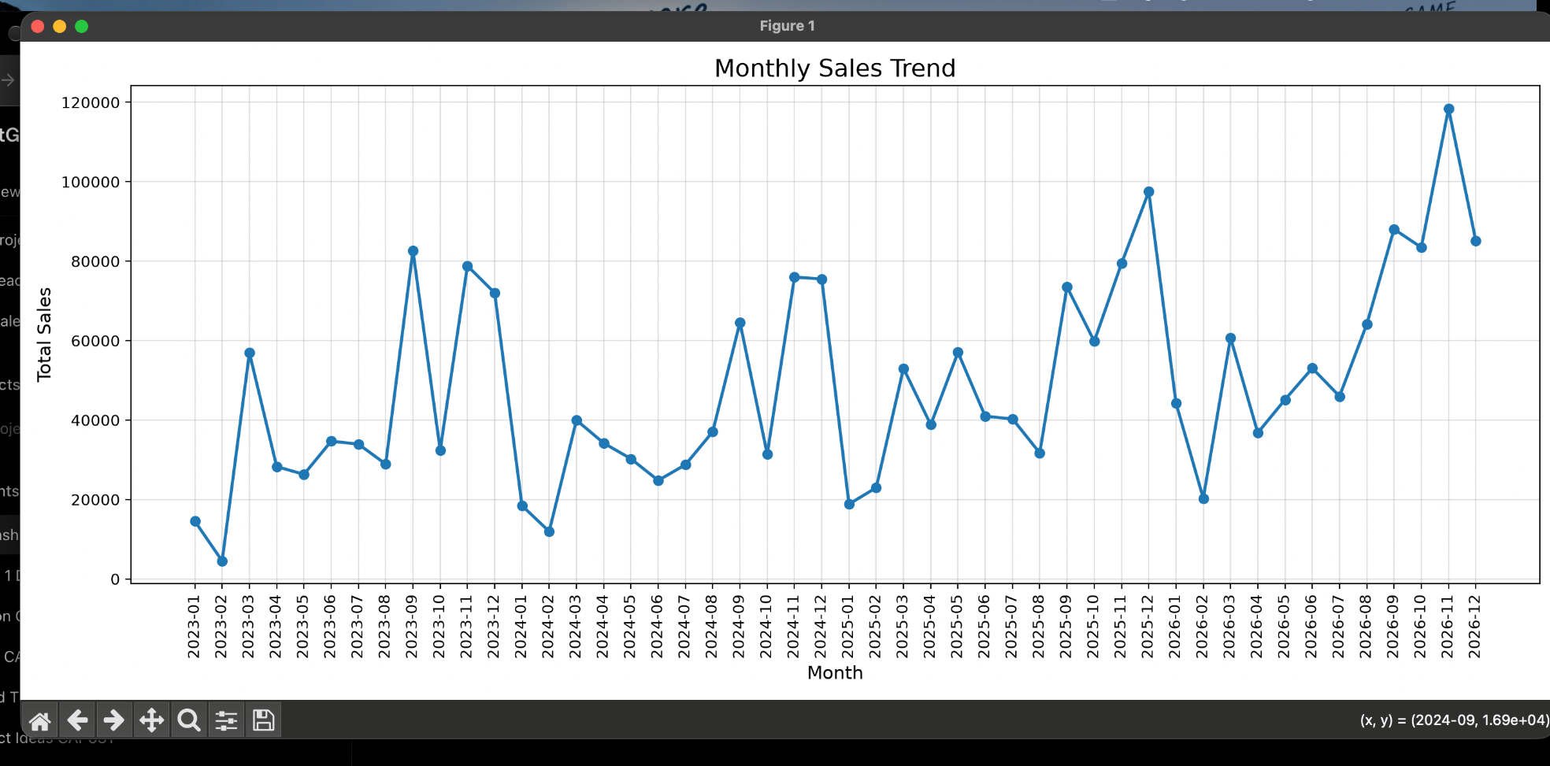
Figure 6.1. Monthly sales trend visualization captured during analysis.

6.7 Discount Impact Analysis
The dashboard groups records by discount rate and summarizes total sales, total profit, average profit per record and unique orders. It also displays total profit by discount level. This is an observational comparison: the chart does not prove that a discount caused a particular profit outcome. Pricing, product mix, costs, regions and order composition may also influence the observed results.

7. Dashboard Design and Features
The dashboard is implemented in dashboard_app.py and runs locally through Streamlit. The left sidebar contains multi-select controls for Region and Category and a date-range selector for Order Date. The main page presents performance indicators and interactive visualizations based on the selected records.
- Key performance indicators: Total Sales, Total Profit, Total Orders, Unique Customers and Profit Margin.
- Monthly sales and profit trend line chart.
- Sales by Region and Profit by Region bar charts.
- Category sales and profit visualization.
- Top 10 products by sales chart.
- Business insights including leading region, profitable category, best-selling product and loss-making sub-categories.
- Discount Impact Analysis showing profit by discount level.
- Expandable filtered dataset table and CSV download.
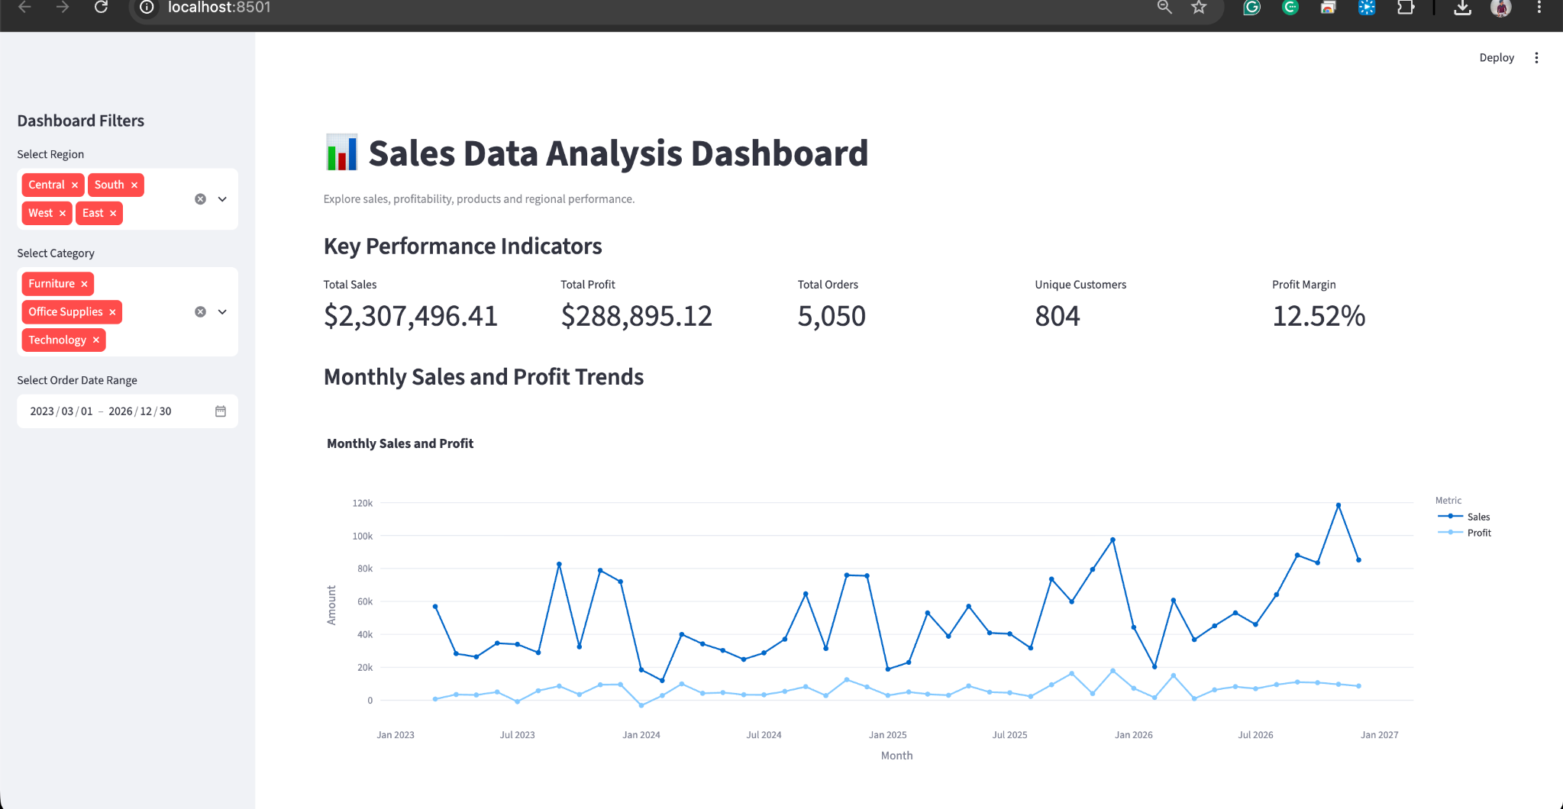
Figure 7.1. Dashboard overview with KPI cards and monthly sales/profit trend under the filter settings visible in the captured screen.
The KPI values shown in a screenshot can differ from the base analysis totals because dashboard metrics respond to the selected filters and date range. The base totals in Section 6 represent the full-dataset summary from the standalone analysis script.

8. Testing and Validation
The following manual checks were confirmed during development. Checks not explicitly confirmed are identified as not verified rather than assumed successful.
Test | Expected result | Recorded status
Start dashboard with Streamlit | Application opens in browser | Passed
Apply Region and Category filters | Metrics and charts update to filtered records | Previously checked by user
Expand filtered dataset | Table displays filtered rows | Passed after Postal Code fix
Handle mixed Postal Code values | No ArrowInvalid conversion failure in displayed table | Passed after Postal Code was cast to string
Business Insights section | Insights and loss-making sub-category table display | Passed
Discount Impact Analysis section | Discount summary metrics and chart display | Confirmed visible by user
CSV download action | CSV file downloads correctly | Not separately verified
Fresh install from requirements.txt | All packages install and dashboard runs | Not separately verified

A PyArrow error occurred because Postal Code contained alphanumeric strings such as M7A while the column was being interpreted as numeric. The dashboard data-loading function was updated to convert Postal Code to Pandas string type, and the displayed table was updated accordingly. The dashboard was reopened and the filtered table was confirmed visible.
The Streamlit chart calls were also updated from the deprecated use_container_width argument to width="stretch". A Pandas warning about the xlrd engine deprecation was observed while reading the .xls file; it did not prevent the customer analysis script from completing.

9. How to Run and Use the Dashboard

9.1 Requirements
- Python installed on the computer.
- Project files cloned from the GitHub repository.
- The authorized Excel workbook placed at data/raw/sample_-_superstore (1).xls.
- Required packages installed from requirements.txt.

9.2 Setup Commands
git clone https://github.com/KPriyanshu775/Sales-Data-Analysis.git
cd Sales-Data-Analysis
python -m venv .venv
source .venv/bin/activate
pip install -r requirements.txt
streamlit run dashboard_app.py
After Streamlit starts, open the local URL printed in the terminal. On Windows, activate the virtual environment using .venv\Scripts\activate instead of the macOS/Linux activation command.

9.3 User Guide
- Use Select Region to choose one or more regions.
- Use Select Category to choose one or more categories.
- Set the Order Date Range to filter transactions by date.
- Review the KPI cards and charts; displayed values respond to the selected filters.
- Scroll down to review Business Insights, loss-making sub-categories and Discount Impact Analysis.
- Expand View Filtered Dataset to inspect the filtered records and use Download Filtered Data as CSV to export them.

10. Limitations and Future Enhancements

10.1 Current Limitations
- The application depends on a locally available Excel workbook at a fixed relative path.
- The dashboard is a local Streamlit application; cloud deployment and authentication are not implemented.
- The analysis is descriptive and diagnostic, not a forecasting model.
- Discount-level comparisons are observational and do not establish causation.
- A centralized database and automated refresh pipeline are not included.
- Reproducibility depends on installing compatible dependency versions and obtaining the authorized source dataset.

10.2 Future Enhancements
- Add automated data validation and a repeatable refresh process.
- Store transaction data in a relational database for larger or frequently updated datasets.
- Add time-series forecasting after validating suitable historical data and evaluation methods.
- Introduce role-based access and secure deployment if the dashboard is used by multiple business users.
- Add more detailed product, customer and discount drill-downs.
- Add automated tests for KPI calculations, filters, data types and CSV exports.

11. Conclusion
The Sales Data Analysis Dashboard project demonstrates an end-to-end workflow for inspecting and analyzing a retail sales workbook and communicating the results through an interactive interface. The Python scripts provide repeatable summaries of overall performance, regional and category outcomes, monthly trends, products and customers. The Streamlit dashboard brings selected metrics and visualizations together and allows users to filter the analysis by region, category and order-date range. The project also highlights the importance of correct data typing, validation and cautious interpretation of business patterns. The source code and selected project outputs have been committed to the public GitHub repository.

12. References and Project Files
1. Python Software Foundation. Python Documentation. https://docs.python.org/3/
2. pandas development team. pandas Documentation. https://pandas.pydata.org/docs/
3. Streamlit, Inc. Streamlit Documentation. https://docs.streamlit.io/
4. Plotly Technologies Inc. Plotly Python Documentation. https://plotly.com/python/
5. Matplotlib Development Team. Matplotlib Documentation. https://matplotlib.org/stable/
6. Source dataset: Superstore-style Excel workbook supplied for this project (sample_-_superstore (1).xls). The original publisher, download URL, download date and license were not included in the project materials; verify these details with the dataset provider before redistributing the workbook.

12.1 GitHub Repository
https://github.com/KPriyanshu775/Sales-Data-Analysis

12.2 Main Project Files
File / folder | Description
01_data_understanding.py to 07_business_insights.py | Seven sequential analysis scripts
dashboard_app.py | Interactive Streamlit dashboard
data/raw/ | Expected location of the source Excel workbook; raw dataset excluded from public repository
outputs/ | Saved analysis outputs and charts committed to the repository
Screenshots/ | Selected dashboard screenshots committed to the repository
requirements.txt | Python dependency list
README.md | Repository overview and setup instructions

12.3 Data Source and Reuse
The analysis was performed on the Superstore-style Excel workbook supplied with the project. The available project materials do not identify the original publisher, source URL, download date or license terms. These details should be verified with the original provider before the workbook is redistributed or reused outside this project. The raw workbook is excluded from the public GitHub repository; users must obtain an authorized copy and place it in the documented data/raw location to reproduce the analysis.

