WEEK 4 INTERNSHIP PROJECT

Bank Term Deposit
Subscription Prediction
Supervised Learning Model Implementation
Prepared by
Priyanshu Kumar
Internship: Virtual Data Science with Python Trainee
Organization: Yuva Intern
Tools: Python, Pandas, NumPy, Matplotlib, Seaborn and Scikit-learn
Date: 3 November 2026
A practical classification project using the UCI Bank Marketing dataset

1. Project Overview
For this week’s task, I built a supervised machine learning workflow to estimate whether a customer would subscribe to a bank term deposit. The task is a binary classification problem because the target has two outcomes: yes and no. I used the cleaned Bank Marketing data prepared earlier in the internship, then compared Logistic Regression with Random Forest.
The main aim was not simply to obtain a high accuracy value. The dataset contains many more “no” responses than “yes” responses, so I also examined recall, precision, F1-score, ROC-AUC and average precision. This gives a more balanced view of how the models behave when the positive class is less common.

2. Objectives
- Inspect the cleaned dataset and understand the target distribution.
- Prepare numerical and categorical predictors using a repeatable preprocessing pipeline.
- Train and compare Logistic Regression and Random Forest classifiers.
- Use stratified train/test splitting and cross-validation to assess performance.
- Study the selected model using a confusion matrix, ROC curve and Precision-Recall curve.
- Review Random Forest feature importance and discuss practical limitations.

3. Tools and Libraries
Tool / library | Use in this project
Python | Main programming language.
Pandas and NumPy | Loading, inspecting and preparing tabular data.
Matplotlib and Seaborn | Exploratory plots and model evaluation visualizations.
Scikit-learn | Preprocessing pipelines, model training, cross-validation and evaluation.
Jupyter Notebook | Executing the analysis and recording code, output and explanations.
Joblib | Saving the selected fitted model.

4. Dataset Description
The project uses the cleaned Bank Marketing dataset from the earlier data-cleaning task. The cleaned file contains 41,176 records and 21 columns. The target column is y, where “yes” indicates that the customer subscribed to a term deposit and “no” indicates that the customer did not subscribe.
Dataset detail | Value
Records | 41,176
Original columns | 21
Input features used for modelling | 19
Target column | y
Target classes | no / yes
Missing values in the cleaned dataset | 0 (as checked in the earlier cleaning task)
Duplicate rows in the cleaned dataset | 0 (as checked in the earlier cleaning task)

4.1 Target class distribution
Outcome | Records | Share
No | 36,537 | 88.73%
Yes | 4,639 | 11.27%
Total | 41,176 | 100.00%

The target is imbalanced: the “no” class represents most records, while “yes” represents about one out of nine. A model could obtain a superficially high accuracy by favouring the majority class, so accuracy alone is not enough to judge whether it can identify likely subscribers.

5. Data Preparation and Feature Engineering
I converted the target into a binary value for classification: no = 0 and yes = 1. The model used 19 predictors after excluding the target column and the duration column.
- The duration column was excluded because it records the length of the call. It is only known after the call takes place, so using it for a pre-call prediction would create an unrealistic information advantage and could lead to target leakage.
- The categorical value “unknown” was retained as a category; it is not the same as a blank/null value.

5.1 Preprocessing workflow
I split the data into training and testing portions using an 80:20 split, with stratification to preserve the class proportions. The split used random_state = 42. This produced 32,940 training records and 8,236 testing records.
Preprocessing group | Steps used
Numerical predictors | Median imputation followed by StandardScaler.
Categorical predictors | Most-frequent imputation followed by OneHotEncoder(handle_unknown="ignore").
Workflow design | ColumnTransformer and Pipeline keep preprocessing together with each model.

The preprocessing steps were placed inside Scikit-learn pipelines. This is important because the imputer, scaler and encoder are fitted as part of the training process in each cross-validation fold, rather than being fitted on the complete dataset before splitting.

6. Models Implemented

6.1 Logistic Regression
Logistic Regression was used as a baseline classification model. It estimates the probability of the positive class and converts that probability into a class prediction. The model used max_iter = 2000 and class_weight = “balanced” to give additional weight to the less frequent class.

6.2 Random Forest Classifier
Random Forest combines predictions from multiple decision trees. The implementation used 200 trees, min_samples_leaf = 2 and class_weight = “balanced_subsample”. The random state was fixed at 42 for reproducibility.

6.3 Cross-validation
I used 3-fold StratifiedKFold cross-validation on the training data. The models were compared using ROC-AUC, average precision and F1-score. The held-out test set was reserved for the final evaluation.

7. Cross-validation Results
Model | Mean ROC-AUC | ROC-AUC Std. | Mean Avg. Precision | Mean F1
Logistic Regression | 0.7899 | 0.0029 | 0.4447 | 0.4500
Random Forest | 0.7823 | 0.0044 | 0.4482 | 0.4822

Logistic Regression achieved the higher mean cross-validation ROC-AUC (0.7899 compared with 0.7823). It also had a lower fold-to-fold standard deviation. Random Forest had slightly higher mean average precision and mean F1-score. Since the notebook’s pre-defined model selection rule used mean cross-validation ROC-AUC, Logistic Regression was selected for the main test-set interpretation.

8. Test-set Model Comparison
Metric | Logistic Regression | Random Forest
Accuracy | 0.8303 | 0.8866
Balanced accuracy | 0.7496 | 0.7141
Precision (yes) | 0.3591 | 0.4967
Recall (yes) | 0.6455 | 0.4914
F1-score (yes) | 0.4615 | 0.4940
ROC-AUC | 0.8002 | 0.7983
Average precision | 0.4463 | 0.4716

The test results show a trade-off. Random Forest had higher accuracy, precision, F1-score and average precision. Logistic Regression had higher balanced accuracy, recall for the “yes” class and ROC-AUC. This means Logistic Regression found a larger share of actual subscribers, while Random Forest made fewer positive predictions that were incorrect. The model choice depends on the cost of missed subscribers versus unnecessary follow-up calls.

9. Detailed Evaluation of Logistic Regression
The selected Logistic Regression model achieved a test accuracy of 83.03%, ROC-AUC of 0.8002 and average precision of 0.4463. For the positive “yes” class, precision was 35.91%, recall was 64.55% and F1-score was 46.15%.

9.1 Confusion matrix
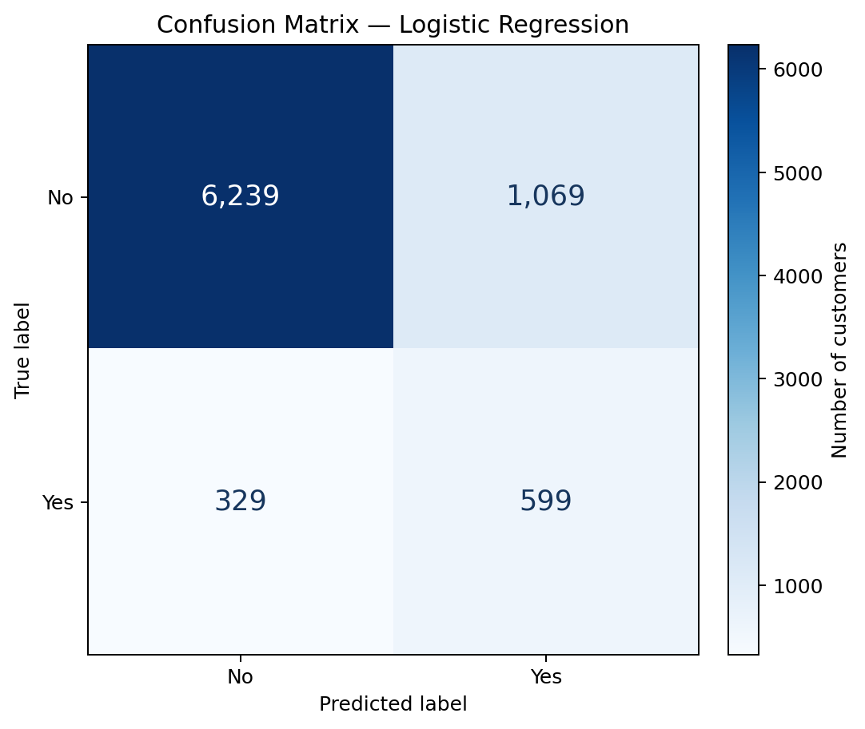
Figure 1. Confusion matrix for the selected Logistic Regression model on the held-out test set.
Actual / predicted | Predicted No | Predicted Yes
Actual No | 6,239 (True Negative) | 1,069 (False Positive)
Actual Yes | 329 (False Negative) | 599 (True Positive)

The model correctly identified 6,239 non-subscribers and 599 subscribers. It incorrectly flagged 1,069 non-subscribers as subscribers (false positives), and it missed 329 actual subscribers (false negatives). In a marketing setting, false positives may lead to wasted contact effort, while false negatives may mean missing a potential customer.

9.2 ROC and Precision-Recall curves
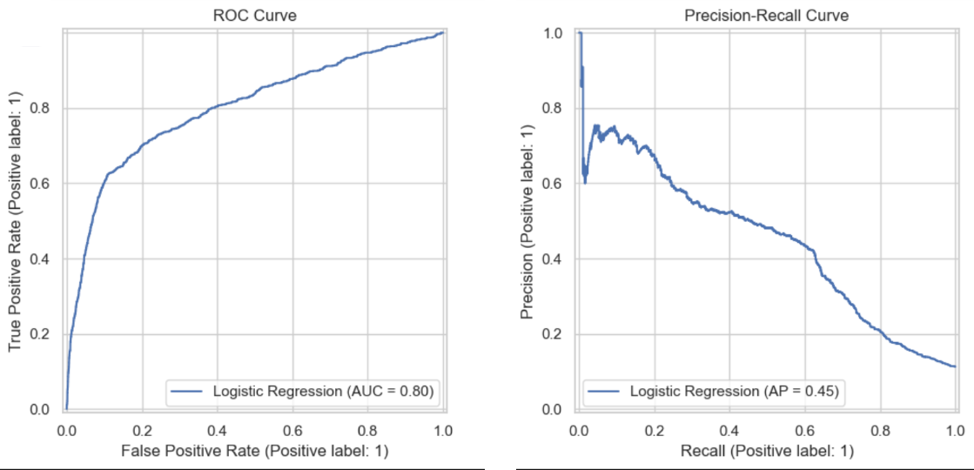
Figure 2. ROC curve (AUC = 0.80) and Precision-Recall curve (Average Precision = 0.45) for Logistic Regression.
The ROC curve summarizes the trade-off between the true positive rate and false positive rate across classification thresholds. Its AUC of 0.8002 indicates useful discrimination between the two outcomes. The Precision-Recall curve focuses on performance for the less common positive class. Its average precision of 0.4463 highlights that identifying subscribers remains challenging and that positive predictions should be interpreted carefully.

10. Random Forest Feature Importance
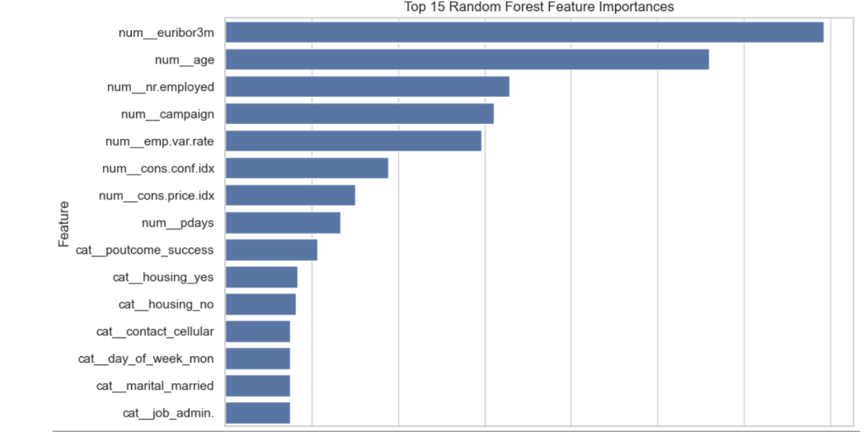
Figure 3. Top 15 feature importances reported by the Random Forest model.
In the Random Forest model, the largest displayed importance values were associated with euribor3m and age, followed by nr.employed, campaign and emp.var.rate. Other features in the displayed top 15 included consumer confidence and price indices, pdays, previous campaign outcome, housing, contact, day of week, marital status and job category. These values describe how the fitted forest used the transformed features; they do not show that a feature causes a customer to subscribe.

11. Main Findings and Discussion
- The target variable is imbalanced, with 11.27% “yes” outcomes. Therefore, accuracy alone would not provide a complete picture of model performance.
- Excluding duration makes the task more realistic for a prediction intended to be made before a call. A separate post-call model could study duration, but that would answer a different question.
- The preprocessing pipeline handled numerical and categorical columns separately and kept preprocessing inside cross-validation and model training.
- Logistic Regression was selected by the stated cross-validation ROC-AUC rule. Random Forest performed better on several other test metrics, so the comparison is not one-sided.
- The Logistic Regression confusion matrix shows a meaningful number of false positives as well as correctly identified subscribers. Threshold selection could be explored if the business objective assigns different costs to these errors.

12. Limitations
- The evaluation uses one stratified 80:20 train/test split and 3-fold cross-validation, so results may vary with a different split or validation design.
- Class weights were used, but no probability-threshold tuning or calibration study was carried out in this version.
- Random Forest feature importance is not a causal explanation and can be affected by correlated predictors and one-hot encoded categories.
- The dataset represents a particular bank marketing campaign context. Performance on a different bank, time period or customer population would need separate validation.
- The report evaluates predictive performance on historical data; it does not establish that using the model will improve campaign profit or customer outcomes.

13. Possible Improvements
- Tune the classification threshold based on the relative costs of false positives and false negatives.
- Compare additional algorithms and hyperparameters using cross-validation, while keeping the test set untouched until final evaluation.
- Review probability calibration and inspect performance across relevant customer subgroups.
- If deployment is considered, validate the model on newer data and monitor performance over time.

14. Conclusion
In this project, I developed a supervised learning workflow to predict bank term deposit subscription using the cleaned Bank Marketing dataset. I prepared numerical and categorical data through a Scikit-learn preprocessing pipeline, used a stratified train/test split, and compared Logistic Regression with Random Forest. Logistic Regression was selected because it had the higher mean cross-validation ROC-AUC. On the held-out test set it achieved 83.03% accuracy and 0.8002 ROC-AUC, with 64.55% recall for actual subscribers. Random Forest produced higher test accuracy and precision, showing that the choice of model should consider the business cost of different types of prediction errors rather than accuracy alone.
This task gave me practical experience with supervised classification, categorical encoding, numerical scaling, data pipelines, cross-validation and model evaluation. It also showed me why class imbalance and information leakage need to be considered before interpreting model results.

15. Output Files
File | Purpose
Week4_Supervised_Learning_Complete.ipynb | Notebook containing the full code, outputs and discussion prompts.
bank_marketing_test_predictions.csv | Test-set records with actual labels, predicted labels and predicted probabilities.
bank_marketing_best_model.joblib | Serialized selected Logistic Regression pipeline.
bank_marketing_cleaned.csv | Cleaned source dataset used for this project.

16. References
Moro, S., Cortez, P., and Rita, P. (2014). A Data-Driven Approach to Predict the Success of Bank Telemarketing. Decision Support Systems. Dataset: UCI Machine Learning Repository, Bank Marketing.
Scikit-learn documentation: preprocessing pipelines, Logistic Regression, Random Forest and classification model evaluation.
Note: All numerical results in this report are taken from the executed Week 4 notebook outputs and screenshots shared during the project. The report does not claim that the model is ready for production use.

