**ROLES IN IT:**

* **Collaboration:** Working together with stakeholders to define the project's goals, boundaries, and outcomes.
* **Facilitate Development:** Allocate resources based on project requirements
* **Quality Assurance:** Collaborate with testing team to ensure quality assurance is met
* **Deployment:** Ensure smooth deployment with proper planning
* **KPI Metrics:** Evaluate KPIs to make sure they are met

**INFORMATION GAPS:**

* **Missing Buy-in from Business Unit Leaders:**

**Action:** Organize discussions with leaders of business units to grasp their anticipations and reservations.

**Reaction:** Guarantee that the objectives of the AI project are in harmony with the strategic aims of the business unit leaders.

* **Absence of a solid development plan:**

**Action:** Work with TPZ to draft an overview of the AI development procedure.

**Reaction:** Offer a distinct framework for AI development, facilitating an organized method to attain project objectives.

* **Unclear expectations from Business Unit Leaders:**

**Action:** Carry out interviews and surveys to collect information on what Business Unit Leaders expect and prefer.

**Reaction:** Make sure that the project's approaches are tailored to fulfil the unique requirements and goals of Business Unit Leaders.

* **No specific timeline for Involuntary Layoffs and Personnel Training:**

**Action:** Collaborate with HR and key stakeholders to establish a definitive schedule for staff training and possible layoffs.

**Reaction:** Tackle the worries of current teams, prepare for a seamless changeover, and reduce interruptions to the workforce.

**SUCCESS MEASURES:**

* Substantial enhancement in forecasting methods, perfectly in line with the company's objective of boosting sales revenue without sacrificing market share.
* Successful deployment of the AI tool both on time and within the allocated budget.
* High levels of acceptance and satisfaction among users throughout various business sectors.
* Reduction in labour costs, accounting for potential severance expenses.
* Improved decision-making processes and increased operational efficiency across the company.
* Favourable coverage in the media and a rise in investor trust as a result of the successful implementation of the AI solution.

**NEW FEE STRUCTURE:**

* Liz proposes a payment of up to $500,000 for overseeing the entire project, managing third-party vendors (TPZ), providing updates, collaborating with internal stakeholders, and guaranteeing the project is completed on time and within budget.
* Liz is paying for the resources within the current budget to hire Project Coordinator, Senior Project Manager, Project Manager, and others.
* Current Budget: $450,000
* Incentives: Performance based bonus of about 10% of the fee upon meeting Key Performance Indicators (KPIs) that contribute to the company's goals.

**MS PROJECT:**

**PROJECT PLANNING:**

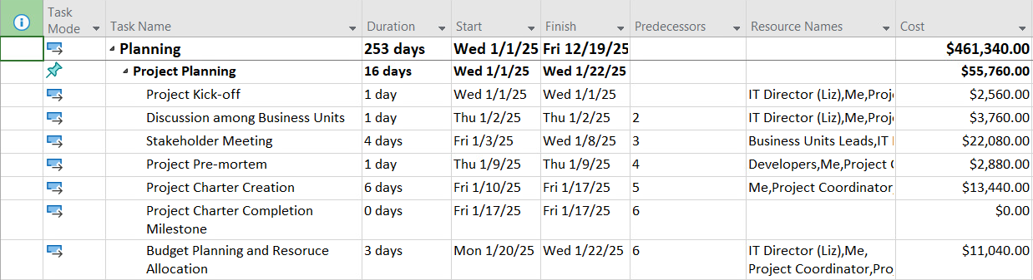

**IMPLEMENTATION:**

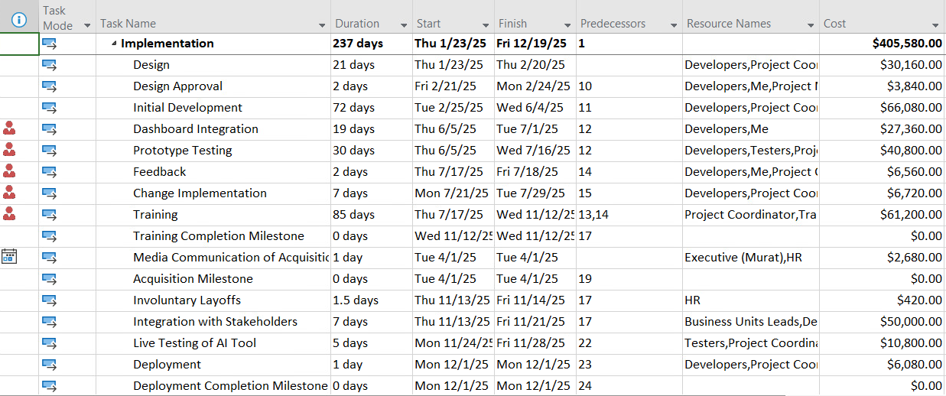

**CLOSEOUT:**

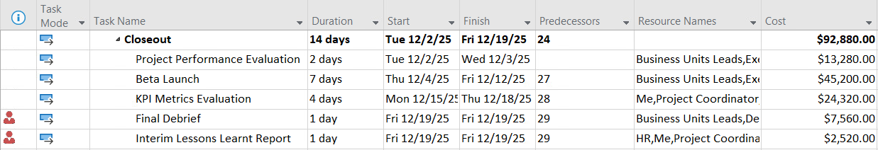

**GANTT CHART:**

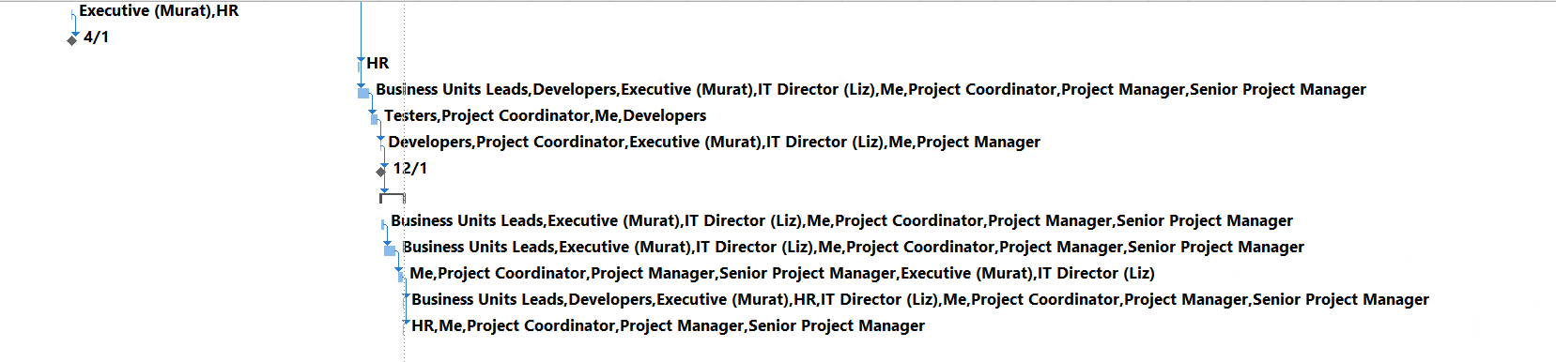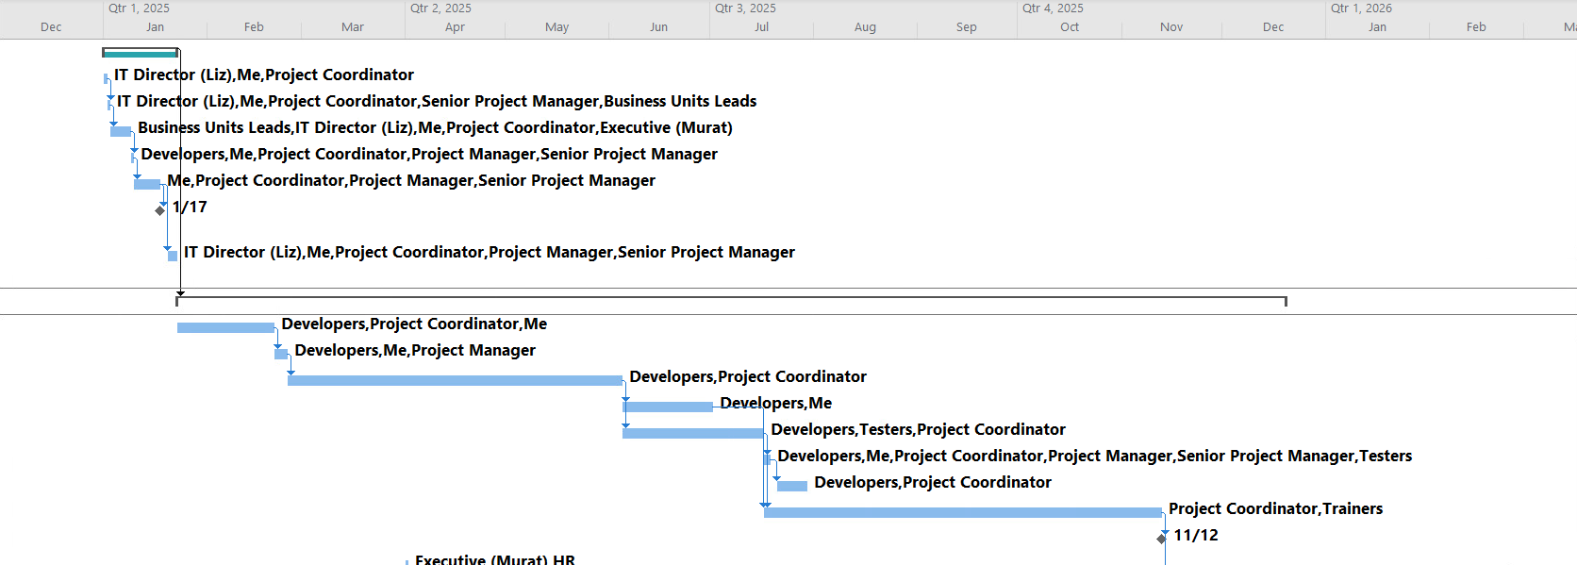

**BUDGET STRUCTURE:**

* **Base Fee:** $450,000
* **Performance Bonus:** $50,000-earned upon achieving KPIs.

The budget allocation aligns with the cost breakdown outlined in the Project Charter, comprising $450,000 dedicated to project management services and a $50,000 bonus contingent upon achieving predetermined KPIs and metrics. This structure ensures the project's objectives are in harmony with the strategic aims and goals of the company.

* **Evaluation:**

Based on the specific requirements and scope outlined in the case study, a budget of $450,000 seems adequate for the project management services. Although $450,000 may be ample for the project's needs, there are inherent risks related to the quality of resources, satisfaction of employees, and the capacity for unforeseen circumstances.

Setting aside a budget that exceeds $450,000 would allow for improved compensation for resources, which would enhance employee morale and productivity. Investing in equitable pay is crucial for fostering a positive work environment and attracting the best talent for the project. Ultimately, focusing on the well-being of employees is key to enhancing the success of the project and its long-term impacts.

**KPI METRICS AND BUDGET IMPROVEMENTS:**

**Incentive Structure based on KPI Metrics:**

* Finishing the project on budget and according to schedule (with a completion target of October 31st, 2025 - 270 days).
* Timely and effective integration into current systems.
* The level of user contentment and the adoption percentage of the newly implemented forecasting tool.
* The improvement in forecasting precision over earlier techniques.
* The financial savings realized by implementing automation and the possible reduction of staff.

**Budget Improvements will be needed if:**

* Incidental costs arise throughout the project.
* The deployment phase requires more managerial assistance than initially anticipated.
* Expenditures related to team members exceed the planned budget.

**CLOSEOUT: LESSONS LEARNED**

**Limited Buy-in from Business Unit Leaders:** Despite Helen's initial evaluation, it's essential to engage further with leaders. Early involvement in collecting requirements and making decisions would have fostered a sense of ownership and helped prevent possible opposition.

**Stakeholder Involvement:** The failure to fully engage key stakeholders led to a disagreement over the project's goals and expectations.

**Communication:** Lack of clear communication channels and defined processes and active participation of all stakeholders from the beginning.

**Personnel Layoffs and Severance Plans:** The effect of the AI tool on current teams requires immediate attention. It's essential to maintain transparent communication about potential layoffs and severance packages to ensure a seamless transition.

**PERSONALITIES AND CONFLICTS:**

* Helen and Murat exhibit contrasting leadership styles, leading to differing expectations regarding TBZ's deliverables and requirements, as each leader has distinct expectations.
* A clash exists between Liz and Helen concerning their roles and personalities.
* With Helen's impending exit from the company, there will be a shift of duties to TBZ's lead person. This transition of responsibilities necessitates changes in the contract's nature and prompts adjustments to the cost frameworks.
* The company's organizational framework is notably outdated, characterized by role duplications and a disjointed decision-making process, exacerbated by discrepancies in information and expectations.
* There is a noticeable deficiency in the mechanisms and frameworks for setting up effective communication channels.

**PROJECT ROLES:**

Executive (CEO Team) – Murat Senior Project Manager

Previous Project Head – Helen Development Team

IT Director – Liz Testers

Project Lead Trainers

Project Coordinator HR

Project Manager Business Unit Managers

**OTHER ENGAGEMENT ISSUES:**

* The initial offer of a fixed fee contract was not the most suitable approach for the agreement as it failed to incorporate all necessary considerations from the start, especially given the project's uncertainties, associated risks, and timeline.
* Our proposal indicates that a Time & Materials contract would have been more appropriate from the outset, offering the needed flexibility in line with the project's demands.
* Additionally, the Key Performance Indicators (KPIs) needed to be specified more clearly and agreed upon from the beginning.
* Aligning incentives and structuring compensation are crucial elements of any contract, which should have been carefully structured or negotiated to reflect this.

Top of Form