ed-05v2 – 09/09/2021

**Exercício 1.**

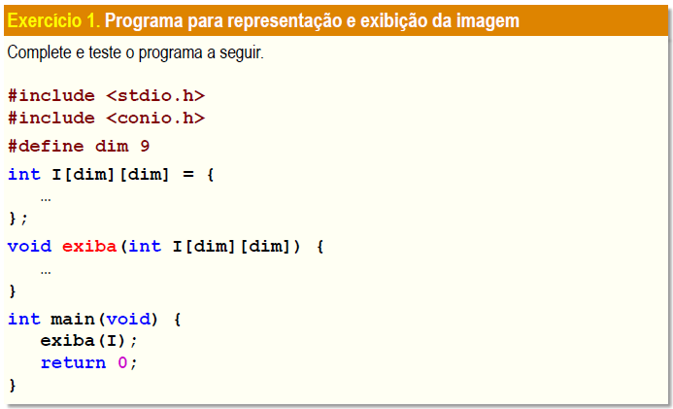

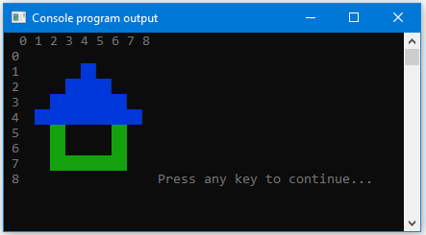

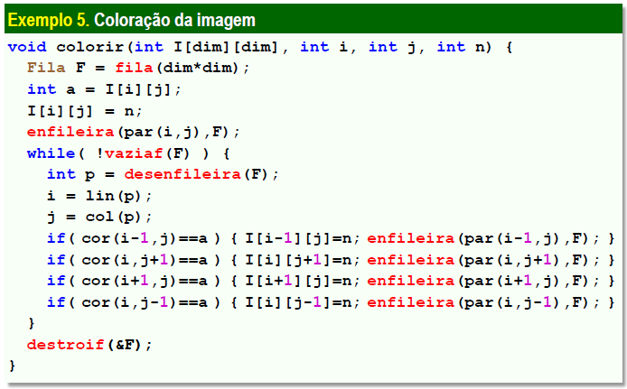

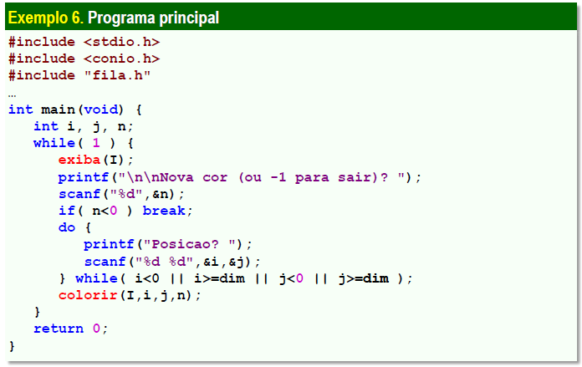

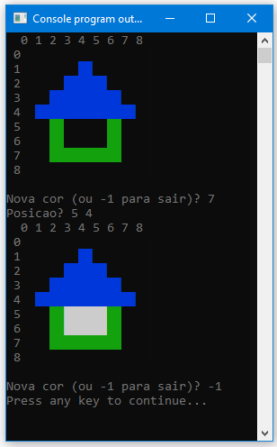

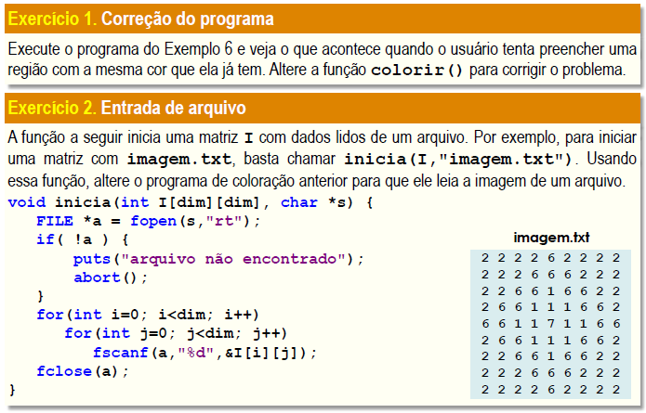

**Exercício 1.**

#include <stdio.h>

#include <conio.h>

#include "fila.h"

#define dim 9

#define cor(i,j) (i>=0&&i<dim&&j>=0&&j<dim?I[i][j]:-1)

#define par(i,j) ((i)*100+(j))

#define lin(p) ((p)/100)

#define col(p) ((p)%100)

int I[dim][dim] = {

{0, 0, 0, 0, 0, 0, 0, 0, 0},

{0, 0, 0, 0, 1, 0, 0, 0, 0},

{0, 0, 0, 1, 1, 1, 0, 0, 0},

{0, 0, 1, 1, 1, 1, 1, 0, 0},

{0, 1, 1, 1, 1, 1, 1, 1, 0},

{0, 0, 2, 0, 0, 0, 2, 0, 0},

{0, 0, 2, 0, 0, 0, 2, 0, 0},

{0, 0, 2, 2, 2, 2, 2, 0, 0},

{0, 0, 0, 0, 0, 0, 0, 0, 0}

};

void exiba(int I[dim][dim]){

for(int i = -1; i<dim; i++){

_textcolor(8);

for(int j = -1; j<dim; j++){

if(i<0 && j<0) printf(" ");

else if(i<0) printf("%2d", j);

else if(j<0) printf("\n%2d", i);

else {

_textcolor(I[i][j]);

printf("%c%c", 219, 219);

}

}

}

_textcolor(8);

}

void colorir(int I[dim][dim], int i, int j, int n){

Fila F = fila(dim*dim);

int a = I[i][j];

I[i][j] = n;

enfileira(par(i, j), F);

while(!vaziaf(F)){

int p = desenfileira(F);

i = lin(p);

j = col(p);

if(cor(i-1, j)==a) {I[i-1][j] = n; enfileira(par(i-1, j), F);}

if(cor(i, j+1)==a) {I[i][j+1] = n; enfileira(par(i, j+1), F);}

if(cor(i+1, j)==a) {I[i+1][j] = n; enfileira(par(i+1, j), F);}

if(cor(i, j-1)==a) {I[i][j-1] = n; enfileira(par(i, j-1), F);}

}

destroif(&F);

}

int main(void){

int i, j, n;

while(1){

exiba(I);

printf("\n\nNova cor (ou -1 para sair)? ");

scanf("%d", &n);

if(n<0) break;

do{

printf("Posicao? ");

scanf("%d %d", &i, &j);

} while(i<0 || i>dim || j<0 || j>=dim);

colorir(I, i, j, n);

}

return 0;

}

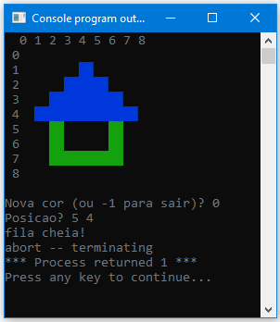

**//Alterando a função colorir();**

#include <stdio.h>

#include <conio.h>

#include "fila.h"

#define dim 9

#define cor(i,j) (i>=0&&i<dim&&j>=0&&j<dim?I[i][j]:-1)

#define par(i,j) ((i)*100+(j))

#define lin(p) ((p)/100)

#define col(p) ((p)%100)

int I[dim][dim] = {

{0, 0, 0, 0, 0, 0, 0, 0, 0},

{0, 0, 0, 0, 1, 0, 0, 0, 0},

{0, 0, 0, 1, 1, 1, 0, 0, 0},

{0, 0, 1, 1, 1, 1, 1, 0, 0},

{0, 1, 1, 1, 1, 1, 1, 1, 0},

{0, 0, 2, 0, 0, 0, 2, 0, 0},

{0, 0, 2, 0, 0, 0, 2, 0, 0},

{0, 0, 2, 2, 2, 2, 2, 0, 0},

{0, 0, 0, 0, 0, 0, 0, 0, 0}

};

void exiba(int I[dim][dim]){

for(int i = -1; i<dim; i++){

_textcolor(8);

for(int j = -1; j<dim; j++){

if(i<0 && j<0) printf(" ");

else if(i<0) printf("%2d", j);

else if(j<0) printf("\n%2d", i);

else {

_textcolor(I[i][j]);

printf("%c%c", 219, 219);

}

}

}

_textcolor(8);

}

**void colorir(int I[dim][dim], int i, int j, int n){**

**int a;**

**if(n==a) puts("Cor ja aplicada!!!\n\n");**

**else{**

**Fila F = fila(dim*dim);**

**a = I[i][j];**

**I[i][j] = n;**

**enfileira(par(i, j), F);**

**while(!vaziaf(F)){**

**int p = desenfileira(F);**

**i = lin(p);**

**j = col(p);**

**if(cor(i-1, j)==a) {I[i-1][j] = n; enfileira(par(i-1, j), F);}**

**if(cor(i, j+1)==a) {I[i][j+1] = n; enfileira(par(i, j+1), F);}**

**if(cor(i+1, j)==a) {I[i+1][j] = n; enfileira(par(i+1, j), F);}**

**if(cor(i, j-1)==a) {I[i][j-1] = n; enfileira(par(i, j-1), F);}**

**}**

**destroif(&F);**

**}**

**}**

int main(void){

int i, j, n;

while(1){

exiba(I);

printf("\n\nNova cor (ou -1 para sair)? ");

scanf("%d", &n);

if(n<0) break;

do{

printf("Posicao? ");

scanf("%d %d", &i, &j);

} while(i<0 || i>dim || j<0 || j>=dim);

colorir(I, i, j, n);

}

return 0;

}

**Exercício 2.**

#include <stdio.h>

#include <conio.h>

#include "fila.h"

#define dim 9

#define cor(i,j) (i>=0&&i<dim&&j>=0&&j<dim?I[i][j]:-1)

#define par(i,j) ((i)*100+(j))

#define lin(p) ((p)/100)

#define col(p) ((p)%100)

int I[dim][dim];

void exiba(int I[dim][dim]){

for(int i = -1; i<dim; i++){

_textcolor(8);

for(int j = -1; j<dim; j++){

if(i<0 && j<0) printf(" ");

else if(i<0) printf("%2d", j);

else if(j<0) printf("\n%2d", i);

else {

_textcolor(I[i][j]);

printf("%c%c", 219, 219);

}

}

}

_textcolor(8);

}

void colorir(int I[dim][dim], int i, int j, int n){

int a;

if(n==a) puts("Cor ja aplicada!!!\n\n");

else{

Fila F = fila(dim*dim);

a = I[i][j];

I[i][j] = n;

enfileira(par(i, j), F);

while(!vaziaf(F)){

int p = desenfileira(F);

i = lin(p);

j = col(p);

if(cor(i-1, j)==a) {I[i-1][j] = n; enfileira(par(i-1, j), F);}

if(cor(i, j+1)==a) {I[i][j+1] = n; enfileira(par(i, j+1), F);}

if(cor(i+1, j)==a) {I[i+1][j] = n; enfileira(par(i+1, j), F);}

if(cor(i, j-1)==a) {I[i][j-1] = n; enfileira(par(i, j-1), F);}

}

destroif(&F);

}

}

void inicia(int I[dim][dim], char *s){

FILE *a = fopen(s, "r");

if(!a){

puts("Arquivo nao encontrado");

abort();

}

for(int i=0; i<dim; i++)

for(int j=0; j<dim; j++)

fscanf(a, "%d", &I[i][j]);

fclose(a);

}

int main(void){

int i, j, n;

inicia(I, "imagem.txt");

while(1){

exiba(I);

printf("\n\nNova cor (ou -1 para sair)? ");

scanf("%d", &n);

if(n<0) break;

do{

printf("Posicao? ");

scanf("%d %d", &i, &j);

} while(i<0 || i>dim || j<0 || j>=dim);

colorir(I, i, j, n);

}

return 0;

}

