**Securein**

**Github Link:** [**Link**](https://github.com/KR655/The--Doomed-Dice-Challenge)

**Problem statement:**

Given that there are essentially two dice, dice A and dice B can be taken as [1,2,3,4,5,6] in the grid matrix.

1. How many total combinations are possible? Show the math along with the code!

So, now we need to find the count of total number of possibilities

Two methods can be used for this solution.

1.By using 2 for loops to count all the possibilities: -

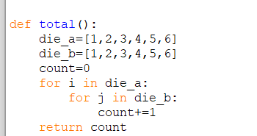

2.This can also be done by squaring the number of possibilities of a single dice has as both have same number of sides.

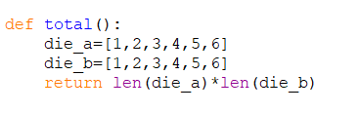Output:



2. Calculate and display the distribution of all possible combinations that can be

obtained when rolling both Die A and Die B together. Show the math along with

the code!

Hint: A 6 x 6 Matrix

We need to find the combinations, which can be achieved by using the nested for loop.



This creates a matrix where each row represents a value of DieA and each column represents a value of DieB

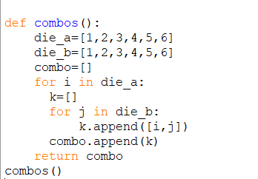

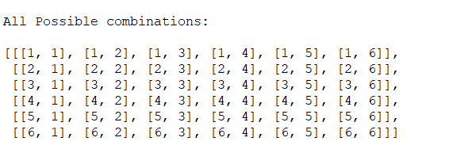Output:

3) Calculate the Probability of all Possible Sums occurring among the number of combinations from (2).

Example: P(Sum = 2) = 1/X as there is only one combination possible to obtain

Sum = 2. Die A = Die B = 1.

Now we need to find the probability of all possible sums where the minimum

sum that can be possible is 2 by having 1 on dice A and 1 on dice B and has the maximum of 12 by having 6 on dice A and 6 on dice B.

In order to do so, the mathematical formula is:



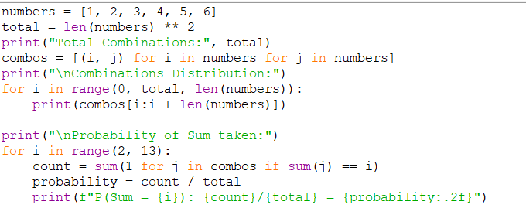

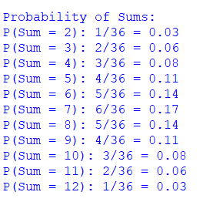**Output:**

**Part B**

Everything was running fine but suddenly the cunning Norse god Loki materialised out of nowhere.

For his own amusement, Loki destroys all of the "Spots" on your dice, dooming it.



To reattach the spots, we have some rules

**● Die A cannot have more than 4 Spots on a face.**

**● Die A may have multiple faces with the same number of spots.**

**● Die B can have as many spots on a face as necessary i.e. even more than 6.**

In the process of reattaching spots to the dice faces, specific rules are employed to ensure uniform probabilities. For dice A, it is stipulated that no value should exceed 4. To adhere to this condition, any value greater than 4 undergoes a subtraction of 3.

This adjustment is determined through trial and error, guaranteeing an equal likelihood of repeated numbers on dice A. For instance, if a dice A value is initially 5, subtracting 3 results in 2, effectively introducing a repetition of the value. Conversely, for dice B, the objective is to allow both repeated values and values surpassing 6. To achieve this, even values are selected from the entire collection, and each is incremented by 2.

This modification ensures that the probability distribution remains unchanged, maintaining the desired equilibrium without compromising the inherent probabilities.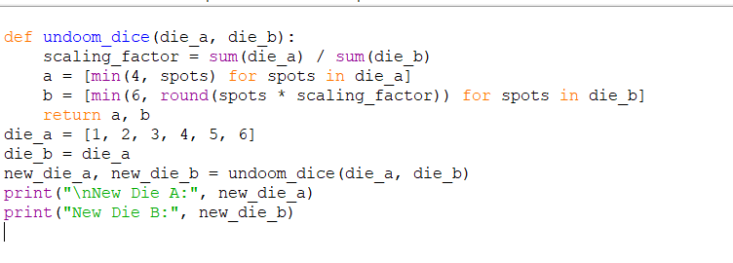

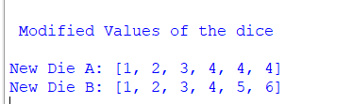Output: