Project Synopsis
HCLTech Career Shaper Programme | III Year Industry Project | 2025-26
Field | Details
Project Title | Vehicle Health Monitoring System Using CAN
Project No. | 8
Domain | Embedded IoT
Difficulty | Advanced
Duration | 4 Weeks
Format | Individual Project
Learner Name | Kratika Singh
Roll Number | 2300320310106
College / Campus | ABES Engineering College (Branch: ECE)
Mentor Name | [Mentor name - fill in]
Submission Date | 03 November 2026

1. Problem Statement
Who: drivers and workshop or fleet maintenance engineers. What: engine overheating and abnormal vibration build up within seconds, yet the first sign a driver gets is often a warning light or a breakdown. When/where: during normal driving at 60-100 km/h and while idling, on any vehicle whose sensors are linked by a Controller Area Network (CAN). Why it matters: an unnoticed overheating event can damage the engine, and persistent vibration points to mechanical wear, so late detection raises repair cost and safety risk. How: sensor nodes publish temperature, vibration and engine speed as 8-byte CAN frames once per second; a receiver node validates every frame, applies fault rules, shows a fault code on a 7-segment display and sounds a buzzer, while a Python layer logs the data, runs machine-learning detectors and produces a dashboard.
Success criteria. (1) Every fault episode in the drive log is detected within one sampling period (1 s). (2) Every corrupted frame is rejected by the CRC check. (3) Lost frames are counted from a sequence counter. (4) A label-free detector flags faults without using the alarm label.

2. Proposed Solution & Approach
The solution is a two-node STM32 CAN system and a Python software twin that run the same protocol and logic. The transmitter node samples a DHT11 temperature sensor, a vibration sensor and an engine-speed pulse input once per second and packs them into a classic CAN 2.0A frame (IDs 0x101 engine, 0x102 transmission, 0x103 chassis) with a rolling sequence counter and a CRC-8 byte. The receiver node filters the IDs, verifies the CRC, estimates lost frames from sequence gaps, and raises fault code 101 (temperature at or above 105 degrees C), 102 (vibration at or above 0.80 g) or 103 (both). It shows the temperature or the code (E101/E102/E103) on a 4-digit 7-segment display and drives a buzzer and LED.
Because the physical rig could not be exercised in this submission, the working, tested part of the project is the software twin: a transmitter, a virtual CAN bus that injects frame loss and bit corruption, and a receiver, all driven by a 15,000-row vehicle CAN log. On top of this sit exploratory analysis, a supervised Random Forest, an unsupervised Isolation Forest, an HTML dashboard and 17 automated tests. Reference STM32 firmware that mirrors the Python code is included but has not been flashed or bench-tested.

Plan versus status (4-week schedule)
Week | Planned focus (from the project brief) | Status in this submission
1 | Problem understanding, tool setup, EDA on the dataset | Done: dataset mismatch resolved, 15,000-row CAN log, 6-figure EDA script
2 | Architecture design and core implementation | Done: CAN frame format, transmitter, receiver, rule engine, 7-segment model; STM32 reference firmware written
3 | Integration, testing and validation | Done in software: end-to-end simulation, 17 tests, robustness sweep. Hardware bench test still to do
4 | Report, presentation, demo | Synopsis, README, dashboard and console live demo ready; demo video to be recorded by the learner

3. System Architecture
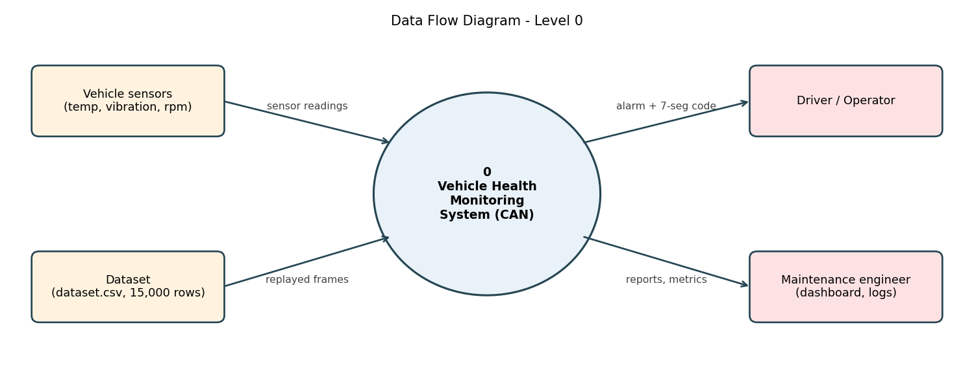
Figure 1. Data Flow Diagram, Level 0
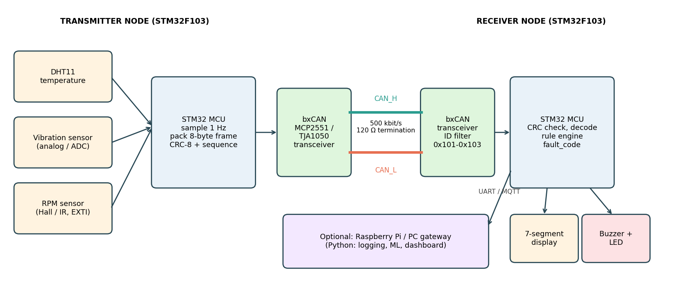
Figure 2. System block diagram (transmitter node, CAN bus, receiver node, optional gateway)
Data flow: sensors feed the transmitter MCU, which sends frames over a 500 kbit/s CAN bus with 120 ohm termination. The receiver MCU decodes and checks each frame and drives the display and buzzer. An optional Raspberry Pi or PC gateway receives the same data over UART or MQTT for logging, machine learning and the dashboard. The 8-byte payload is laid out as follows:
Bytes | Field | Type / scale | Notes
0-1 | Temperature | int16, 0.1 degC | Signed, big-endian
2-3 | Vibration | uint16, 1 mg | RMS magnitude in milli-g
4-5 | Engine speed | uint16, 1 rpm | Hall or IR pulses x 60
6 | Sequence | uint8 | Increments per node; gaps = lost frames
7 | CRC-8 | poly 0x07 | Over bytes 0-6; detects corruption

Fault code | Meaning | Rule (receiver node)
0 | No fault | temperature below 105 degC and vibration below 0.80 g; display shows temperature + H
101 | Overheating | temperature at or above 105 degC; display shows E101
102 | Abnormal vibration | vibration at or above 0.80 g; display shows E102
103 | Overheating + vibration | both conditions true; display shows E103

4. Technology Stack
Frontend / UI | Self-contained HTML dashboard (outputs/dashboard.html); 4-digit 7-segment display on the receiver node
Backend / Logic | Python 3 (CAN protocol, virtual bus, nodes, rules); C with STM32 HAL for the firmware
Database | CSV files: data/dataset.csv (input) and outputs/receiver_log.csv (decoded log)
AI/ML Framework | scikit-learn: Random Forest classifier and Isolation Forest; pandas and NumPy
Visualisation | matplotlib (10 figures) embedded in the HTML dashboard
Hardware | 2 x STM32F103C8T6, 2 x CAN transceiver (TJA1050 or MCP2551), DHT11, analog vibration sensor (ADXL335), Hall/IR speed sensor, 7-segment display, buzzer
Testing | Python unittest (17 tests); fixed random seeds for reproducibility

5. Dataset Used
Note on the starter file. The dataset.csv supplied in the project folder contained healthcare columns (patient_id, heart_rate_bpm, SpO2_pct) and did not match the project brief, so a vehicle CAN log with the brief's schema was generated with an AI tool and a documented, seeded Python script (data/generate_can_dataset.py). It is synthetic, not recorded from a real vehicle.
Dataset file name | data/dataset.csv (with data/data_dictionary.csv)
Number of rows | 15,000 (1 reading per second, 4.17 hours)
Number of columns | 7
Key columns | timestamp, node_id, temp_C, vibration_g, rpm, fault_code, alarm_flag
Missing values / duplicates | 0 missing; 0 duplicate timestamps
Drive states | Idle (17.6% of rows, about 800 rpm), acceleration, cruising at 60-100 km/h, braking; cold-start warm-up at the beginning
Faults | 440 rows (2.93%) in 15 episodes of about 29.3 s: 101 overheating = 105, 102 vibration = 238, 103 both = 97
Additional data collected | None (the receiver run adds outputs/receiver_log.csv)

Signal | Mean | Std | Min | Max | Mean (fault rows)
temp_C (deg C) | 88.1 | 5.1 | 35.2 | 125.1 | 100.5
vibration_g (g) | 0.322 | 0.202 | 0.030 | 2.408 | 1.121
rpm | 2252 | 765 | 702 | 3361 | 2191

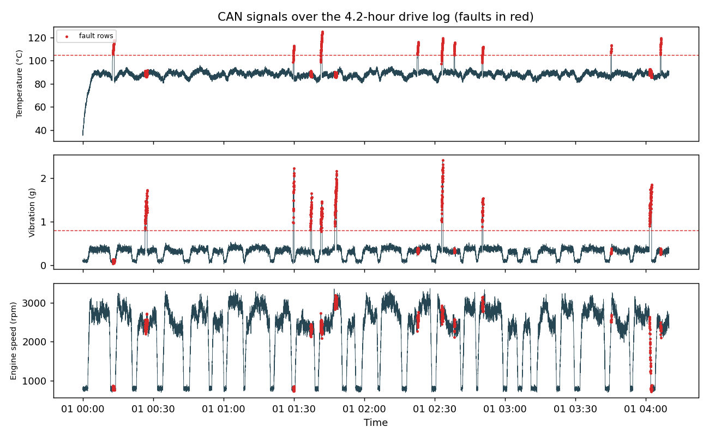
Figure 3. Temperature, vibration and rpm over the drive log; fault rows in red, thresholds dashed
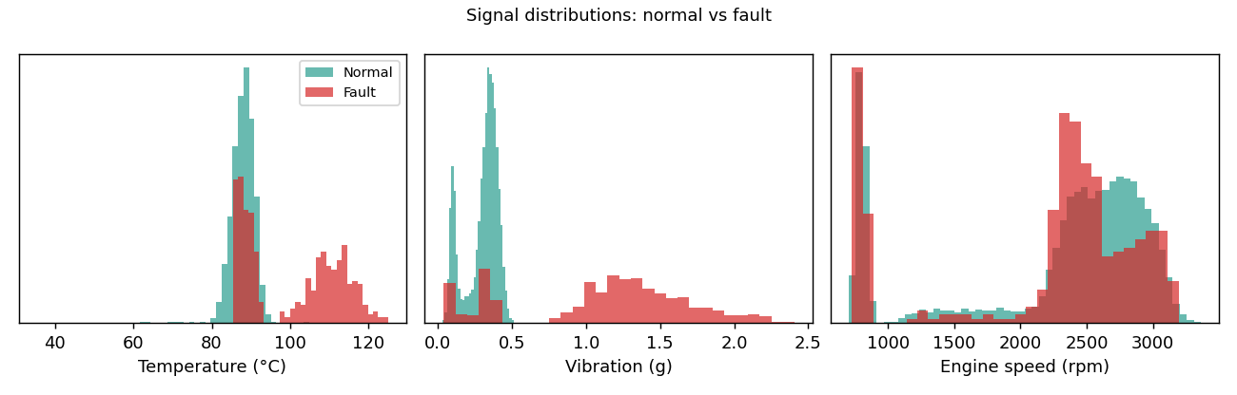
Figure 4. Normal versus fault distributions of each signal
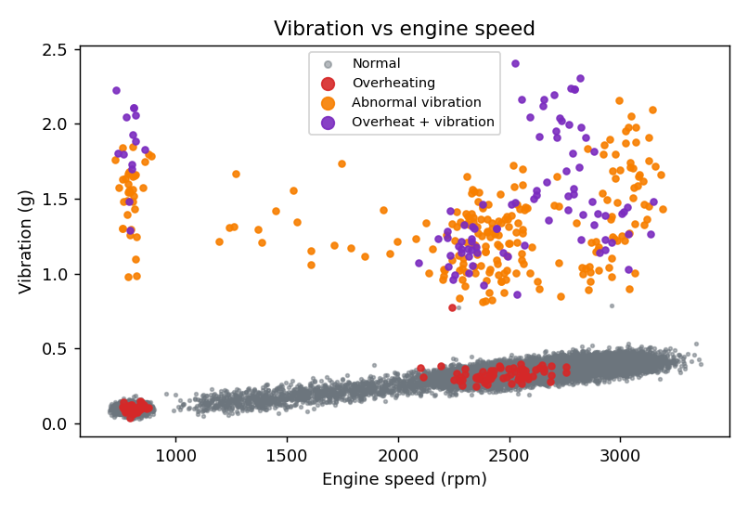
Figure 5. Vibration versus engine speed, coloured by fault code
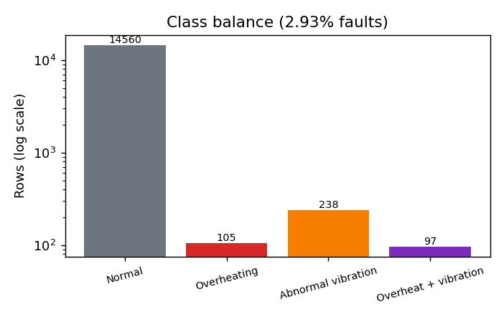
Figure 6. Class balance on a log scale
The exploratory analysis (notebook-style script src/eda.py) produces six figures: the time series, the distributions, a vibration-versus-rpm scatter plot, a correlation matrix, the class balance and a zoom on one fault episode. Faults are rare (2.93% of rows), so accuracy alone is misleading and precision, recall and F1 are reported instead. Normal vibration rises gently with speed, while fault vibration is well above the 0.80 g threshold, and overheating rows sit above 105 degrees C.

6. Key Results & Metrics
Metric 1: Fault-episode detection on the simulated CAN link: 15 of 15 episodes detected, mean detection delay 0 s (rule engine; 15,000 frames sent, 14,903 decoded).
Metric 2: Link integrity: 13 of 13 corrupted frames rejected by the CRC (100.0%); the sequence counter reported 97 missing frames, equal to 84 dropped plus 13 corrupted frames.
Metric 3: Label-free anomaly detection (Isolation Forest, held-out last 30% of the log): precision 1, recall 0.5904, F1 0.7424, ROC-AUC 1.
Business value achieved: a tested end-to-end design and reference firmware that turn raw CAN readings into an immediate, readable fault code, with a measured way to check link errors and a dashboard for maintenance review.
Detector (test window, 4500 rows, 83 fault rows) | Accuracy | Precision | Recall | F1 | ROC-AUC
Rule engine (105 C / 0.80 g) | 1 | 1 | 1 | 1 | -
Random Forest (supervised) | 1 | 1 | 1 | 1 | 1
Isolation Forest (no labels) | 0.9924 | 1 | 0.5904 | 0.7424 | 1
Early warning, 10 s ahead (RF) | 0.978 | 0.0964 | 0.2667 | 0.1416 | 0.6613

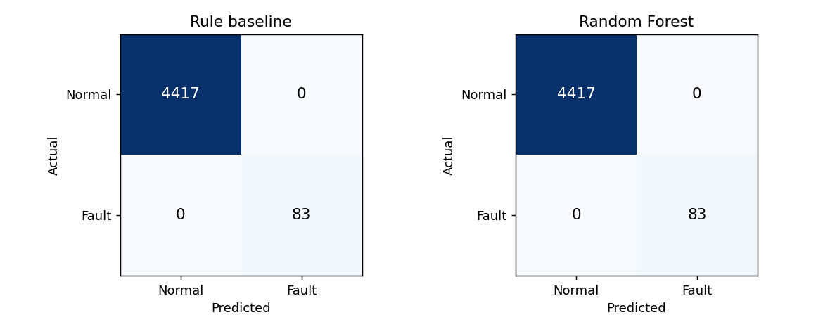
Figure 7. Confusion matrices on the held-out test window
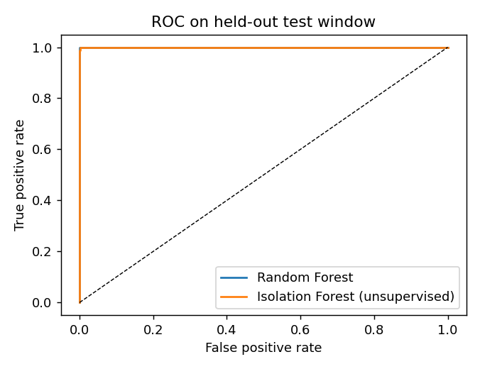
Figure 8. ROC curves on the held-out test window
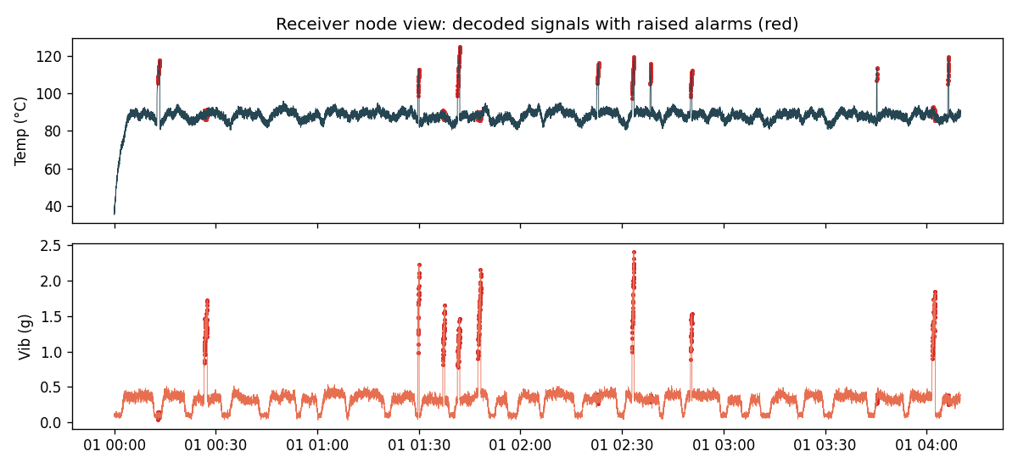
Figure 9. Receiver-node view of the full simulated run, with alarms in red
How to read these numbers. The fault labels in the synthetic dataset are defined by the same thresholds the rule engine uses, so the rule engine and the supervised Random Forest reach a perfect or near-perfect score by construction; this shows the pipeline is consistent, not that the model will perform equally on real vehicle data. The informative results are the Isolation Forest, which never saw the labels and still reaches an F1 of 0.7424 (it misses the milder fault rows), and the link-integrity results. The early-warning model is weak (precision 0.0964) and is reported as a limitation that needs real, recorded data.

Robustness of the CAN link
The virtual bus was run with increasing frame loss and bit corruption (outputs/robustness.csv). Every corrupted frame was rejected by the CRC and every fault episode was still detected; the only effect at high error rates was a delay of at most one sample on a few episodes, because the first frame of an episode can be lost. Precision and recall are computed on the frames that reached the receiver.
Loss % | Corrupt % | Decoded | CRC rejected | Missing (seq.) | Episodes | Delay (s) | Recall
0.0 | 0.0 | 15,000 | 0 | 0 | 15/15 | 0.0 | 1.0
0.5 | 0.2 | 14,897 | 25 | 103 | 15/15 | 0.0 | 1.0
2.0 | 1.0 | 14,578 | 142 | 422 | 15/15 | 0.0 | 1.0
5.0 | 2.0 | 13,969 | 287 | 1031 | 15/15 | 0.07 | 1.0
10.0 | 5.0 | 12,809 | 734 | 2191 | 15/15 | 0.07 | 1.0

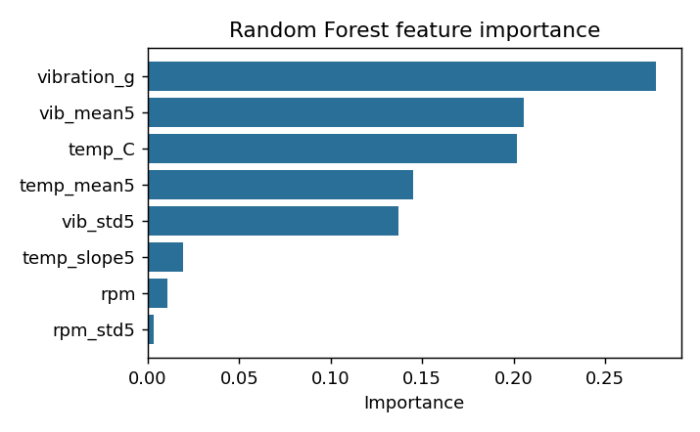
Figure 10. Random Forest feature importance (vibration features dominate)

7. Challenges Faced & How Resolved
Challenge 1: The supplied dataset.csv had healthcare columns instead of CAN data. Resolution: followed the schema in the project brief and generated a 15,000-row vehicle log, keeping the generator script and a data dictionary for traceability.
Challenge 2: Labels disagreed with the thresholds for a few rows. Resolution: an automated test comparing the receiver rules with the labels found that a node temperature offset and value rounding were applied after labelling; the generator now applies both before labelling and the tests pass.
Challenge 3: The DHT11 reads only 0-50 degrees C, while overheating means 100 degrees C or more. Resolution: documented the limit; on a bench rig the DHT11 acts as an enclosure sensor with a scaled mapping, or a thermocouple/NTC probe replaces it for coolant temperature.
Challenge 4: Perfect scores from label-defined faults can mislead. Resolution: added a label-free Isolation Forest, a chronological train/test split, and clearly stated that the supervised score reflects how the labels were built.
Challenge 5: Lost and corrupted frames on a real bus. Resolution: added a rolling sequence counter and CRC-8, plus a virtual bus that injects loss and bit flips; all 13 corrupted frames were rejected and gaps were counted correctly.

8. References
1. Robert Bosch GmbH, "CAN Specification, Version 2.0," Stuttgart, 1991.
2. ISO 11898-1:2015, "Road vehicles - Controller area network (CAN) - Part 1: Data link layer and physical signalling," International Organization for Standardization.
3. STMicroelectronics, "RM0008: STM32F101xx, STM32F102xx, STM32F103xx reference manual" (bxCAN chapter).
4. F. T. Liu, K. M. Ting and Z.-H. Zhou, "Isolation Forest," Proc. IEEE International Conference on Data Mining (ICDM), 2008, pp. 413-422.
5. F. Pedregosa et al., "Scikit-learn: Machine Learning in Python," Journal of Machine Learning Research, vol. 12, pp. 2825-2830, 2011.
6. SAE International, "SAE J1979: E/E Diagnostic Test Modes" (OBD-II), and ISO 15031 series.
7. Aosong Electronics, "DHT11 humidity and temperature sensor datasheet."

9. Ethical Compliance Declaration
I confirm that:
☐ All dataset usage complies with the source licence.
☐ No personally identifiable information (PII) is stored without consent.
☐ AI tools used for code/writing are disclosed in the Appendix.
☐ This project complies with the DPDP Act 2023 where applicable.
Vehicle diagnostic data may be proprietary: follow OBD-II data regulations and the manufacturer's terms before logging a real vehicle. This project uses only synthetic data.
Learner Signature: _________________________ Date: ________________

Appendix A. AI Tool Disclosure
An AI assistant (Claude, by Anthropic) was used to generate the synthetic vehicle CAN dataset and its generator script, to write the Python code, tests, reference firmware and documentation drafts, and to help draft this synopsis. All outputs were run and checked: the dataset was validated by automated tests and the reported figures come from running the code (python run_all.py). The learner is responsible for reviewing, understanding and being able to explain every part before submission.

Appendix B. How to Run and Test
Command | Result
pip install -r requirements.txt | Installs numpy, pandas, matplotlib, scikit-learn
python run_all.py | EDA, training, CAN simulation, dashboard and 17 unit tests in about 30 s
python -m src.simulate --live --rows 60 | Console demo with 7-segment display and alarm messages
open outputs/dashboard.html | Dashboard with KPIs, alarm table and charts

Test coverage (17 tests, all passing): CAN encode/decode round trip, CRC-8 reference value and corruption detection, rule thresholds, 7-segment encoding, bus loss and corruption counting, dataset schema, quality and fault-share checks, clean-bus end-to-end detection of every label, lossy-bus handling, and live-versus-offline feature consistency.

