Wed Jun 28 16:40:26 CEST 2017

RC fitowane dst_7252.root

PA z 0.5 pF i 20 MΩ i kondensatorami stabilizującymi na motherboardzie
MOD==0
wyznaczanie RC
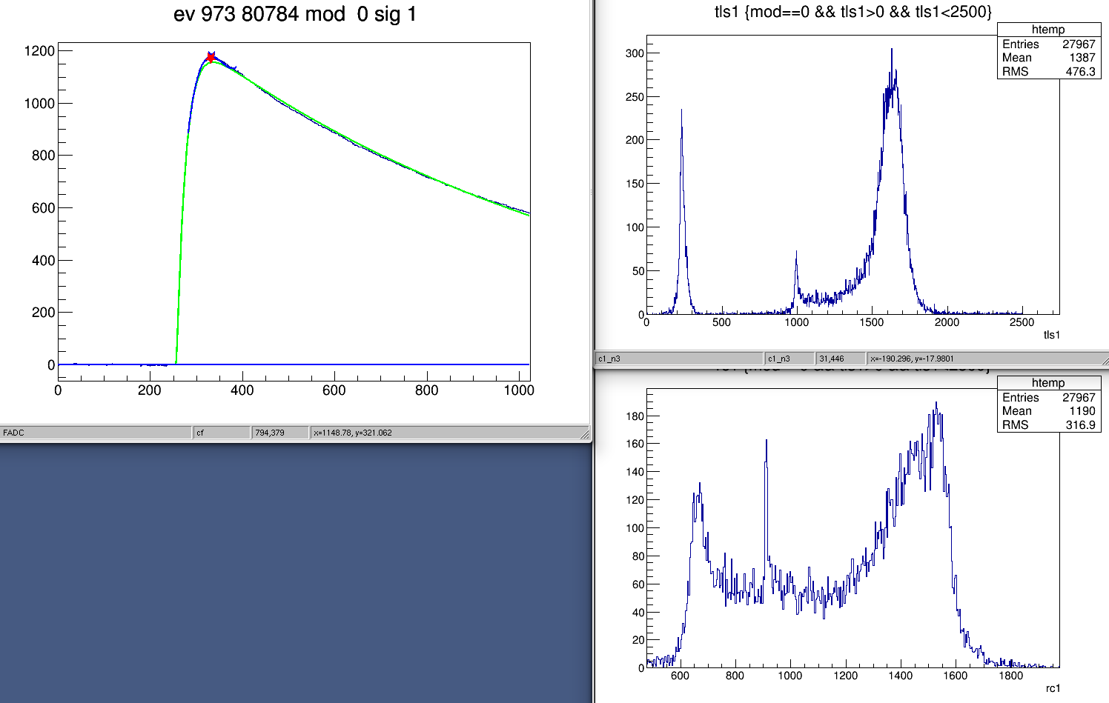
średnie RC z tls 994.4 σ 8.9
średnie RC z rc1 911.1 σ 3.5

dla hitu z rysunku
973 0 1 |1256.551 0.000 0.000| 255.218| 20.000 40.000 150.000| 2.160^ 54.645| 939.896|1003.888 0.439
tls1 = 1003.888
rc1 = 939.896

czysta eksponenta i fitowana funkcja (exp*exp) daje inne RC, tls jest średnio ~83 ch większe od rc1
możliwe, że potrzeba „nieco światła” żeby fit był lepszy i stąd sztuczna składowa światła i „slope”
jak niżej:
(być może wymuszając RC da się zmniejszyć sztuczną składową światła ???)

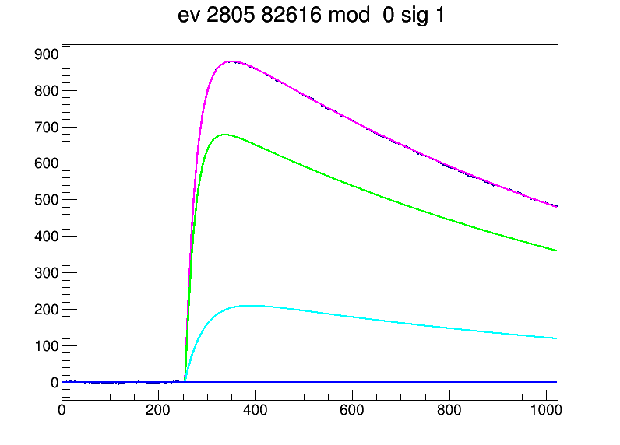
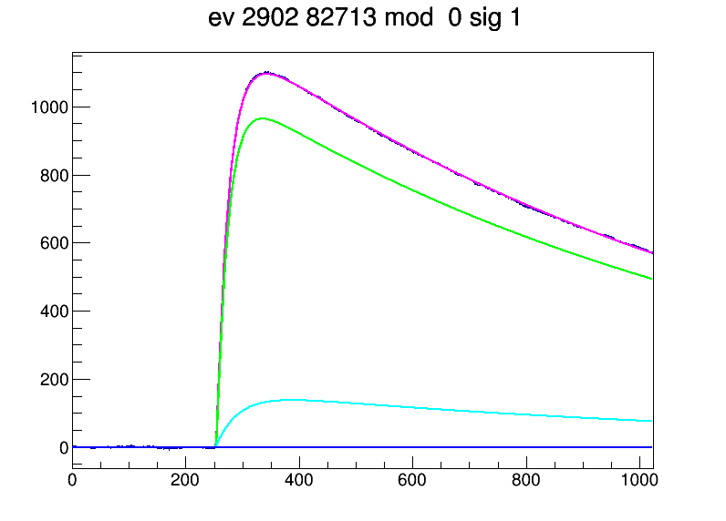

2805 0 1 | 731.951 238.130 0.000| 252.680| 20.000 40.000 150.000| 2.640^ 0.949|1051.654|1066.328 0.389

2902 0 1 |1044.599 157.492 0.000| 251.769| 20.000 40.000 150.000| 3.274^ 0.527| 996.072|1018.667 0.460

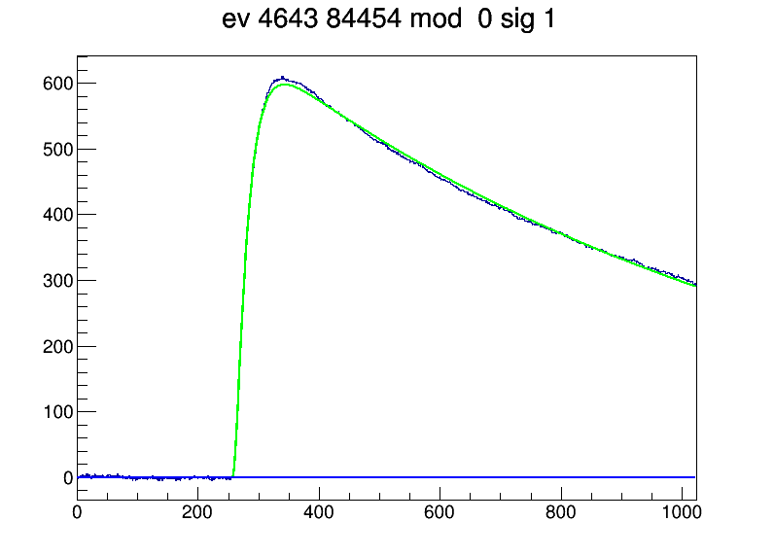

4643 0 1 | 651.887 0.000 0.000| 256.836| 20.000 40.000 260.093| 9.020^ 0.100| 914.304| 994.455 0.421

// 230 MeV, 0.2 nA (current source 8.01), Trigg: PD0, 48 Ti pretrigger PD0=200 ch
runs 7252-7265
all parameters free:
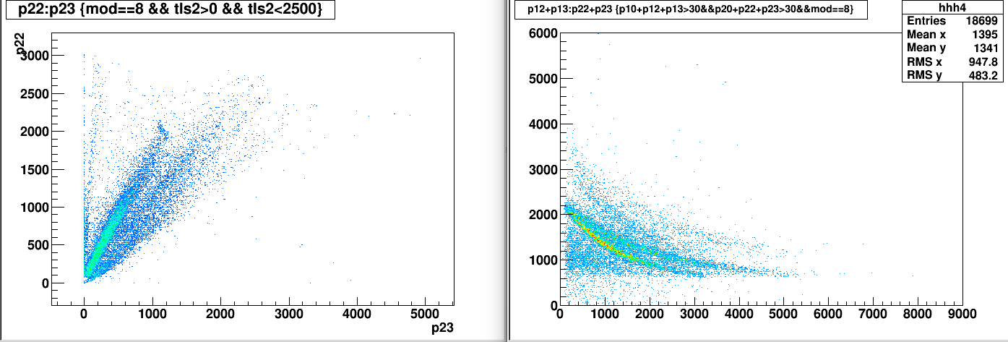
tls1 distributions (exp fit to the tail):
MOD 02 looks as if not seeing light (???)
/home/lukasik/spall-2017-06/mktreedst/fit/plot_par.C

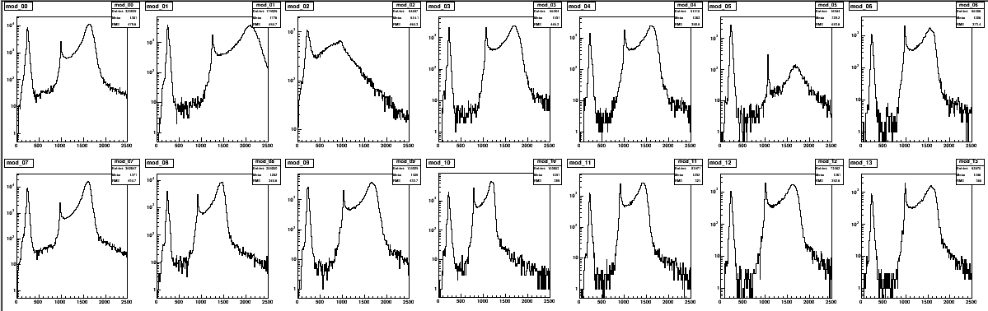
par.ods, par.dat:
tls1: bump peak (stopped in PD1)

rc1 (parameter from waveform fit) vs tls1 (from exp fit to tail) for particles stopped in PD1

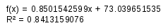

tls0 in PD0 (from exp fit to tail):
problem with PD0 in MOD 2 & 5
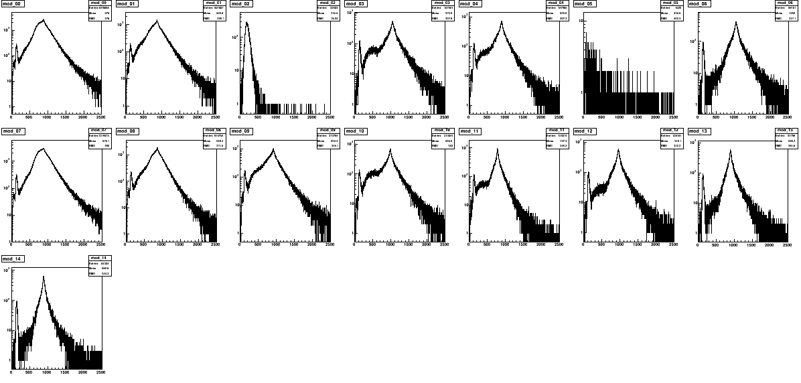
no HV ????:
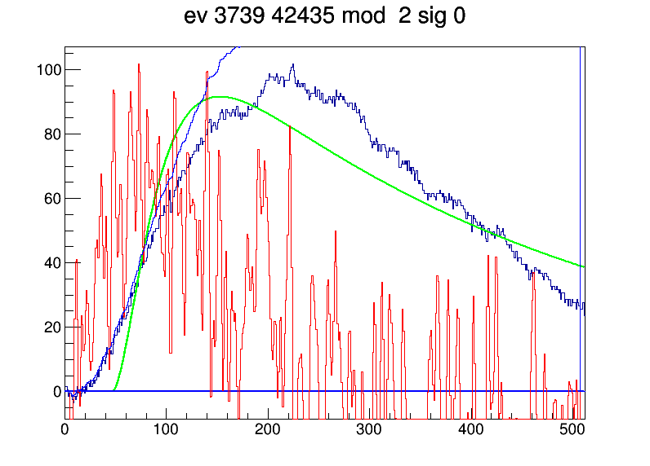

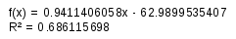

gaussian fits with background subtraction

hh1 = (TH1F*)mod_09->Clone();
bck = (TH1F*)mod_09->ShowBackground(15,"same");
hh1->Add(bck, -1.0);
new TCanvas();
hh1->DrawCopy();

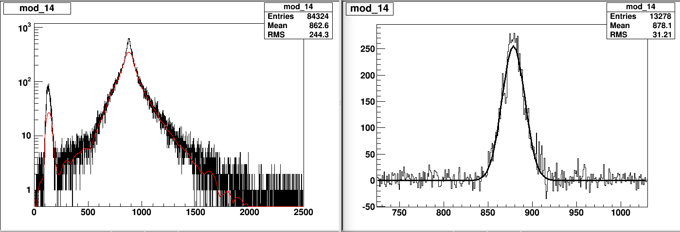

rc0 in PD0 (from waveform fit)
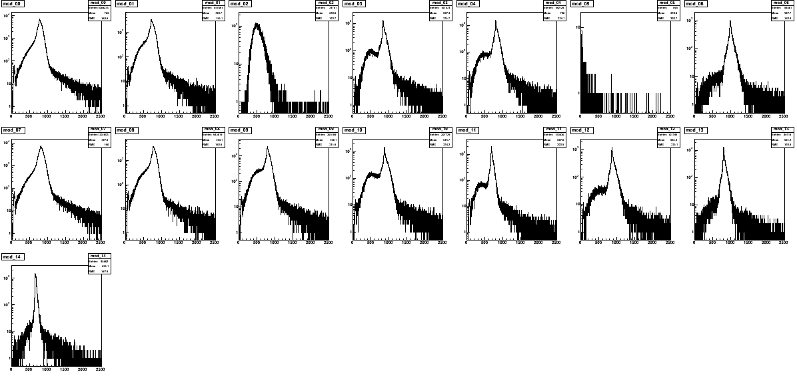

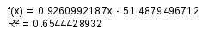

base lines
runs 7252-7265
// 230 MeV, 0.2 nA (current source 8.01), Trigg: PD0, 48 Ti pretrigger PD0=200 ch

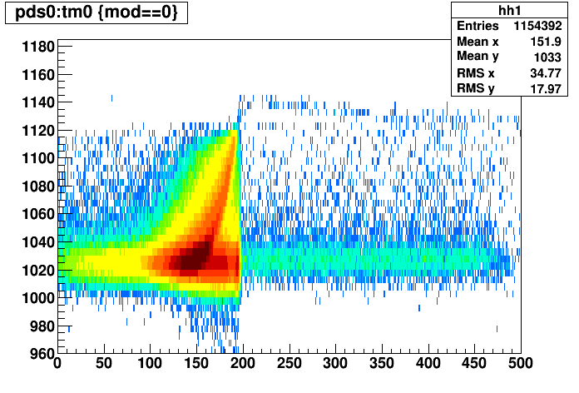

pds from fit mean pds

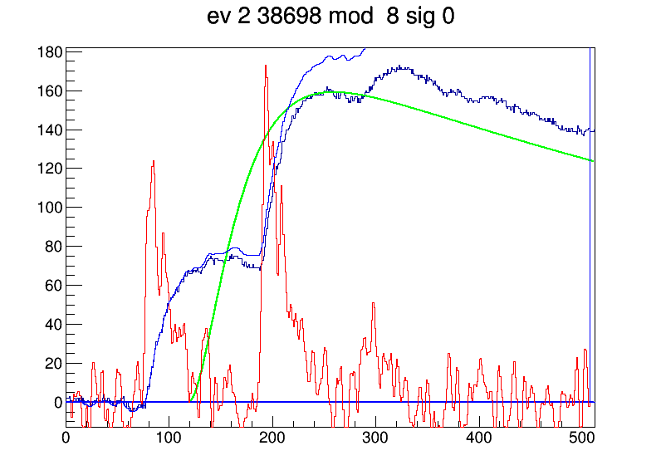
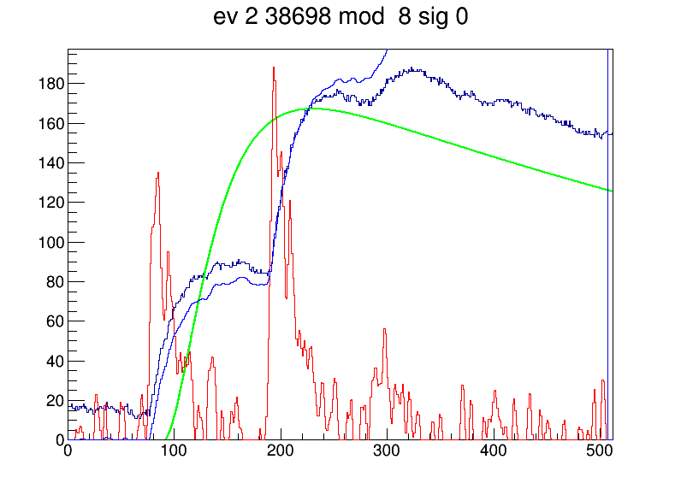

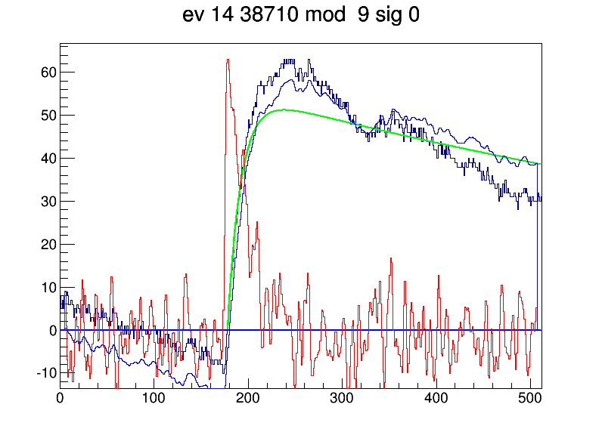
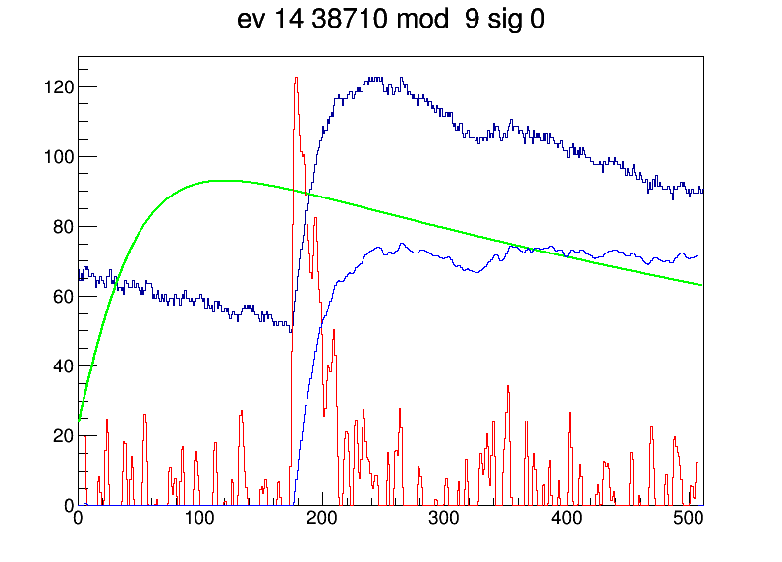

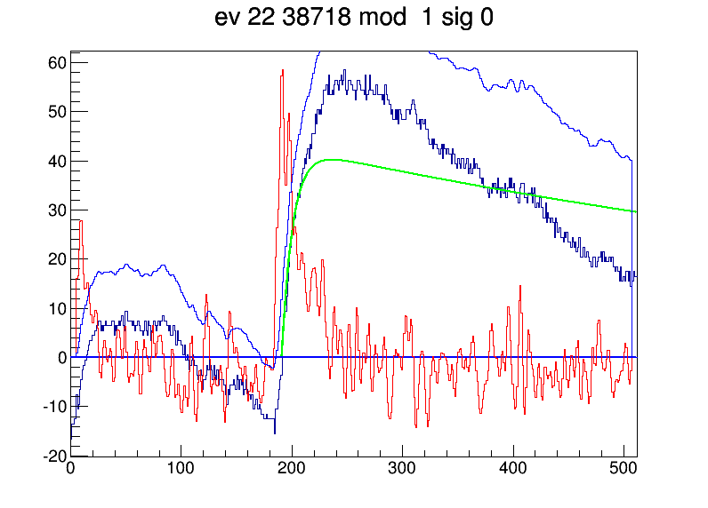
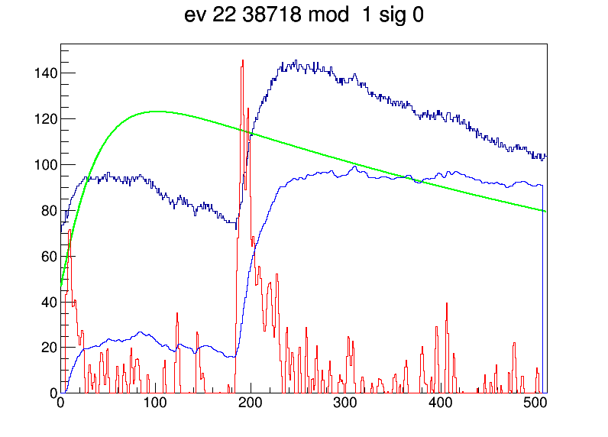

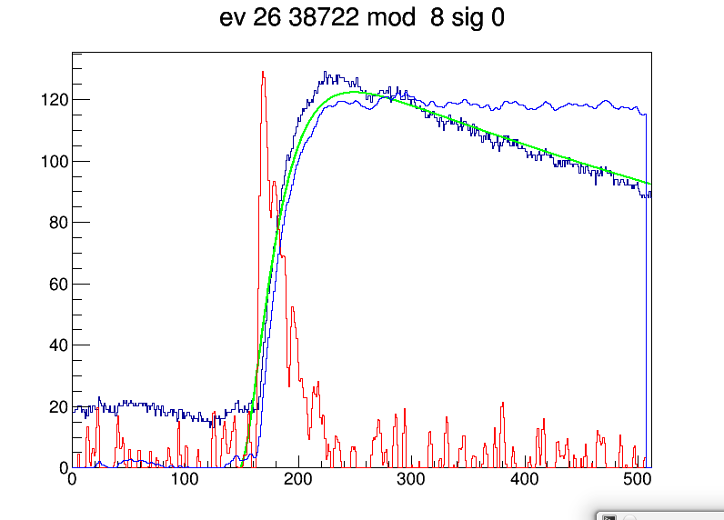
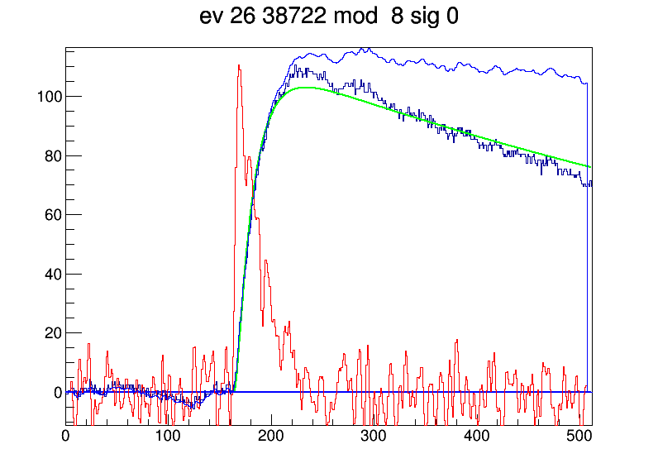

tls (exp fit) rc (waveform fit)

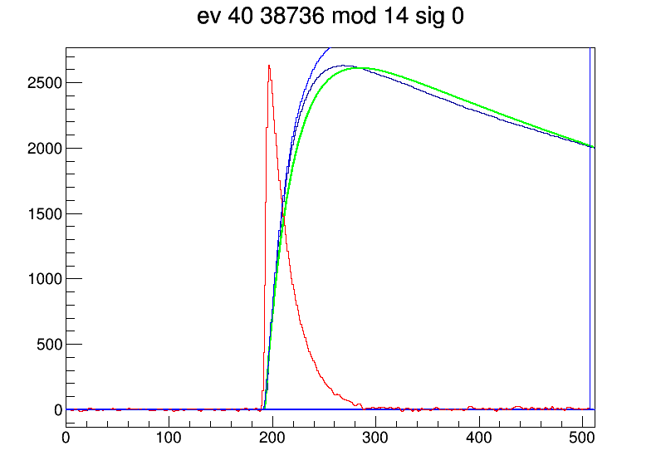

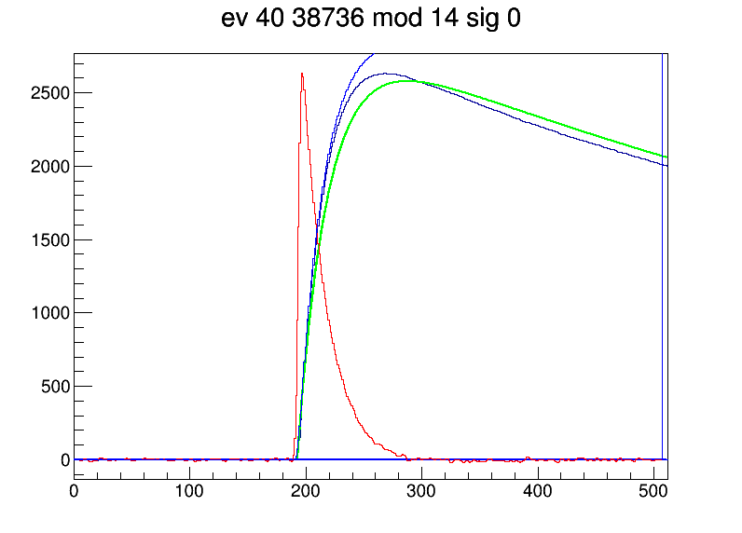

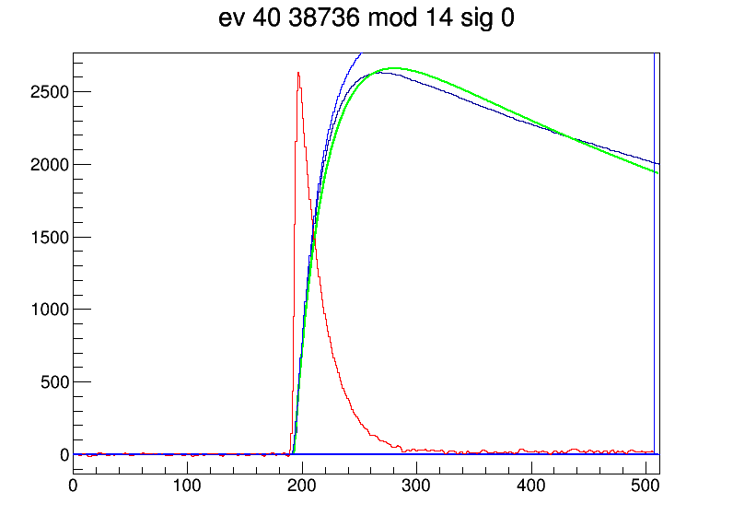

free RC does not help
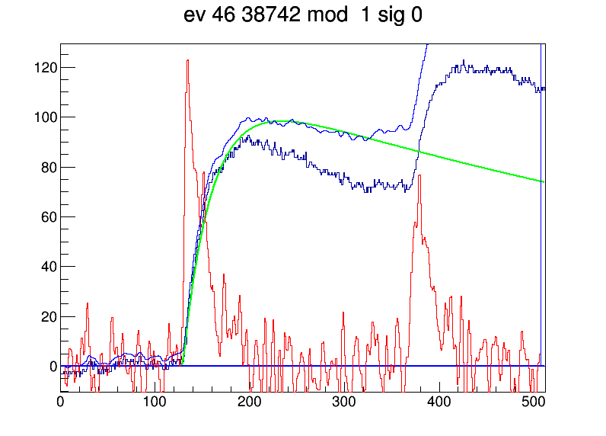
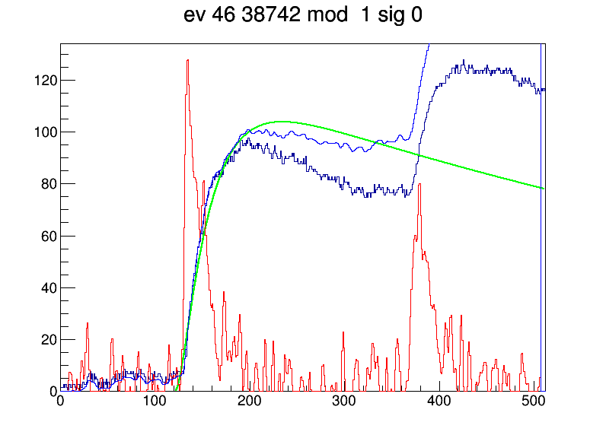

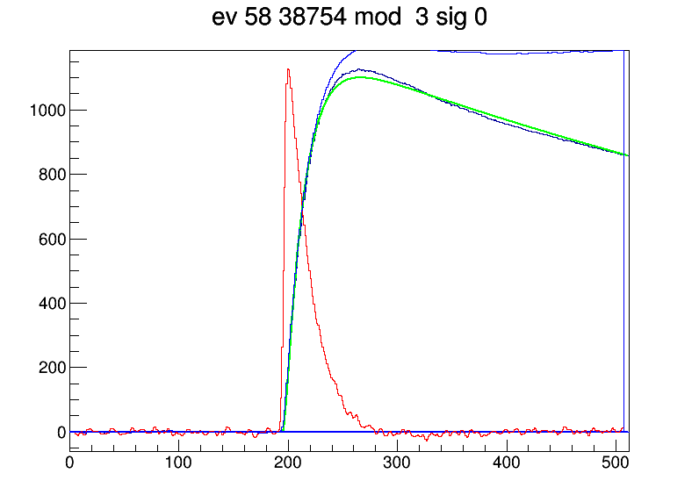

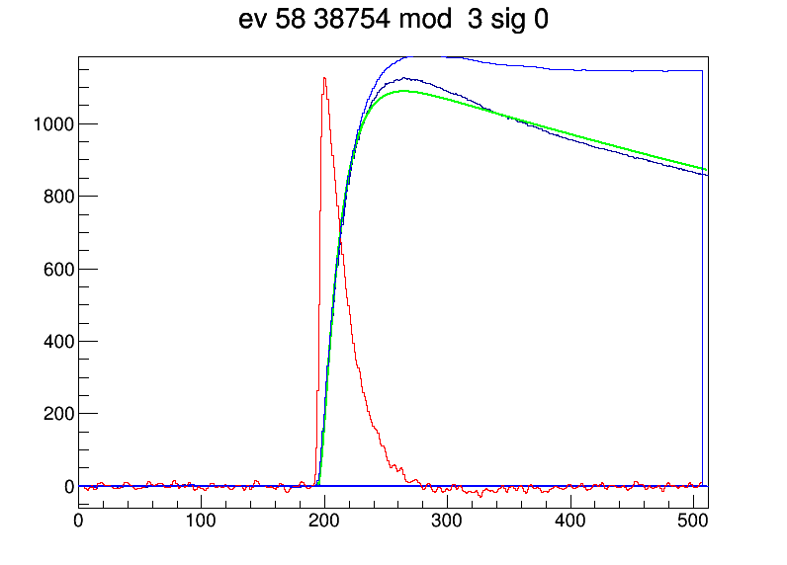

single component is not enough see above | free RC does not help

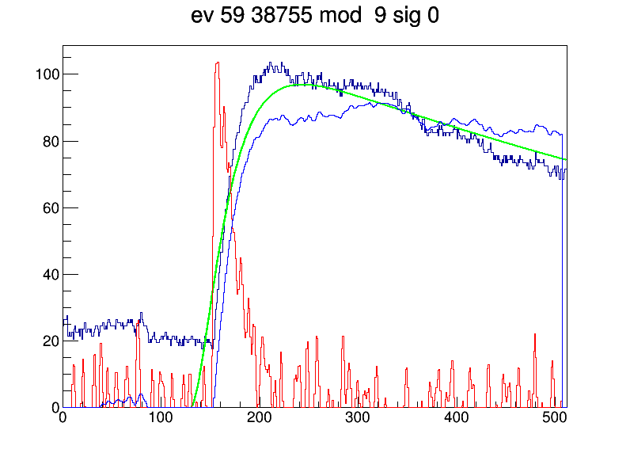
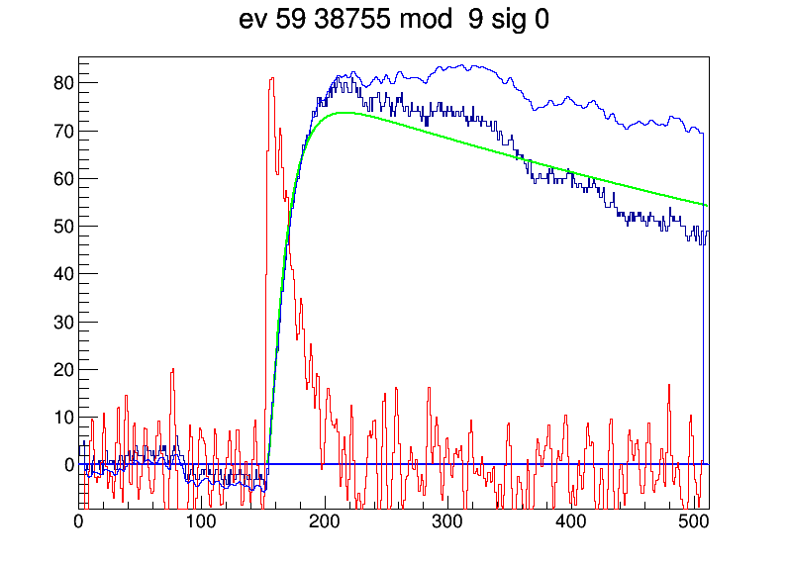

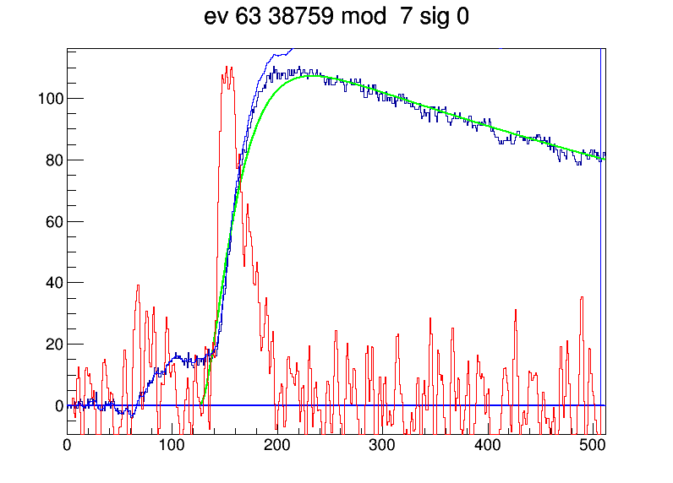
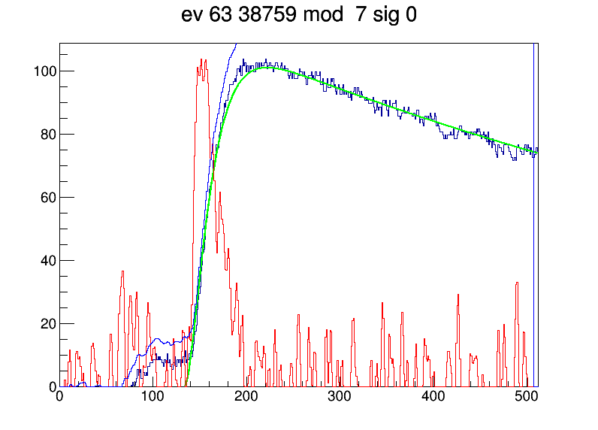

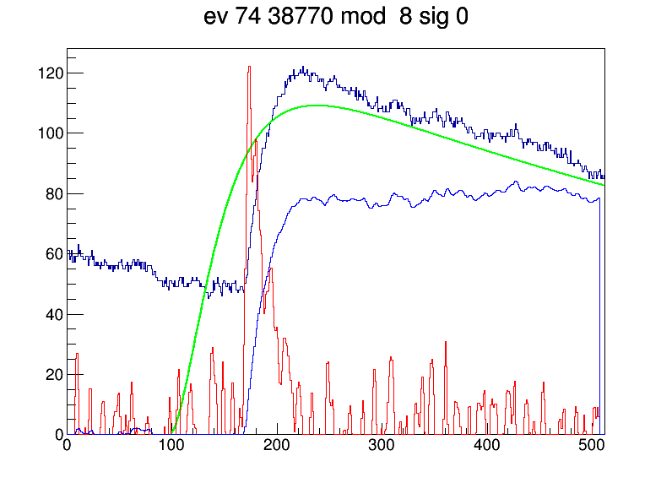
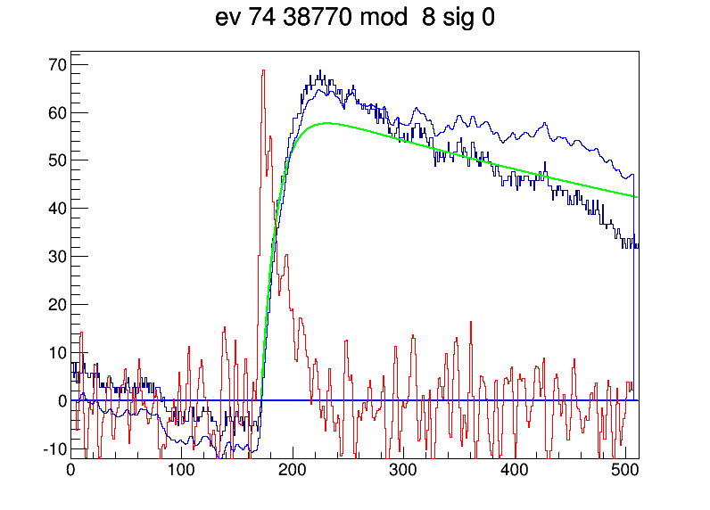

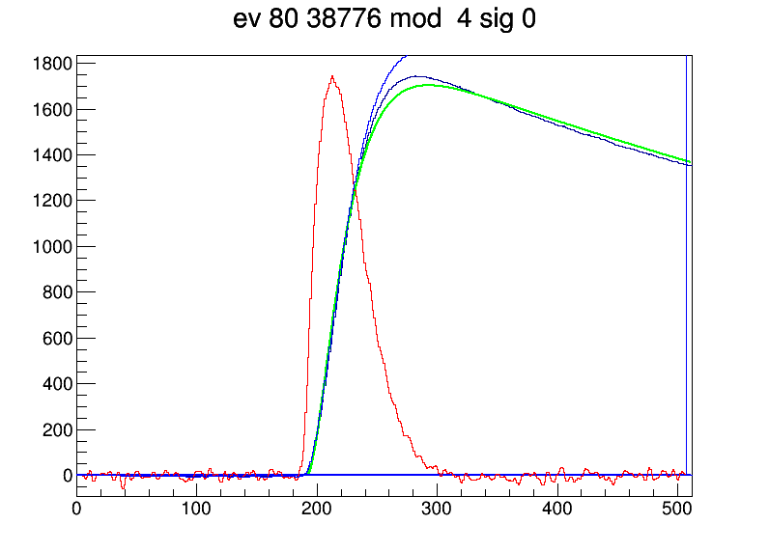
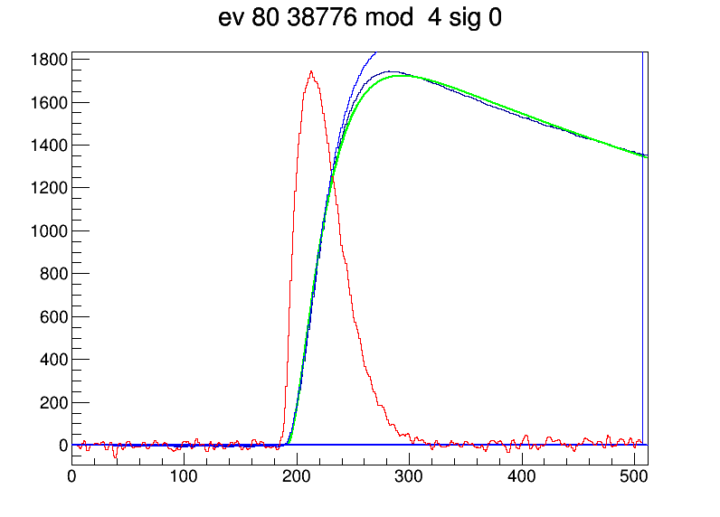

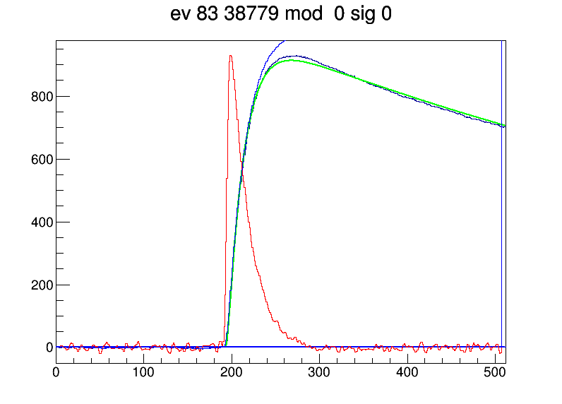
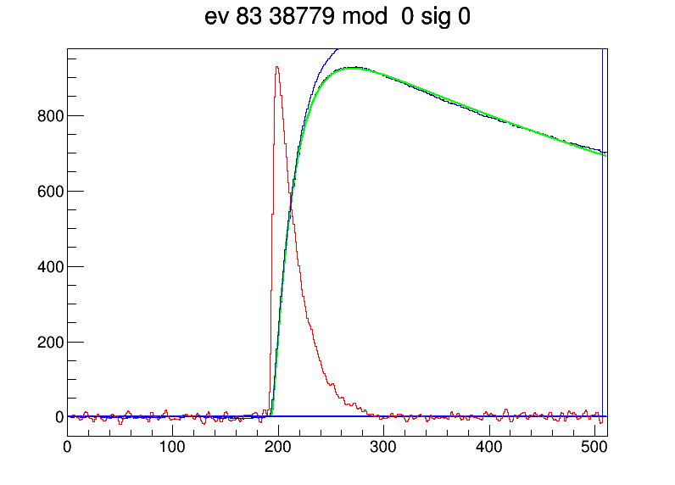

above a bit better when using RC from the fit and not from the exp tail

light component forced on the right below
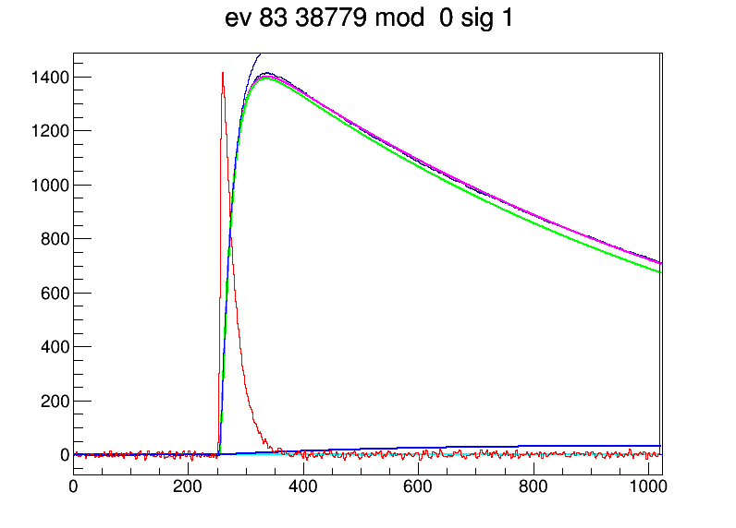

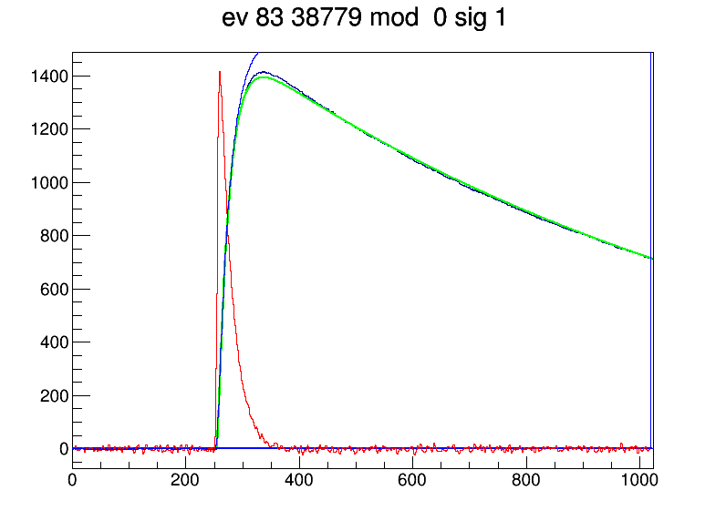

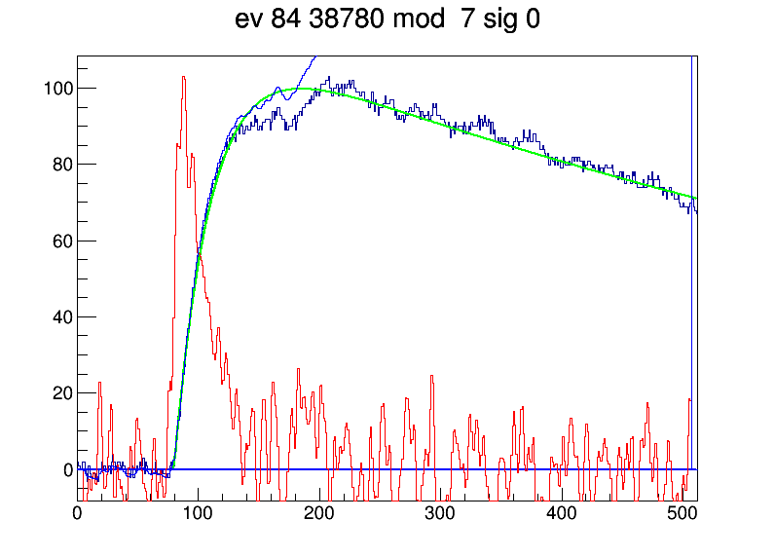
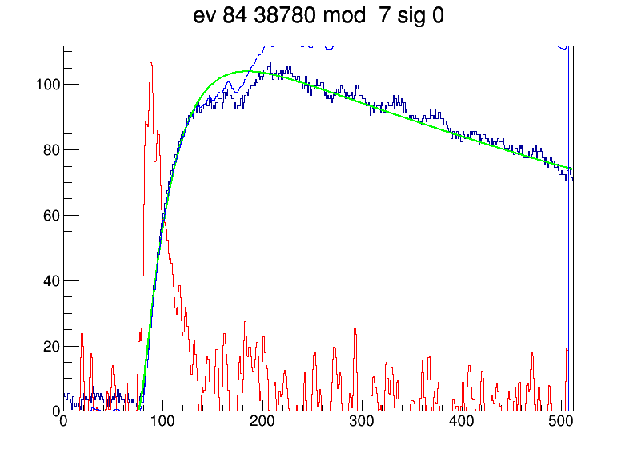

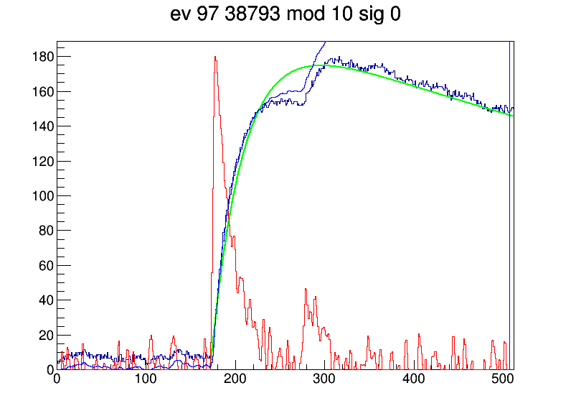
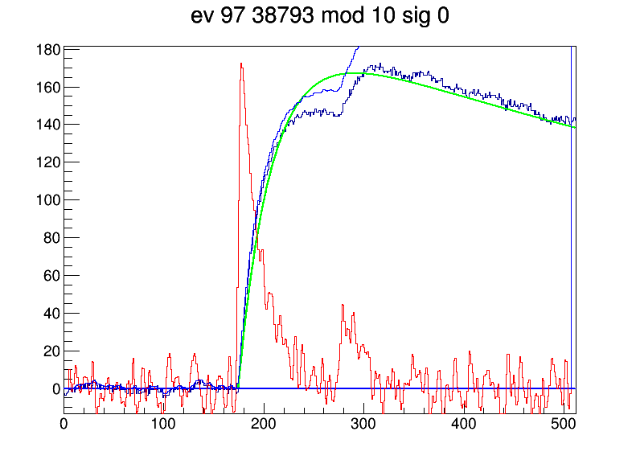

UNDERSHOOT in Si current component

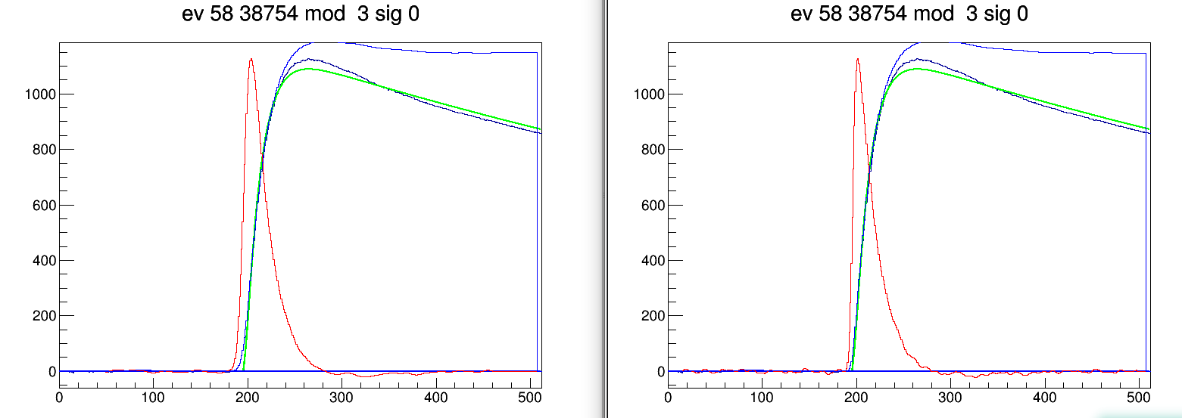

Tue Jul 25 10:30:32 CEST 2017
mod 07 fitował się ~ 5 x dłużej niż pozostałe
pds1 25 nA mod 0 70-85 MeV 25 nA mod 7 70-85 MeV 0.2 nA 230 MeV mod 7
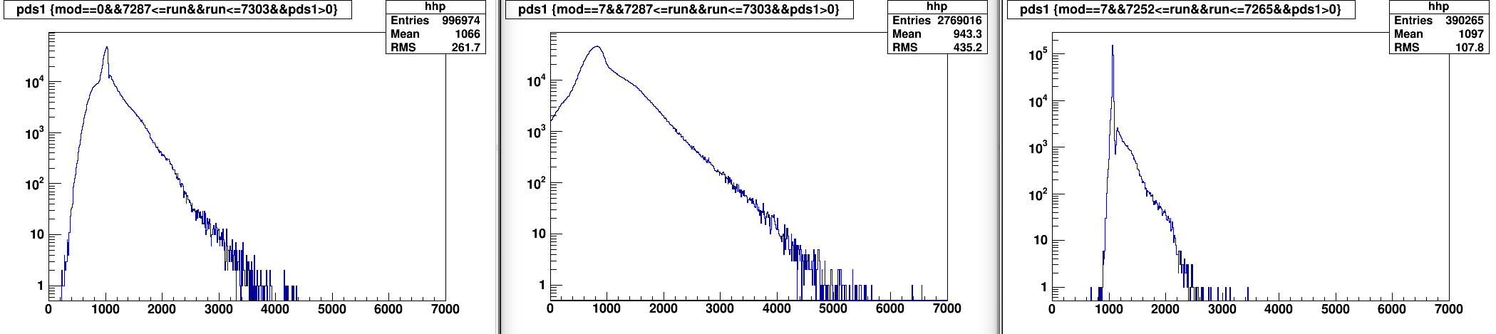
pdr1
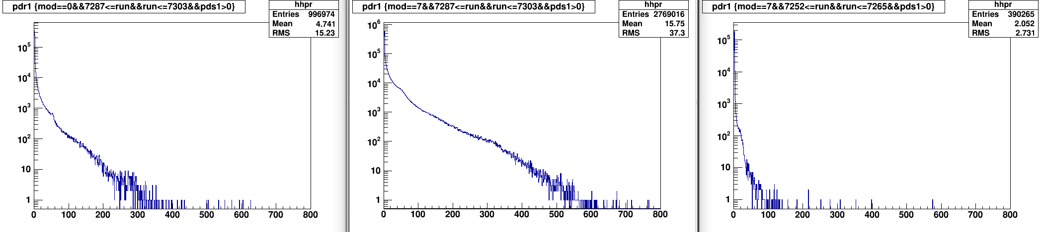
chi2
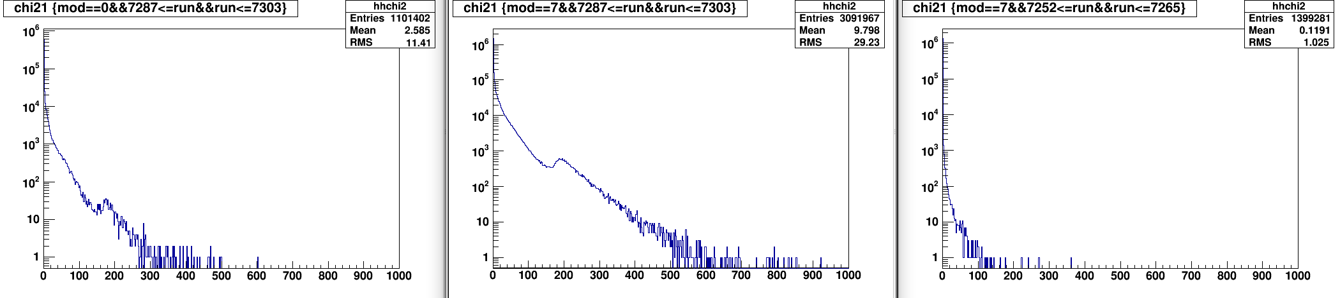

Si vs CsI1
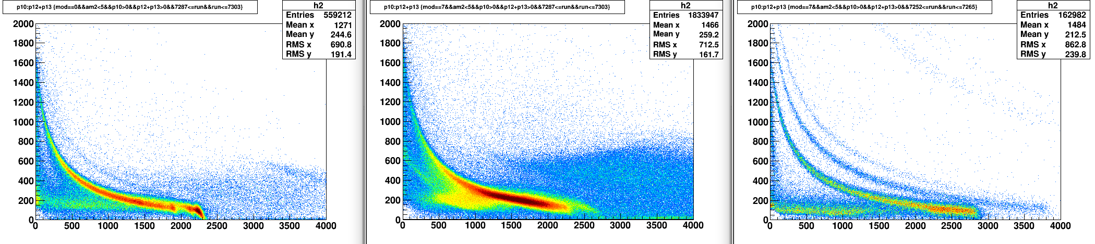
Si vs CsI1 chi21<0.6&&pdr1<5
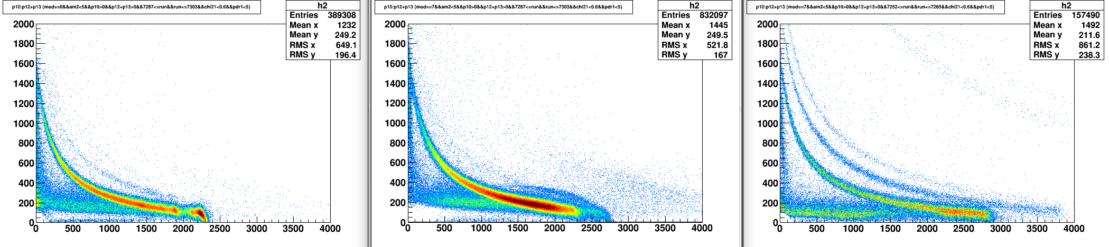
Si vs CsI1 chi21<0.6&&pdr1<5 && 150<tm1&&tm1<250
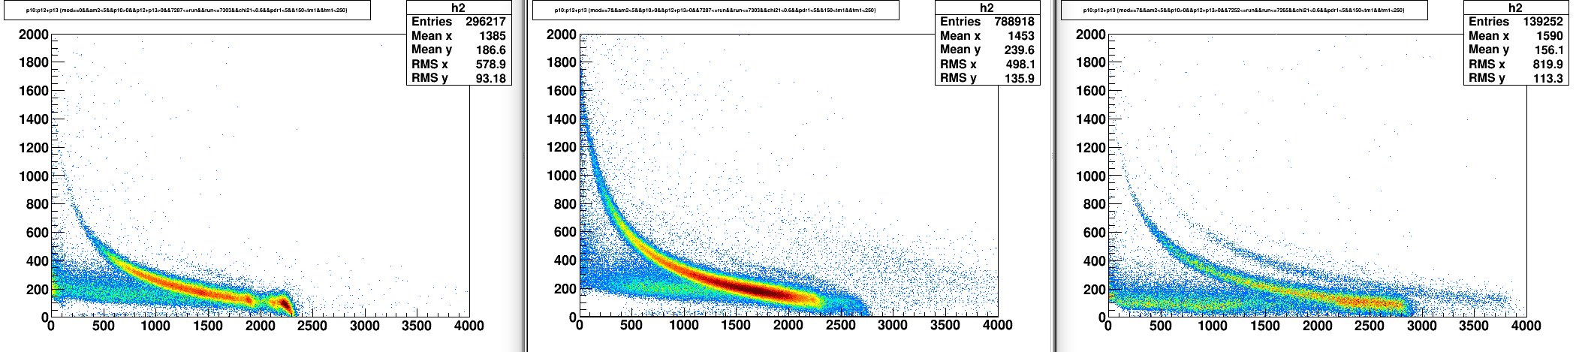

energy range for protons in CsI1 from 16.3 to 90.5 MeV
energy range for protons in CsI2 from 90.5 to 254.5 MeV

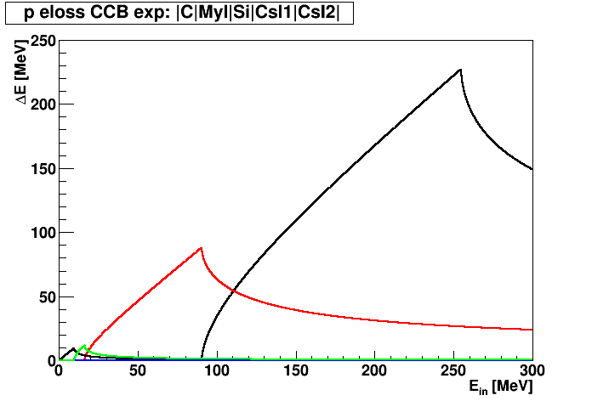

No CsI1: energy range for protons in CsI2 from 16.3 to 228 MeV
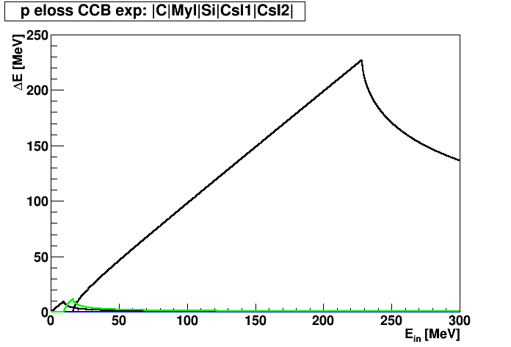

calib CsI1 /home/lukasik/spall-2017-06/mktreedst/fit_undreshoot/calib1.C
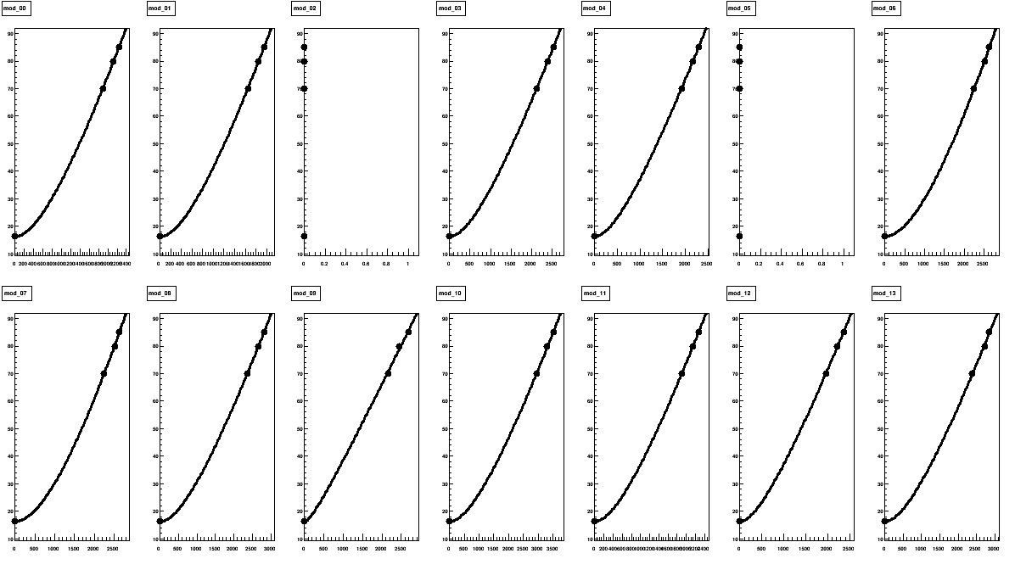
fun[ip] = new TF1(Form("g_%02d",ip),"[0]+[1]*(x-[2]*log(1+x/[2]))",0,5000);
mod [0] [1] [2]
00 16.2993 0.0610352 883.2794
01 16.2981 0.0698643 765.1452
02 62.8250 -305444.8047119 0.0000
03 16.2975 0.0489455 785.9020
04 16.2992 0.0508002 599.0044
05 62.8250 -305444.8047119 0.0000
06 16.3037 0.0697988 1895.5729
07 16.3033 0.0676883 1789.1726
08 16.2981 0.0448321 913.1717
09 16.2961 0.0295746 104.6813
10 16.2960 0.0360005 1140.1522
11 16.2983 0.0546094 696.9680
12 16.2966 0.0460687 495.8570
13 16.3040 0.0422302 822.7445

calib CsI2 /home/lukasik/spall-2017-06/mktreedst/fit_undreshoot/calib2.C
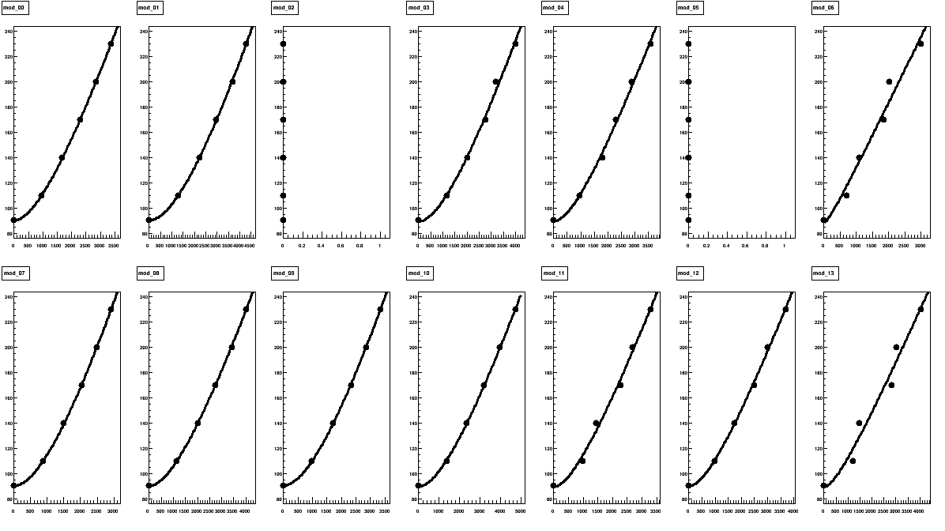
fun[ip] = new TF1(Form("g_%02d",ip),"[0]+[1]*(x-[2]*log(1+x/[2]))",0,5000);
mod [0] [1] [2]
00 90.4732 0.0814595 1283.3827
01 90.6144 0.0761636 2383.4937
02 156.7500 -569928.0144414 0.0000
03 89.5550 0.0693743 1477.5685
04 89.7350 0.0664059 877.4305
05 156.7500 -569928.0144414 0.0000
06 88.8356 0.0535118 65.8366
07 90.6283 0.1121942 1635.9421
08 90.4332 0.0688956 1562.4278
09 90.7312 0.0940671 1729.4226
10 89.9599 0.0568751 1671.6420
11 89.6810 0.0696917 750.0690
12 90.1567 0.0621641 846.9224
13 89.6153 0.0459601 393.5633

Si1 vs CsI1

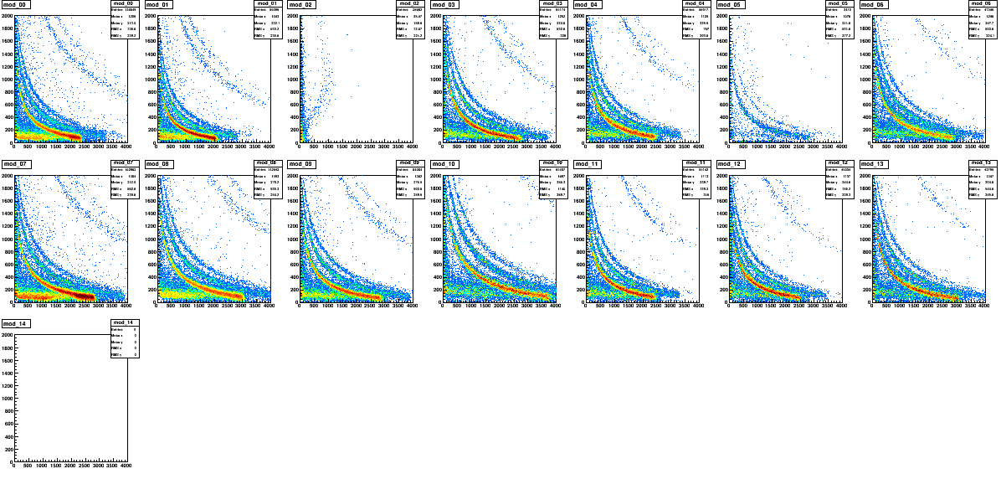
CsI1 vs CsI2 -> za wysokie progi na CsI2, zwłaszcza mod 07
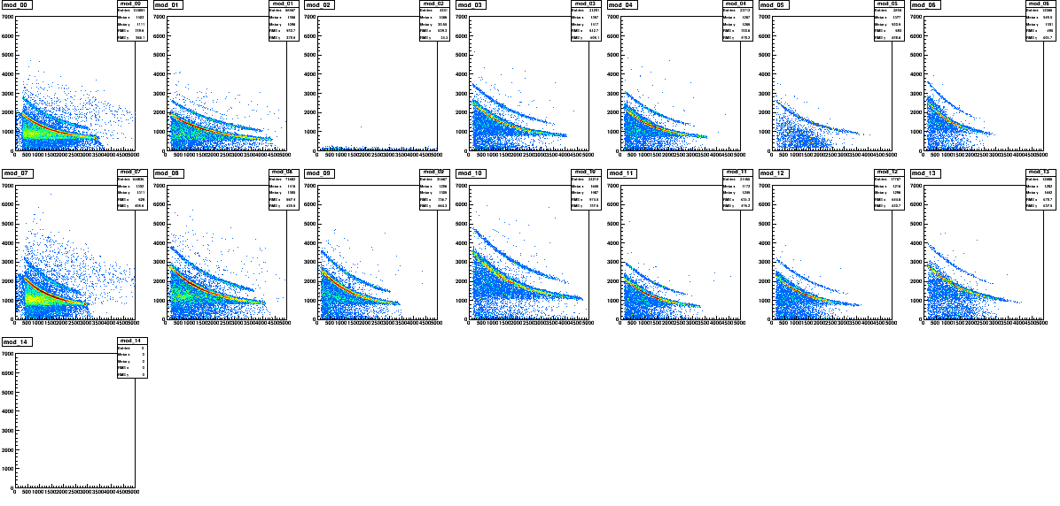

Fast-Slow
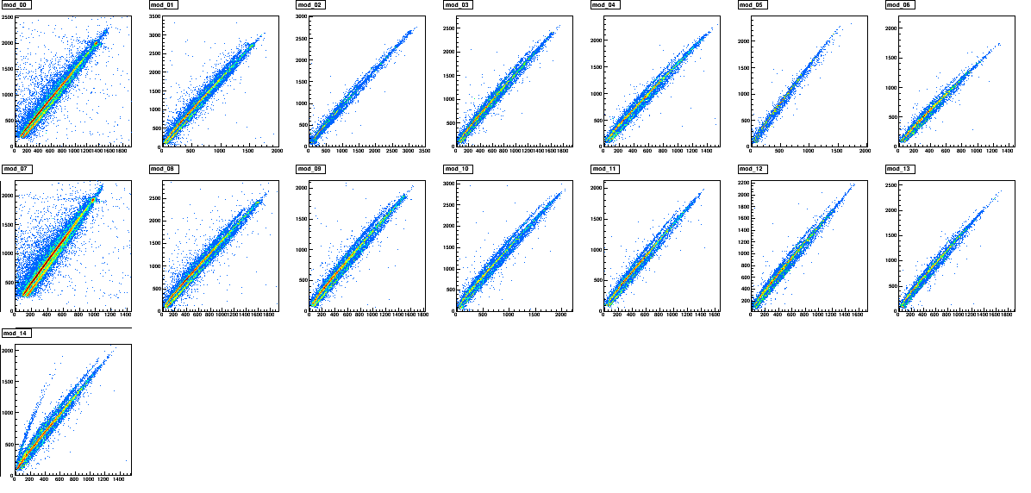
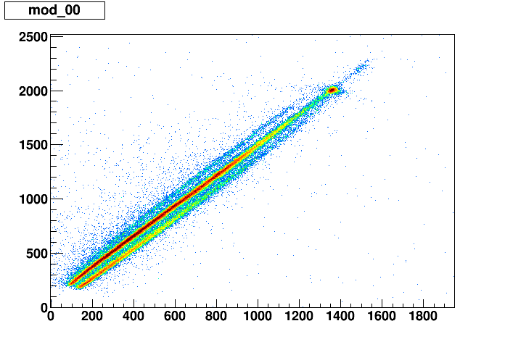

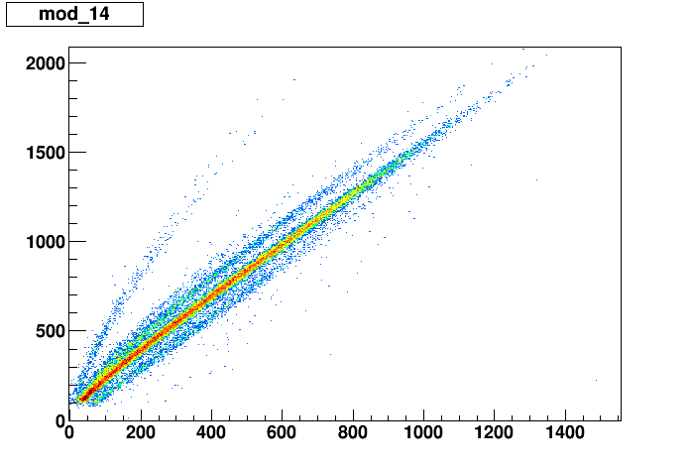

230 MeV, 0.2 nA too high thresholds in CsI2 -> cannot clearly remove backbands in CsI1 -> discontinuities
energy calibration may not be precise at larger angles (no elastic, beam energies assumed)
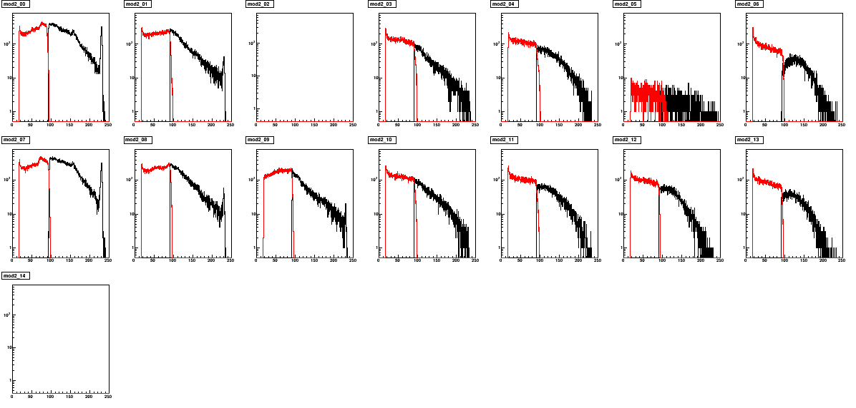
resolution:
mod 00 σ=1.3 MeV (FWHM = 3.1 MeV)
mod 01 σ=1.4 MeV (FWHM = 3.2 MeV)
mod 07 σ=1.4 MeV (FWHM = 3.4 MeV)
mod 08 σ=1.2 MeV (FWHM = 2.9 MeV)

ghost peak at ~156 MeV (E* = 74 MeV)

70 MeV, 25 nA 48Ti
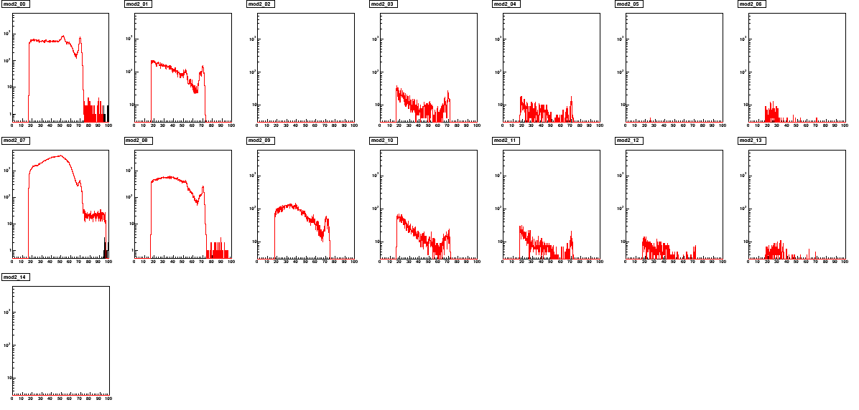
resolution:
mod 00 σ=1.1 MeV (FWHM = 2.6 MeV)
mod 01 σ=1.1 MeV (FWHM = 2.5 MeV)
mod 03 σ=0.9 MeV (FWHM = 2.1 MeV)
mod 04 σ=1.0 MeV (FWHM = 2.3 MeV)
mod 07 σ=1.6 MeV (FWHM = 3.6 MeV)
mod 08 σ=1.0 MeV (FWHM = 2.4 MeV)

ghost peak at ~52 MeV (E* = 18 MeV)

80 MeV, 25 nA 48Ti
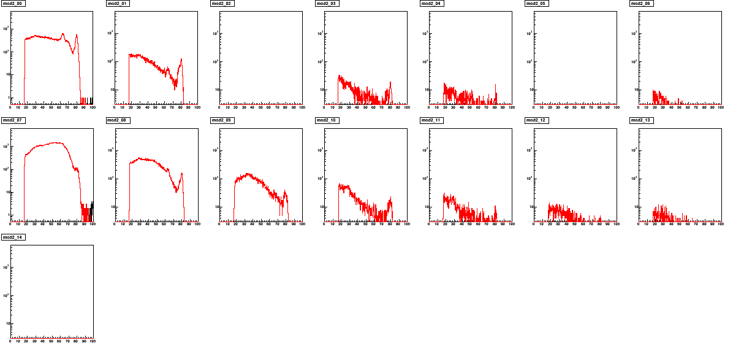
resolution:
mod 00 σ=1.2 MeV (FWHM = 2.9 MeV)
mod 01 σ=1.1 MeV (FWHM = 2.5 MeV)
mod 03 σ=1.0 MeV (FWHM = 2.4 MeV)
mod 04 σ=1.0 MeV (FWHM = 2.3 MeV)
mod 07
mod 08 σ=1.2 MeV (FWHM = 2.8 MeV)

ghost peak at ~63 MeV (E* = 17 MeV)

85 MeV, 25 nA 48Ti
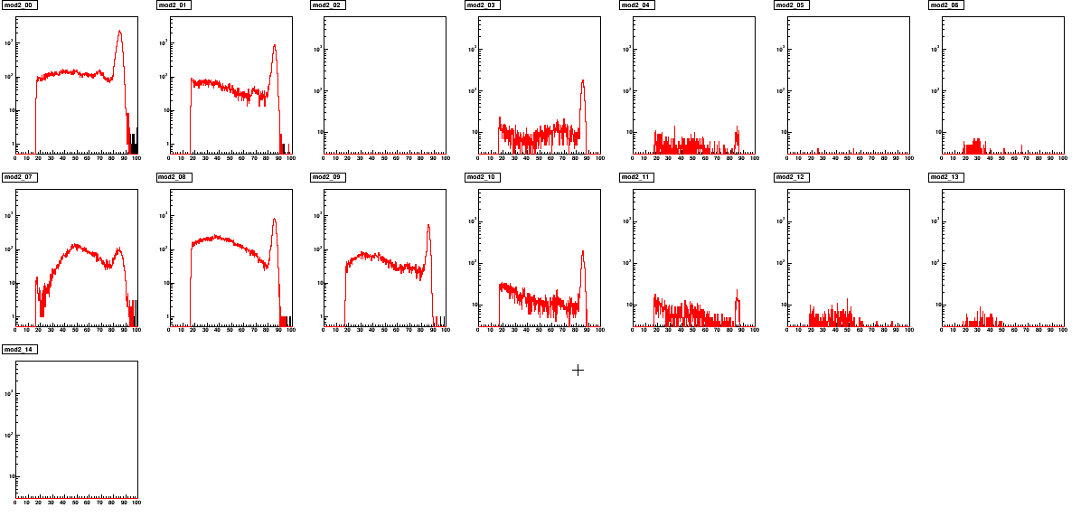
resolution:
mod 00 σ=1.5 MeV (FWHM = 3.6 MeV)
mod 01 σ=1.2 MeV (FWHM = 2.9 MeV)
mod 03 σ=1.1 MeV (FWHM = 2.6 MeV)
mod 04 σ=1.2 MeV (FWHM = 2.8 MeV)
mod 07
mod 08 σ=1.3 MeV (FWHM = 3.0 MeV)
mod 09 σ=0.9 MeV (FWHM = 2.2 MeV)
mod 10 σ=1.1 MeV (FWHM = 2.6 MeV)
mod 11 σ=1.2 MeV (FWHM = 2.8 MeV)

ghost peak at ~68 MeV (E* = 17 MeV)

110 MeV, 5 nA 48Ti
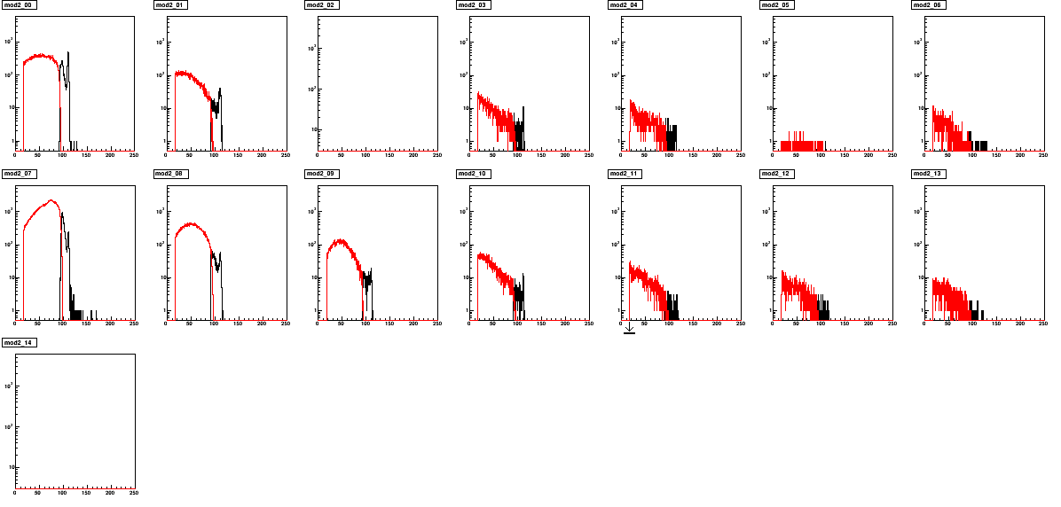

resolution:
mod 00 σ=1.1 MeV (FWHM = 2.6 MeV)
mod 01 σ=1.4 MeV (FWHM = 3.4 MeV)
mod 03 σ=1.2 MeV (FWHM = 2.7 MeV)
mod 04 σ=1.2 MeV (FWHM = 2.8 MeV)
mod 07 σ=1.2 MeV (FWHM = 2.8 MeV)
mod 08 σ=1.3 MeV (FWHM = 3.1 MeV)
mod 09 σ=1.2 MeV (FWHM = 2.9 MeV)
mod 10 σ=1.0 MeV (FWHM = 2.4 MeV)

ghost peak: no clear evidence

140 MeV, 10 nA 48Ti

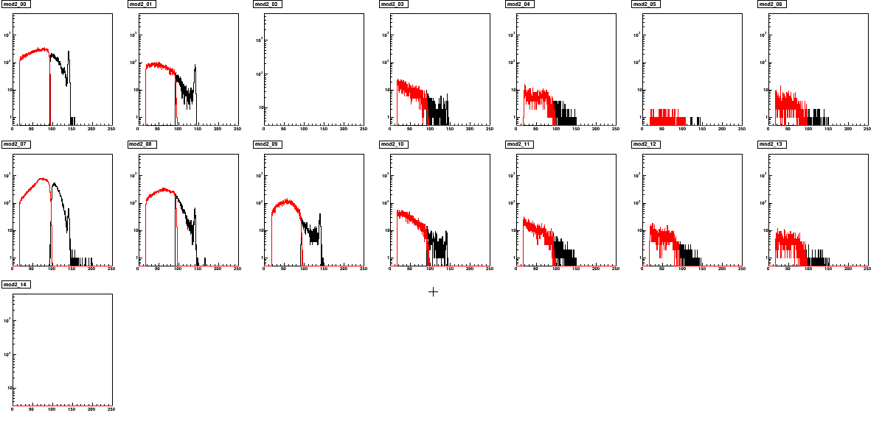

resolution:
mod 00 σ=1.3 MeV (FWHM = 3.2 MeV)
mod 01 σ=1.4 MeV (FWHM = 3.2 MeV)
mod 03
mod 04
mod 07 σ=1.5 MeV (FWHM = 3.5 MeV)
mod 08 σ=1.5 MeV (FWHM = 3.5 MeV)
mod 09 σ=1.5 MeV (FWHM = 3.5 MeV)

ghost peak: at ~129 MeV (E* = 11 MeV)

170 MeV, 5 nA 48Ti
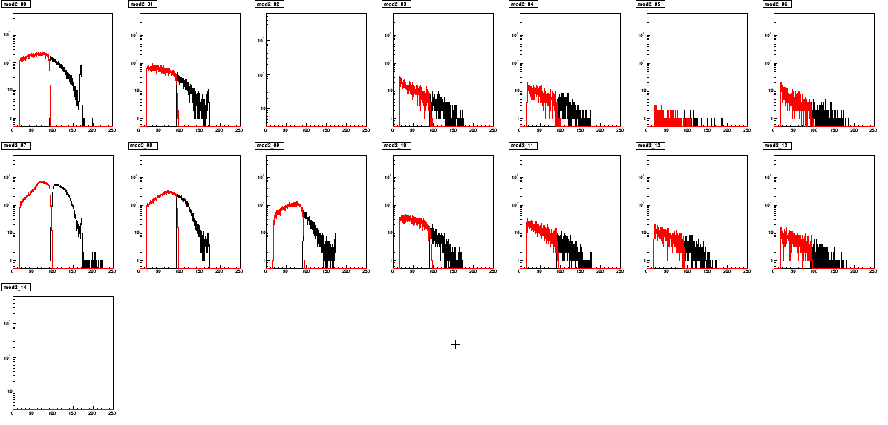

resolution:
mod 00 σ=1.4 MeV (FWHM = 3.3 MeV)
mod 01
mod 03
mod 04
mod 07 σ=1.8 MeV (FWHM = 4.1 MeV)

ghost peak: no clear evidence

200 MeV, 1 nA 48Ti

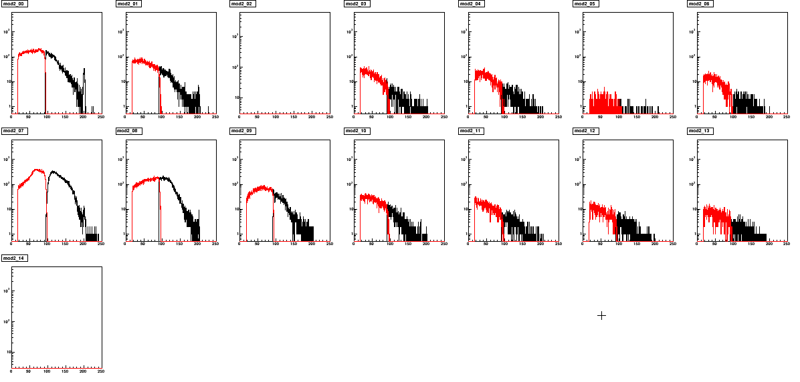
resolution:
mod 00 σ=1.3 MeV (FWHM = 3.2 MeV)
mod 01
mod 03
mod 04
mod 07 σ=2.2 MeV (FWHM = 5.3 MeV)

ghost peak: no clear evidence

