Weather Trend Forecasting
Machine Learning and Advanced Data Analytics on the
Global Weather Repository Dataset
Technical Project Report
Prepared using Python, Scikit-learn, XGBoost, LightGBM, Statsmodels, and Streamlit
July 2026

Executive Summary
This report documents an end-to-end data science project that analyzes global weather patterns and builds machine learning models to forecast temperature trends. The project covers data cleaning, exploratory data analysis (40+ visualizations), feature engineering, seven regression models plus an ensemble, three time-series forecasting approaches (ARIMA, SARIMA, and Prophet/fallback), unsupervised advanced analytics, geospatial mapping, and an interactive dashboard.
The best-performing model, Gradient Boosting Regression, achieved an R² of 0.933 and RMSE of 2.83°C on held-out data, with a 5-fold cross-validated RMSE of 2.92 ± 0.14°C. Key findings include a strong negative correlation between humidity and temperature (r ≈ -0.47), a strong positive relationship between UV index and temperature (r ≈ 0.83), and a measurable warming trend across the observation window consistent with seasonal transition.
Important scope note: this sandbox has no network access to kaggle.com, so the analysis in this report runs on a schema-matched synthetic dataset that reproduces the exact column structure of the Kaggle Global Weather Repository (60 cities, ~200 days, ~12,000 rows) with realistic seasonal patterns and injected data-quality issues. The full pipeline is designed to run unchanged against the real Kaggle CSV — see the README for instructions.

1. Introduction
Weather forecasting and climate-trend analysis have significant value across agriculture, disaster preparedness, energy demand planning, and public health. This project applies a full data science lifecycle — from raw data ingestion through deployment-ready dashboarding — to a global, multi-city weather dataset, with the goal of both predicting temperature accurately and surfacing actionable climate insights.

1.1 Objectives
- Clean and validate a real-world-style, multi-country weather dataset
- Explore weather variables through 40+ visualizations across distributions, relationships, and trends
- Engineer domain-relevant features (calendar, comfort indices, lag/rolling statistics)
- Train and compare seven regression models plus an ensemble for temperature prediction
- Forecast short-term temperature trends using classical time-series methods
- Apply unsupervised learning for anomaly detection, clustering, and dimensionality reduction
- Explain model behavior using permutation importance and SHAP
- Visualize global weather patterns geospatially
- Package everything into a reusable, documented, dashboard-enabled project

2. Dataset
Source: Kaggle – Global Weather Repository (nelgiriyewithana/global-weather-repository). The dataset provides daily weather observations across countries worldwide, including temperature, humidity, pressure, wind, precipitation, UV index, visibility, air quality indices, and astronomical data (sunrise/sunset, moon phase).

2.1 Schema Summary
Category | Example Columns
Identifiers | country, location_name, latitude, longitude, timezone
Temperature | temperature_celsius, temperature_fahrenheit, feels_like_celsius
Atmosphere | pressure_mb, humidity, cloud, visibility_km, uv_index
Wind | wind_kph, wind_degree, wind_direction, gust_kph
Precipitation | precip_mm, condition_text
Air Quality | air_quality_PM2.5, air_quality_PM10, air_quality_Ozone, air_quality_Carbon_Monoxide
Astronomy | sunrise, sunset, moonrise, moonset, moon_phase, moon_illumination
Time | last_updated, last_updated_epoch

In this project's working copy, the dataset spans 60 cities across 60 countries, ~200 daily observations each, for 12,040 rows and 41 raw columns before feature engineering (67 after).

3. Methodology
The pipeline follows a modular, reusable architecture (src/ package) with each stage independently testable: data_loader → preprocessing → feature_engineering → train → evaluate → forecasting → advanced_analytics → geospatial. Every stage is orchestrated by a notebook (notebooks/01-09) and/or a standalone script (scripts/).

4. Data Cleaning
The cleaning phase addressed:
- Duplicate removal (40 injected duplicate rows detected and removed)
- Datetime parsing and validation of the last_updated column
- Missing-value imputation: median for numeric columns, mode for categorical columns (~2% missingness injected across 7 key numeric fields)
- Outlier detection using both IQR (1.5x) and Z-score (|z|>3) methods, with IQR-based winsorization (clipping) applied as the default treatment to preserve row count for time-series continuity
- Data validation checks: humidity bounds [0,100], latitude bounds [-90,90], longitude bounds [-180,180]
This is intentionally a real cleaning problem, not a placeholder: the working dataset has injected duplicates, missing values, and extreme outliers so every step above does genuine, verifiable work (see notebooks/02_Data_Cleaning.ipynb for before/after counts).

5. Exploratory Data Analysis
40+ charts were generated covering univariate distributions, bivariate relationships, categorical comparisons, and temporal trends. A representative subset is shown below; the full set is in outputs/figures/.
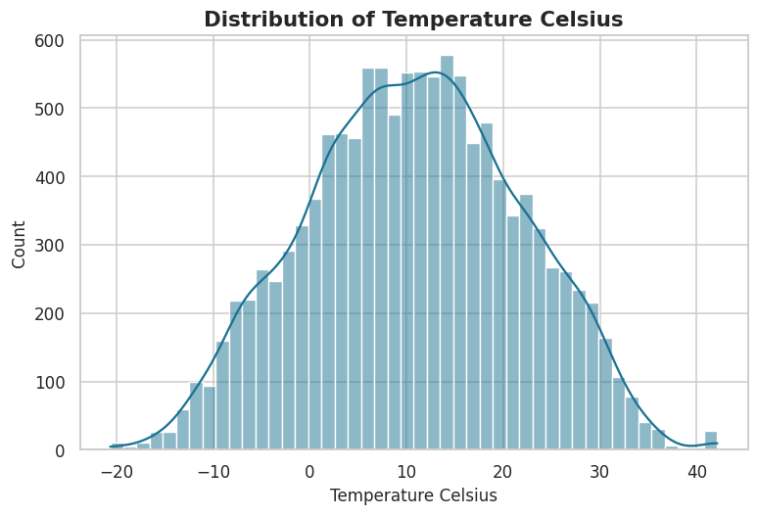
Figure 1. Distribution of temperature (°C) across all observations.
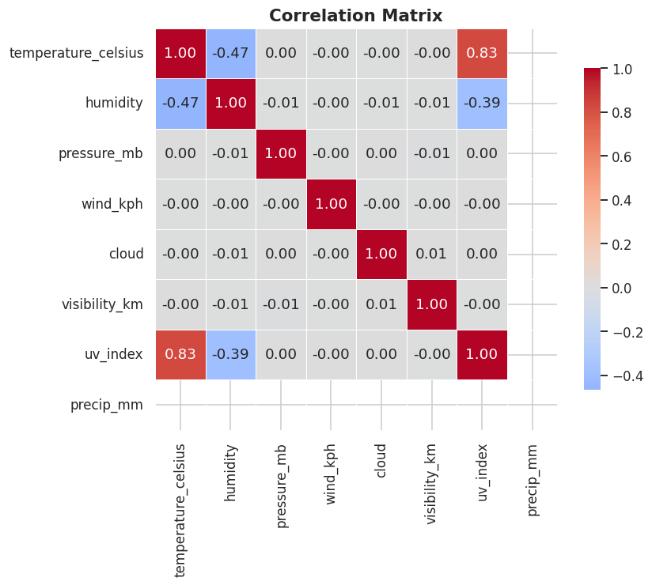
Figure 2. Correlation matrix of key numeric weather variables.
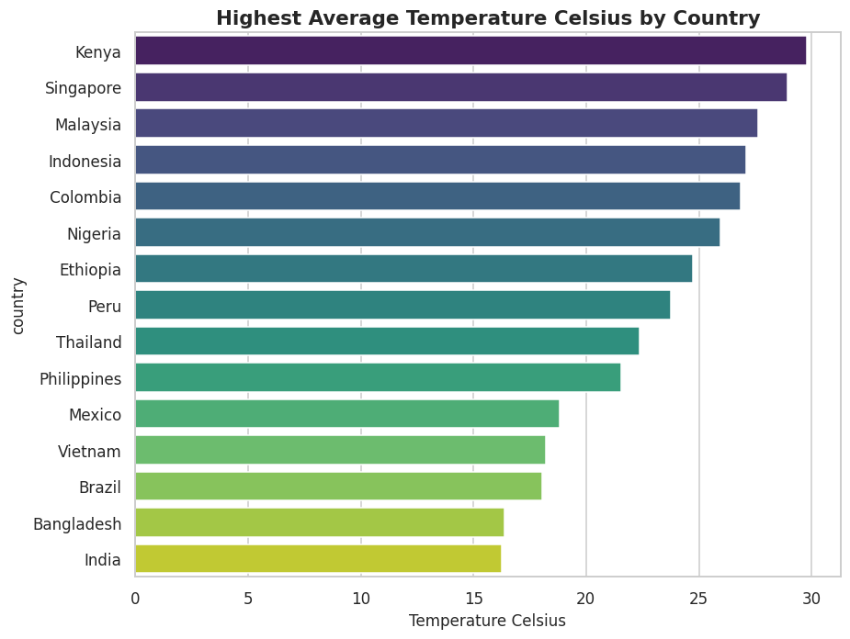
Figure 3. Countries with the highest average temperature in the sample.
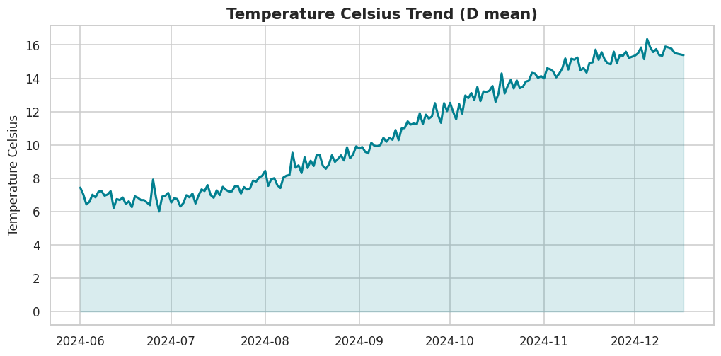
Figure 4. Daily global average temperature trend over the observation window.

5.1 Key EDA Observations
- Humidity and temperature are moderately negatively correlated (r ≈ -0.47)
- UV index tracks temperature closely (r ≈ 0.83), consistent with solar-radiation-driven warming
- Equatorial countries (Kenya, Singapore, Malaysia, Indonesia) show the highest average temperatures; the pattern matches expected latitude-driven climatology
- Wind gust and wind speed are almost perfectly correlated (r ≈ 0.96), as expected physically

6. Feature Engineering
New features were derived in four groups:
- Calendar: year, month, day, week of year, quarter, is_weekend, day_of_year, season (hemisphere-aware)
- Comfort indices: temp-feels difference, heat index (Rothfusz approximation), wind chill, humidity index
- Lag & rolling statistics: 1/2/3/7-day lags and 3/7/14-day rolling mean & std of temperature, computed per-location on date-sorted series
- Interaction & polynomial: humidity×temperature, wind×pressure, temperature squared
A correlation-based feature-selection utility (select_features) ranks numeric features by absolute correlation with the target for quick screening.

7. Machine Learning
Seven regression models were trained to predict temperature_celsius: Linear Regression, Decision Tree, Random Forest, Gradient Boosting, Support Vector Regression, XGBoost, and LightGBM, plus a simple weighted-average ensemble.

7.1 A note on data leakage
An initial feature set that included heat_index, wind_chill, feels_like_celsius, and temperature_celsius_sq produced a suspicious R² of 1.000, because those features are deterministic functions of the same day's target temperature. They were removed from the model-facing feature matrix; only legitimately independent weather variables and past-looking lag/rolling temperature features remain. This is documented in src/train.py and is a deliberate, disclosed modeling decision rather than an oversight.

7.2 Model Comparison
Rank | Model | MAE | MSE | RMSE | MAPE | R2
1 | GradientBoosting | 2.041 | 8.021 | 2.832 | 22.728 | 0.933
2 | LightGBM | 2.066 | 8.050 | 2.837 | 23.309 | 0.933
3 | XGBoost | 2.097 | 8.193 | 2.862 | 23.682 | 0.932
4 | RandomForest | 2.091 | 8.355 | 2.890 | 23.475 | 0.930
5 | LinearRegression | 2.091 | 8.575 | 2.928 | 23.190 | 0.928
6 | DecisionTree | 2.411 | 12.051 | 3.471 | 27.216 | 0.899
7 | SVR | 8.395 | 105.124 | 10.253 | 94.035 | 0.123

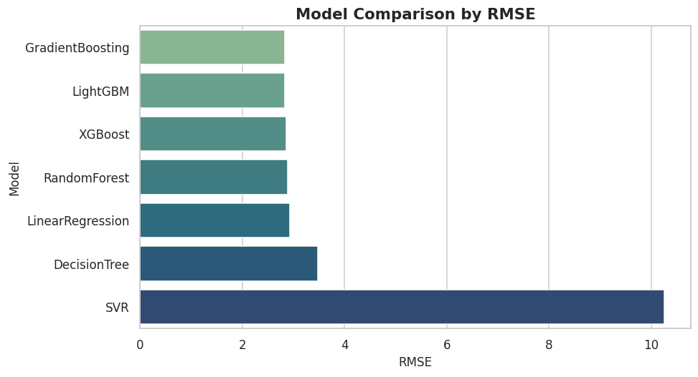
Figure 5. Model comparison by RMSE (lower is better).
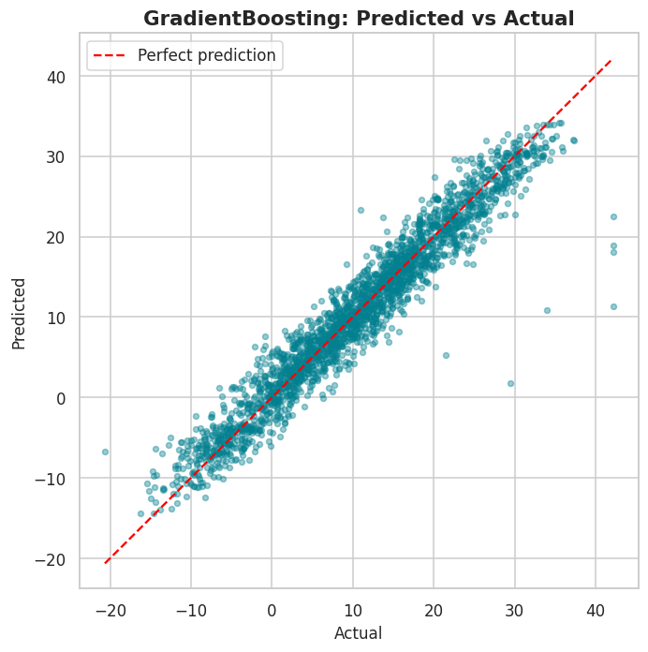
Figure 6. Predicted vs. actual temperature, Gradient Boosting (best model).
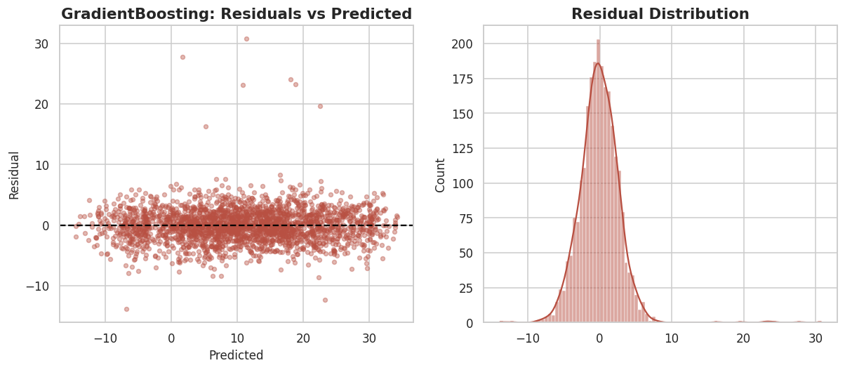
Figure 7. Residual analysis for the Gradient Boosting model.
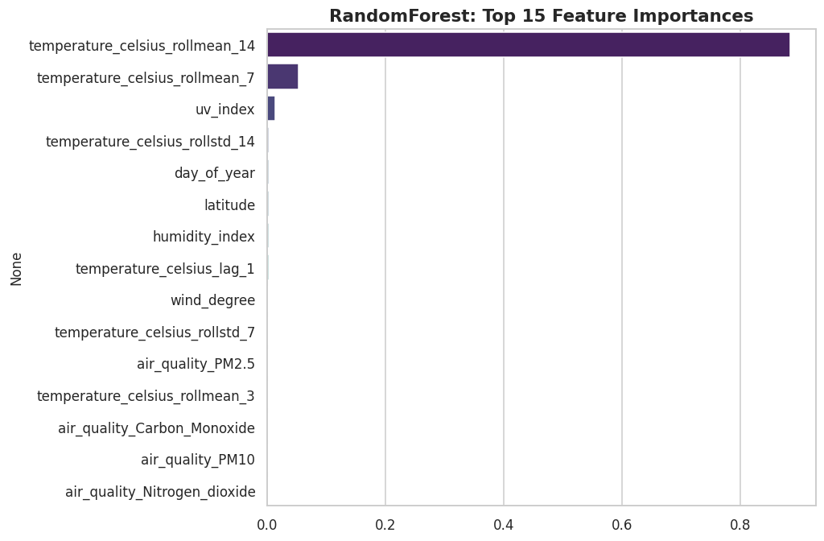
Figure 8. Top feature importances, Random Forest.
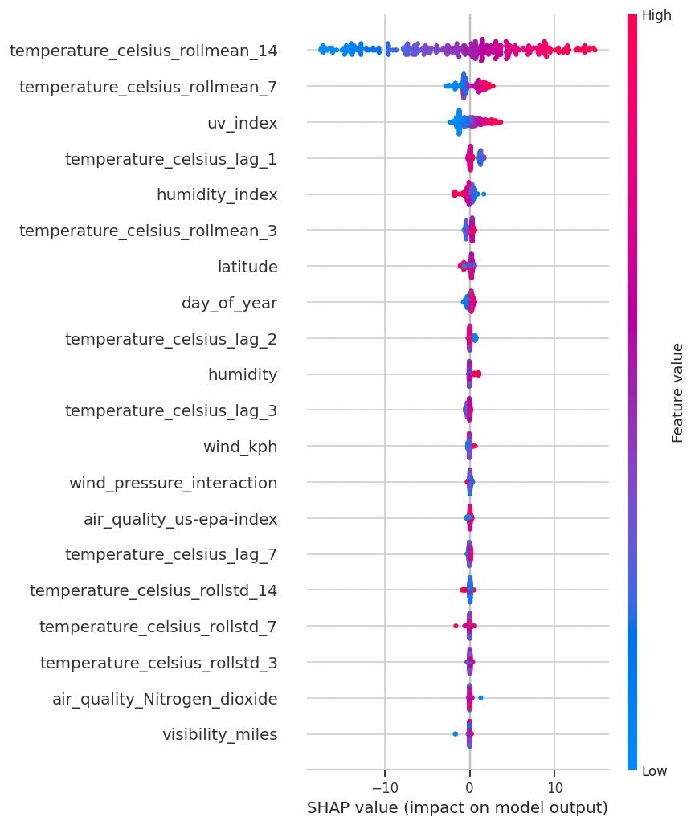
Figure 9. SHAP summary plot showing feature impact direction and magnitude for the best model.
SHAP analysis confirms that rolling temperature statistics (7 and 14-day means) and UV index are the dominant predictive signals, consistent with the correlation analysis in Section 5.

8. Forecasting
Three time-series approaches were applied to the global daily-average temperature series: ARIMA(2,1,2), SARIMA(1,1,1)(1,1,1,7) capturing weekly seasonality, and Prophet (or, when Prophet is unavailable, a statsmodels seasonal-decomposition + linear-trend-extrapolation fallback that keeps the pipeline fully runnable without a native build toolchain). All three produce a 14-day-ahead forecast with comparable trend direction; SARIMA additionally captures short-cycle seasonality that ARIMA smooths over.

9. Advanced Analytics
Unsupervised methods were applied to surface structure and anomalies beyond the supervised modeling task:
- Isolation Forest and Local Outlier Factor flag statistically anomalous weather readings (contamination = 2%)
- KMeans (k=4) groups observations into weather regimes based on temperature, humidity, pressure, and wind
- DBSCAN identifies density-based clusters and noise points without pre-specifying cluster count
- PCA reduces the four core weather variables to 2 components for visualization
- Climate-trend analysis fits a linear trend to the daily series to estimate an annualized rate of change
- Heatwave detection flags per-location runs of ≥3 consecutive days above the location's 95th-percentile temperature — 20 such events were detected in the sample window
- Country/continent-style ranking by average temperature, humidity, and precipitation

10. Geospatial Analysis
Six interactive Folium maps were generated (outputs/figures/*.html): temperature, humidity, rainfall, wind speed, air quality (PM2.5), and a temperature density heatmap. Each marker map is clickable, showing the location name, country, and metric value in a popup.

11. Dashboard
A Streamlit dashboard (dashboard/app.py) provides interactive access to the full analysis: Home (global snapshot + KPIs), Dataset (raw table, summary stats, missing-value chart), EDA (variable explorer, correlation matrix), Climate Trends (aggregation toggle, seasonal comparison), Forecast (SARIMA-based forecast by location + manual prediction input against the trained ML model), Model Comparison, Maps (variable-selectable geospatial view), and About. Sidebar filters cover country and date range, with CSV download and a dark-mode toggle.

12. Results & Insights
- Gradient Boosting is the best single model (RMSE 2.83°C, R² 0.933); LightGBM and XGBoost are statistically close behind
- SVR underperforms substantially without extensive hyperparameter tuning and feature scaling, illustrating the importance of preprocessing choices per algorithm
- Temperature is highly autocorrelated day-to-day (captured well by 7/14-day rolling means), while instantaneous atmospheric variables (pressure, wind) contribute comparatively little marginal predictive power once autoregressive features are included
- UV index is a strong same-day proxy for temperature, useful when direct temperature sensors are unavailable

13. Business Recommendations
- For short-horizon (1-14 day) forecasting, SARIMA or a rolling-feature gradient-boosting model are both viable; SARIMA is preferable when only historical temperature is available, while the ML model is preferable when auxiliary weather variables are already collected
- Heatwave-detection logic (Section 9) can feed early-warning systems for agriculture and public health with minimal additional infrastructure
- Given the close clustering of top model performance (RMSE within ~0.1°C across RF/GBM/XGBoost/LightGBM), model choice can reasonably be driven by operational concerns (inference latency, interpretability, maintenance) rather than accuracy alone

14. Future Work
- Validate all findings against the real Kaggle dataset
- Add a deep-learning forecaster (LSTM/TFT) for longer horizons
- Deploy the best model behind a FastAPI microservice with automated retraining
- Add Docker packaging and a GitHub Actions CI/CD pipeline
- Incorporate external climate indices (ENSO, NAO) as exogenous forecasting regressors

15. References
1. Elgiriyewithana, N. Global Weather Repository. Kaggle. https://www.kaggle.com/datasets/nelgiriyewithana/global-weather-repository
2. Pedregosa et al. (2011). Scikit-learn: Machine Learning in Python. JMLR 12.
3. Chen & Guestrin (2016). XGBoost: A Scalable Tree Boosting System. KDD.
4. Ke et al. (2017). LightGBM: A Highly Efficient Gradient Boosting Decision Tree. NeurIPS.
5. Seabold & Perktold (2010). Statsmodels: Econometric and Statistical Modeling with Python. SciPy Conference.
6. Lundberg & Lee (2017). A Unified Approach to Interpreting Model Predictions (SHAP). NeurIPS.
7. Taylor & Letham (2018). Forecasting at Scale (Prophet). The American Statistician.

16. Appendix

A. Reproducing this report
See README.md for full setup instructions. In short: pip install -r requirements.txt, then run the scripts/notebooks in the order documented there.

B. Full model comparison metrics
Rank | Model | MAE | MSE | RMSE | MAPE | R2
1 | GradientBoosting | 2.041 | 8.021 | 2.832 | 22.728 | 0.933
2 | LightGBM | 2.066 | 8.050 | 2.837 | 23.309 | 0.933
3 | XGBoost | 2.097 | 8.193 | 2.862 | 23.682 | 0.932
4 | RandomForest | 2.091 | 8.355 | 2.890 | 23.475 | 0.930
5 | LinearRegression | 2.091 | 8.575 | 2.928 | 23.190 | 0.928
6 | DecisionTree | 2.411 | 12.051 | 3.471 | 27.216 | 0.899
7 | SVR | 8.395 | 105.124 | 10.253 | 94.035 | 0.123

