JAYPEE INSTITUTE OF INFORMATION AND TECHNOLOGY



Algorithms & Problem Solving Lab **[**15B17CI471**] PROJECT**

**CAB POOLING SYSTEM FOR JIIT STUDENTS**

**SUBMITTED TO:**

**Dr. Hema N**

**and**

**Prof. Vivek Kumar Singh**

**SUBMITTED BY:**

**Saksham Saxena (20103241)**

**Prabudh Kumar (20103246)**

**Kritank Rishi Goyal(20103252)**

**Vasu Verma (20103299)**

**Chaitanya Yadav (20103309)**

**PROJECT REPORT**

# ACKNOWLEDGEMENT

We are highly obliged to our project guide Dr. Hema , for guiding and giving us timely advices and suggestions in successful completion of project work “**CAR POOLING SYSTEM FOR JIIT STUDENTS**”. We extend sincere thanks to her for her whole hearted support in completion of this project.

# INTRODUCTION

**AIM:** To provide a comprehensive solution for a cab pooling system.

As we all know, people have been relying on the ola and uber for many years to get expensive and often uncomfortable rides to even destinations just a few kilometers away!

Traditionally we have relied on a system which favors its own benefit over achieving maximum efficiency in car rides to common destinations.

This calls for a better design of a system wherein people can easily book a cab to common locations. Keeping this in mind we have extended this project help to all students of JIIT in the bid of providing safe and efficient rides.

"Cab pooling system" has been designed to overcome this problem.

# ABOUT THE PROJECT

The concept of carpooling is both environment and pocket friendly. But the question remains how to start carpooling. To start it off, you first need a group of people who are willing to take and offer rides. You can always make a group among your friends or colleagues to start carpooling on your way to the office or whichever destination you might want to travel to. However, managing such a group is a tedious task as it involves a lot of planning and the differences in time, route, distance makes it even more difficult to manage everything on your own.

This is where our project chips in. You can make use of “Cab pooling system for JIIT students” available for carpooling using which you can hitch a ride. In an ideal scenario, the system of such an Project matches the ride seeker with the ride giver within a few minutes. Real-time location tracking has also turned out to be of great use for carpooling. When you start carpooling on our Project, you can negotiate the price, customise routes and the people you travel with.

# PROJECT OBJECTIVES

. To create a Cab Pooling System that is user-friendly.

. The software is capable enough to allow the concerned person or group of persons to book and plan a route independently. The software allows interactive, self-describing Graphic User Interface environment where even standalone users can work very comfortably and easily.

. All the data pertaining to contact information is kept at central database from where it can be easily retrieved, viewed or updated. But, such kind of technical details are hidden from the standalone user. He just needs to select the relevant option from the given menu-driven interface. However, the central repository of data can be easily accessed if required.

. Data Redundancy is no more the problem now. The user input from one user will be matched with multiple users and max rides will be ensure. The software ensures that all routes are efficiently planned and costs are kept at a minimum.

. Effective search measures are present in the software from where by just entering a unique input-name or number for that data, its whole record can be readily accessed within microseconds. Moreover, facility of canceling the ride is also available in a given frame of time.

. The software provides the facility of calculating the amount charged and the most efficient way of producing change to the driver.

# ALGORITHM AND FUNCTIONS USED

## show_map(): To display the map of areas served.

## partition(), sort_time(): Quick Sort algorithm to sort the input data based on time.

## Time Complexity – O(n*logn)

## find_shortest_dest(): Recursive algorithm to find shortest distance between destinations.

## route_cab1(), route_cab2(): Print the path traversed by Cab1 & Cab2, respectively while serving their users.

## countMinCoins(): DP algorithm to find the minimum number of notes to pay the incurred cost.

## den_comb(), count_den(): Backtracking algorithm to find the minimum combinations of notes required to pay given incurred cost.

## Time Complexity – O (Cost*No. of different available notes)

## cost(): To find the cost incurred by each user.

## dest_grouping(): To group the destinations on the basis of area served by cab1 & cab2, respectively.

## time_grouping(): To make rounds for cab1 & cab2.

## main(): Driver program.

# OUTPUT SCREENSHOTS

# Starting Screen

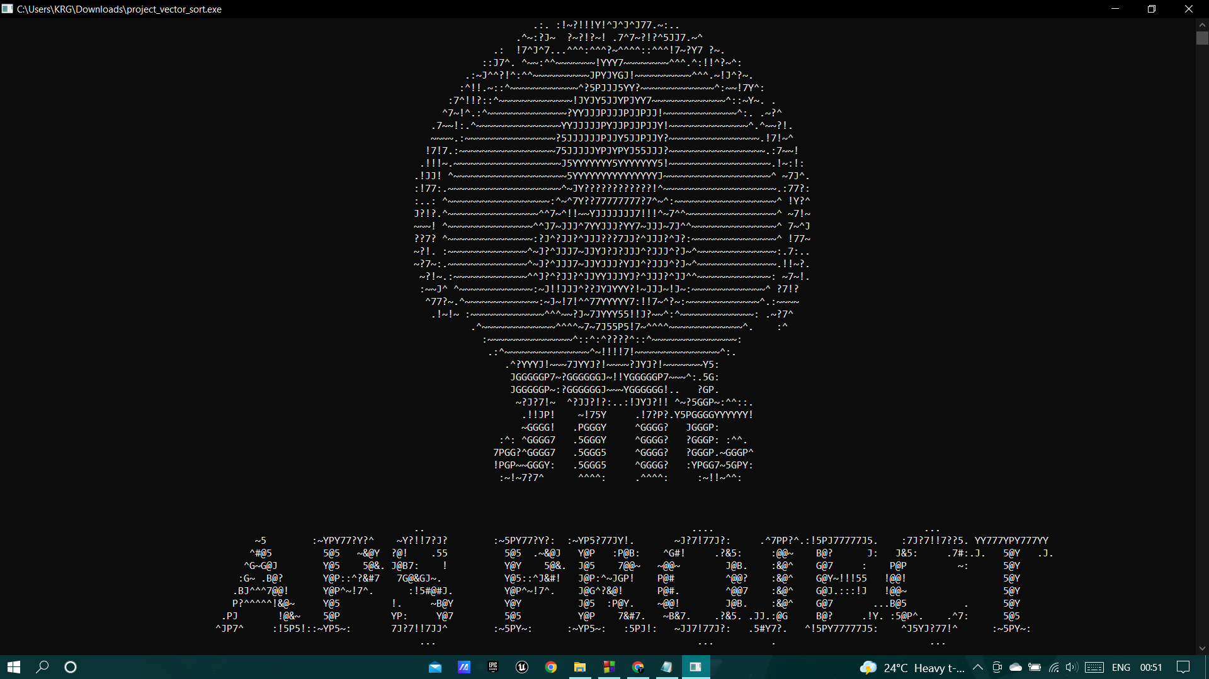

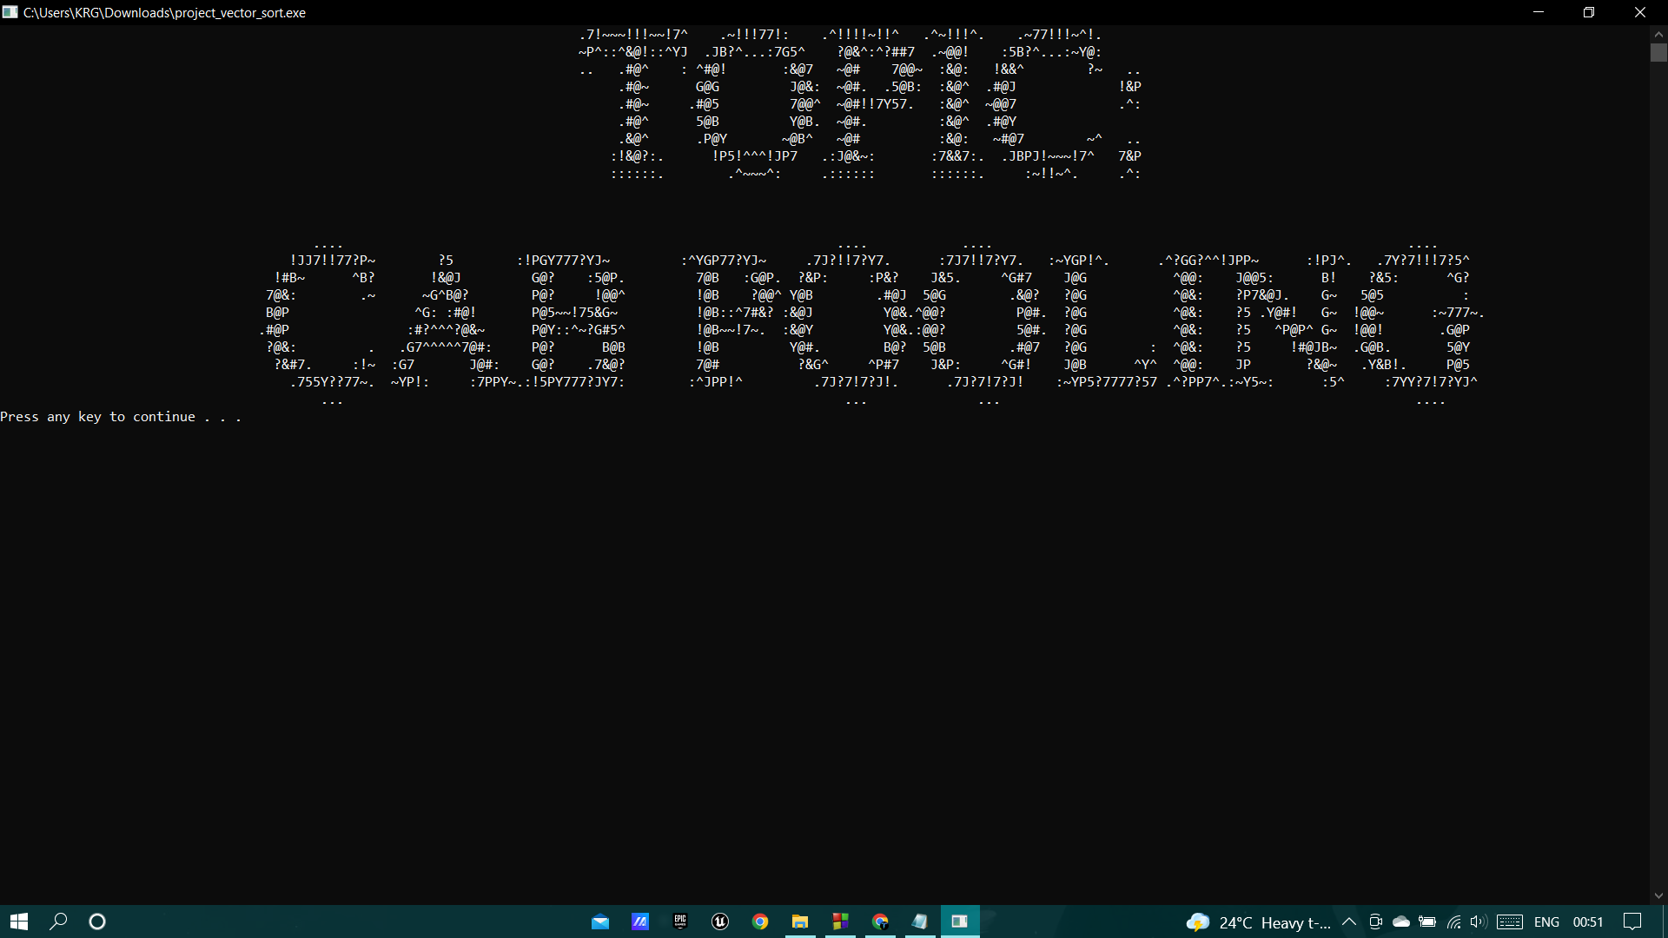

1. **Taking Inputs from Users**

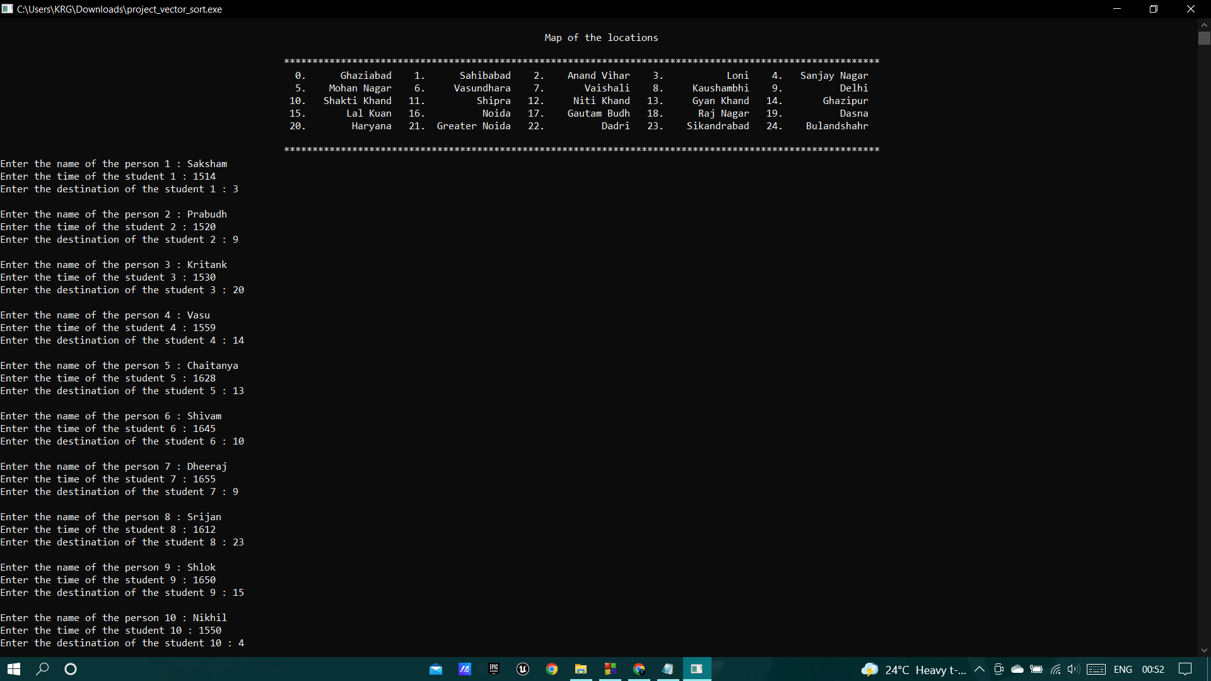

1. **Displaying Users Served in Different Rounds Along With Cost Incurred by Each User**

**ROUND 1:**

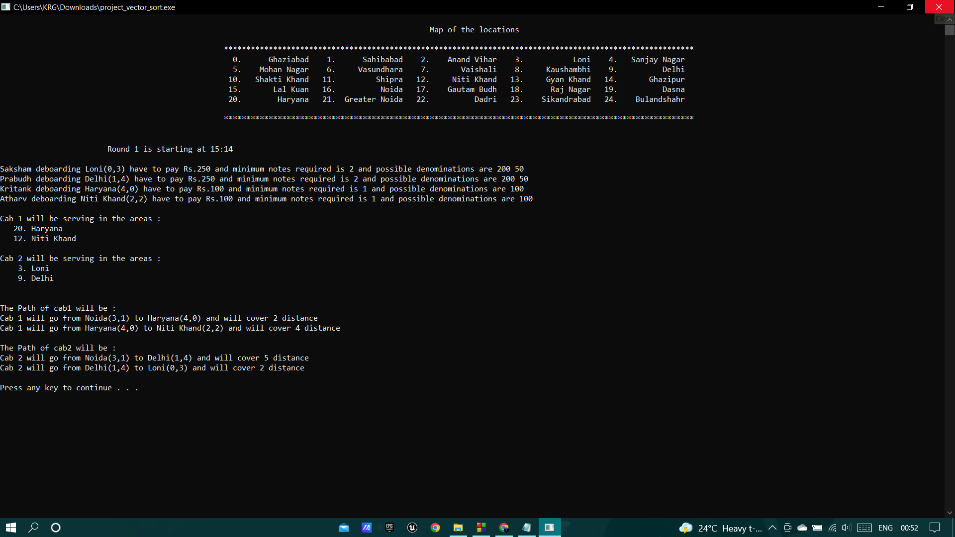

**ROUND 2:**

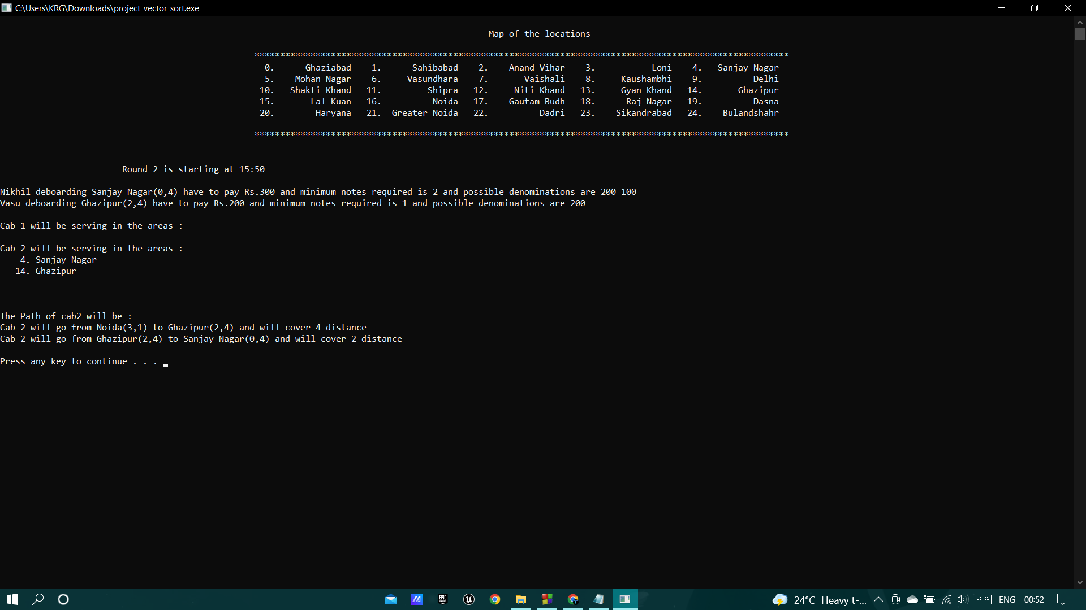

**ROUND 3:**

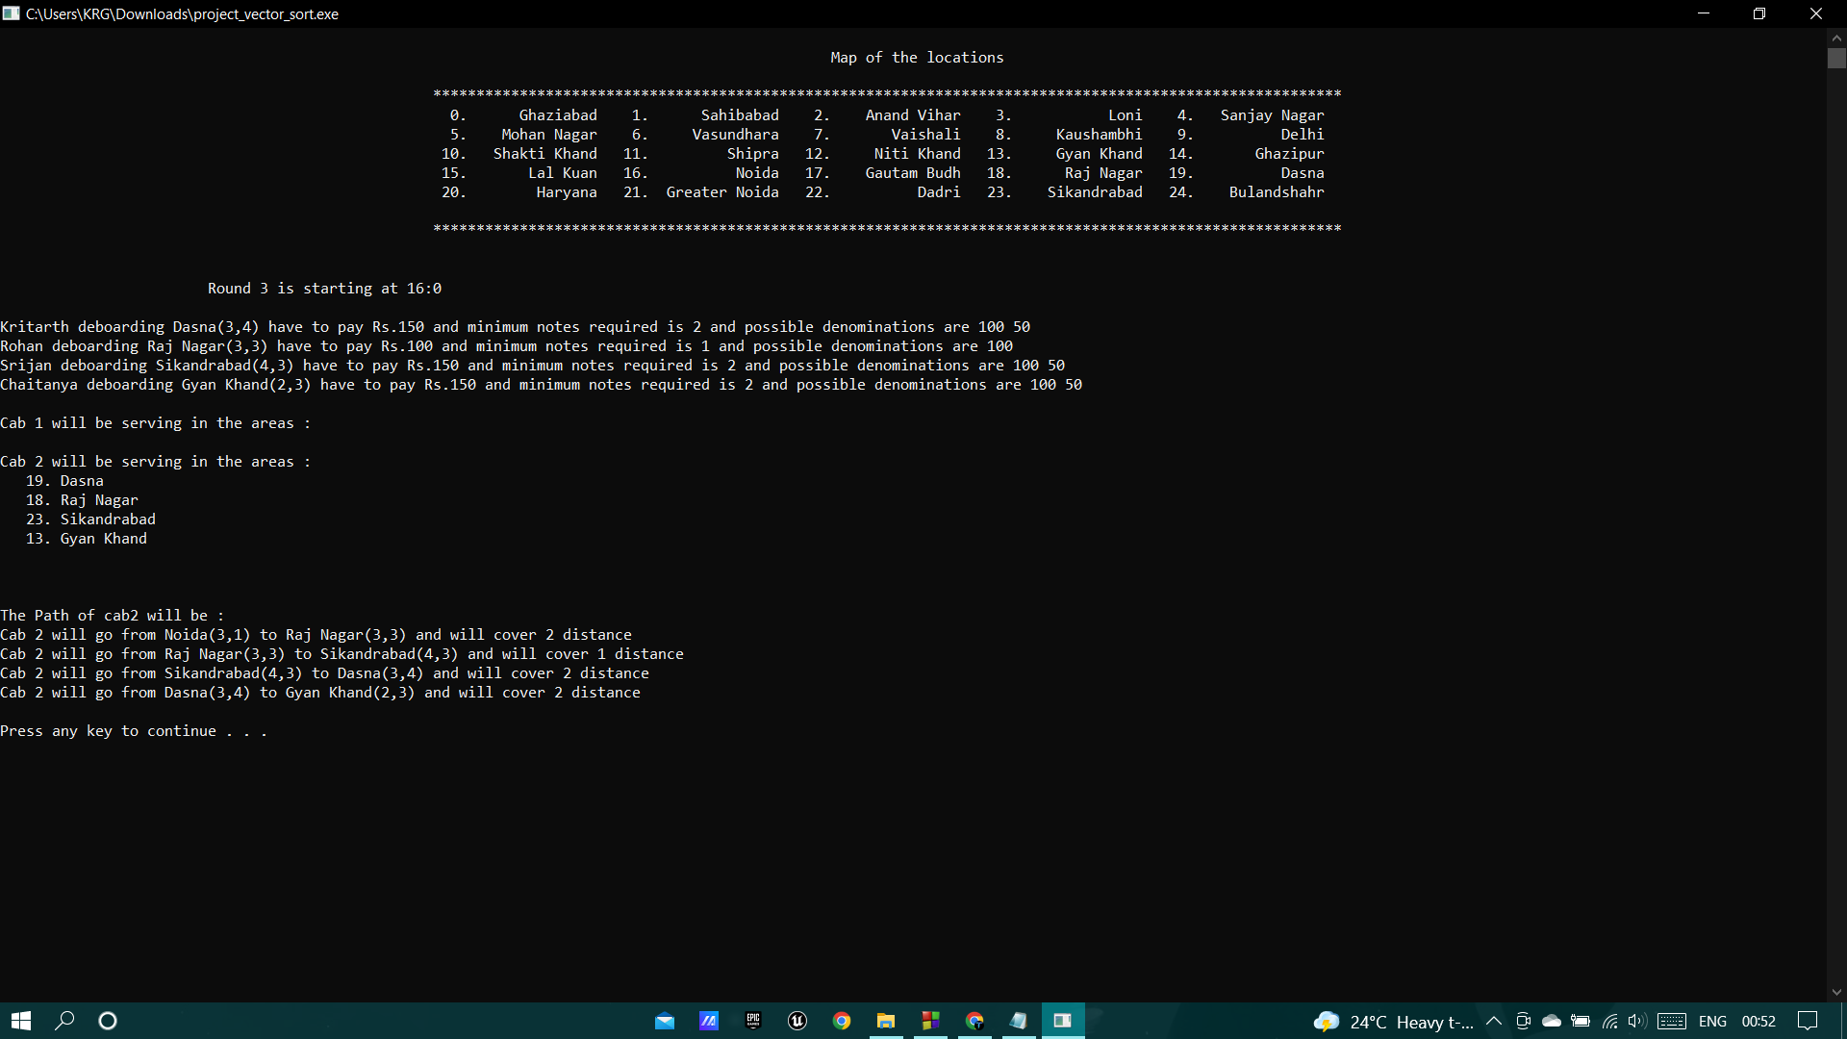

**ROUND 4:**

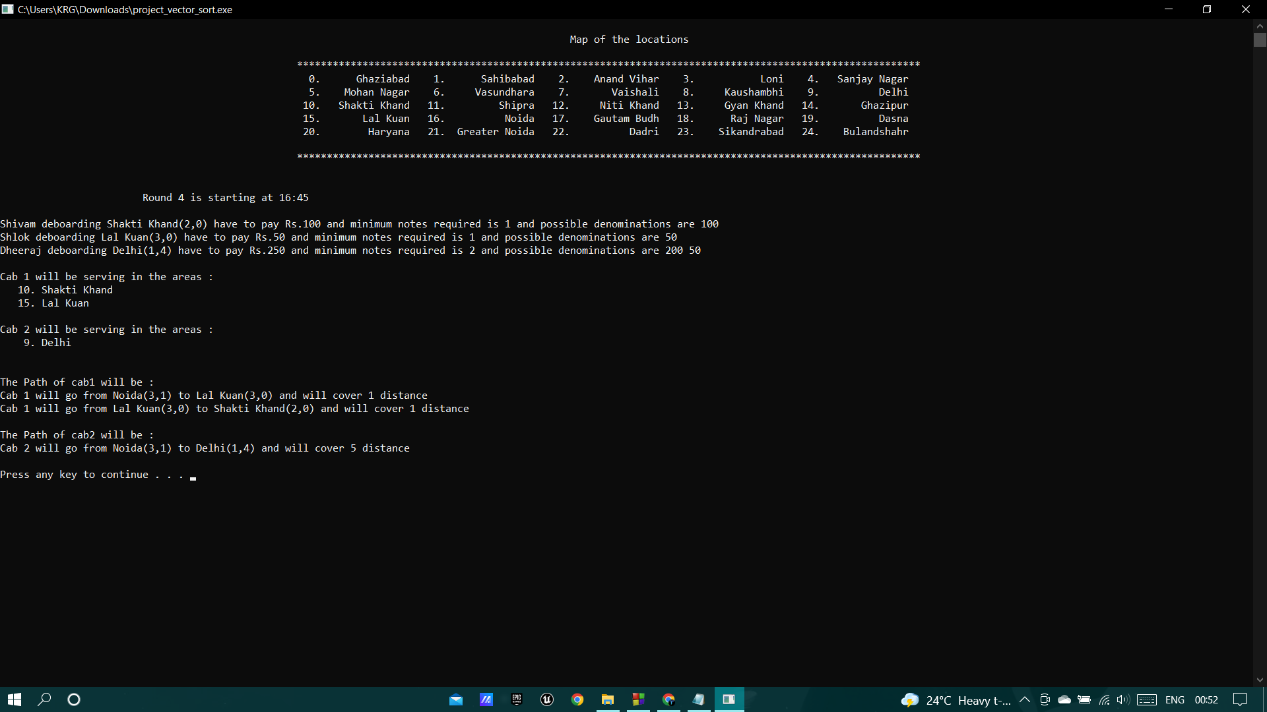

**ROUND 5:**

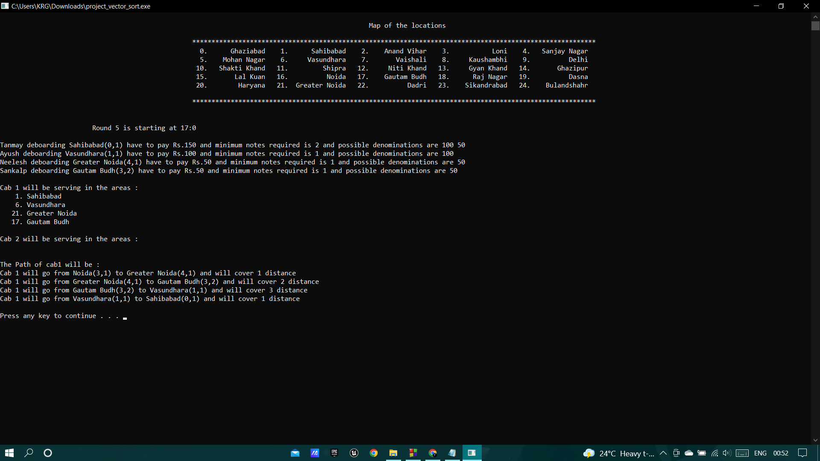

**ROUND 6 (LAST ROUND):**

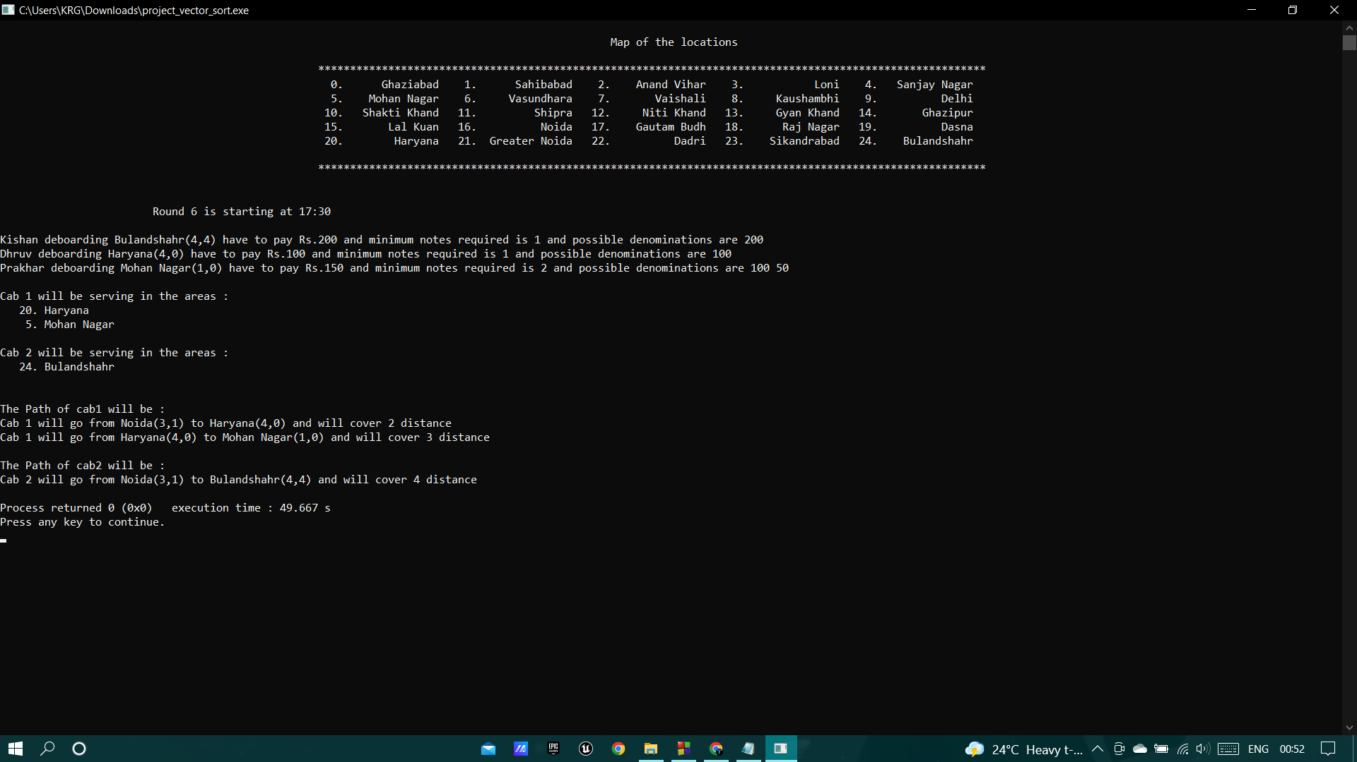

1. **Error Generating Input**

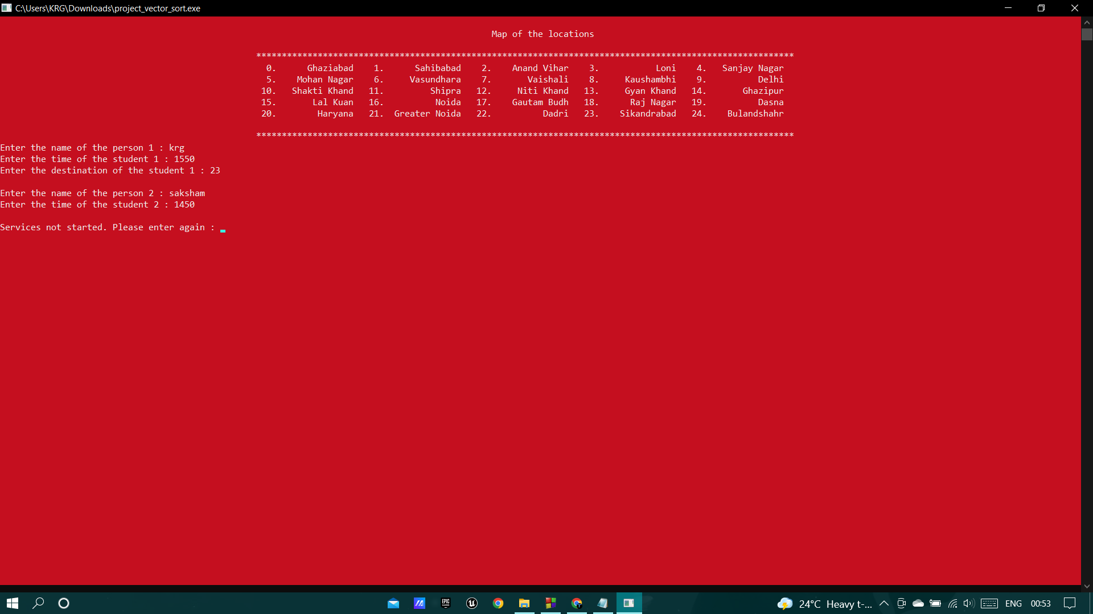

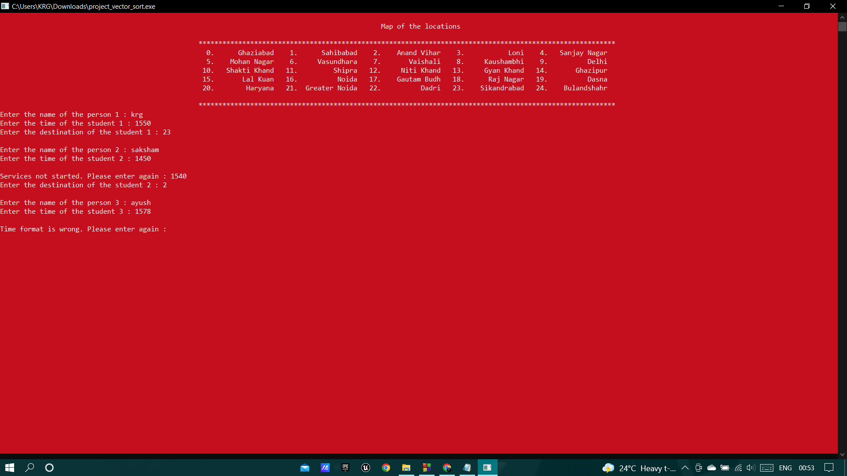

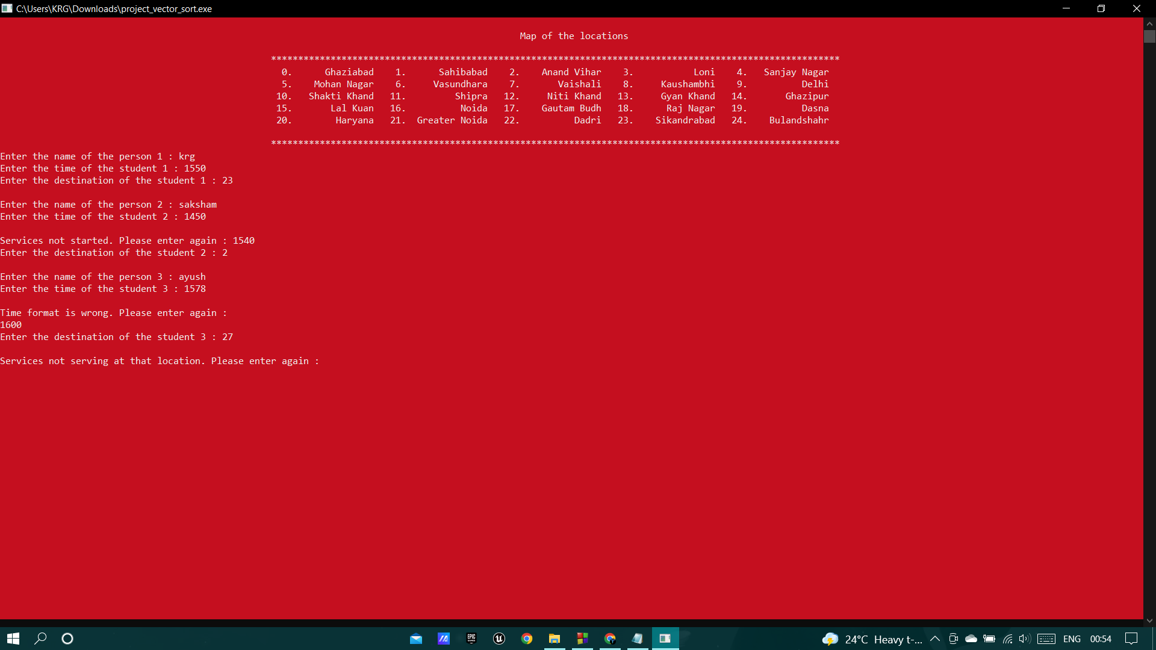

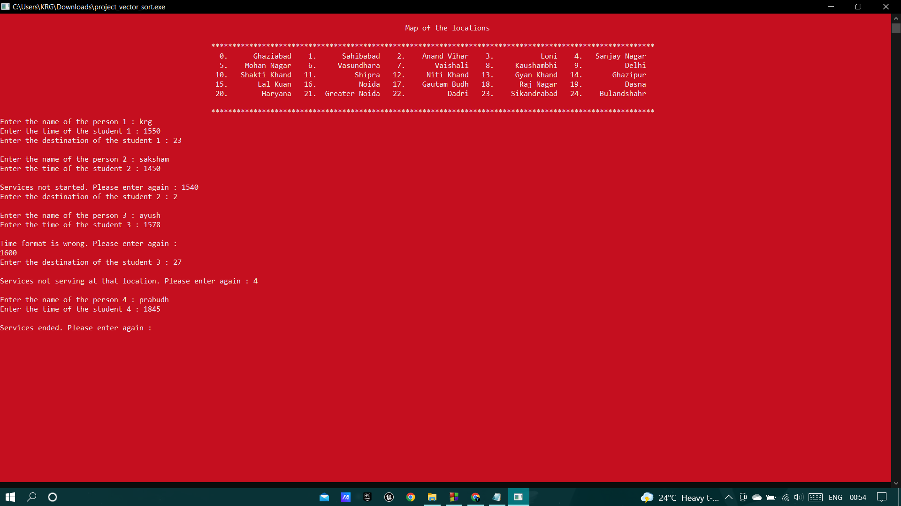

# CONCLUSION

The application program has been successfully implemented using experimental cases and the language used is C++. This application works for other functions that make it easy to search for cabs on common routes and saves a lot of time for JIIT students on long routes. This project on CAR POOLING application in C++ helped us as a reference project to understand algorithm and functions.