|  |  |  |
| --- | --- | --- |
| Series : QQCRR/2 |  | SET-I |

 31/2/1

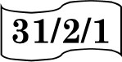Roll No.

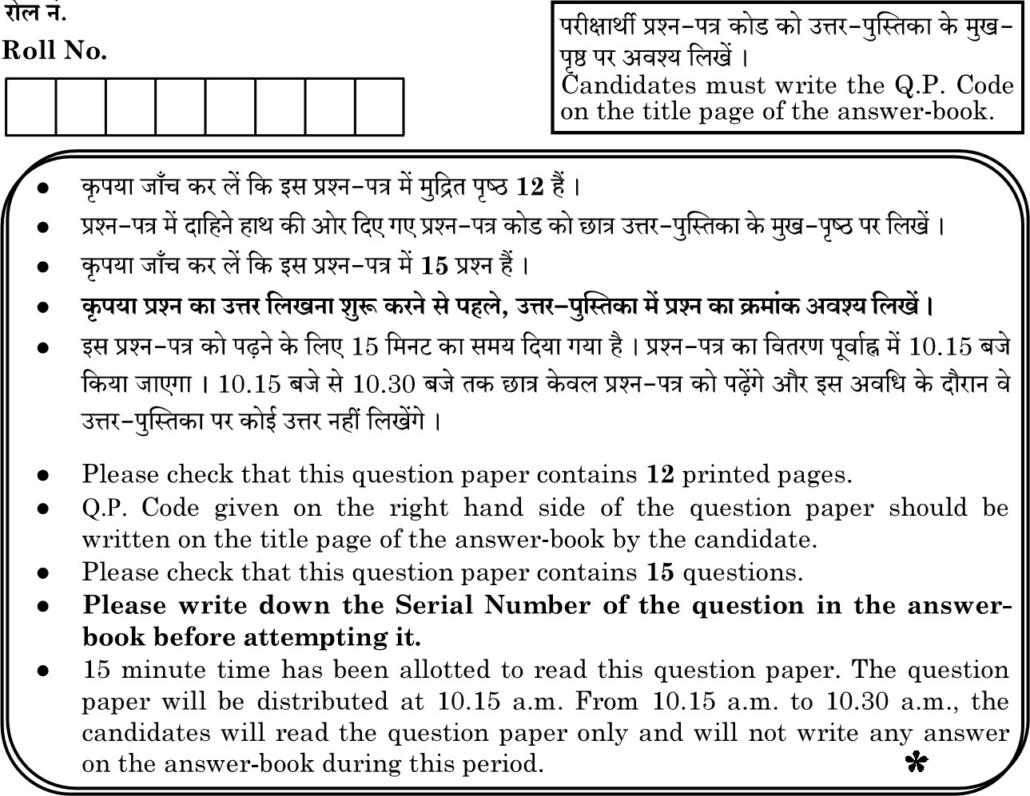

Q.P.

Code



General Instructions :

Q1. "Carbon prefers to share its valence electrons with other atoms of carbon or with atoms of other elements rather than gaining or losing the valence electrons in order to attain noble gas configuration." Give reasons to justify this statement.

Q2. The atomic number of an element ‘X’ is 11.

* 1. Write the electronic configurations of X and find its valency.
  2. Write the formula and nature of its oxide.

Q3. Give reasons:

* 1. Placenta is extremely essential for foetal development.
  2. Uterine lining becomes thick and spongy after fertilisation.

Q4. (a) Name the reproductive and non-reproductive parts of bread mould (Rhizopus).

(b) List any two advantages of vegetative propagation.

Q5. Name the reproductive parts of an angiosperm. Where are these parts located ? Explain the structure of its male reproductive part. 2

## OR

What is puberty? Mention any two changes that are common to both boys and girls in early teenage years.

Q6. (a) Name the poles P, Q, R and S of the magnets in the following figures a' and 'b' (b) State the inference drawn about the direction of the magnetic field lines on the basis of these diagrams.

## OR

When is the force experienced by a current carrying straight conductor placed in a uniform magnetic field.

1. Maximum ;
2. Minimum ?

Q7. In the following food chain, only 2J of energy was available to the peacocks. How much energy would have been present in Grass ? Justify your answer. 2 GRASS -9 GRASS HOPPER -+ FROG -+ SNAKE -+ PEACOCK OR

* 1. What is meant by garbage ? List two classes into which garbage is classified.
  2. What do we actually mean when we say that the "enzymes are specific in Q8. (a) State Newland Law of Octaves.
  3. With an example, explain Dobereiner’s Triads.
  4. List one limitation each of both the attempts mentioned in 'a' & 'b'.

Q8. (a) State Newland Law of Octaves.

* 1. With an example, explain Dobereinefs Triads.
  2. List one limitation each of both the attempts mentioned in 'a' & 'b'.

Q9. Consider the following organic compounds

* 1. Name the functional group present in then• compounds.
  2. Write the general formula for the compounds of this functional group.
  3. State the relationship between these compounds and draw the structure of any other compound having similar functional group.

## OR

1. Draw the electron dot structure for ethyne.
2. List two differences between the properties exhibited by covalent compounds and ionic compounds.

Q10. (a) Name the two types of gametes produced by men.

* + 1. Does a male child inherit X chromosome from his father? Justify.
    2. How many types of gametes are produced by a human female?

Q11. (a) State Ohm's Law. Represent it mathematically.

(b) Define 1 ohm.

(c) What is the resistance of a conductor through which a current of

0.5 A flows when a potential difference Of 2 V is applied across its ends ?

Q12. (a) List the factors on which the resistance Of a uniform cylindrical conductor of a given material depends.

(b) The resistance of a wire of 0.01 cm radius is 10 Q. If the resistivity of the wire is 50 x 10-8 Q m, find the length of this wire.

## OR

1. What is the meaning of electric power of an electrical device ? Write its SI unit.
2. An electric kettle of 2kW is used for 2h. Calculate the energy consumed in
   1. kilowatt hour and
   2. joules.

Q13. (a) We do not clean ponds or lakes, but an aquarium needs to be cleaned regularly.Why?

(b) Why is ozone layer getting depleted at the higher levels of the atmosphere? Mention one harmful effect caused by its depletion.

Q14. Mendel blended his knowledge of Science and mathematics to keep the count of the individuals exhibiting a particular trait in each generation. He observed a number of contrasting visible characters controlled in pea plants in a field. He conducted many experiments to arrive at the laws of inheritance.

1. What do the Fl progeny of tall plants with round seeds and short plants with wrinkled seeds look like ?
2. Name the recessive traits in above case.
3. Mention the type of the new combinations of plants obtained in F2 progeny along with their ratio, if Fl progeny was allowed to self pollinate.

If 1600 plants were obtained in F2 progeny, write the number of plants having traits :

1. Tall with round seeds
2. Short with wrinkled seeds

Write the conclusion of the above experiment.

Q15. A student was asked to perform an experiment to study the force on a current carrying conductor in a magnetic field. He took a small aluminum rod AB, a strong horse shoe magnet, some connecting wires, a battery and a switch and connected them as shown. He observed that on passing current, the rod gets displaced. On reversing the direction of current, the direction of displacement also gets reversed. On the basis of your understanding of this phenomenon, answer the following questions :

1. Why does the rod get displaced on passing current through it ?
2. State the rule that determines the direction of the force on the conductor AB.
3. If the U shaped magnet is held vertically and the aluminum rod is suspended horizontally with its end B towards due north, then on passing current through the rod from B to A as shown, in which direction will the rod be displaced ?

(ii) Name any two devices that use current carrying conductors and magnetic field.

## OR

Draw the pattern of magnetic field lines produced around a current carrying straight conductor held vertically on a horizontal cardboard. Indicate the direction of the field lines as well as the direction of current flowing through the conductor.