RESUME

S. PRASATH, M.Sc.(Agri.),  S/O C. SIVAJI,  Door no-235, Ward-20, L.F. Road (karumettu patty),  Gudalur-625518  Theni- dist  Tamil Nadu, India.  Mobile :+91 8148568233  Email ID: prasath916@gmail.com | 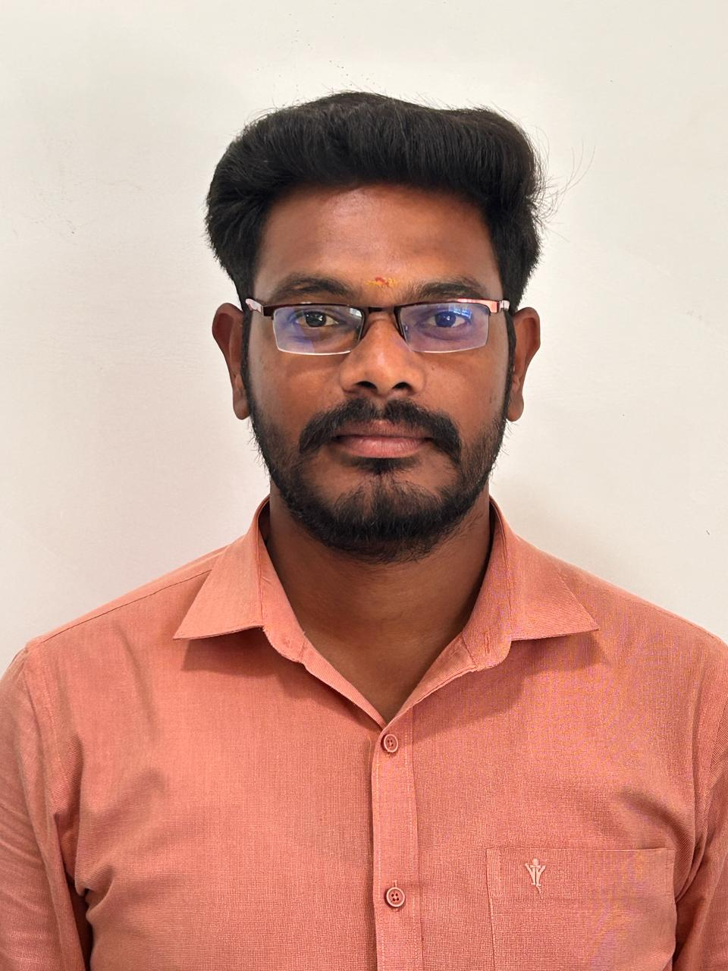

CAREER OBJECTIVE
Quest to work in a professional environment where I will extend my technical, interpersonal and organizational skills of an affable leader, motivator and agile team worker which will improve the growth of the organization..
Academic Qualification
Qualification | Name of the Institution | Percentage of Marks | Year of completion
M.Sc.,(Agri.)  (SS & AC) | Annamalai University, Chidambaram. | 87.70% | 2016
B.Sc., (Agri.) | Adhiparasakthi Agriculture and Horticulture college, Kalavai | 75.10% | 2014
HSC | N.S.K.P. Hr. Sec. School, Gudalur | 77.16% | 2010
SSLC | Thiruvalluvar High School, Gudalur | 76.40% | 2008

Research
- B.Sc. (Ag) – A study on the efficacy of foliar nutrition on growth and yield of blackgram.
- M.Sc. (Ag)  A Study on the influence of phosphorus and sulphur on soil properties, yield and quality of brinjal (cv. Annamalai)
AWARDS
- The Dr. R. Govindasamy Prize for securing the first mark in the subject Soil Classification & Taxonomy of the M.Sc (Ag.) Soil Science & Agricultural Chemistry Degree Examinations - 2016
- The Swamins Prize for securing the first mark in the M.Sc (Ag.) Soil Science & Agricultural Chemistry Degree Examinations - 2016
- The Srilochani Varadarajulu Prize for securing the first mark in the M.Sc (Ag.) Soil Science & Agricultural Chemistry Degree Examinations - 2016
- The Vallalar Endowment cash award for academic performance 2014 to 2015 by the Government of Tamil Nadu.
TEACHING EXPERIENCE

- Working as an Assistant professor (Department of Soil Science & Agricultural Chemistry) and Warden in Krishna college of Agriculture and Technology since 02.8.2016 to till date ( 8 years and 8 months)

Research Convention Participated
- ICP-OES: A Novel Technique for Elemental Analysis Organized by Department of Soils And Environment, Agricultural College and Research Institute, Madurai
- National seminar on recent trends in plant growth regulators and nutrient management in agricultural and horticultural crops
Research guidance: 14 students in Undergraduate programme
2023 | Standardization of seed rate and time of harvest fro maize under hydroponic fodder production

2024 | An experimental study on the Chemical Properties of Vermicompost and growth of Earthworm in available crop residues and cowdung at KRISAT

Publications
Authors | Year | Title | Details of Journals,  Symposia, Workshop, Training etc.
Gh.[hd;rd; lh.n[gg;;gphpj;jh kw;Wk; rp. gpurhj; | 2018 | mwptpay; jkpopy; Ntshz;ik | GhGGwehDw;wpy; coTj;njhopYk; mwptpay;jkpopy; Ntshz;ikMa;T fl;Liufs; nrg;lk;gh; 2018 gf;fk; 355-358
(ii) Popular Articles /Leaflets
Authors | Year | Title | Details of publication
rp. gpurhj; | 2019 | fopT ePh; Nkyhz;ik | ekJ mwptpay;
S.Prasad , J.S.Navaneetha | 2022 | Effect of salt on soil | Kissan world
Research Article
S.Prasath,K.Anupriya, S.Harresh Balan, S.Keerthana, N.Nagasakthi, M Nandhini and M Priyadharshini. 2024. An experimental study on the Biological Properties of Vermicompost and Growth of Earthworm in avialable crop residues and cowdung at KRISAT. Farm chtonicle -An Agriculture Newsletter .03(09),32-35. (e-ISSN: 2583-732X)
S.Prasath,K.Anupriya, S.Harresh Balan, S.Keerthana, N.Nagasakthi, M Nandhini and M Priyadharshini. 2024. An experimental study on the Chemical Properties of Vermicompost and growth of Earthworm in avialable crop residues and cowdung at KRISAT. Farm chtonicle -An Agriculture Newsletter .03(09),36-40 (e-ISSN: 2583-732X)
Book
New Technology in Agriculture and horticulture.2023.S.Thangapazham Agriculture College. ISBN 978- 81-961520-1-7

Extension

- Training programmes organized

Sl. No. | Name of the Training Programme | Duration with dates | Place | Leader / Associate
1. | ATMA- Rainfed black gram cultivation | One day | Viruveedu | Leader
2. | Vermicompost production technices | One day | Usilampatti | Leader
3. | INM in maize cultivation | One day | Sedapatti | Leader
4. | Capacity building – Mushroom cultivation, Azolla cultivation, Vermi cultivation -58 farmers | one day  17.07.19 | KRISAT | Leader
5. | ATMA – Exposure visit on Rainfed technologies – Usilampatti block  52 farmers | One day  29.6.2018 | KRISAT | Associate
6. | ATMA – Exposure visit on Rainfed technologies – Kallikudi block  32 farmers | One day  06.07.2018 | KRISAT | Leader
7. | SSEPERS- ATMA- Exposure visit on Integrated farming system - Usilampatti block – 28 farmers | one day  20.11.2018 | KRISAT | Leader
8. | Capacity building – Mushroom cultivation, Azolla cultivation, Vermi cultivation -58 farmers | one day  17.07.19 | KRISAT | Associate
9. | Dry land farming system | One day | KRISAT | Associate

b. Development of Video/Radio programmes on technologies developed by self (Nos.)

 | Title of Video/Radio Programme | Leader/Co-Leader | Period
 | Environment Pollution | Speaker | 1 Hr
 | Preparation of Vermicomposting and its advantages in farming | Speaker | 1 Hr
Fields of Interest
- Soil Science
- Research and development
- Having well knowledge in Soil, plant and water sample testing.
- All agricultural work
Extracurricular activities:
- Kabbadi winner
- NCC C and B certificate

Hobbies
- Swimming, Listening Music
- Playing Cricket & Kabaddi.

Strength & Skills
- Positive mental attitude.
- Perseverance, Patience and Self-confidence.
- Time management skills.
- Friendly nature.
- Sincere and understanding body language.
- Independent and self-motivated.
- Good team man.
- Honest and Hard Worker with a high level of Integrity.

PERSONAL PROFILE
Name : S. PRASATH
Date of birth : 03.06.1993
Sex : Male
Educational qualification : M. Sc., Agri. (Soil Science & Agricultural Chemistry)
Father’s name : Mr.C.Sivaji
Nationality : Indian
Marital status : Married
Mother tongue : Tamil
Languages known : Tamil and English-To Read, Write and Speak

Declaration

I hereby declare that all the information furnished above is true to the best of my knowledge.
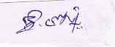
Date: 08.04.2025 Signature of the candidate
Place: Gudalur (S. PRASATH)

