Spark Distributed Inference
How work is distributed across workers in every execution mode (RDD CPU / GPU / hybrid, GPU-aware scheduling, pandas UDF, predict_batch_udf, Triton), worker- and task-level statistics, and the recommended architecture with Triton Inference Server in front of the cluster
Measured on a 2-node AWS cluster (m5.2xlarge CPU node + g4dn.xlarge T4 GPU node), 26 September 2026 · pytorch-spark-inference-platform
1. Executive summary 3
1.1 Where the time goes in the DataFrame-based modes 3
2. Test cluster and method 5
2.1 Workloads 6
2.2 Method 6
2.3 Reading the statistics 6
3. How Spark distributes inference across workers 7
4. RDD mapPartitions: rdd_cpu, rdd_gpu, rdd_hybrid 8
4.1 rdd_cpu - statistics 8
4.2 rdd_gpu - statistics 9
4.3 rdd_hybrid - statistics 9
4.4 Where each partition ran (from the tasks' own reports) 10
4.5 Executors and task timeline - rdd_hybrid 11
5. GPU-aware scheduling: rdd_gpu_aware 13
5.1 rdd_gpu_aware - statistics 13
6. pandas UDF - the repo's predict_batch_udf: udf_cpu, udf_gpu 16
6.1 udf_cpu - statistics 16
6.2 udf_gpu - statistics 17
6.3 Executors and task timeline - udf_gpu 17
7. Spark's built-in predict_batch_udf: native_pbu_cpu, native_pbu_gpu 19
7.1 native_pbu_cpu - statistics 19
7.2 native_pbu_gpu - statistics 20
8. predict_batch_udf -> Triton: triton_pbu 22
8.1 triton_pbu - Spark-side statistics 22
8.2 Triton-side statistics (from :8002 metrics, delta over the job) 23
8.3 Model configuration used 23
9. The platform's 10-model workload: platform10_cpu / _gpu / _hybrid 26
9.1 Partition scaling on one executor (single-node T4 run) 27
9.2 Anatomy of a task (single-node T4 run, 10 models, rdd_gpu) 27
10. All modes side by side 28
11. Findings in the current platform (with fixes) 34
12. Recommended architecture: Triton in front of the cluster 35
12.1 Principles 35
12.2 Components 36
12.3 Spark integration 36
12.4 Capacity planning from the measurements 37
12.5 Deployment on AWS 38
12.6 Air-gapped deployment 39
12.7 Migration plan 39
12.8 Risks and mitigations 40
13. Alternative architectures 41
13.1 Triton sidecar on every GPU worker 41
13.2 Keep in-process inference, fix its overheads 42
13.3 Ray Data + Ray Serve 42
13.4 Kubernetes: Spark on K8s + KServe (Triton runtime) 43
13.5 Asynchronous, queue-driven inference 44
13.6 Comparison 44
Appendix A - task timelines for every run 45
Appendix B - files and how to reproduce 56

1. Executive summary
- Where tasks land: with plain scheduling the 8 resnet18 tasks of rdd_hybrid split 4 on the CPU node / 4 on the GPU node - whichever slot frees first takes the next task. In rdd_gpu (gpu_only) 6 of 8 partitions landed on the CPU node and silently ran on CPU. With GPU-aware scheduling (rdd_gpu_aware) all 8 tasks ran on the GPU executor.
- The first GPU application on a node pays a warm-up: GPU partitions of resnet18 spent 14.1 s in inference in rdd_gpu (the first CUDA/cuDNN convolution run on the node) but 0.12 s in the next application (rdd_hybrid); the 10-model run shows the same (10.0 s vs 0.28 s). That is why rdd_gpu (12/s) looks slower than rdd_cpu (24/s). Long-lived GPU processes (a model server) pay it once.
- End to end, the RDD engine is fastest at these data sizes: resnet18 rdd_hybrid 29.0/s, ew_classifier rdd_hybrid 20,300/s. The DataFrame-based modes (pandas UDF, native predict_batch_udf, Triton) first spend 17.8 s (resnet18) / 9.7 s (ew_classifier) on the driver turning numpy arrays into Python lists and shipping them, then 9.1 s / 3.5 s in the repartition shuffle - before any model runs.
- Inside the inference stage, Triton is fastest: resnet18: triton_pbu 3.07 s vs native_pbu_gpu 6.95 s, udf_gpu 7.00 s, udf_cpu 9.26 s (2.3x faster than in-process GPU); ew_classifier: 3.82 s vs 4.31 s / 3.95 s / 22.72 s. With Triton, executors on the CPU node drive the GPU too and no task builds a model.
- Model loads: RDD engine 8 loads for 8 tasks (once per task, although its docstring says once per executor); Spark's built-in predict_batch_udf and the Triton client 4 for 16 tasks (once per Python worker, then cached).
- The GPU is idle most of the time: average SM utilisation during any run was at most 6.1 % (peak 28 %). These jobs are bound by Python/JVM overhead, data movement and warm-up - not by the T4.
- Triton batching: ew_classifier: 104 requests became 97 GPU executions (avg batch 1,031, queue 6.4 ms, compute 30.7 ms); resnet18: 8 -> 7 (avg 36.6 images). Only 4 concurrent Spark clients sending near-full batches leave little to merge; online traffic and more executors would.
- Recommendation: Triton Inference Server as the shared GPU tier (models resident and warm, batching across all callers, online + batch), Spark executors as lean CPU-only clients through pyspark.ml.functions.predict_batch_udf, and - the precondition measured here - columnar ingestion (Parquet/Arrow read by the executors) instead of driver-side Python lists, which today costs more than the inference itself. Use GPU-aware scheduling for anything that must stay in-process. Sections 12-13.
model | rdd_cpu | rdd_gpu | rdd_hybrid | rdd_gpu_aware | udf_cpu | udf_gpu | native_pbu_cpu | native_pbu_gpu | triton_pbu
ew_classifier | 19,398/s | 14,614/s | 20,300/s | 16,879/s | 2,806/s | 5,859/s | 5,311/s | 5,743/s | 5,864/s
resnet18 | 24/s | 12/s | 29/s | 28/s | 7/s | 7/s | 7/s | 8/s | 9/s

Throughput = samples processed / wall time of the Spark job (including data ingestion, scheduling, model loading and result collection) - what a user of each mode actually experiences end to end.

1.1 Where the time goes in the DataFrame-based modes
model | mode | wall s | driver ingestion s (wall - jobs) | shuffle stage s | inference stage s | model loads
ew_classifier | udf_cpu | 35.6 | 9.8 | 3.14 | 22.72 | per task
ew_classifier | udf_gpu | 17.1 | 9.7 | 3.41 | 3.95 | per task
ew_classifier | native_pbu_cpu | 18.8 | 9.8 | 3.27 | 5.77 | 4
ew_classifier | native_pbu_gpu | 17.4 | 9.7 | 3.38 | 4.31 | 4
ew_classifier | triton_pbu | 17.1 | 9.7 | 3.49 | 3.82 | 4
resnet18 | udf_cpu | 37.1 | 19.1 | 8.72 | 9.26 | per task
resnet18 | udf_gpu | 34.5 | 18.7 | 8.76 | 7.00 | per task
resnet18 | native_pbu_cpu | 35.3 | 18.3 | 8.83 | 8.14 | 4
resnet18 | native_pbu_gpu | 34.0 | 18.2 | 8.83 | 6.95 | 4
resnet18 | triton_pbu | 30.0 | 17.8 | 9.09 | 3.07 | 4

2. Test cluster and method
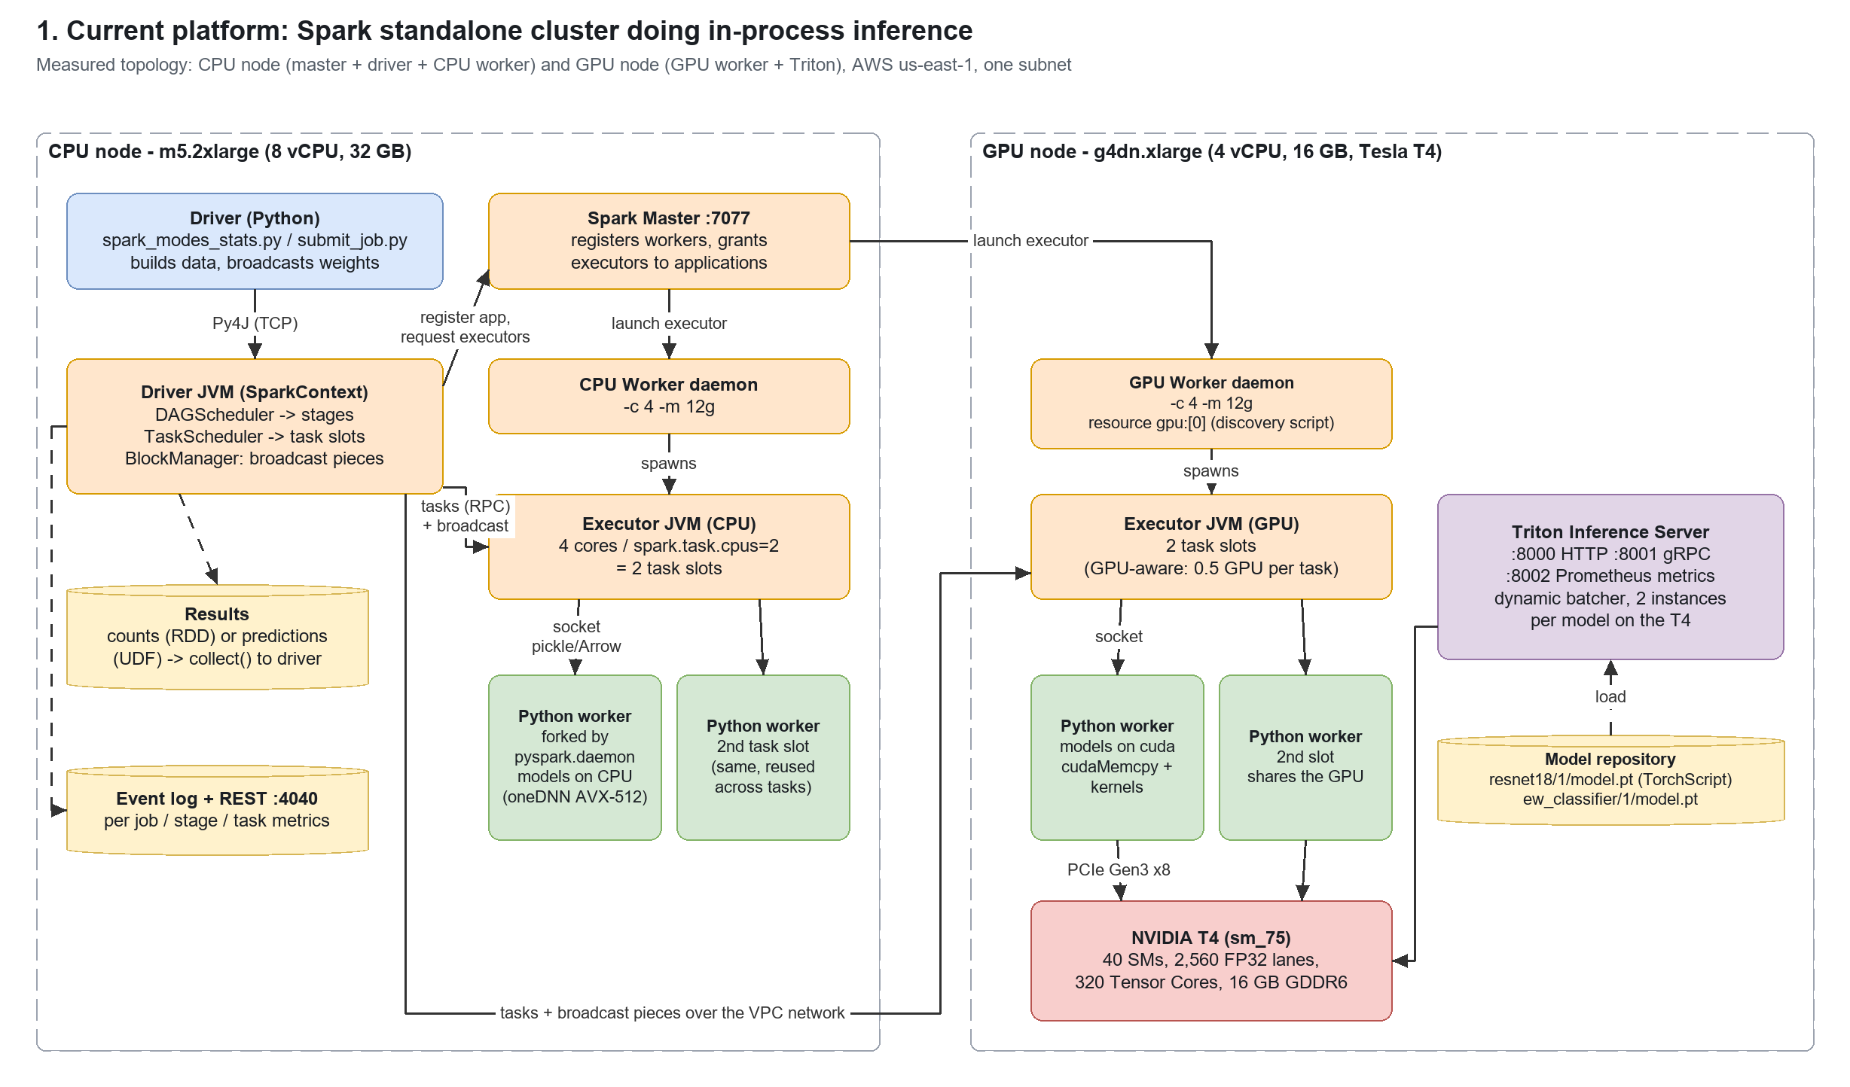
Figure 1 - the measured topology (editable: docs/diagrams/spark_inference_architectures.drawio, page 1)
component | CPU node | GPU node
instance | m5.2xlarge: 8 vCPU (Xeon Platinum, AVX-512), 32 GB | g4dn.xlarge: 4 vCPU (Xeon 8259CL), 16 GB, 1 x Tesla T4 16 GB (PCIe Gen3 x8)
Spark roles | master :7077, driver (spark_modes_stats.py), CPU worker -c 4 -m 12g | GPU worker -c 4 -m 12g, advertises resource gpu:[0] via deploy/scripts/gpu_discovery.sh
executors | 1 executor x 4 cores, spark.task.cpus=2 -> 2 task slots | 1 executor x 4 cores -> 2 task slots (GPU-aware: 0.5 GPU per task)
other | - | Triton Inference Server (NGC image), model repo from benchmark/triton_export.py
software | multi-model-inference image: Spark 3.5.1, PyTorch 2.6.0+cu126, pyarrow, tritonclient[grpc] | same image for the worker; Triton 2.x container for serving

2.1 Workloads
model | input per sample | samples | batch size B | partitions P | why
ew_classifier | 128 float32 (512 B) | 100,000 | 1,024 | 8 | tiny MLP: overhead-dominated, shows scheduling / serialization costs
resnet18 | 3x224x224 float32 (602 KB) | 256 | 64 | 8 | CNN: compute- and transfer-heavy, shows where GPUs matter
platform10 (10 models) | signals + images + 640x640 detections | 3,000 / 100 / 30 | 256 | 8 | the platform's real multi-model workload (cluster_benchmark)

2.2 Method
- Every mode x model runs as its own Spark application in a fresh Python process (benchmark/spark_modes_stats.py), so executors, event log, JVM heap and Python workers never carry over between measurements.
- 8 partitions over 4 task slots (2 per node) = at least two scheduling waves, so the statistics show how Spark spreads tasks over both workers.
- Spark event logs (spark.eventLog.enabled) give per-task: executor, host, launch/finish, deserialize, run, JVM CPU, GC, shuffle and result bytes. Executor stdout/stderr (worker work dirs) give model-load events. nvidia-smi dmon (1 s) gives GPU utilisation; Triton's :8002 metrics are captured before and after the Triton mode.
- benchmark/analyze_modes_stats.py turns those into the tables and task timelines in this document.

2.3 Reading the statistics
statistic | meaning | what a large value tells you
deserialize | executor time to unpack the task (closure, broadcast references) | big closures or broadcast fetches
run | wall time the task thread spent, including waiting for its Python worker | the real cost of the task
JVM CPU | CPU time of the JVM thread only (Python and GPU work are invisible here) | JVM-side work: shuffle, Arrow conversion, serialization
GC | JVM garbage-collection pause inside the task | memory pressure in the executor heap
shuffle write / read (remote) | bytes written to local shuffle files / fetched (from other nodes) | data movement caused by repartition/joins
results to driver | serialized task results returned to the driver | collect() of predictions
model loads | times a Python worker built the model and moved it to its device | fixed cost repeated per task vs per worker
task slot timeline | one row per executor slot, one bar per task (colour = stage) | idle slots, stragglers, waves

3. How Spark distributes inference across workers
- Application start. The driver registers with the master; the master starts executors on workers that have free cores/memory (standalone spreads executors over workers by default, spark.deploy.spreadOut=true). Each executor is a JVM with spark.executor.cores cores. With spark.task.cpus=2 a 4-core executor runs 2 tasks at a time.
- Job and stages. An action (collect) creates a job. The DAG scheduler cuts it into stages at shuffle boundaries: the RDD engine has one stage; the DataFrame/UDF engines have a shuffle-map stage (repartition) and a result stage.
- Task placement. The task scheduler offers each free slot the next pending task, preferring data locality (PROCESS_LOCAL -> NODE_LOCAL -> ANY, waiting spark.locality.wait=3 s at each level). Nothing in plain scheduling knows about GPUs: a task goes to whichever slot frees up first.
- Getting code and weights to the executor. The task carries the serialized closure; large read-only data (the model state_dicts) is a broadcast variable, fetched once per executor in 4 MB pieces by TorrentBroadcast (from the driver or from other executors that already have them).
- Python side. The executor streams the partition to a Python worker process over a local socket (pickle frames for RDDs, Arrow record batches for pandas UDFs); on Linux the worker is forked from pyspark.daemon and reused between tasks (spark.python.worker.reuse=true).
- Results. Each task returns its result bytes to the driver (small ones inline, large ones via the block manager); the driver concatenates them in collect().
- Failures. A failed task is retried up to spark.task.maxFailures=4 times, possibly on another executor; an executor loss re-runs its tasks elsewhere.
Consequence for inference: every task pays whatever per-task setup the engine does (model construction, weight load, CUDA context, cuDNN autotune) and every executor holds its own copy of the model. The modes below differ mainly in how often that setup happens, where the tasks land, and how the data reaches the Python process.

4. RDD mapPartitions: rdd_cpu, rdd_gpu, rdd_hybrid
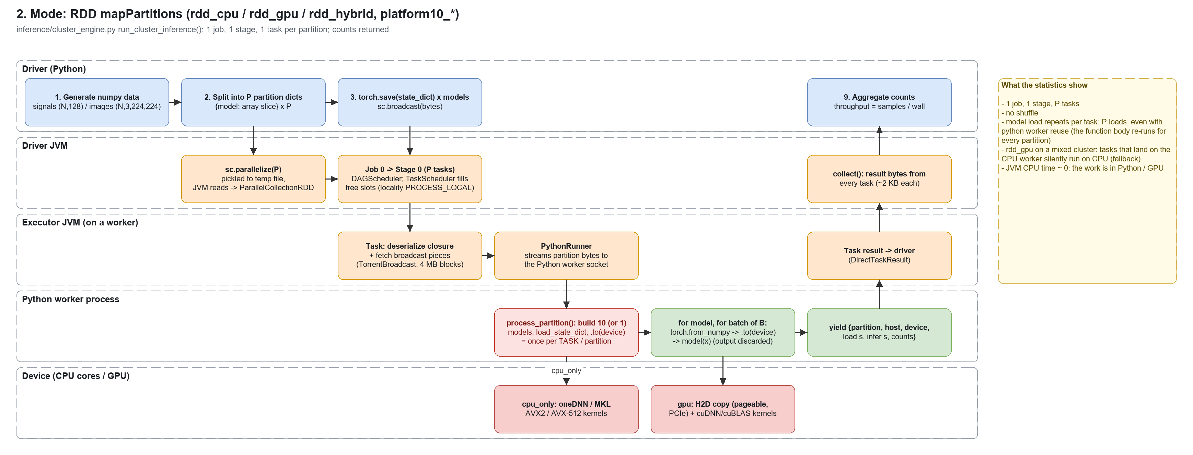
The platform's default engine (inference/cluster_engine.py). The driver slices the numpy arrays into P partition dicts, broadcasts the serialized state_dicts and runs mapPartitions(process_partition). device_mode is resolved inside each task: cpu_only -> CPU; gpu_only and hybrid -> CUDA if that executor sees a GPU, otherwise CPU (gpu_only prints a warning, hybrid does not).

4.1 rdd_cpu - statistics
metric | ew_classifier | resnet18
throughput (samples/s) | 19,398/s | 24/s
wall time of the job | 5.16 s | 10.79 s
samples x batch size x partitions | 100,000 x 1024 x 8 | 256 x 64 x 8
jobs / stages / tasks | 1 / 1 / 8 | 1 / 1 / 8
stages | s0: map (Python) -> collect (8 tasks, 4.59 s) | s0: map (Python) -> collect (8 tasks, 9.56 s)
tasks per worker (device) | 10.0.0.178 (gpu): 2 tasks; 10.0.0.66 (cpu): 6 tasks | 10.0.0.178 (gpu): 4 tasks; 10.0.0.66 (cpu): 4 tasks
inference task min / median / max | 0.23 / 2.81 / 2.99 s | 1.44 / 5.74 / 6.71 s
sum deserialize / run / JVM CPU / GC | 1.46 / 10.34 / 0.21 / 0.04 s | 1.35 / 28.44 / 0.21 / 0.10 s
shuffle write / read (remote) | 0.0 / 0.0 (0.0) MB | 0.0 / 0.0 (0.0) MB
task results to driver | 0.0 MB | 0.0 MB
model loads | 8 (8 cpu), avg 0.01 s | 8 (8 cpu), avg 0.87 s
GPU SM util avg / max | 0 % / 0 % | 0 % / 0 %
GPU memory used max | 439 MB | 493 MB

4.2 rdd_gpu - statistics
metric | ew_classifier | resnet18
throughput (samples/s) | 14,614/s | 12/s
wall time of the job | 6.84 s | 21.43 s
samples x batch size x partitions | 100,000 x 1024 x 8 | 256 x 64 x 8
jobs / stages / tasks | 1 / 1 / 8 | 1 / 1 / 8
stages | s0: map (Python) -> collect (8 tasks, 6.29 s) | s0: map (Python) -> collect (8 tasks, 20.18 s)
tasks per worker (device) | 10.0.0.178 (gpu): 2 tasks; 10.0.0.66 (cpu): 6 tasks | 10.0.0.178 (gpu): 2 tasks; 10.0.0.66 (cpu): 6 tasks
inference task min / median / max | 0.22 / 2.79 / 4.93 s | 1.35 / 5.65 / 19.33 s
sum deserialize / run / JVM CPU / GC | 1.34 / 14.15 / 0.21 / 0.06 s | 1.41 / 52.43 / 0.19 / 0.11 s
shuffle write / read (remote) | 0.0 / 0.0 (0.0) MB | 0.0 / 0.0 (0.0) MB
task results to driver | 0.0 MB | 0.0 MB
model loads | 8 (6 cpu, 2 cuda), avg 0.08 s | 8 (6 cpu, 2 cuda), avg 0.93 s
GPU SM util avg / max | 0 % / 0 % | 0 % / 4 %
GPU memory used max | 743 MB | 1,521 MB

4.3 rdd_hybrid - statistics
metric | ew_classifier | resnet18
throughput (samples/s) | 20,300/s | 29/s
wall time of the job | 4.93 s | 8.82 s
samples x batch size x partitions | 100,000 x 1024 x 8 | 256 x 64 x 8
jobs / stages / tasks | 1 / 1 / 8 | 1 / 1 / 8
stages | s0: map (Python) -> collect (8 tasks, 4.36 s) | s0: map (Python) -> collect (8 tasks, 7.54 s)
tasks per worker (device) | 10.0.0.178 (gpu): 2 tasks; 10.0.0.66 (cpu): 6 tasks | 10.0.0.178 (gpu): 4 tasks; 10.0.0.66 (cpu): 4 tasks
inference task min / median / max | 0.22 / 2.76 / 3.11 s | 0.55 / 5.38 / 5.79 s
sum deserialize / run / JVM CPU / GC | 1.35 / 10.46 / 0.20 / 0.04 s | 1.40 / 22.71 / 0.19 / 0.14 s
shuffle write / read (remote) | 0.0 / 0.0 (0.0) MB | 0.0 / 0.0 (0.0) MB
task results to driver | 0.0 MB | 0.0 MB
model loads | 8 (6 cpu, 2 cuda), avg 0.07 s | 8 (4 cpu, 4 cuda), avg 0.93 s
GPU SM util avg / max | 0 % / 0 % | 0 % / 0 %
GPU memory used max | 439 MB | 1,541 MB

4.4 Where each partition ran (from the tasks' own reports)

ew_classifier - rdd_gpu
partition | host | device | model load s | inference s | samples
0 | ip-10-0-0-66 | cpu | 0.01 | 0.06 | 12500
1 | ip-10-0-0-66 | cpu | 0.02 | 0.06 | 12500
2 | ip-10-0-0-178 | cuda | 0.28 | 1.88 | 12500
3 | ip-10-0-0-178 | cuda | 0.30 | 1.88 | 12500
4 | ip-10-0-0-66 | cpu | 0.01 | 0.06 | 12500
5 | ip-10-0-0-66 | cpu | 0.01 | 0.07 | 12500
6 | ip-10-0-0-66 | cpu | 0.01 | 0.05 | 12500
7 | ip-10-0-0-66 | cpu | 0.01 | 0.05 | 12500

resnet18 - rdd_gpu
partition | host | device | model load s | inference s | samples
0 | ip-10-0-0-66 | cpu | 1.50 | 0.91 | 32
1 | ip-10-0-0-66 | cpu | 1.50 | 0.91 | 32
2 | ip-10-0-0-178 | cuda | 1.76 | 14.14 | 32
3 | ip-10-0-0-178 | cuda | 1.76 | 14.14 | 32
4 | ip-10-0-0-66 | cpu | 0.22 | 0.91 | 32
5 | ip-10-0-0-66 | cpu | 0.22 | 0.94 | 32
6 | ip-10-0-0-66 | cpu | 0.22 | 0.91 | 32
7 | ip-10-0-0-66 | cpu | 0.22 | 0.93 | 32

ew_classifier - rdd_hybrid
partition | host | device | model load s | inference s | samples
0 | ip-10-0-0-66 | cpu | 0.01 | 0.07 | 12500
1 | ip-10-0-0-66 | cpu | 0.01 | 0.06 | 12500
2 | ip-10-0-0-178 | cuda | 0.23 | 0.08 | 12500
3 | ip-10-0-0-178 | cuda | 0.23 | 0.08 | 12500
4 | ip-10-0-0-66 | cpu | 0.01 | 0.06 | 12500
5 | ip-10-0-0-66 | cpu | 0.02 | 0.06 | 12500
6 | ip-10-0-0-66 | cpu | 0.01 | 0.06 | 12500
7 | ip-10-0-0-66 | cpu | 0.01 | 0.06 | 12500

resnet18 - rdd_hybrid
partition | host | device | model load s | inference s | samples
0 | ip-10-0-0-66 | cpu | 1.48 | 0.95 | 32
1 | ip-10-0-0-66 | cpu | 1.49 | 0.94 | 32
2 | ip-10-0-0-178 | cuda | 1.74 | 0.24 | 32
3 | ip-10-0-0-178 | cuda | 1.73 | 0.24 | 32
4 | ip-10-0-0-178 | cuda | 0.26 | 0.01 | 32
5 | ip-10-0-0-178 | cuda | 0.30 | 0.01 | 32
6 | ip-10-0-0-66 | cpu | 0.22 | 0.96 | 32
7 | ip-10-0-0-66 | cpu | 0.22 | 0.94 | 32

4.5 Executors and task timeline - rdd_hybrid

ew_classifier
executor | host | device | cores | tasks | busy s | run s | JVM CPU s | GC s | longest task s | shuffle read MB | results MB
0 | 10.0.0.178 | gpu | 4 | 2 | 6.20 | 5.24 | 0.09 | 0.02 | 3.11 | 0.0 | 0.0
1 | 10.0.0.66 | cpu | 4 | 6 | 6.46 | 5.22 | 0.11 | 0.02 | 2.81 | 0.0 | 0.0

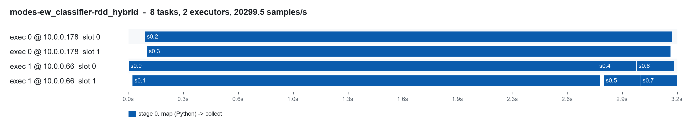
Task slots over time - ew_classifier rdd_hybrid

resnet18
executor | host | device | cores | tasks | busy s | run s | JVM CPU s | GC s | longest task s | shuffle read MB | results MB
0 | 10.0.0.178 | gpu | 4 | 4 | 11.92 | 10.18 | 0.10 | 0.10 | 5.41 | 0.0 | 0.0
1 | 10.0.0.66 | cpu | 4 | 4 | 14.20 | 12.53 | 0.09 | 0.04 | 5.79 | 0.0 | 0.0

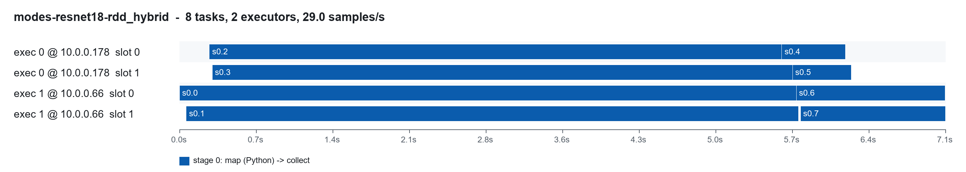
Task slots over time - resnet18 rdd_hybrid

5. GPU-aware scheduling: rdd_gpu_aware
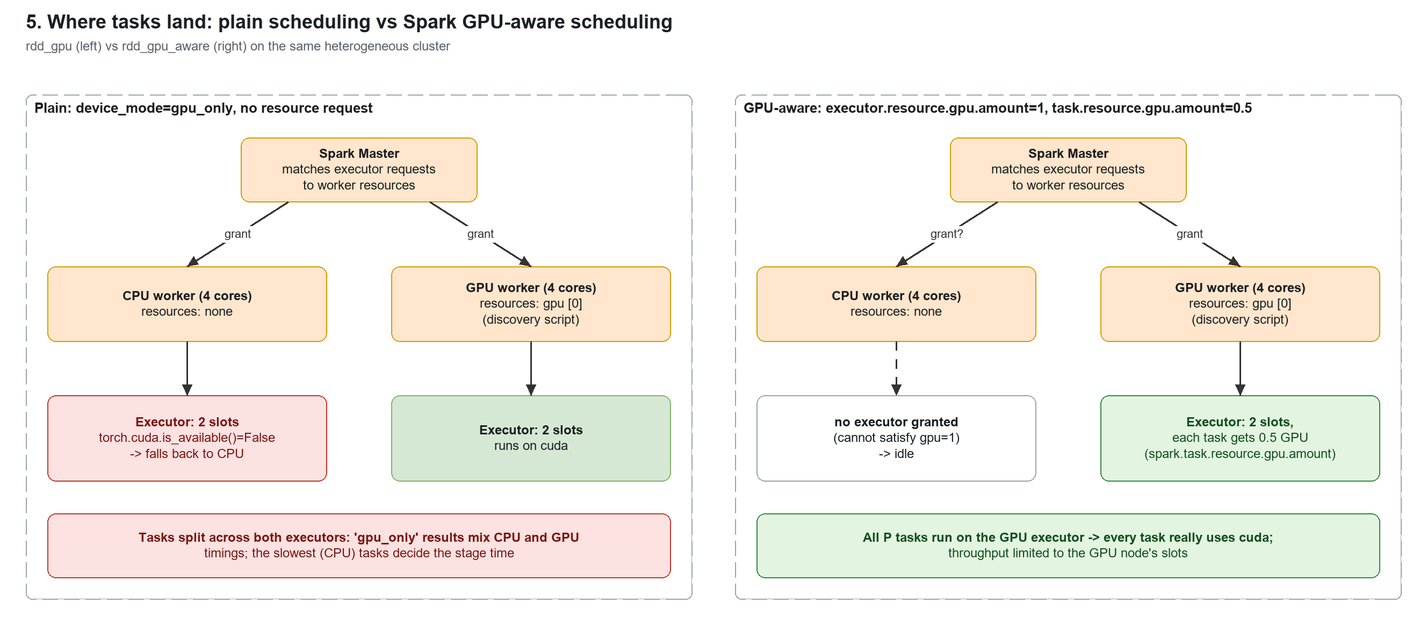
Same engine, but the session is created with create_cluster_session(gpu_aware_scheduling=True): spark.executor.resource.gpu.amount=1, spark.task.resource.gpu.amount=0.5. The GPU worker advertises its GPU through the discovery script; the CPU worker has none, so the master grants this application executors only on the GPU node. Every task then really runs on CUDA - at the price of using only that node's 2 slots.

5.1 rdd_gpu_aware - statistics
metric | ew_classifier | resnet18
throughput (samples/s) | 16,879/s | 28/s
wall time of the job | 5.92 s | 9.16 s
samples x batch size x partitions | 100,000 x 1024 x 8 | 256 x 64 x 8
jobs / stages / tasks | 1 / 1 / 8 | 1 / 1 / 8
stages | s0: map (Python) -> collect (8 tasks, 5.48 s) | s0: map (Python) -> collect (8 tasks, 8.13 s)
tasks per worker (device) | 10.0.0.178 (gpu): 8 tasks | 10.0.0.178 (gpu): 8 tasks
inference task min / median / max | 0.19 / 0.24 / 3.10 s | 0.53 / 0.58 / 5.43 s
sum deserialize / run / JVM CPU / GC | 0.72 / 5.96 / 0.12 / 0.04 s | 0.81 / 11.75 / 0.11 / 0.06 s
shuffle write / read (remote) | 0.0 / 0.0 (0.0) MB | 0.0 / 0.0 (0.0) MB
task results to driver | 0.0 MB | 0.0 MB
model loads | 8 (8 cuda), avg 0.07 s | 8 (8 cuda), avg 0.64 s
GPU SM util avg / max | 2 % / 9 % | 6 % / 28 %
GPU memory used max | 801 MB | 2,475 MB

# worker (GPU node)
SPARK_WORKER_OPTS="-Dspark.worker.resource.gpu.amount=1 \
-Dspark.worker.resource.gpu.discoveryScript=/app/deploy/scripts/gpu_discovery.sh"

# application
spark.executor.resource.gpu.amount = 1
spark.task.resource.gpu.amount = 0.5 # 2 concurrent tasks share the GPU

ew_classifier
executor | host | device | cores | tasks | busy s | run s | JVM CPU s | GC s | longest task s | shuffle read MB | results MB
0 | 10.0.0.178 | gpu | 4 | 8 | 7.48 | 5.96 | 0.12 | 0.04 | 3.10 | 0.0 | 0.0

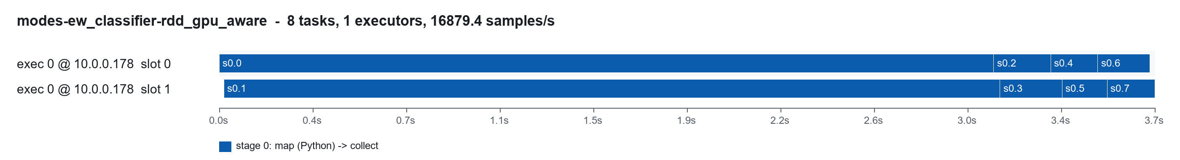
Task slots over time - ew_classifier rdd_gpu_aware

resnet18
executor | host | device | cores | tasks | busy s | run s | JVM CPU s | GC s | longest task s | shuffle read MB | results MB
0 | 10.0.0.178 | gpu | 4 | 8 | 14.26 | 11.75 | 0.11 | 0.06 | 5.43 | 0.0 | 0.0

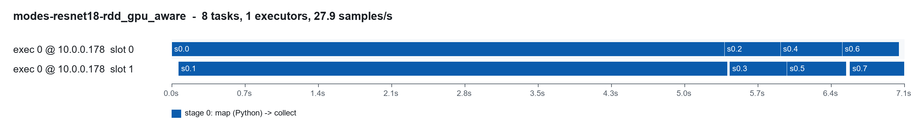
Task slots over time - resnet18 rdd_gpu_aware

6. pandas UDF - the repo's predict_batch_udf: udf_cpu, udf_gpu
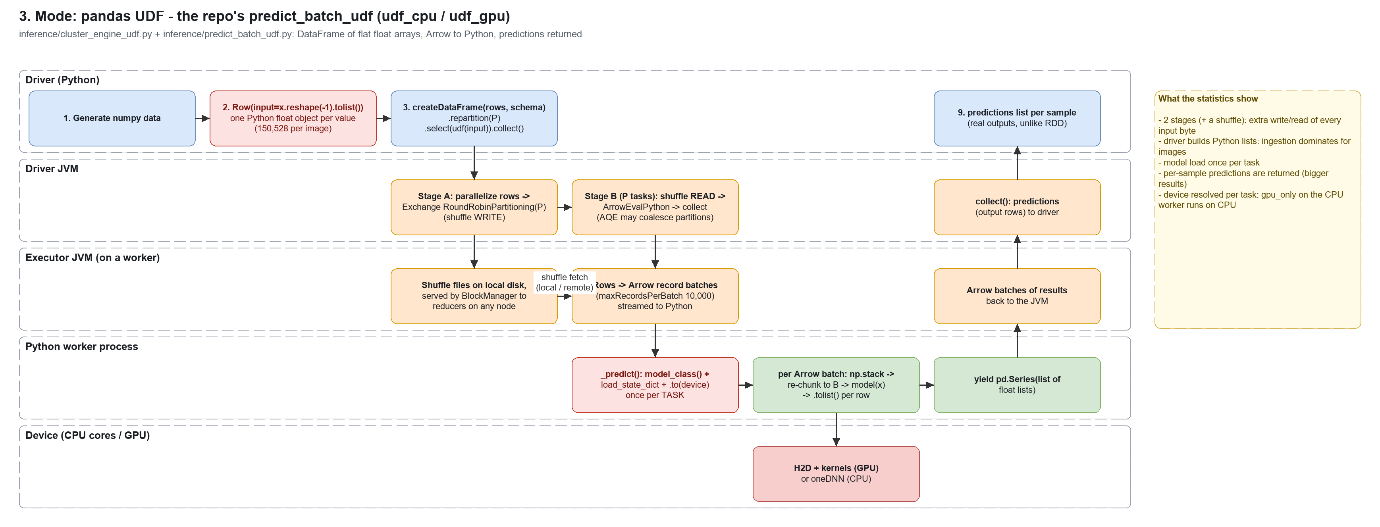
submit_job.py --engine udf -> inference/cluster_engine_udf.py -> inference/predict_batch_udf.py. Inputs become a DataFrame of flat float arrays (Row(input=x.reshape(-1).tolist())), repartition(P), then a scalar-iterator pandas UDF that builds the model once per task and re-chunks each Arrow batch to the model batch size. Unlike the RDD engine it returns the predictions.

6.1 udf_cpu - statistics
metric | ew_classifier | resnet18
throughput (samples/s) | 2,806/s | 7/s
wall time of the job | 35.64 s | 37.11 s
samples x batch size x partitions | 100,000 x 1024 x 8 | 256 x 64 x 8
jobs / stages / tasks | 2 / 2 / 16 | 2 / 2 / 16
stages | s0: shuffle map (repartition -> shuffle write) (8 tasks, 3.14 s); s2: shuffle read -> Python UDF -> collect (8 tasks, 22.72 s) | s0: shuffle map (repartition -> shuffle write) (8 tasks, 8.72 s); s2: shuffle read -> Python UDF -> collect (8 tasks, 9.26 s)
tasks per worker (device) | 10.0.0.178 (gpu): 4 tasks; 10.0.0.66 (cpu): 12 tasks | 10.0.0.178 (gpu): 8 tasks; 10.0.0.66 (cpu): 8 tasks
inference task min / median / max | 0.27 / 3.26 / 22.71 s | 1.58 / 5.95 / 6.98 s
sum deserialize / run / JVM CPU / GC | 2.41 / 60.55 / 5.35 / 0.13 s | 2.31 / 57.86 / 16.24 / 4.57 s
shuffle write / read (remote) | 51.9 / 51.9 (19.3) MB | 154.3 / 154.3 (77.2) MB
task results to driver | 3.6 MB | 1.1 MB
model loads | per task (not instrumented) | per task (not instrumented)
GPU SM util avg / max | 0 % / 0 % | 0 % / 0 %
GPU memory used max | 439 MB | 493 MB

6.2 udf_gpu - statistics
metric | ew_classifier | resnet18
throughput (samples/s) | 5,859/s | 7/s
wall time of the job | 17.07 s | 34.49 s
samples x batch size x partitions | 100,000 x 1024 x 8 | 256 x 64 x 8
jobs / stages / tasks | 2 / 2 / 16 | 2 / 2 / 16
stages | s0: shuffle map (repartition -> shuffle write) (8 tasks, 3.41 s); s2: shuffle read -> Python UDF -> collect (8 tasks, 3.95 s) | s0: shuffle map (repartition -> shuffle write) (8 tasks, 8.76 s); s2: shuffle read -> Python UDF -> collect (8 tasks, 7.00 s)
tasks per worker (device) | 10.0.0.178 (gpu): 6 tasks; 10.0.0.66 (cpu): 10 tasks | 10.0.0.178 (gpu): 8 tasks; 10.0.0.66 (cpu): 8 tasks
inference task min / median / max | 0.29 / 3.26 / 3.88 s | 0.84 / 5.64 / 5.85 s
sum deserialize / run / JVM CPU / GC | 2.29 / 23.51 / 5.51 / 0.15 s | 2.42 / 51.54 / 16.23 / 4.24 s
shuffle write / read (remote) | 51.9 / 51.9 (26.1) MB | 154.3 / 154.3 (77.2) MB
task results to driver | 3.6 MB | 1.1 MB
model loads | per task (not instrumented) | per task (not instrumented)
GPU SM util avg / max | 0 % / 5 % | 1 % / 14 %
GPU memory used max | 747 MB | 1,541 MB

6.3 Executors and task timeline - udf_gpu

ew_classifier
executor | host | device | cores | tasks | busy s | run s | JVM CPU s | GC s | longest task s | shuffle read MB | results MB
0 | 10.0.0.178 | gpu | 4 | 6 | 14.26 | 12.21 | 2.79 | 0.10 | 3.88 | 13.0 | 0.9
1 | 10.0.0.66 | cpu | 4 | 10 | 13.35 | 11.30 | 2.73 | 0.05 | 3.26 | 38.9 | 2.7

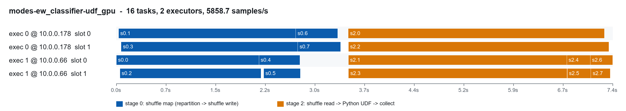
Task slots over time - ew_classifier udf_gpu (two stages: shuffle map, then UDF)

resnet18
executor | host | device | cores | tasks | busy s | run s | JVM CPU s | GC s | longest task s | shuffle read MB | results MB
0 | 10.0.0.178 | gpu | 4 | 8 | 30.67 | 27.15 | 8.83 | 2.67 | 5.85 | 77.2 | 0.5
1 | 10.0.0.66 | cpu | 4 | 8 | 27.63 | 24.39 | 7.41 | 1.57 | 5.65 | 77.2 | 0.5

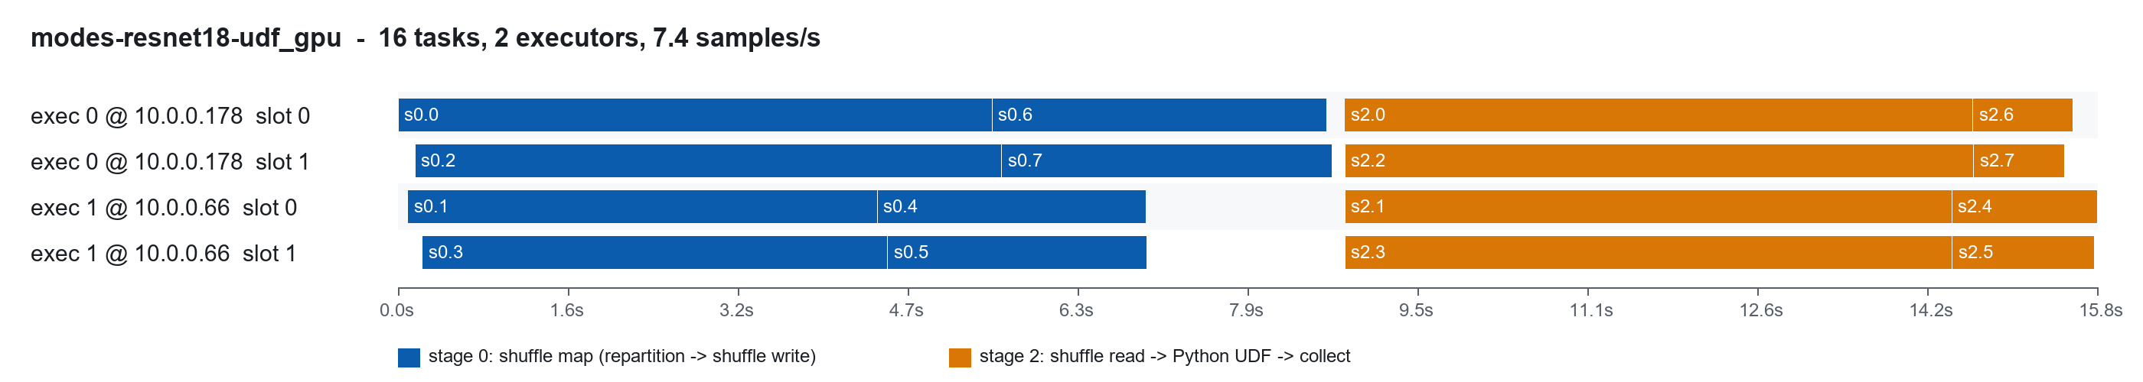
Task slots over time - resnet18 udf_gpu (two stages: shuffle map, then UDF)

7. Spark's built-in predict_batch_udf: native_pbu_cpu, native_pbu_gpu
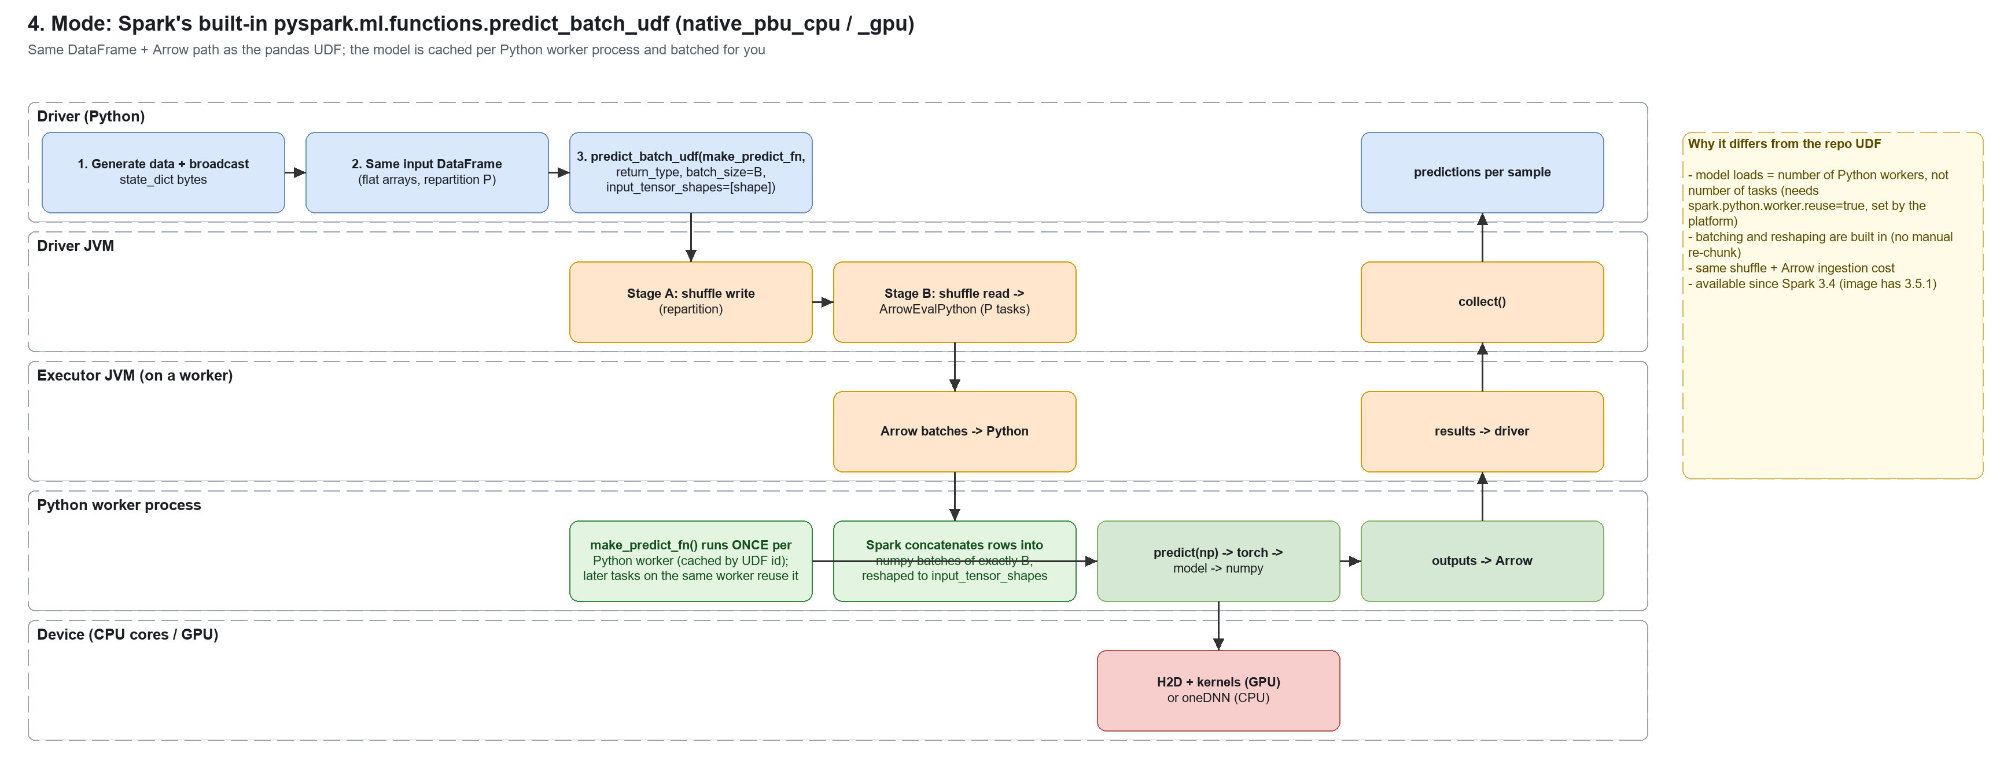
pyspark.ml.functions.predict_batch_udf (Spark 3.4+) takes a make_predict_fn that returns a predict function. Spark caches the result per Python worker process, so with worker reuse the model is built once per worker, not once per task. It also assembles fixed-size numpy batches (batch_size) and reshapes flat arrays (input_tensor_shapes). Same DataFrame ingestion and shuffle as section 6.

7.1 native_pbu_cpu - statistics
metric | ew_classifier | resnet18
throughput (samples/s) | 5,311/s | 7/s
wall time of the job | 18.83 s | 35.27 s
samples x batch size x partitions | 100,000 x 1024 x 8 | 256 x 64 x 8
jobs / stages / tasks | 2 / 2 / 16 | 2 / 2 / 16
stages | s0: shuffle map (repartition -> shuffle write) (8 tasks, 3.27 s); s2: shuffle read -> Python UDF -> collect (8 tasks, 5.77 s) | s0: shuffle map (repartition -> shuffle write) (8 tasks, 8.83 s); s2: shuffle read -> Python UDF -> collect (8 tasks, 8.14 s)
tasks per worker (device) | 10.0.0.178 (gpu): 6 tasks; 10.0.0.66 (cpu): 10 tasks | 10.0.0.178 (gpu): 6 tasks; 10.0.0.66 (cpu): 10 tasks
inference task min / median / max | 0.39 / 3.56 / 5.75 s | 1.07 / 5.92 / 7.20 s
sum deserialize / run / JVM CPU / GC | 2.35 / 27.95 / 5.39 / 0.14 s | 2.42 / 54.92 / 16.19 / 4.41 s
shuffle write / read (remote) | 51.9 / 51.9 (25.9) MB | 154.3 / 154.3 (77.2) MB
task results to driver | 3.6 MB | 1.1 MB
model loads | 4 (4 cpu), avg 0.01 s | 4 (4 cpu), avg 1.51 s
GPU SM util avg / max | 0 % / 0 % | 0 % / 0 %
GPU memory used max | 439 MB | 493 MB

7.2 native_pbu_gpu - statistics
metric | ew_classifier | resnet18
throughput (samples/s) | 5,743/s | 8/s
wall time of the job | 17.41 s | 34.02 s
samples x batch size x partitions | 100,000 x 1024 x 8 | 256 x 64 x 8
jobs / stages / tasks | 2 / 2 / 16 | 2 / 2 / 16
stages | s0: shuffle map (repartition -> shuffle write) (8 tasks, 3.38 s); s2: shuffle read -> Python UDF -> collect (8 tasks, 4.31 s) | s0: shuffle map (repartition -> shuffle write) (8 tasks, 8.83 s); s2: shuffle read -> Python UDF -> collect (8 tasks, 6.95 s)
tasks per worker (device) | 10.0.0.178 (gpu): 6 tasks; 10.0.0.66 (cpu): 10 tasks | 10.0.0.178 (gpu): 8 tasks; 10.0.0.66 (cpu): 8 tasks
inference task min / median / max | 0.37 / 3.53 / 4.03 s | 0.45 / 5.88 / 6.14 s
sum deserialize / run / JVM CPU / GC | 2.34 / 24.64 / 5.59 / 0.18 s | 2.33 / 51.47 / 16.14 / 4.58 s
shuffle write / read (remote) | 51.9 / 51.9 (26.1) MB | 154.3 / 154.3 (77.2) MB
task results to driver | 3.6 MB | 1.1 MB
model loads | 4 (2 cpu, 2 cuda), avg 0.14 s | 4 (2 cpu, 2 cuda), avg 1.64 s
GPU SM util avg / max | 0 % / 7 % | 0 % / 13 %
GPU memory used max | 747 MB | 1,541 MB

from pyspark.ml.functions import predict_batch_udf

def make_predict_fn(): # runs once per Python worker (cached)
model = ResNet18Classifier(); model.load_state_dict(torch.load(io.BytesIO(bc.value)))
model = model.to("cuda").eval()
def predict(x: np.ndarray) -> np.ndarray: # x: (B, 3, 224, 224)
with torch.no_grad():
return model(torch.from_numpy(x).cuda()).cpu().numpy()
return predict

udf = predict_batch_udf(make_predict_fn, return_type=ArrayType(FloatType()),
batch_size=64, input_tensor_shapes=[[3, 224, 224]])
df.select(udf("input")).collect()

ew_classifier
executor | host | device | cores | tasks | busy s | run s | JVM CPU s | GC s | longest task s | shuffle read MB | results MB
0 | 10.0.0.178 | gpu | 4 | 6 | 14.60 | 12.55 | 2.90 | 0.13 | 4.03 | 13.0 | 0.9
1 | 10.0.0.66 | cpu | 4 | 10 | 14.15 | 12.08 | 2.68 | 0.05 | 3.53 | 38.9 | 2.7

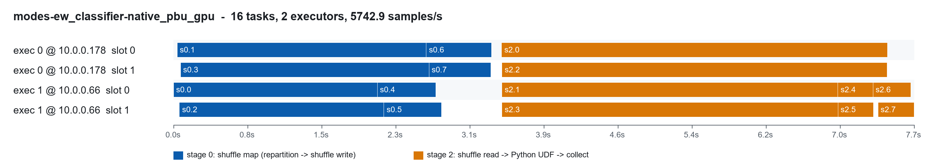
Task slots over time - ew_classifier native_pbu_gpu

resnet18
executor | host | device | cores | tasks | busy s | run s | JVM CPU s | GC s | longest task s | shuffle read MB | results MB
0 | 10.0.0.178 | gpu | 4 | 8 | 30.54 | 27.14 | 8.72 | 3.03 | 6.14 | 77.2 | 0.5
1 | 10.0.0.66 | cpu | 4 | 8 | 27.56 | 24.34 | 7.42 | 1.55 | 5.89 | 77.2 | 0.5

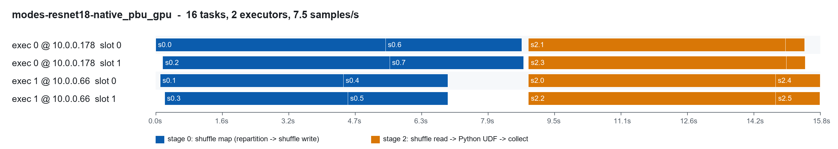
Task slots over time - resnet18 native_pbu_gpu

8. predict_batch_udf -> Triton: triton_pbu
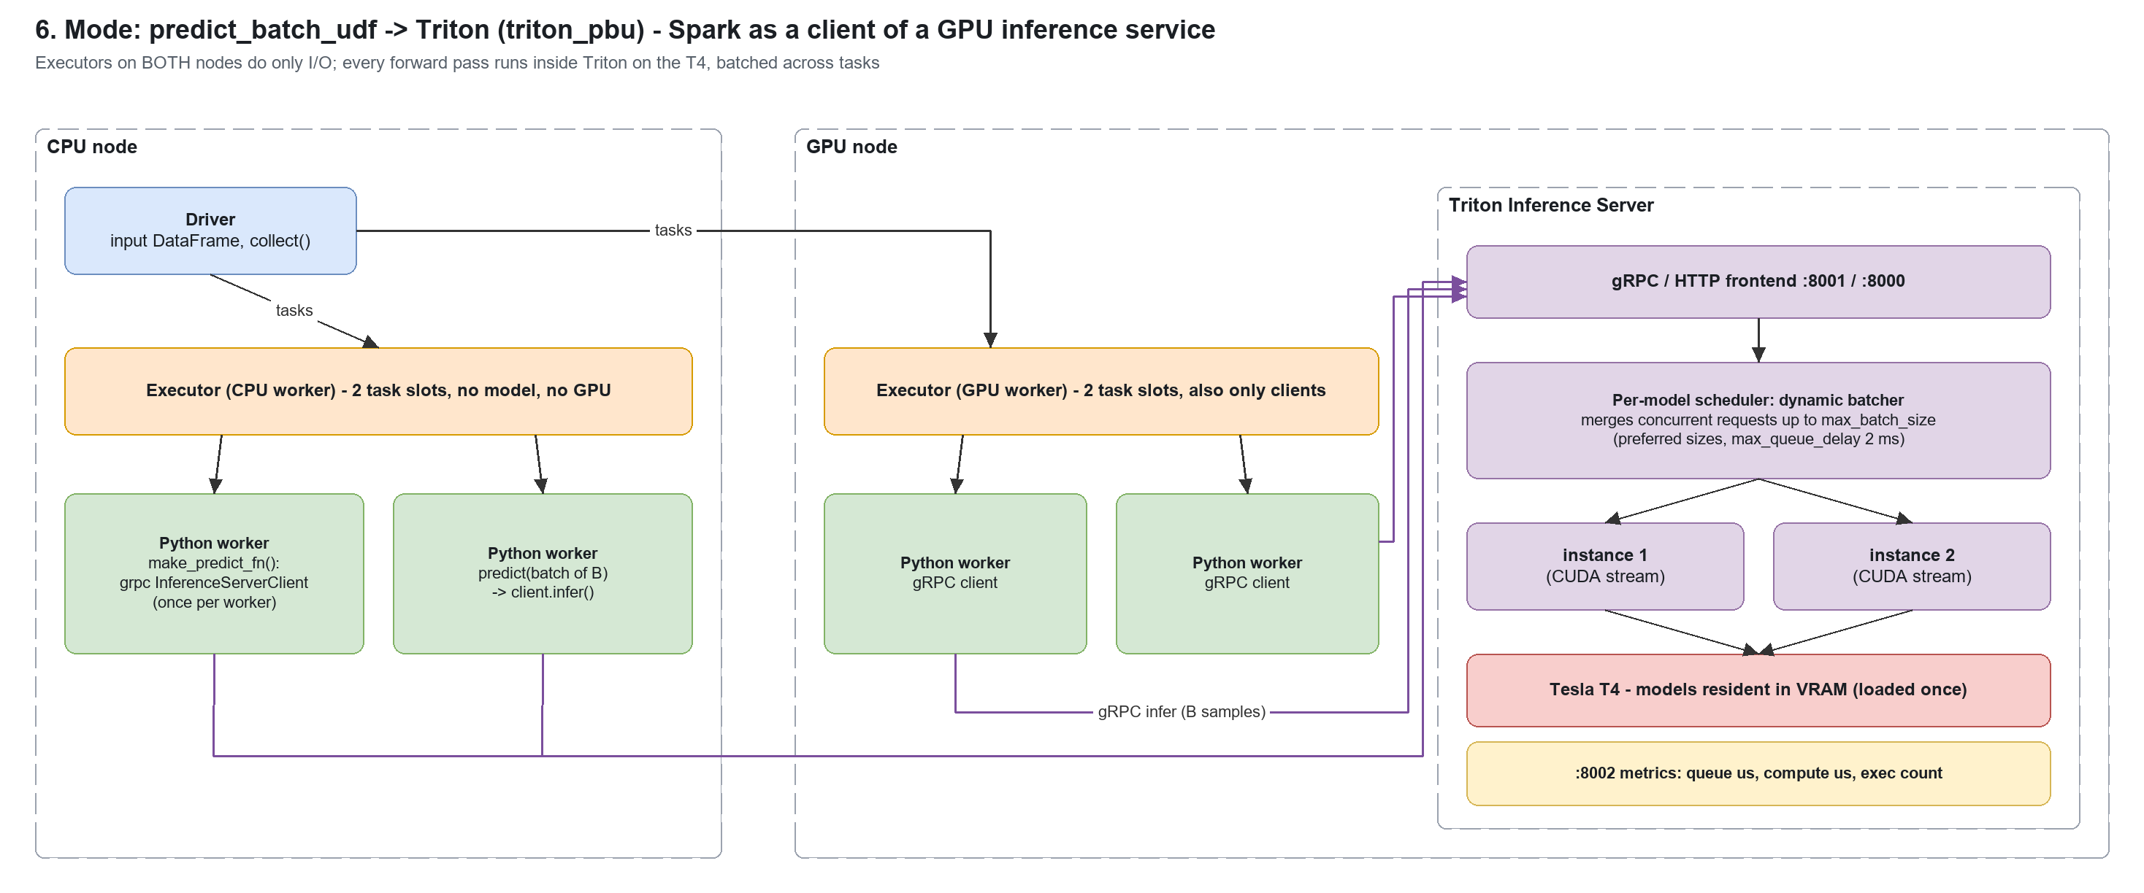
The proposed architecture, measured: the same built-in predict_batch_udf, but make_predict_fn only opens a tritonclient.grpc.InferenceServerClient and predict() sends each batch to Triton. No executor loads a model or touches a GPU; executors on both nodes feed the single T4 through Triton, whose dynamic batcher merges concurrent requests from different Spark tasks.

8.1 triton_pbu - Spark-side statistics
metric | ew_classifier | resnet18
throughput (samples/s) | 5,864/s | 9/s
wall time of the job | 17.05 s | 30.01 s
samples x batch size x partitions | 100,000 x 1024 x 8 | 256 x 64 x 8
jobs / stages / tasks | 2 / 2 / 16 | 2 / 2 / 16
stages | s0: shuffle map (repartition -> shuffle write) (8 tasks, 3.49 s); s2: shuffle read -> Python UDF -> collect (8 tasks, 3.82 s) | s0: shuffle map (repartition -> shuffle write) (8 tasks, 9.09 s); s2: shuffle read -> Python UDF -> collect (8 tasks, 3.07 s)
tasks per worker (device) | 10.0.0.178 (gpu): 8 tasks; 10.0.0.66 (cpu): 8 tasks | 10.0.0.178 (gpu): 8 tasks; 10.0.0.66 (cpu): 8 tasks
inference task min / median / max | 0.27 / 2.78 / 3.34 s | 0.48 / 2.27 / 2.41 s
sum deserialize / run / JVM CPU / GC | 2.34 / 22.37 / 5.38 / 0.20 s | 2.43 / 35.78 / 16.06 / 4.40 s
shuffle write / read (remote) | 51.9 / 51.9 (25.9) MB | 154.3 / 154.3 (77.2) MB
task results to driver | 3.6 MB | 1.1 MB
model loads | 4 (4 triton), avg 0.01 s | 4 (4 triton), avg 0.00 s
GPU SM util avg / max | 0 % / 0 % | 1 % / 23 %
GPU memory used max | 493 MB | 1,427 MB

8.2 Triton-side statistics (from :8002 metrics, delta over the job)
metric | ew_classifier | resnet18
requests / inferences / executions | 104 / 100,000 / 97 | 8 / 256 / 7
avg batch sent by Spark (client) | 961.5 | 32.0
avg batch executed on GPU (after dynamic batching) | 1,030.9 | 36.6
avg request latency (us) | 37,599 | 73,364
of which queue (us) | 6,359 | 1,752
compute input / infer / output (us) | 202 / 30,651 / 60 | 8,982 / 62,076 / 194

8.3 Model configuration used
name: "resnet18"
platform: "pytorch_libtorch"
max_batch_size: 256
input [ { name: "INPUT__0" data_type: TYPE_FP32 dims: [ 3, 224, 224 ] } ]
output [ { name: "OUTPUT__0" data_type: TYPE_FP32 dims: [ 1000 ] } ]
dynamic_batching {
preferred_batch_size: [ 64, 128, 256 ]
max_queue_delay_microseconds: 2000
}
instance_group [ { count: 2 kind: KIND_GPU } ]

Correctness check (benchmark/triton_export.py --verify): max |triton - eager| = 5.781650543212891e-06; max |triton - eager| = 0.13430580496788025 - Triton's GPU outputs vs eager PyTorch on CPU for the same inputs. resnet18 uses pretrained weights, so the two match to float precision; ew_classifier has no trained checkpoint and every process initialises it randomly, so the exported and the eager model differ by construction - export trained weights (weights_path) before relying on such a comparison.
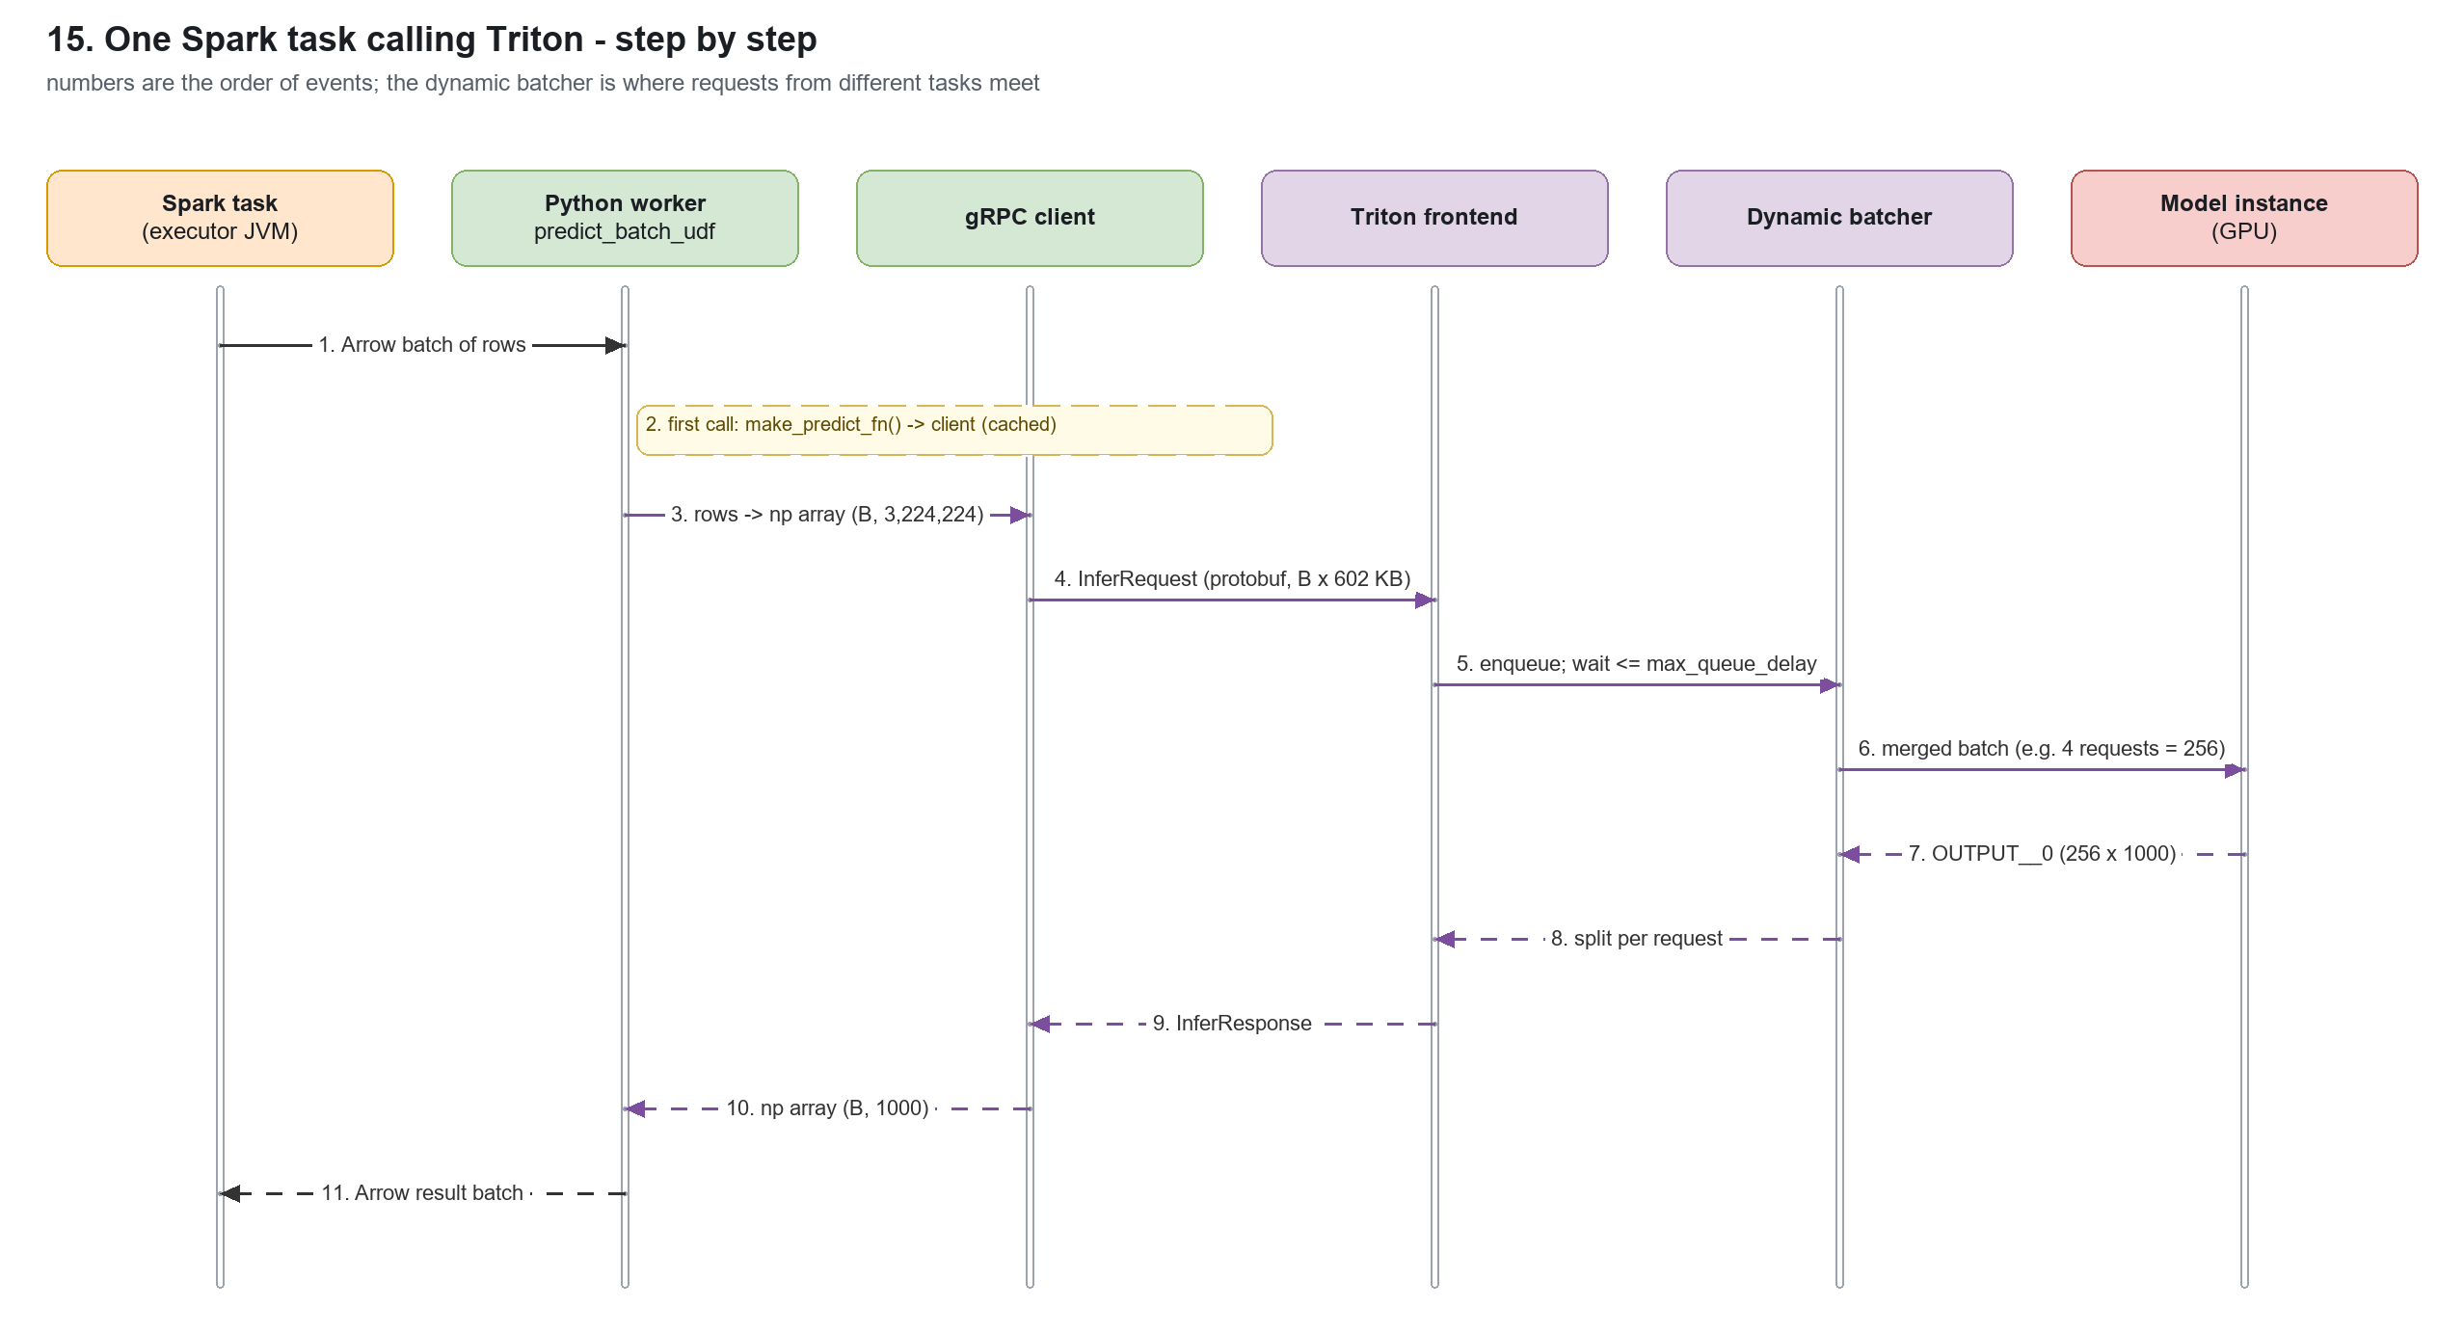
Figure - one Spark task calling Triton, step by step

ew_classifier
executor | host | device | cores | tasks | busy s | run s | JVM CPU s | GC s | longest task s | shuffle read MB | results MB
0 | 10.0.0.178 | gpu | 4 | 8 | 14.22 | 12.02 | 2.94 | 0.10 | 3.34 | 25.9 | 1.8
1 | 10.0.0.66 | cpu | 4 | 8 | 12.47 | 10.35 | 2.44 | 0.09 | 3.28 | 25.9 | 1.8

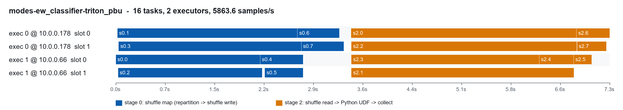
Task slots over time - ew_classifier triton_pbu

resnet18
executor | host | device | cores | tasks | busy s | run s | JVM CPU s | GC s | longest task s | shuffle read MB | results MB
0 | 10.0.0.178 | gpu | 4 | 8 | 23.59 | 19.76 | 8.72 | 2.79 | 5.63 | 77.2 | 0.5
1 | 10.0.0.66 | cpu | 4 | 8 | 19.03 | 16.02 | 7.34 | 1.61 | 4.45 | 77.2 | 0.5

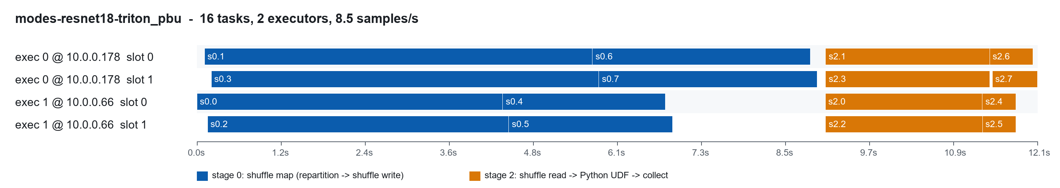
Task slots over time - resnet18 triton_pbu

9. The platform's 10-model workload: platform10_cpu / _gpu / _hybrid
cluster_benchmark-equivalent run of all 10 models (5 signal MLPs, ResNet18, MobileNetV3, EfficientNet-B0, 2 YOLO-style detectors) through the RDD engine - the workload the platform exists for.
metric | platform10_cpu | platform10_gpu | platform10_hybrid
throughput | 822/s | 787/s | 1,133/s
wall s | 18.70 | 19.52 | 13.56
tasks per worker | 10.0.0.178 (gpu): 2; 10.0.0.66 (cpu): 6 | 10.0.0.178 (gpu): 2; 10.0.0.66 (cpu): 6 | 10.0.0.178 (gpu): 4; 10.0.0.66 (cpu): 4
inference task min / median / max s | 1.74 / 6.76 / 16.12 | 1.76 / 6.90 / 16.85 | 1.27 / 7.36 / 7.67
sum task run s | 47.7 | 49.1 | 30.0
model loads (x10 models each) | 8 | 8 | 8
GPU SM util avg / max | 0 / 0 % | 1 / 11 % | 1 / 12 %

platform10_cpu
executor | host | device | cores | tasks | busy s | run s | JVM CPU s | GC s | longest task s | shuffle read MB | results MB
0 | 10.0.0.178 | gpu | 4 | 2 | 32.04 | 29.69 | 0.09 | 0.10 | 16.12 | 0.0 | 0.0
1 | 10.0.0.66 | cpu | 4 | 6 | 22.24 | 17.97 | 0.09 | 0.11 | 7.00 | 0.0 | 0.0

platform10_gpu
executor | host | device | cores | tasks | busy s | run s | JVM CPU s | GC s | longest task s | shuffle read MB | results MB
0 | 10.0.0.178 | gpu | 4 | 2 | 33.56 | 31.00 | 0.09 | 0.08 | 16.85 | 0.0 | 0.0
1 | 10.0.0.66 | cpu | 4 | 6 | 22.39 | 18.07 | 0.09 | 0.10 | 6.91 | 0.0 | 0.0

platform10_hybrid
executor | host | device | cores | tasks | busy s | run s | JVM CPU s | GC s | longest task s | shuffle read MB | results MB
0 | 10.0.0.178 | gpu | 4 | 4 | 17.62 | 13.84 | 0.10 | 0.10 | 7.38 | 0.0 | 0.0
1 | 10.0.0.66 | cpu | 4 | 4 | 20.24 | 16.19 | 0.09 | 0.08 | 7.67 | 0.0 | 0.0

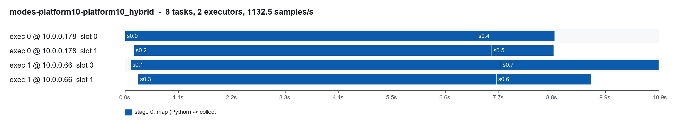
Task slots over time - platform10_hybrid

9.1 Partition scaling on one executor (single-node T4 run)
distributed_gpu.py (run_benchmark --mode distributed) with fixed data (25,170 samples, 10 models) and 2-16 partitions on one executor with 2 task slots: every extra partition adds a full 10-model load while the inference work stays the same.
metric | 2 partitions | 4 partitions | 8 partitions | 16 partitions
throughput | 2,454/s | 2,667/s | 2,320/s | 1,699/s
waves over 2 slots | 1 | 2 | 4 | 8
sum model load s (tasks' reports) | 4.17 | 5.52 | 7.79 | 13.53
sum inference s | 4.22 | 1.33 | 1.38 | 1.56

9.2 Anatomy of a task (single-node T4 run, 10 models, rdd_gpu)
partition | task wall s (event log) | model load s | inference s | unaccounted s (worker start, imports, broadcast, results)
0 | 8.76 | 2.20 | 0.54 | 6.02
1 | 8.24 | 2.19 | 0.54 | 5.51
2 | 1.65 | 0.63 | 0.09 | 0.93
3 | 1.76 | 0.62 | 0.10 | 1.04

The first task on each slot spends ~6 s outside the model code (starting the Python worker, importing torch/torchvision, deserializing the closure and fetching the ~75 MB broadcast); a second task on the warm worker takes ~1.7 s. Model loading then costs several times the GPU inference itself.

10. All modes side by side
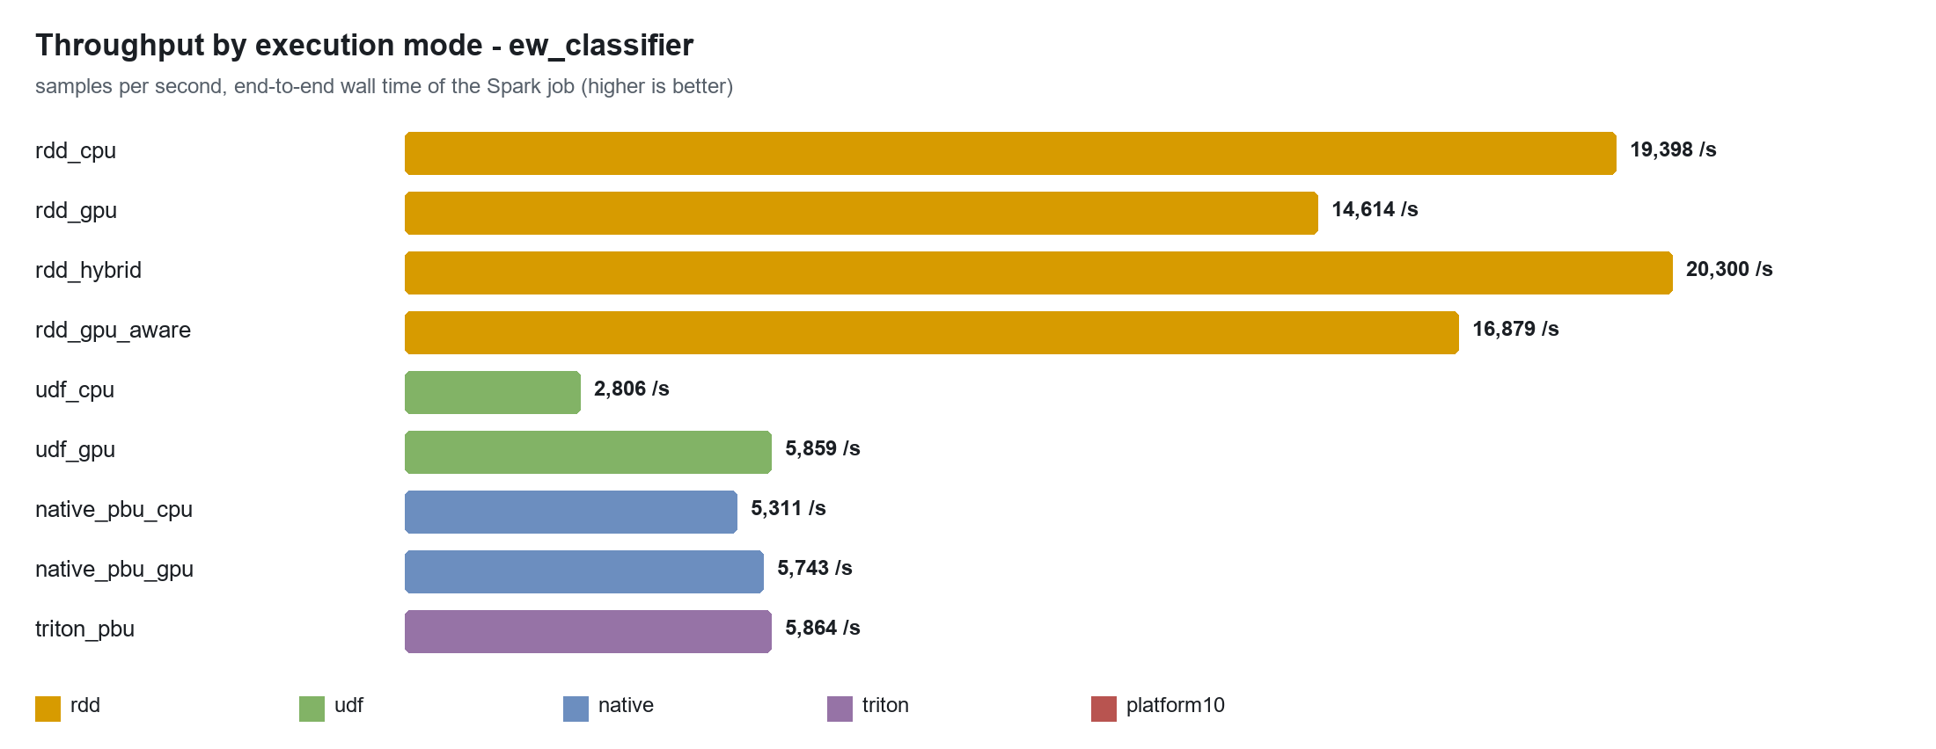
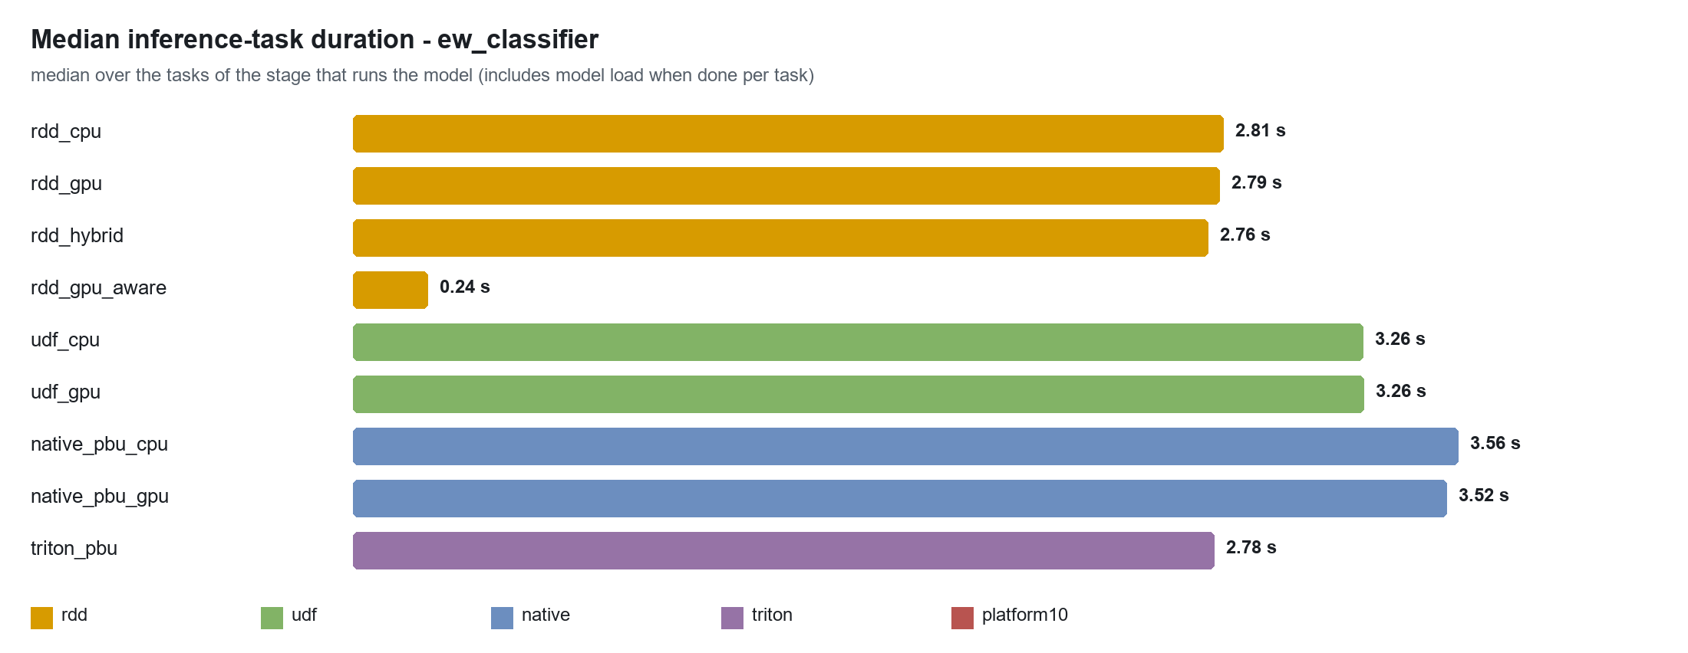
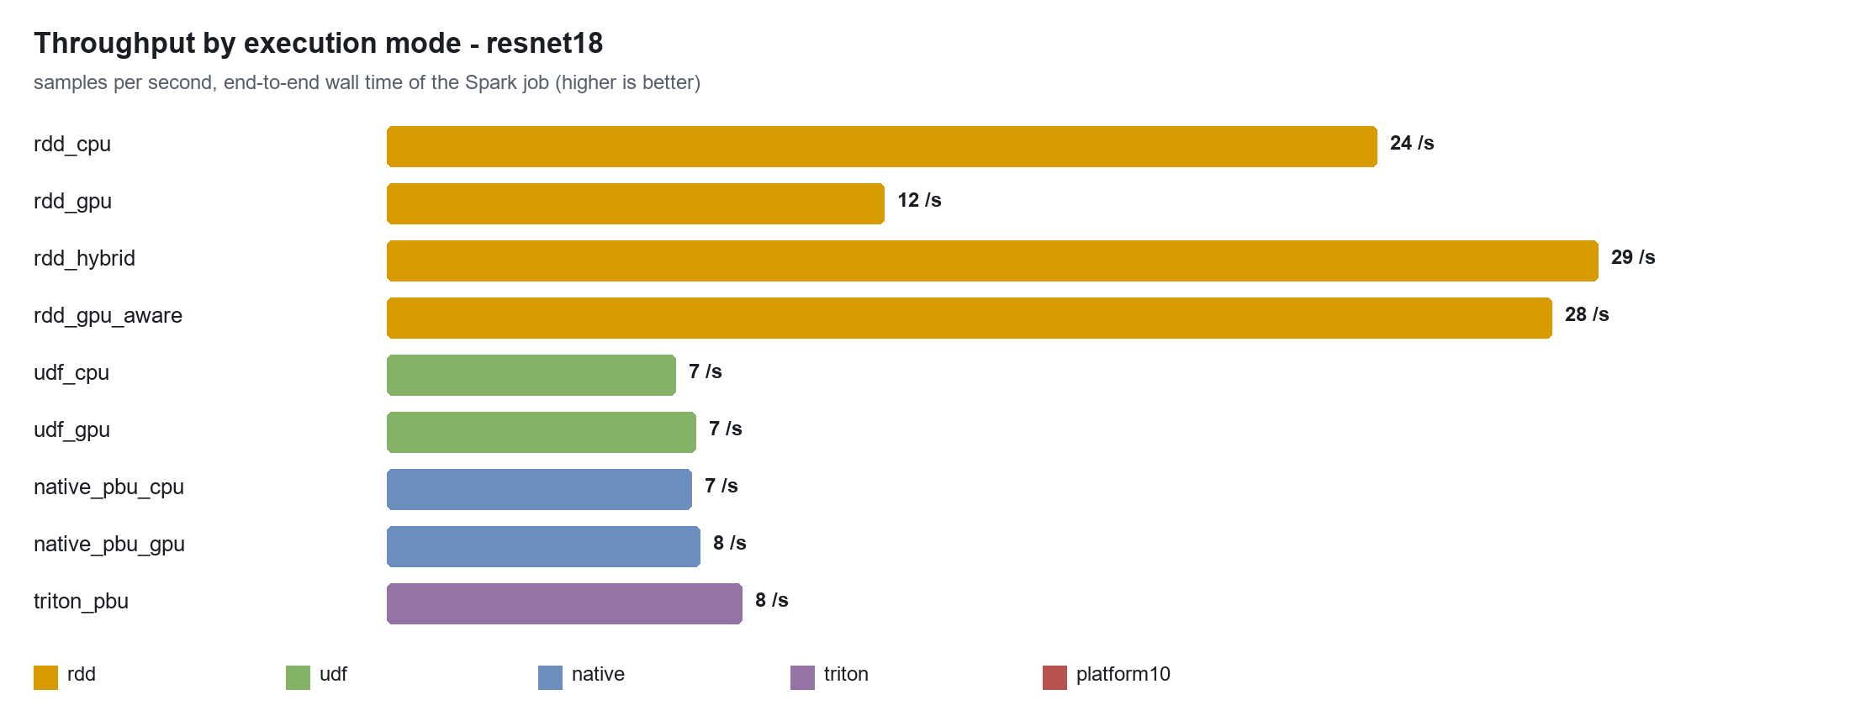
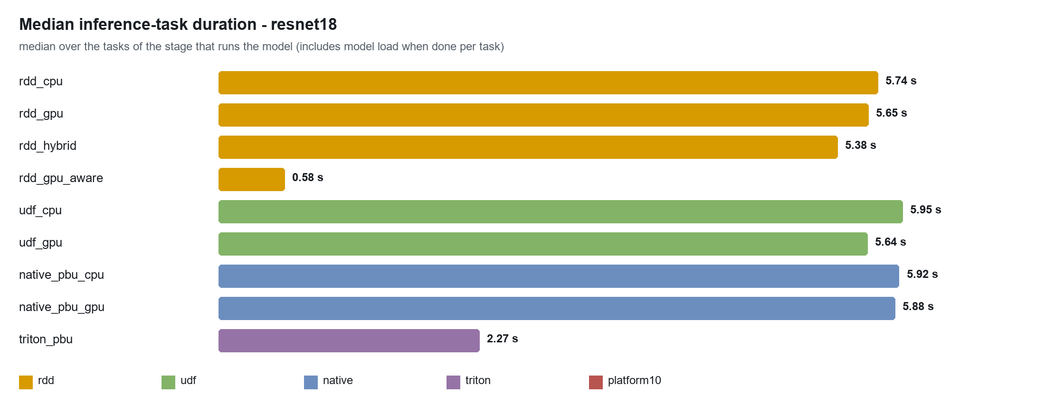
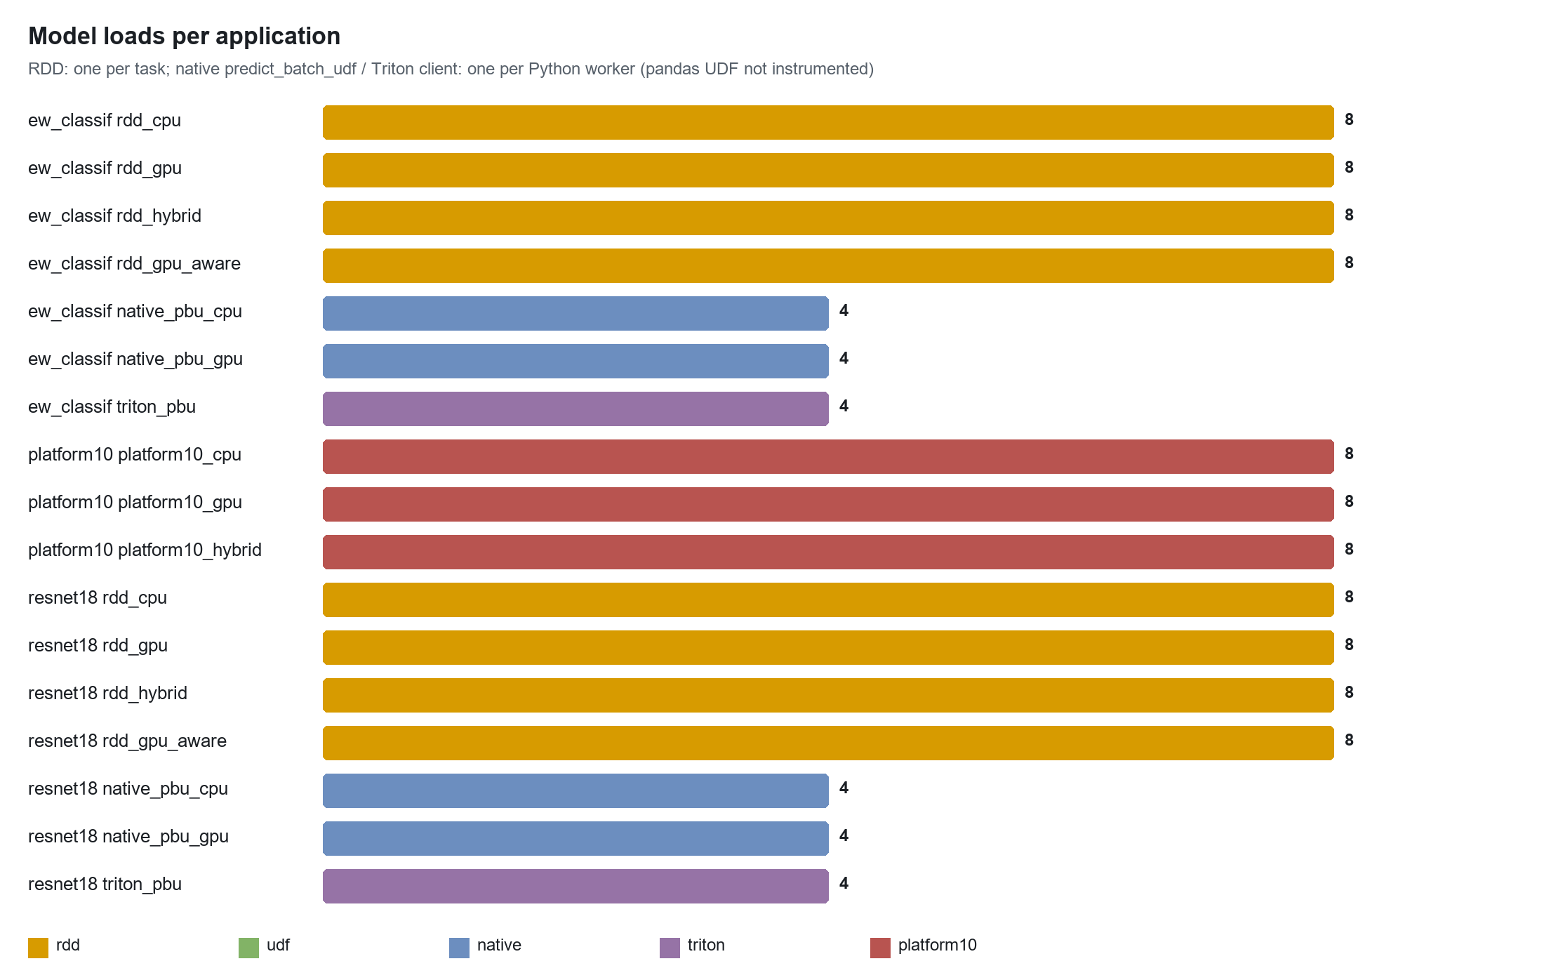
model | mode | samples/s | wall s | jobs/stages/tasks | tasks on CPU node / GPU node | model loads | shuffle MB | results MB | GPU SM avg %
ew_classifier | rdd_cpu | 19,398 | 5.2 | 1/1/8 | 6 / 2 | 8 | 0.0 | 0.0 | 0
ew_classifier | rdd_gpu | 14,614 | 6.8 | 1/1/8 | 6 / 2 | 8 | 0.0 | 0.0 | 0
ew_classifier | rdd_hybrid | 20,300 | 4.9 | 1/1/8 | 6 / 2 | 8 | 0.0 | 0.0 | 0
ew_classifier | rdd_gpu_aware | 16,879 | 5.9 | 1/1/8 | 0 / 8 | 8 | 0.0 | 0.0 | 2
ew_classifier | udf_cpu | 2,806 | 35.6 | 2/2/16 | 12 / 4 | per task | 51.9 | 3.6 | 0
ew_classifier | udf_gpu | 5,859 | 17.1 | 2/2/16 | 10 / 6 | per task | 51.9 | 3.6 | 0
ew_classifier | native_pbu_cpu | 5,311 | 18.8 | 2/2/16 | 10 / 6 | 4 | 51.9 | 3.6 | 0
ew_classifier | native_pbu_gpu | 5,743 | 17.4 | 2/2/16 | 10 / 6 | 4 | 51.9 | 3.6 | 0
ew_classifier | triton_pbu | 5,864 | 17.1 | 2/2/16 | 8 / 8 | 4 | 51.9 | 3.6 | 0
resnet18 | rdd_cpu | 24 | 10.8 | 1/1/8 | 4 / 4 | 8 | 0.0 | 0.0 | 0
resnet18 | rdd_gpu | 12 | 21.4 | 1/1/8 | 6 / 2 | 8 | 0.0 | 0.0 | 0
resnet18 | rdd_hybrid | 29 | 8.8 | 1/1/8 | 4 / 4 | 8 | 0.0 | 0.0 | 0
resnet18 | rdd_gpu_aware | 28 | 9.2 | 1/1/8 | 0 / 8 | 8 | 0.0 | 0.0 | 6
resnet18 | udf_cpu | 7 | 37.1 | 2/2/16 | 8 / 8 | per task | 154.3 | 1.1 | 0
resnet18 | udf_gpu | 7 | 34.5 | 2/2/16 | 8 / 8 | per task | 154.3 | 1.1 | 1
resnet18 | native_pbu_cpu | 7 | 35.3 | 2/2/16 | 10 / 6 | 4 | 154.3 | 1.1 | 0
resnet18 | native_pbu_gpu | 8 | 34.0 | 2/2/16 | 8 / 8 | 4 | 154.3 | 1.1 | 0
resnet18 | triton_pbu | 9 | 30.0 | 2/2/16 | 8 / 8 | 4 | 154.3 | 1.1 | 1
example_mlp | rdd_cpu | 4,192 | 4.8 | 1/1/4 | 0 / 4 | 4 | 0.0 | 0.0 | -
example_mlp | rdd_gpu | 3,964 | 5.0 | 1/1/4 | 0 / 4 | 4 | 0.0 | 0.0 | -
example_mlp | udf_cpu | 1,844 | 10.8 | 2/2/6 | 0 / 6 | per task | 5.2 | 0.4 | -
example_mlp | udf_gpu | 1,774 | 11.3 | 2/2/6 | 0 / 6 | per task | 5.2 | 0.4 | -
platform10_1k | rdd_cpu | 416 | 12.5 | 1/1/2 | 0 / 2 | 2 | 0.0 | 0.0 | -
platform10_1k | rdd_gpu | 560 | 9.3 | 1/1/2 | 0 / 2 | 2 | 0.0 | 0.0 | -
platform10_1k | rdd_hybrid | 569 | 9.1 | 1/1/2 | 0 / 2 | 2 | 0.0 | 0.0 | -
platform10_3k | rdd_cpu | 904 | 17.0 | 1/1/4 | 0 / 4 | 4 | 0.0 | 0.0 | -
platform10_3k | rdd_gpu | 1,444 | 10.6 | 1/1/4 | 0 / 4 | 4 | 0.0 | 0.0 | -
platform10_3k | rdd_hybrid | 1,449 | 10.6 | 1/1/4 | 0 / 4 | 4 | 0.0 | 0.0 | -
platform10_5k | dist_p2 | 2,454 | 10.3 | 1/1/2 | 0 / 2 | 0 | 0.0 | 0.0 | -
platform10_5k | dist_p4 | 2,667 | 9.4 | 1/1/4 | 0 / 4 | 0 | 0.0 | 0.0 | -
platform10_5k | dist_p8 | 2,320 | 10.9 | 1/1/8 | 0 / 8 | 0 | 0.0 | 0.0 | -
platform10_5k | dist_p16 | 1,699 | 14.8 | 1/1/16 | 0 / 16 | 0 | 0.0 | 0.0 | -

11. Findings in the current platform (with fixes)
# | finding | evidence | fix
1 | gpu_only does not keep tasks on GPUs; tasks that land on a CPU worker silently run on CPU | rdd_gpu (resnet18): 6/8 partitions on cpu | use gpu_aware_scheduling=True (resource profiles) or fail the task when CUDA is missing in gpu_only
2 | process_partition() rebuilds all models for every partition (docstring says once per executor) | rdd_hybrid (resnet18): 8 loads for 8 partitions | cache models in a module-level dict keyed by (model, device) inside the Python worker, or move to predict_batch_udf / Triton
3 | UDF ingestion builds Python lists of floats on the driver, then shuffles them | resnet18 udf_gpu: shuffle write 154.3 MB | read inputs from Parquet/Arrow (spark.read.parquet) or createDataFrame(pandas) with Arrow enabled; drop repartition when input already has P files
4 | RDD engine returns only counts | result bytes ~2 KB per task | return predictions (or write them from the executor) when the job needs them
5 | SparkInferenceClusterStack starts its CPU worker with -c 2 while sessions ask for 4-core executors | deploy/aws-cdk/spark_cluster/spark_cluster_stack.py | start workers with -c >= spark.executor.cores (this run used -c 4)
6 | setup_and_run_gpu.sh builds deploy/Dockerfile without --target final (gets the torch-less lean stage) | Dockerfile stage order | add --target final
7 | Every executor keeps its own copy of every model and its own CUDA context | platform10 memory per Python worker | serve models once per GPU (Triton) and keep executors CPU-only

12. Recommended architecture: Triton in front of the cluster
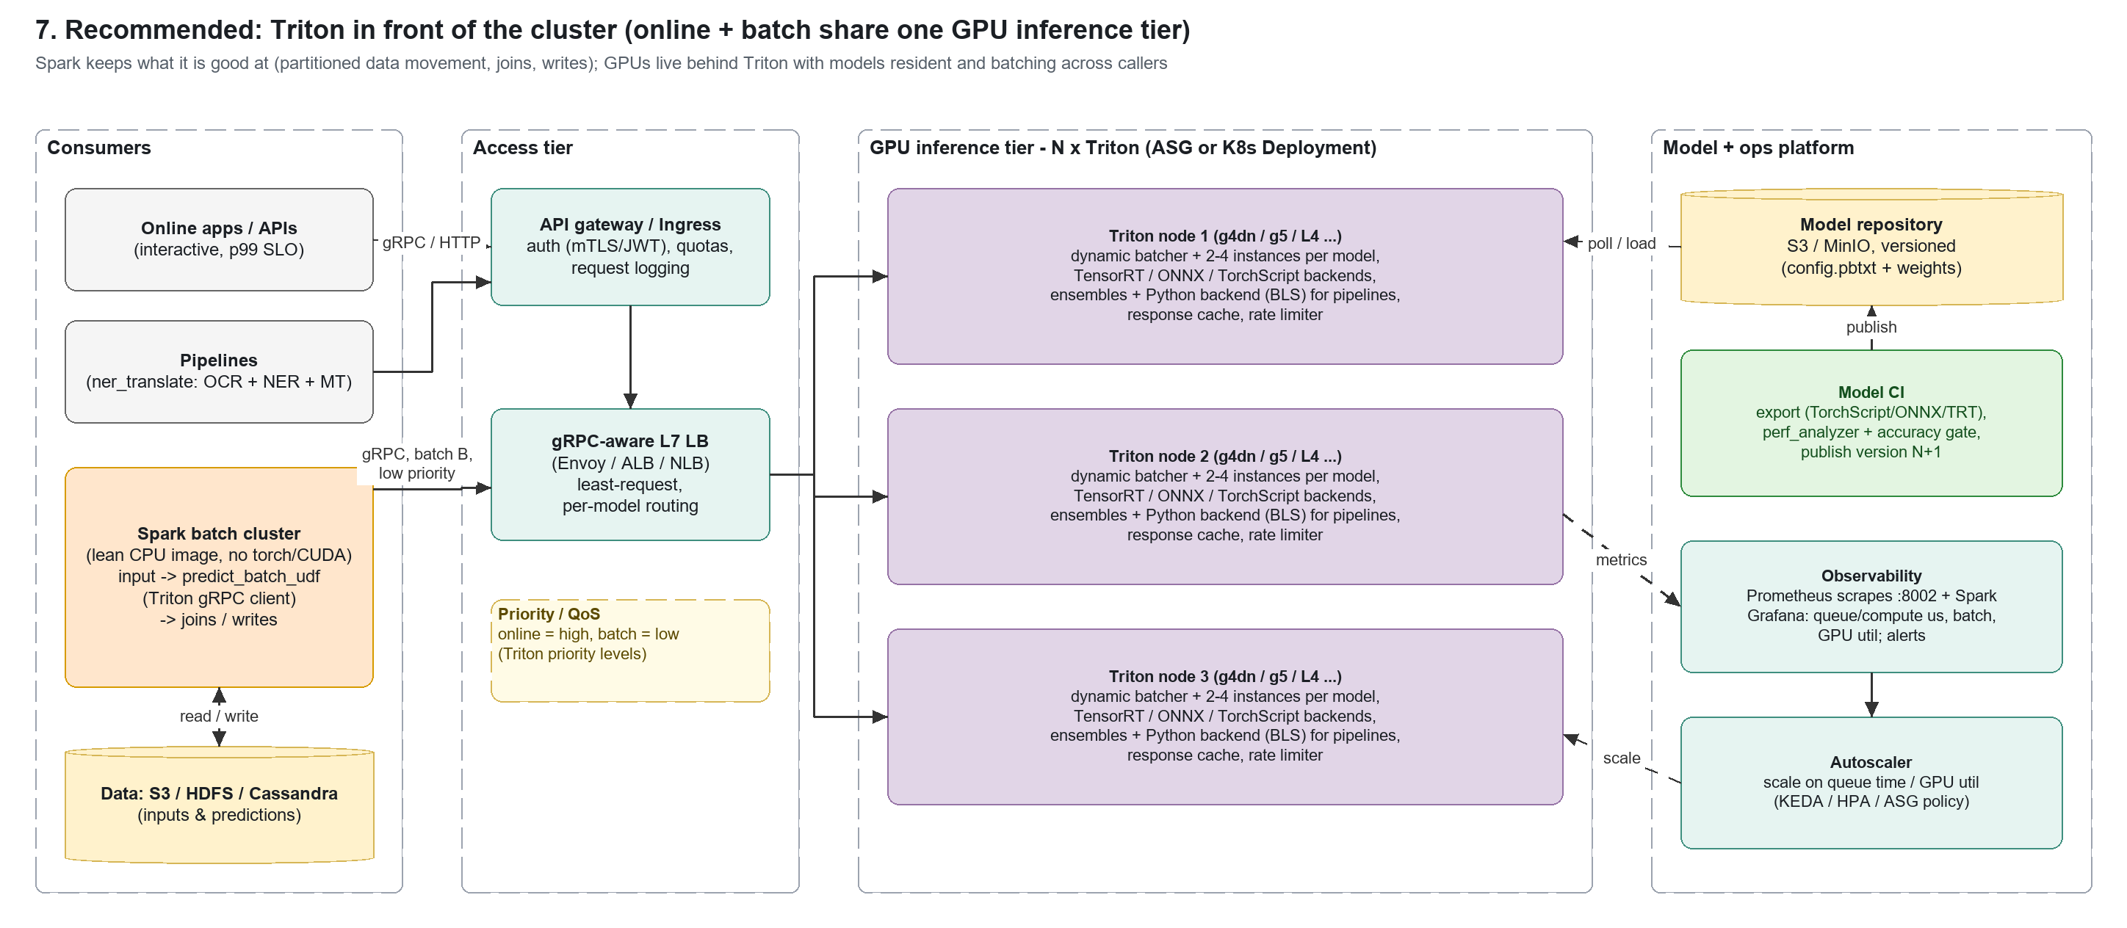
Figure - target architecture (editable in the .drawio file)

12.1 Principles
- Separate data parallelism from model serving. Spark partitions, joins and writes data; Triton owns GPUs, keeps models resident, batches across callers, and serves online and batch traffic from the same deployment.
- Executors become lean clients. No torch/CUDA in the Spark image (the repo already has a lean Docker stage for exactly this - the waiter/kitchen split); one gRPC channel per Python worker, created in make_predict_fn.
- Batching happens twice, deliberately. Spark sends batches of B rows (predict_batch_udf batch_size); Triton's dynamic batcher merges concurrent batches from many tasks up to max_batch_size and preferred sizes within max_queue_delay.
- One model repository, versioned. Model CI exports TorchScript/ONNX (and TensorRT where it pays off), gates on accuracy and perf_analyzer, publishes version N+1; Triton polls or is told to load it explicitly.
- Operate on queue time. Triton's queue duration is the saturation signal: scale GPU nodes on it, and use request priorities so online traffic is served before batch.

12.2 Components
component | choice | notes
Inference server | NVIDIA Triton (NGC tritonserver) | backends: pytorch_libtorch (TorchScript, used here), onnxruntime, tensorrt, python (for pre/post-processing and pipelines via BLS)
Model format | TorchScript now; ONNX -> TensorRT for the CNNs/YOLO | fp16 TensorRT engines use the T4's Tensor Cores (43.9 TFLOPS fp16 measured vs 6.95 fp32)
Batching | dynamic_batching { preferred_batch_size, max_queue_delay_microseconds } | start with 1-2 ms queue delay for batch traffic; online SLOs may need a separate model config with smaller delay
Concurrency | instance_group { count: 2-4, kind: KIND_GPU } | overlaps copy/compute and small kernels; watch VRAM
Access | internal L7 LB (Envoy / ALB with gRPC), API gateway for online | least-request balancing; health on /v2/health/ready
Spark client | pyspark.ml.functions.predict_batch_udf + tritonclient.grpc | one client per Python worker; retries with backoff; timeouts per request
Pipelines (ner_translate) | Triton Python backend + BLS, or keep the existing HTTP kitchen service | OCR/translation have variable-size outputs; ensembles or BLS keep them server-side
Model store | S3 (cloud) / MinIO (air-gapped), versioned | model-control-mode=explicit in production so loads are deliberate
Observability | Prometheus :8002 + Spark metrics -> Grafana | nv_inference_queue_duration_us, compute_infer_duration_us, exec_count vs inference_count (achieved batch), GPU util/memory
Scaling | ASG / K8s HPA-KEDA on queue time and GPU util | scale out Triton nodes independently of Spark

12.3 Spark integration
from pyspark.ml.functions import predict_batch_udf
from pyspark.sql.types import ArrayType, FloatType

TRITON = "triton.internal:8001"

def make_predict_fn(): # once per Python worker
import tritonclient.grpc as grpcclient
client = grpcclient.InferenceServerClient(url=TRITON)
def predict(x): # x: (B, 3, 224, 224) float32
inp = grpcclient.InferInput("INPUT__0", list(x.shape), "FP32")
inp.set_data_from_numpy(x)
out = client.infer("resnet18", [inp], outputs=[grpcclient.InferRequestedOutput("OUTPUT__0")],
client_timeout=30, priority=2) # batch = lower priority than online
return out.as_numpy("OUTPUT__0")
return predict

classify = predict_batch_udf(make_predict_fn, return_type=ArrayType(FloatType()),
batch_size=64, input_tensor_shapes=[[3, 224, 224]])

(spark.read.parquet("s3://bucket/images/") # columnar input, no driver-side lists
.withColumn("logits", classify("pixels"))
.write.parquet("s3://bucket/predictions/"))

12.4 Capacity planning from the measurements
For resnet18 on one T4, Triton executed batches of 37 with an average compute time of 62,076 us per request, i.e. roughly 589 images/s per model instance while busy; with 2 instances the GPU-side ceiling is about 1,178 images/s (TorchScript fp32). The end-to-end Spark job reached 9/s, so the remaining gap is on the Spark side (ingestion, shuffle, Arrow conversion) - not the GPU.
planning quantity | formula | use
GPUs needed (batch) | peak rows/s / per-GPU sustained rows/s at target queue time | per-GPU number from perf_analyzer or section 8.2
Spark client concurrency | executors x task slots (each an in-flight request stream) | enough concurrent requests to fill Triton's preferred batch sizes
max_queue_delay | <= (latency SLO - compute time) / 2 | larger = bigger batches, higher latency
Network per GPU | rows/s x bytes/row | resnet18: 602 KB/image -> 1,000 images/s ~ 4.8 Gbit/s; use g4dn/g5 with >= 10-25 Gbit/s or send compressed JPEG + preprocess in Triton (Python/DALI backend)

Network is the hidden limit for image models: fp32 3x224x224 is 602 KB per sample. Sending encoded images (JPEG ~20-50 KB) and decoding/resizing inside Triton (DALI or Python backend) cuts the bytes on the wire 10-30x.

12.5 Deployment on AWS
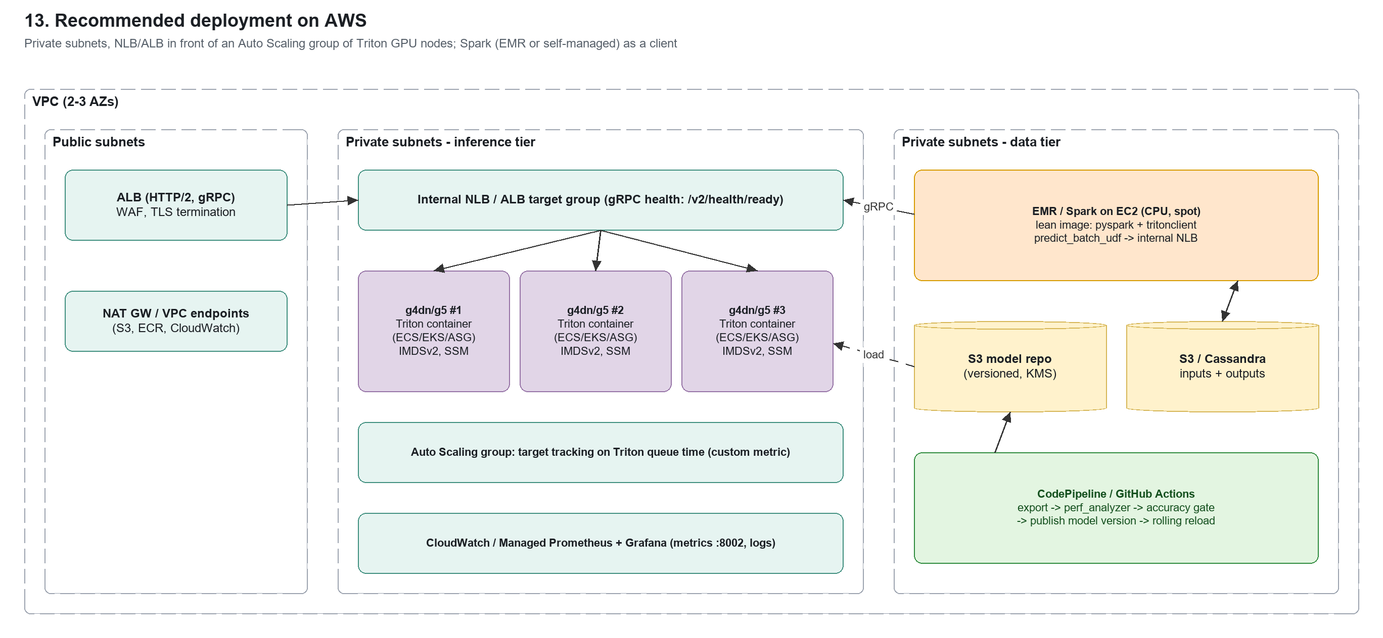

12.6 Air-gapped deployment
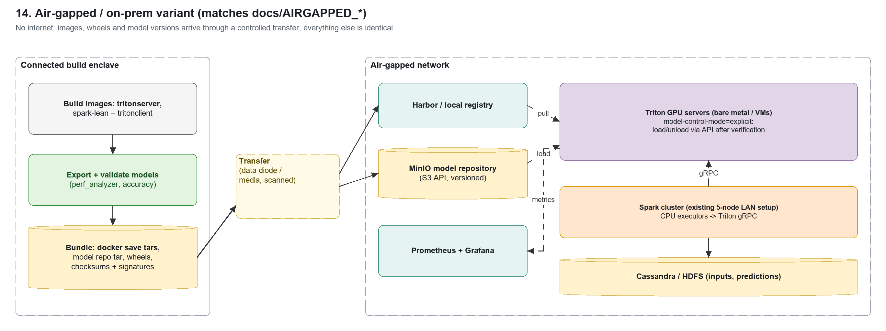
Matches the repo's air-gapped process (docs/AIRGAPPED_*): build and validate in a connected enclave, transfer signed image tars + the model repository, run Triton with --model-control-mode=explicit and load versions only after checksum/accuracy verification. Triton's container already includes all backends, so no pip wheels are needed on the Triton side; Spark only needs tritonclient[grpc] added to the lean image.

12.7 Migration plan
- Stand up Triton next to the current cluster (one GPU node), export the 10 models with benchmark/triton_export.py (extend EXPORT), verify outputs against eager PyTorch (already automated with --verify).
- Switch the batch engine to predict_batch_udf + Triton behind a flag (--engine triton in submit_job.py) - same inputs, same outputs, compare throughput and accuracy on real data.
- Move ingestion to Parquet/Arrow and drop the driver-side list building; keep repartition only where the input layout requires it.
- Convert the heavy CNN/YOLO models to ONNX/TensorRT fp16 and enable Tensor Cores; re-tune max_batch_size and instance counts with perf_analyzer.
- Add the access tier and observability (LB, auth, Prometheus/Grafana dashboards on queue time and achieved batch size) and route online callers to the same Triton pool with higher priority.
- Retire GPUs from Spark workers (lean image, CPU-only executors, spot capacity) once all models are served by Triton; keep GPU-aware in-process mode only for models that cannot be exported.

12.8 Risks and mitigations
risk | mitigation
Network bandwidth for large tensors | send compressed inputs + server-side preprocessing; co-locate Triton and Spark in one AZ/placement group; shared-memory transport for sidecar deployments
Triton becomes a single point of failure | >= 2 nodes behind the LB, health checks, client retries with idempotent requests, circuit breaker in make_predict_fn
Model export differences (TorchScript/ONNX) | automated --verify against eager outputs (max abs diff) in model CI; block publish on regression
Batch jobs starving online traffic | request priorities, separate model configs/instances for online, rate limiter
Version skew between jobs and models | pin model version in the request (model_version) and record it with every prediction

13. Alternative architectures

13.1 Triton sidecar on every GPU worker
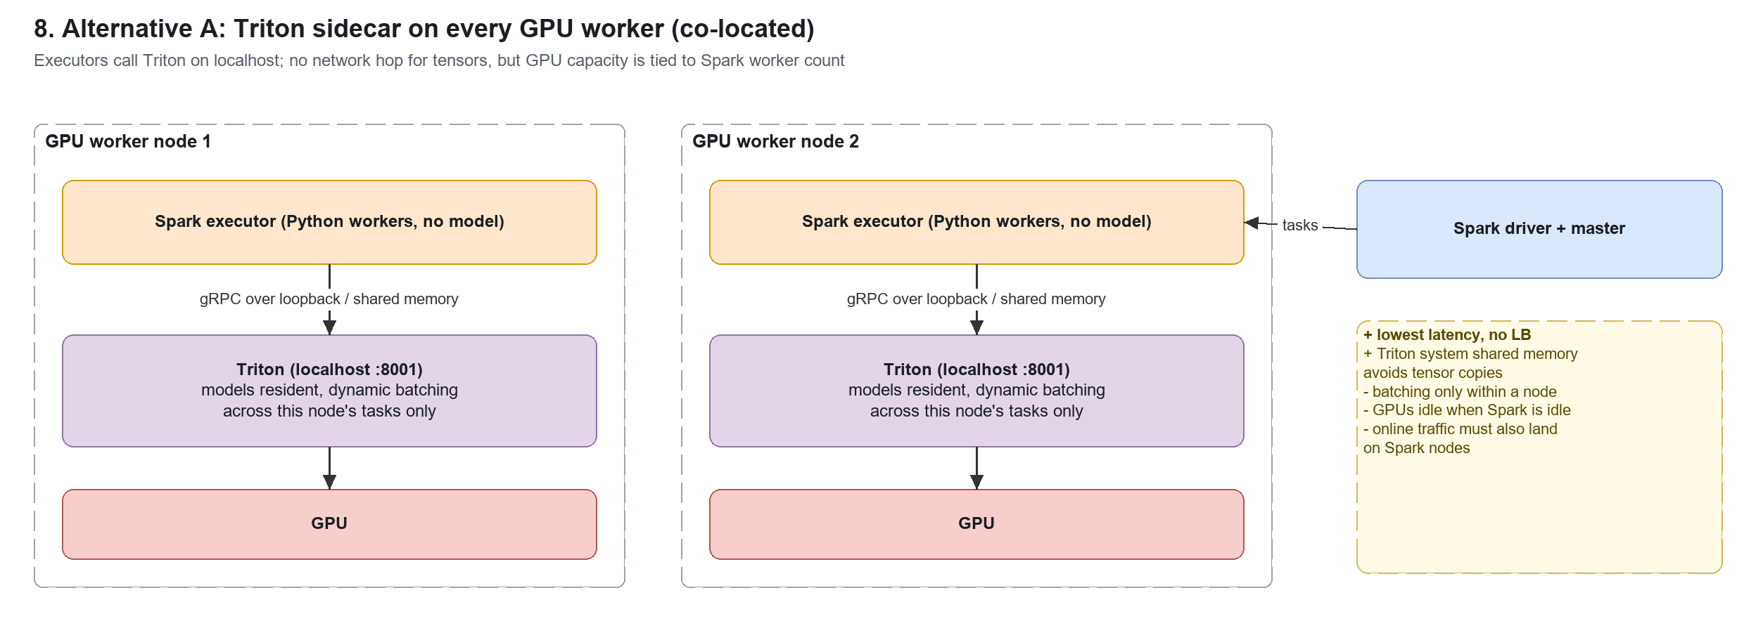

13.2 Keep in-process inference, fix its overheads
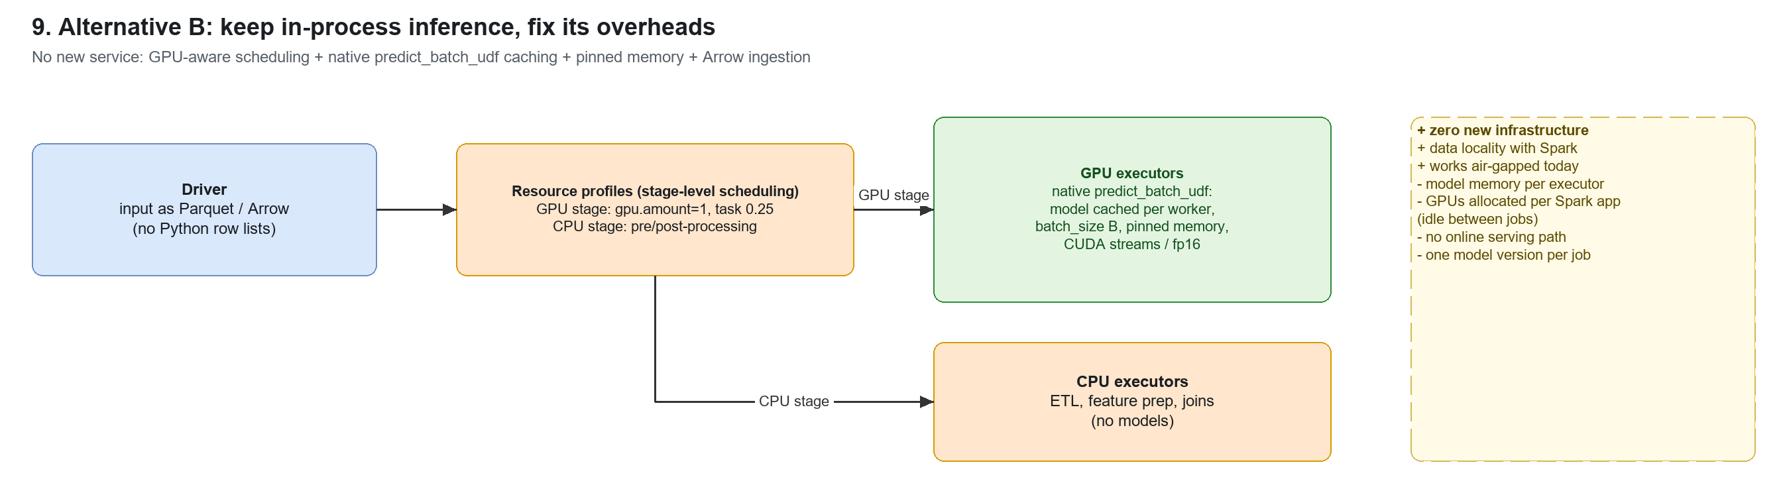

13.3 Ray Data + Ray Serve
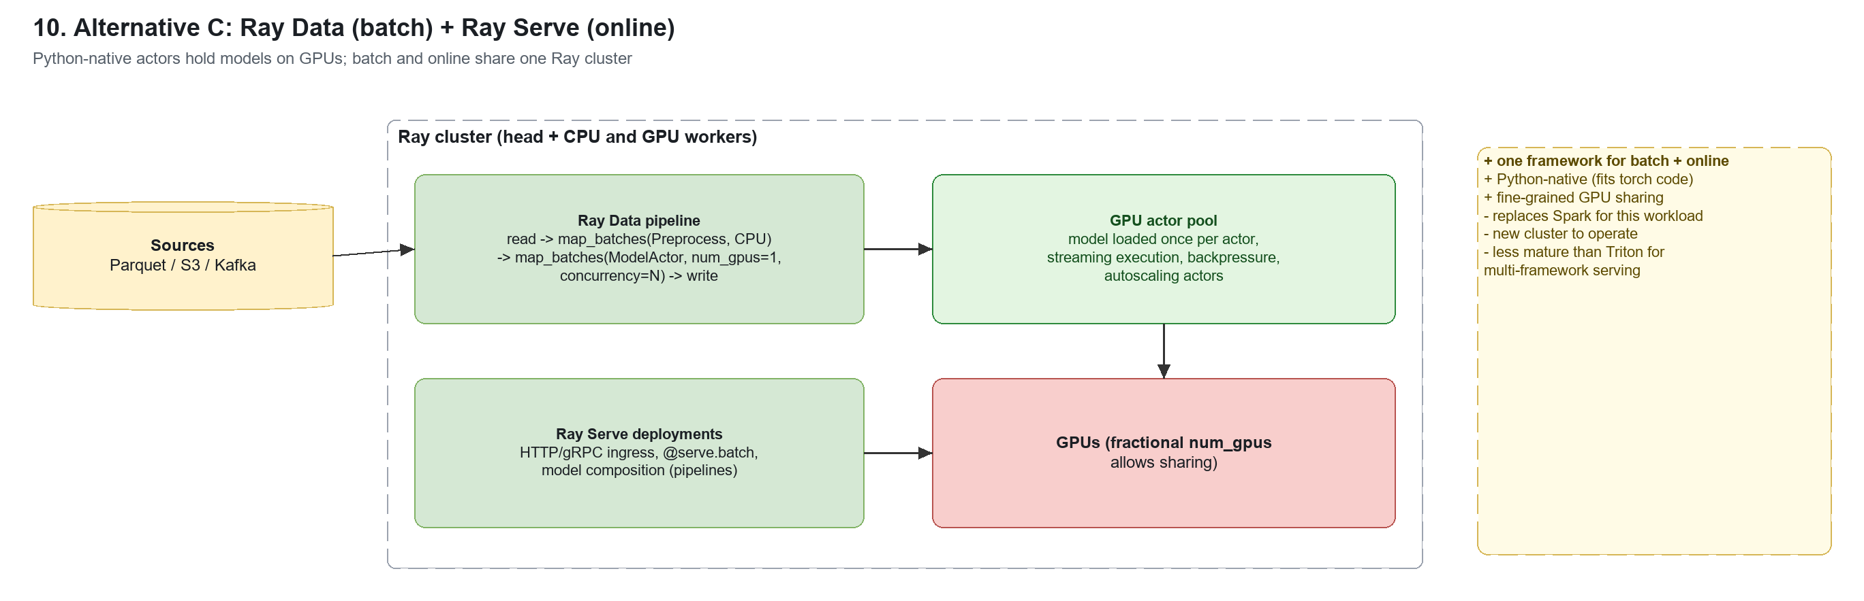

13.4 Kubernetes: Spark on K8s + KServe (Triton runtime)
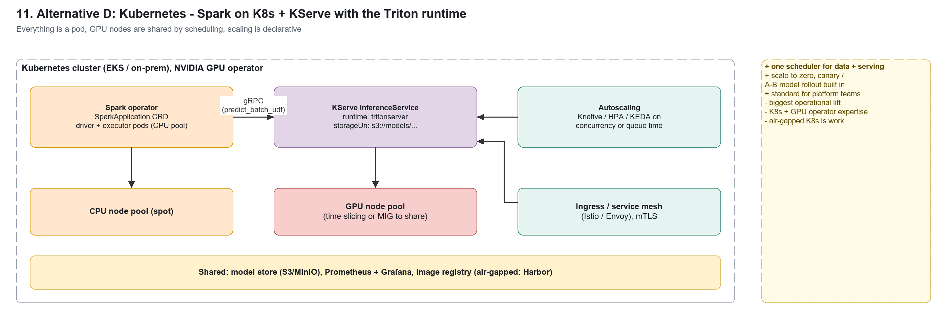

13.5 Asynchronous, queue-driven inference
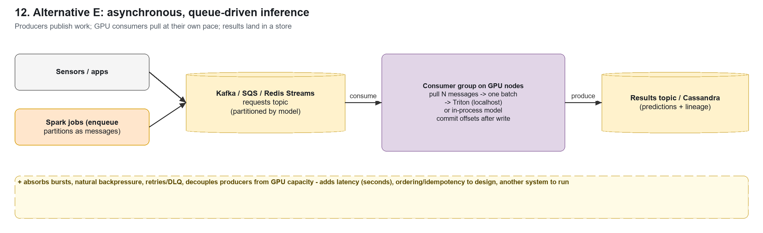

13.6 Comparison
criterion | Recommended: Triton tier | Triton sidecar | In-process (improved) | Ray Data + Serve | K8s + KServe | Queue-driven
batch throughput | high (cross-task batching) | high per node | high with caching | high | high | high, bursty
online serving | yes, same deployment | awkward (on Spark nodes) | no | yes (Serve) | yes | async only
GPU utilisation | high, shared | tied to Spark nodes | per app, idle between jobs | high | high (+ scale to zero) | high
latency | ms | lowest (loopback) | n/a (batch) | ms | ms | seconds
new infrastructure | Triton + LB | Triton per node | none | Ray cluster | K8s platform | broker + consumers
operational effort | medium | low-medium | low | medium-high | high | medium
air-gapped fit | good (containers + MinIO) | good | best (today) | medium | hardest | good
change to Spark code | UDF swap | UDF swap | engine fixes | rewrite pipeline | UDF swap + K8s | producer/consumer
choose when | GPUs shared by batch + online, many models | latency-critical batch on fixed GPU nodes | no new services allowed | team prefers Python-native end to end | platform already on K8s | bursty producers, results can lag

Appendix A - task timelines for every run
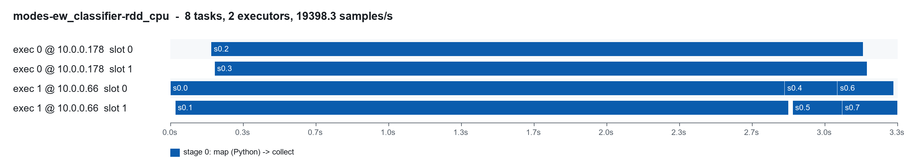
ew_classifier - rdd_cpu
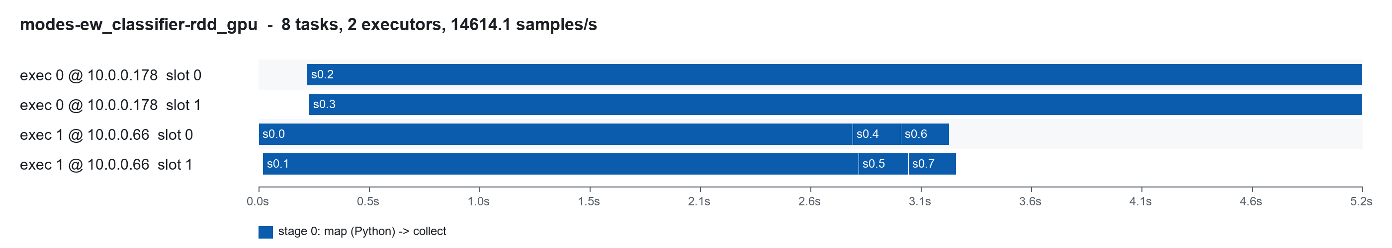
ew_classifier - rdd_gpu
ew_classifier - rdd_hybrid
ew_classifier - rdd_gpu_aware
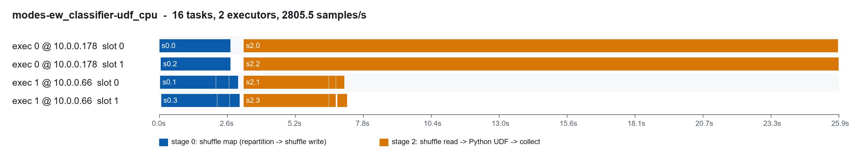
ew_classifier - udf_cpu
ew_classifier - udf_gpu
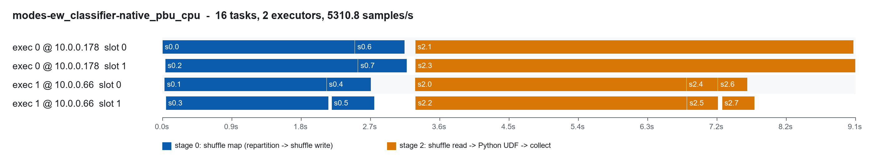
ew_classifier - native_pbu_cpu
ew_classifier - native_pbu_gpu
ew_classifier - triton_pbu
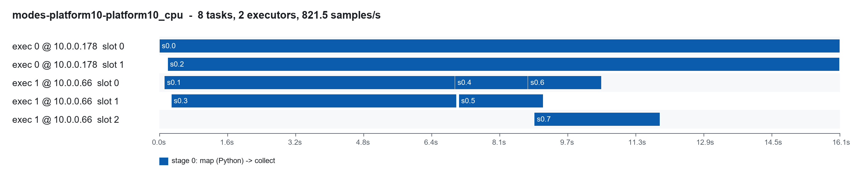
platform10 - platform10_cpu
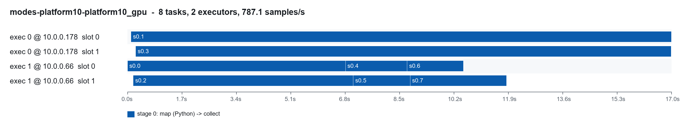
platform10 - platform10_gpu
platform10 - platform10_hybrid
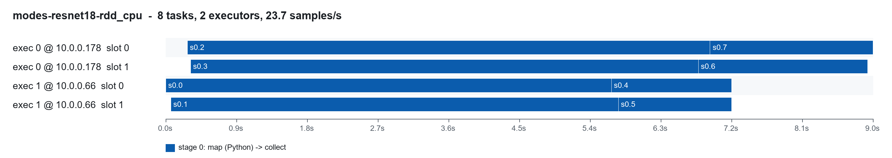
resnet18 - rdd_cpu
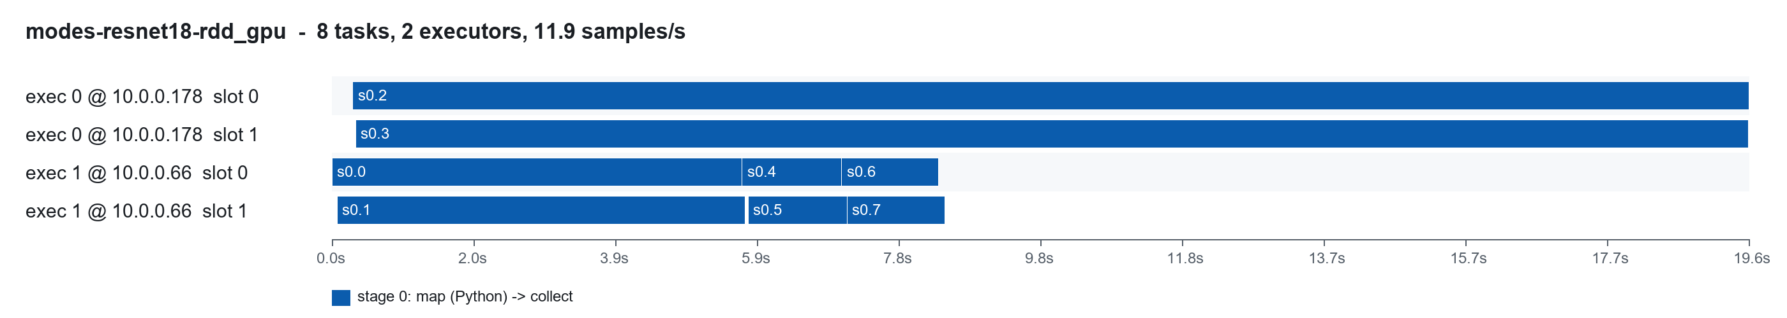
resnet18 - rdd_gpu
resnet18 - rdd_hybrid
resnet18 - rdd_gpu_aware
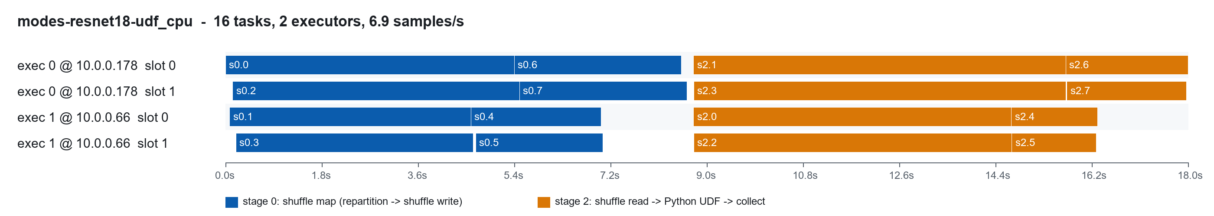
resnet18 - udf_cpu
resnet18 - udf_gpu
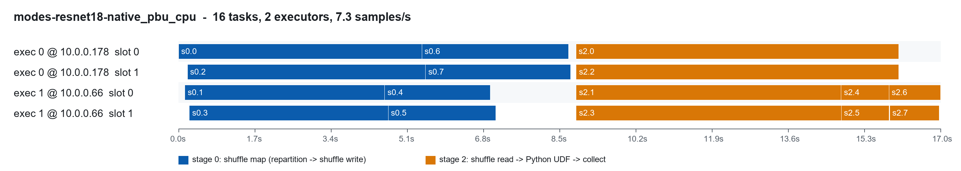
resnet18 - native_pbu_cpu
resnet18 - native_pbu_gpu
resnet18 - triton_pbu
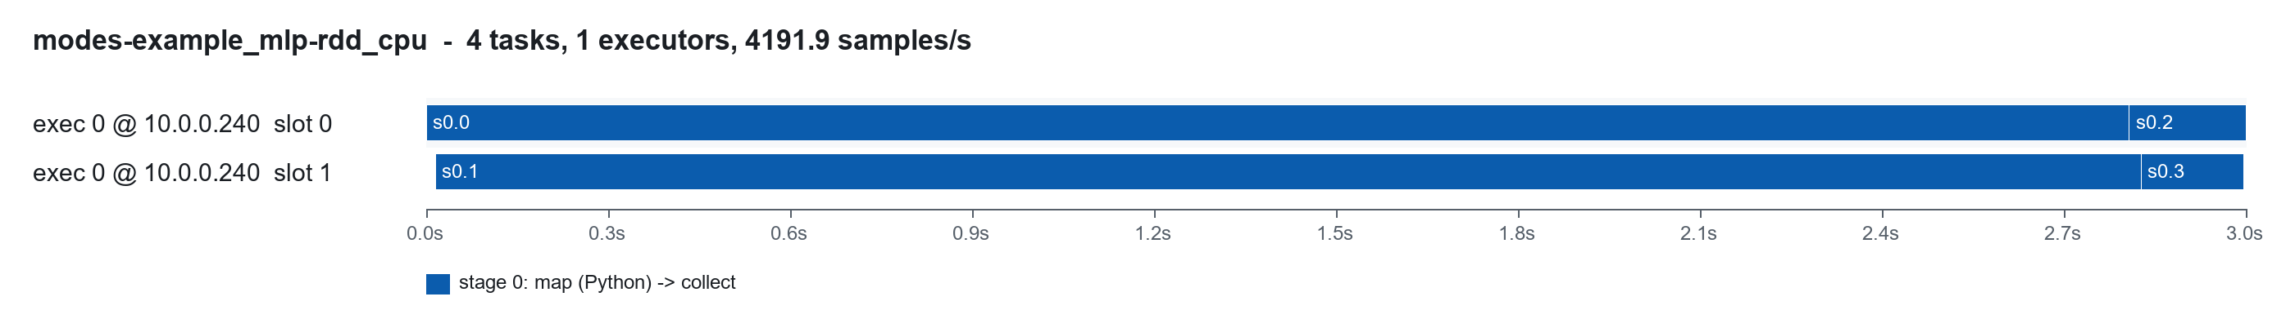
example_mlp - rdd_cpu
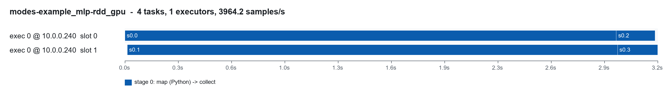
example_mlp - rdd_gpu
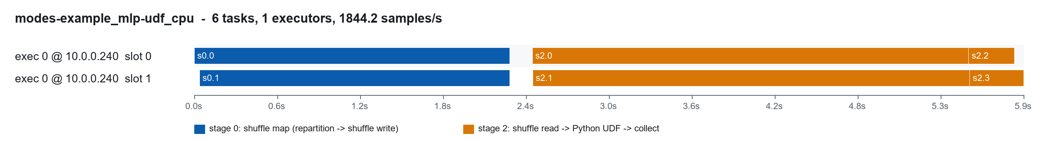
example_mlp - udf_cpu
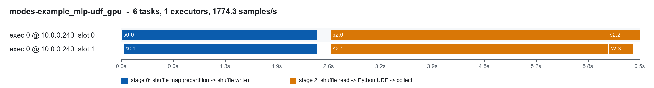
example_mlp - udf_gpu
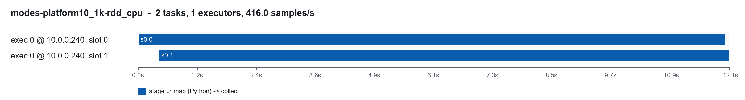
platform10_1k - rdd_cpu
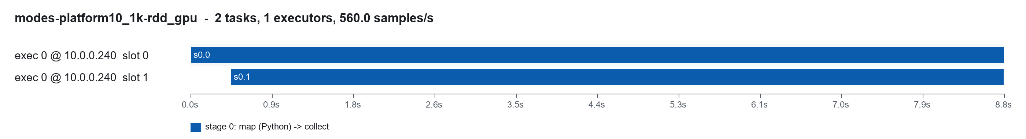
platform10_1k - rdd_gpu
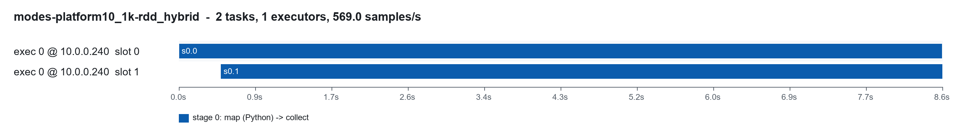
platform10_1k - rdd_hybrid
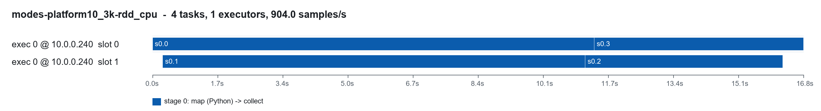
platform10_3k - rdd_cpu
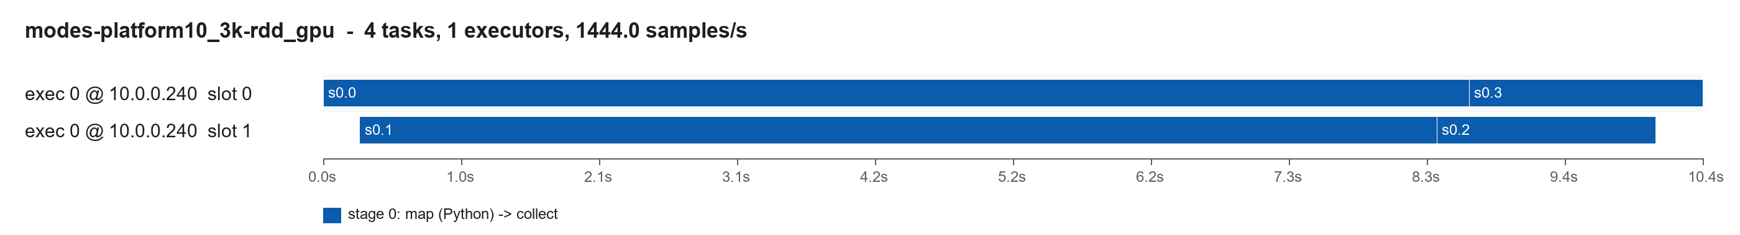
platform10_3k - rdd_gpu
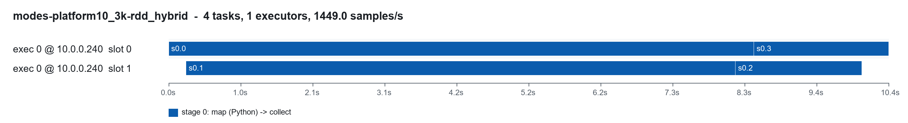
platform10_3k - rdd_hybrid
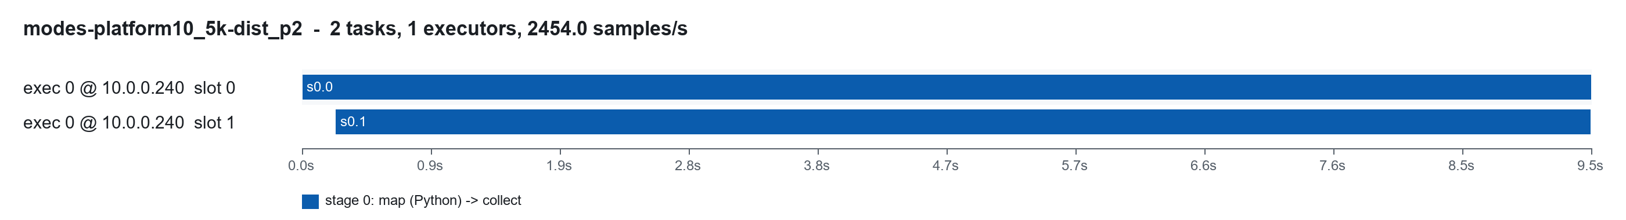
platform10_5k - dist_p2
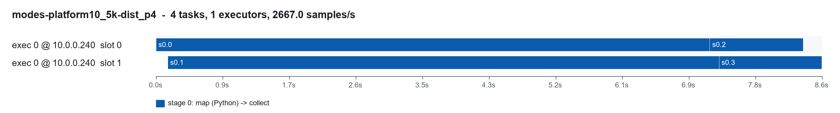
platform10_5k - dist_p4
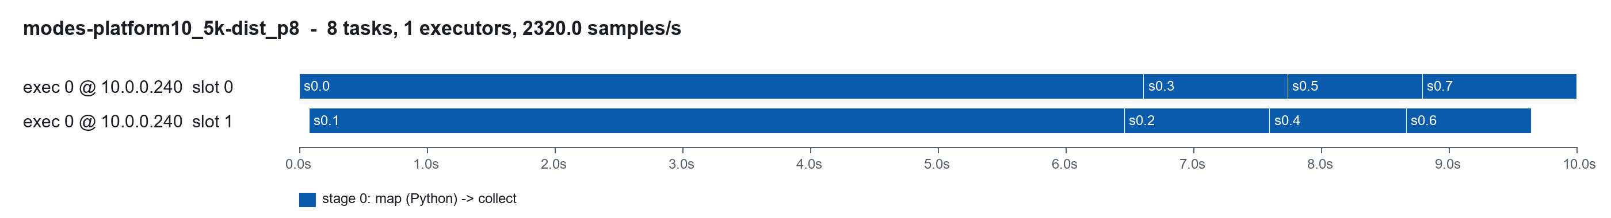
platform10_5k - dist_p8
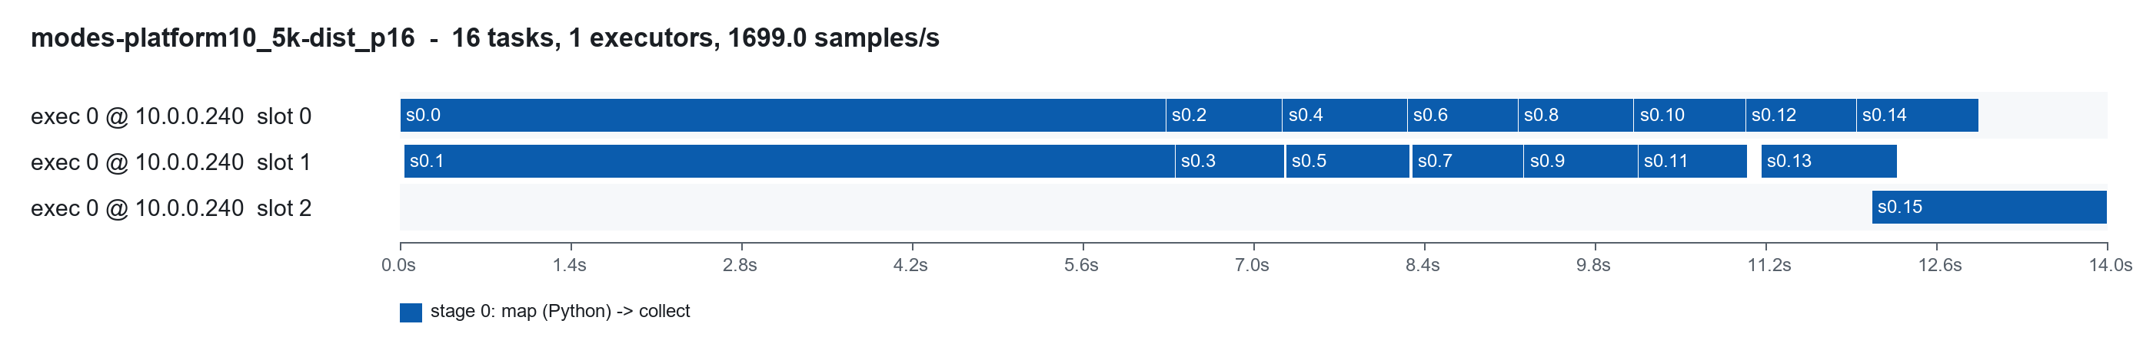
platform10_5k - dist_p16

Appendix B - files and how to reproduce
path | contents
deploy/run_aws_modes.ps1, deploy/scripts/modes_node.sh | deploy the 2-node stack, build, start Spark + Triton, run, collect, destroy
deploy/aws-cdk/spark_cluster/modes_cluster_stack.py | SparkModesClusterStack (CDK)
benchmark/spark_modes_stats.py | runs every mode as its own Spark application
benchmark/triton_export.py | TorchScript model repository + --verify against eager PyTorch
benchmark/analyze_modes_stats.py, benchmark/modes_charts.py | statistics, task timelines, charts
benchmark/build_modes_docx.js, benchmark/modes_doc_text.js | this document
docs/diagrams/build_diagrams.py -> spark_inference_architectures.drawio | all diagrams (15 draw.io pages) + PNGs
results/modes_20260926/aws_2node/ | event logs, executor logs, Triton metrics/configs, GPU dmon, summaries

.\deploy\run_aws_modes.ps1 # ~1.5 h, ~$1.5, destroys the stack
python benchmark/analyze_modes_stats.py results/modes_20260926/aws_2node
python benchmark/modes_charts.py results/modes_20260926/aws_2node
python docs/diagrams/build_diagrams.py
node benchmark/build_modes_docx.js

