Comparative Analysis of Classification Algorithms for Diabetes Detection

^{1,a)}Siddique Ibrahim ,^{1,b)}V.Krishna Chiatanya,^{1,c)}N.Bhuvanesh,^{1,d)}K.V.Pavan Kumar,^{1,e)}A.V.N.S.S .Samanvi,^{1,f)}J.Yaswanth
¹School of Computer Science and Engineering VIT-AP University, Amaravati, Andhra Pradesh, India
- Corresponding author:siddique.ibrahim@vitap.ac.in
- krishnavejendla34@gmail.com
^{c)}bhuvaneshnadellal7@gmail.com ^{d)}vpkr2004@gmail.com ^{e)}samanvikrishna1999@gmail.com
^{f)}jaladiyaswanth2005@gmail.com

Abstract--Diabetes diagnosis has gradually upgraded by the applying the classification mining strategiesThis results helps us in finding different machine learning algorithms, such as Support Vector Machines (SVM),Decision trees and Neural Systems, in predicting diabetes based on data of the patients. Utilizing datasets from sources like the National Institute of Diabetes and Digestive and Kidney Diseases,we evaluated the classifiers based on F1 score,recall,precision and accuracy. Our findings demonstrate that while every strategy provides valuable insights, some computations, such as SVM and neural systems, have common predictive performance. This inquire about underscores the potential of classification mining to progress demonstrative exactness and bolsters its integration into clinical hone for early and solid diabetes location. Random Forest Algorithm has highest accuracy of 96.07% among all models. Cross Validation is also performed ,the box plot(Fig-4)shows the accuracy scores on each model .
Keywords-- Diabetes Prediction, Health Informatics,Model Evaluation Metrics,Machine learning Classification

INTRODUCTION
Diabetes mellitus refers to a broad class of disease of a very long duration which results in abnormal elevation of glucose level in the blood due to lack of insulin production or its improper utilization. Diabetes has become a sensitive health issue throughout the World as it affects millions of people and causes extensive complications such as heart disease, kidney disease, and nervous disorders. Timely identification of problems and treatment of diabetes is important to avoid issues and complications. On the other hand, people who are diabetic needs more careful observation using traditional methods, that include constantly checking blood and urine which are very intrusive, slow, and expensive. Because of this, many people are using more sophisticated methods of classification mining for diagnosing diabetes which is a huge boon in this field These methods are, however, more direct, more precise, and do not need to harm the organism's integrity.
Classification mining, like other varieties of data mining, entails the classification of vast and intricate data sets in an effort to make notice of the amalgamation of features and to understand relations within these features. For example, using Decision Trees, Naïve Bayes, and Random Forest, researchers using other algorithms try to develop a classifier which will predict whether a patient is diabetic or not from the medical history of the patient. These models are trained on available datasets containing people with and without diabetes. As a result, the models learn to identify new data points and expect positive or negative results.
Their precision and efficacy are related to many aspects such as dataset quality, methods of preprocessing, and the algorithms. Models are now more creative and sophisticated due to social problem, psychological study and new advancements in machine learning, hitting the mark not only on the increased accuracy but also giving information about the main risk factors of diabetes. Some approaches like feature selection are also used to enhance the classification model and to reduce the data dimensions, such as use of Principal Component Analysis (PCA) and Recursive Feature Elimination (RFE). Having all these connections will help formulate a more robust machine-learning algorithm with careful selection of training data labelled with appropriate classes.

In this paper, the objective is to review and compare different classification mining techniques to make more accurate algorithms for diabetes diagnosis. These algorithms are considered with various degrees of importance, and their strengths and weaknesses are reviewed so that more accurate and efficient diagnostic tools could be developed which may change the diabetes early detection and management system. The purpose of this paper, is to analyze and compare various classification mining techniques for the diagnosis of diabetes.The study aims to help develop more effective and precise diagnostic tools that might help in early diabetes detection and management by studying the performance of various algorithms and comparing their advantages and disadvantages.

OBJECTIVES

- Comparing the different machine learning models how they predict diabetes using different parameters like recall, precision,accuracy and F1-scores.
- To see how data pre-processing and feature selection results in performance of machine learning models for diabetes detection.
- Going through cross-validation and hyperparameter changes to increases the accuracy of models for predicting diabetes.

ACRONYMS
- NB: Naïve Bayes
- RF: Random Forest
- DM: Diabetes Mellitus
- SVM: Support Vector Machine
- ROC: Receiver Operating Characteristic
- DT:Decision Tree

OVERVIEW
A chronic medical condition like diabetes mellitus (DM) can be identified by high blood sugar levels caused by either insufficient insulin secretion or less insulin use than required. Early diabetes detection and treatment are crucial as they reduce the chance of more serious effects. Coronary heart disease or stroke, are more likely to people with diabetes which could go undetected and even be fatal. While detection using these approaches is not very efficient, a better method of testing with high accuracy rates is brought about with the help of classification mining and other data-centered methods[1].
With the help of machine learning (ML) algorithms that make use of clinical parameters like age, ancestry, body glucose level, BMI, family history, etc., classification mining is the process in which one predicts whether a patient has diabetes or he does not. Artificial Neural Networks (ANN), Naïve Bayes (NB), Support Vector Machines (SVM), and Decision Trees (DT) are few examples of standard methods. Performance can be improved by combining different classifiers to boost detection rates by using important methods like Random Forest (RF) and ensemble methods like XGBoost. Along with this, the model gains benefit from making normal and feature selection methods like Principal Component Analysis (PCA)[2,3,4,5].
Going through several classification strategies and evaluating them for diabetes diagnosis is the aim of this work. The aim of this study is to make a better and efficient diabetes prediction model.
TYPES OF DIABETES
- Type 1 Diabetes occurs when body is unable to produce suffient amount of insulin.It generally occurs in children and adults taking insulin throughout the life is only treatment.
- Type 2 Diabetes is the most common. The body has developed an insensitivity to insulin or just does not secrete enough to meet the needs of the body. It can be prevented by taking proper diet and doing exercises.
- Gestational Diabetes is a type of diabetes that grows during pregnancy period and mostly goes away after child birth, but the risk of getting Type-2 diabetes is high.
- Maturity Onset Diabetes of the Young (MODY) is an extremely rare genetic form of diabetes resulting from a gene mutation that occurs in younger populations.

Most Important Type: Type 2 Diabetes
In diabetes affected people 90% of them are effected by Type 2 diabetes.We already know that we should follow proper diet and not obesity to avoid Type 2 diabetes buit in must developing nations it is not followed.This significantly caused in increase of type 2 diabetes. These days, one of the top priorities in public health and diabetes related researches is the achievement of these objectives when it comes to Type 2 diabetes Type 2 diabetes is preventable, and its emergence can greatly impact punishment[6].

SYMPTOMS, DIAGNOSIS AND TREATMENT
Symptoms of diabetes could change depending on the type and the degree of severity, but typical symptoms consist of:
1. Blurry vision
2. Delay in healing of wounds
3. Unintentional weight loss
4. Frequent hunger pangs
5. frequent urination
6. Greater thirst
7. presence of ketones in urine
8.Numbness or tingling in hands and feet
9.Dry skin and frequent itching
Diabetes is start for so many health problems in the body so it should be found so early and be treated.
Above mentioned symptoms are the most symptoms seen by the person effected by type 1,type 2 diabetes.
For different types of diabetes below mentioned are the treatment or cure for the diabetes,
Type 1 Diabetes: continuous blood sugar monitoring and taking insulin on daily basis
Type 2 Diabetes: Lifestyle changes like dieting, exercise, oral medications recommended by the doctor, and sometimes using insulin.
Gestational Diabetes: Diet, exercise, and occasionally insulin during pregnancy care mandatory
All the above-mentioned types require regular blood sugar monitoring.

RELATED WORK
For more than ten years, the use of predictive models to identify diabetes has been a important field of research. The high majority of researchers focus on using artificial neural networks (ANNs) and clustering computations to increase warning accuracy. Regardless, there has been a continuous need to develop more advanced, faster, and instinctive models[7].
One study grouped diabetes patients using three methods:
1) Hereditary Calculation (GA)
2) H-means+ clustering
3) EM calculation.
When assembling similar indicators into groups, H-means+ clustering did better than alternative methods and proved effective in spotting patterns in data
Diabetes has also been determined using fuzzy insect colony optimization (ACO), specifically with the Pima Indian Diabetes dataset. This approach was successful in creating guidelines that could help identify diabetics patients with higher accuracy.
By examining 13 early side effects, another neural network-based study shown how valuable it is to combine advanced computations with real-time continuous data in order to predict diabetes. It proved useful to use MATLAB to create a demonstration that could identify diabetes at an early stage more accurately.
Other machine learning techniques, like Random Forest and Calculated reverting, have also been linked to diabetes diagnosis along with these methods. Although it seems compromising, these tactics include lengthy preparation times and significant parameter adjustment, which can limit their practical application in real-time therapeutic contexts.
Although there is progress in these areas, there is still a long gap in developing models that combine highlight determination with probability-based categorisation to improve computing efficiency and accuracy. Earlier research has employed complex, time-consuming techniques, frequently using weighted procedures that needs extensive handling control and are not suitable for real-time diagnosis.
Along with this, this show might be compared globally, and more research suggests that datasets from diverse populations can be combined. The accuracy and generalisation of the predictive show may be improved if data that is not used to its fullest extent becomes available, mainly from various geographic regions, making it a more useful tool for global healthcare systems. Future research may also bring into research other cutting-edge techniques, like deep learning, promote progress in expectations, and shorten the time required to finish.

METHODOLOGIES
A)Dataset Description and Data Modelling
The Pima Indians dataset is a medical dataset used for predicting diabetes in women of Pima Indian heritage. It includes 768 samples with 8 features, such as the number of pregnancies, glucose levels, BMI, and age. The target variable indicates whether a patient has diabetes. The dataset is widely used for binary classification tasks in machine learning, particularly for testing algorithms like logistic regression and decision trees. It also includes some missing or invalid values, making it useful for data preprocessing exercises[8].
The study investigates the use of Random Forest, Gradient Boosting, and Decision Trees as data mining tools to identify diabetes. The major goal is to use data mining techniques and the available medical data to predict if the patient has been impacted by diabetes. The Pima Indians Diabetes dataset has undergone data mining using the classification type.Table -1 tells about numbers of attributes present in dataset and instances present.Table – 2 gives a description of dataset we have taken into consideration.Figure 1 shows attributes Co-relation.Figure 2 shows class attribute detection.Figure 3 shows value ranges of different attributes[2,3,4,5,8].
Dataset | Number of Attributes | Number of Instances
Pima Indian Diabetes | 9 | 2000
Table 1. Dataset Information and Description

Table 2. Description Of Each Attribute
S.No | Attribute | Description[datatype]
1 | Pregnancies | 2000 non – null int 64
2 | Glucose | 2000 non – null int 64
3 | Blood Pressure | 2000 non – null int 64
4 | Skin Thickness | 2000 non – null int 64
5 | Insulin | 2000 non – null int 64
6 | BMI | 2000 non – null float 64
7 | Diabetes Pedigree Function | 2000 non – null float64
8 | Age | 2000 non – null int 64
9 | Outcome | 2000 non – null int 64
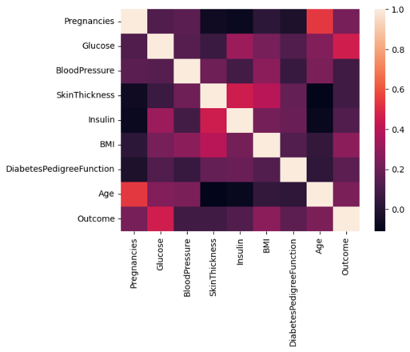

Figure-1: Co-relation between attributes

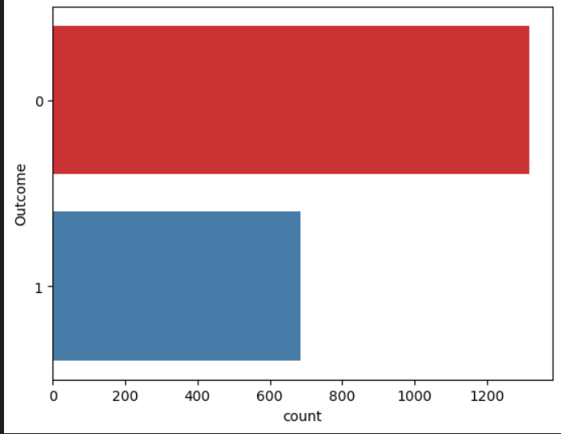
Figure-2: Class Attribute Detection (0-means tested -ve ,1-means tested +ve )
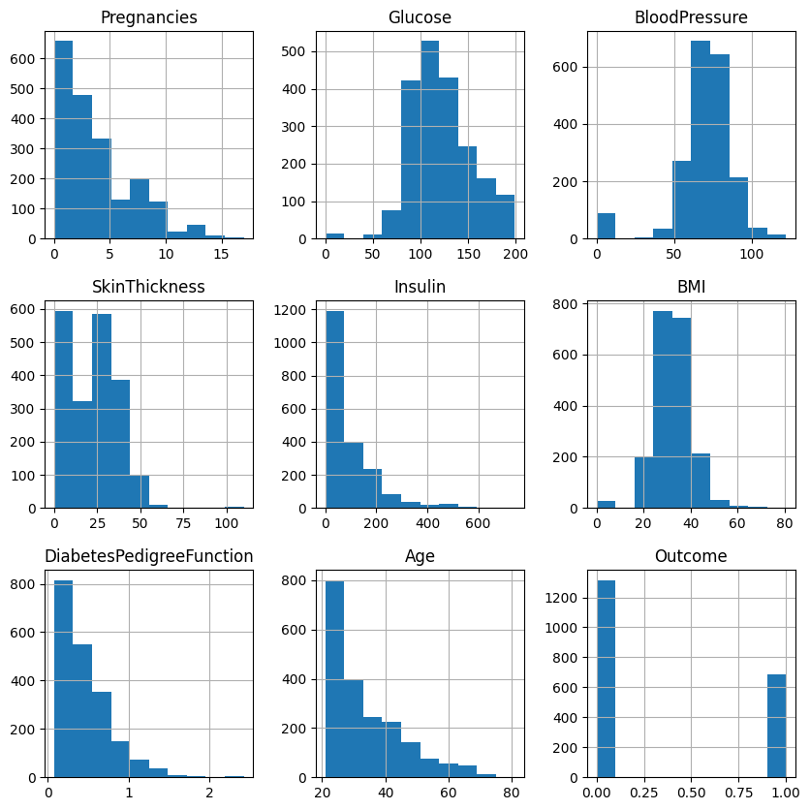
Figure-3: Histograms of the different attribute
B) Data Pre-Processing
Generally in processing starts with by handling missing data, which is common in real-world datasets. This can be done by either removing records with missing values or imputing them with the mean, median, or mode of the available data. Feature scaling is then applied to standardize the range of numerical features like glucose levels and BMI, so that no single feature dominates the model.We use Normalization and standardization for bringing all features in data set to a common scale. We use NLP topics like onehotencoding for bringing categorical variables into 0 and 1.which is easy for machine learning models.
Outliers and extreme values which effect the models performance.Normally for finding outliers we use methods like IQR and z-score by normalizing the values. Finally, feature selection and dimensionality reduction techniques are applied to ensure the model focuses on the most relevant features.We also remove variables which are not that much helpful in dataset helps in achieving higher accuracy. Dimensionality reduction techniques, such as principal component analysis (PCA), can further simplify the dataset while retaining essential patterns. All these above mentioned pre-processing helps us in achieving reliable predictions in diabetes prediction.
The process involves filling the missing values with mean of the variables, scaling features with StandardScaler, and use PCA for dimensionality reduction, ensuring the dataset is made for improved performance in machine learning models.
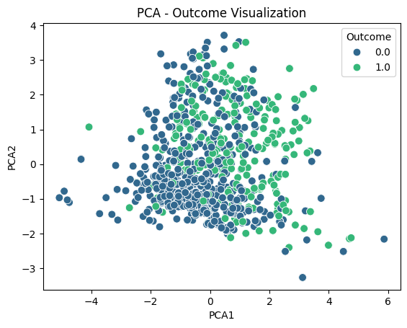
Figure - 4: Missing Data Handling

C) Cross-Validation
This is a model evaluation method which splits the data into multiple parts (folds) and after trains and validates the model with different folds to achieve better performance.
The classifiers' performance was evaluated using 10-fold cross-validation. This is a very popular technique to validate the models and is particularly useful for avoiding overfitting and for validating the generalization error. StratifiedKFold was used to divide the dataset into 10 equally sized parts, such that the percentage of diabetes and non-diabetic cases was the same in every partition. All the models mentioned were trained on 9 folds and tested on the last fold. Here the models are tested and trained 10 times.
Generally SVM is not efficient with feature magnitude,so we already applied Standardscalar.We also calculated the mean accuracy and standard deviation to determine the performance of the model and how much the performance metrics differs in each folds, after performing the cross-validation. This allowed us to come up with a more generalized measure of the performance without being too biased or variable due to a single train-test split.Figure 5 contains information about cross validation reports of different models[9,10,11].
D) Hyper Parameter Tuning and its effect on Reliabilty
Tuning hyperparameters is an integral step of building a machine learning model. Even though model parameters are derived from the training dataset, hyperparameters are set prior to the dataset being learnt, and determines the training process of the model. Hyperparameters are learning rates, regularization parameters, or the number of trees in a random forest, or even the kernel functions in support vector machines. These hyperparameters, when optimized proper, can tremendously increase the model performance.
The accuracy, precision, recall, and other metrics may be improved by the alteration of hyperparameters if a suitable trade off between underfitting and overfitting is achieved. The tuning process increases a model’s performance on new data, making it more accurate and dependable, which is especially important when such models are used in practice.Methods for Hyperparameter Tuning
1. Grid Search: With grid search, each parameter will be tested systematically. Though it guarantees desired results, the process can be highly computationally expensive.
2. Randomized Search: The way Randomized search works is that it takes random combinations of the parameters and tries them out. Even though not every possibility may be attempted, this approach can be effective especially if there are more parameters than normal.
3. Bayesian Optimization: This technique is far more effective than grid or randomized search because it capitalizes on the association that exists amongst hyperparameters and the evaluation metric in a specific manner conducive to faster computations. Evaluation Metrics in Hyperparameter Tuning
The efficiency of hyperparameter tuning is frequently assessed using approaches such as cross-validation, which involves training and validating the model numerous times on different splits of the dataset. This ensures that the hyperparameters generalize effectively to new data and do not overfit a specific training set[12].
Example: Tuning Hyperparameters in SVM.
The hyperparameters of an SVM consist of the regularization parameter “C”, the kernel type, and ‘γ’ (if an RBF kernel is used, gamma is also a parameter).These should be chosen carefully if wrongly selected it affects the whole model.
This is a crucial step in training machine learning models.It is important to select the right one from the three– is crucial, as is the subsequent cross validation analysis, so that the model is robust enough to be put into practice. Tuning in particular has greatly benefited from better visualization techniques which help in understanding these models and makes the process more efficient[3].

Tuning Random Forest...
Best parameters for Random Forest: {'max_depth': None, 'min_samples_leaf': 1, 'min_samples_split': 2, 'n_estimators': 100}
Best accuracy for Random Forest: 0.9765
Tuning Gradient Boosting...
Best parameters for Gradient Boosting: {'learning_rate': 0.2, 'max_depth': 5, 'n_estimators': 100, 'subsample': 0.8}
Best accuracy for Gradient Boosting: 0.9795
Tuning SVM...
Best parameters for SVM: {'C': 10, 'gamma': 'auto', 'kernel': 'rbf'}
Best accuracy for SVM: 0.8760000000000001
Hyper Parameter Tuning helps in improving efficiency. By the help of parameter tuning for instance Grid Search or Randomized Search, you model the performance of different hyperparameter configurations to determine which one produces the best results (accuracy, precision, recall, etc. this helps in model generalization and deals better with problems like underfitting and overfitting)[12].
E)Results:
Random Forest[2] Accuracy Scores: [0.99 0.99 0.975 0.99 0.975 0.99 1. 0.995 1. 0.985]
Random Forest Mean Accuracy: 0.9889999999999999
Random Forest Standard Deviation of Accuracy: 0.008306623862918082
Gradient Boosting [5]Accuracy Scores: [0.865 0.845 0.835 0.86 0.85 0.9 0.89 0.88 0.9 0.85 ]
Gradient Boosting Mean Accuracy: 0.8675
Gradient Boosting Standard Deviation of Accuracy: 0.022388613177238132
SVM [3] Accuracy Scores: [0.84 0.8 0.785 0.83 0.84 0.825 0.865 0.855 0.825 0.815]
SVM Mean Accuracy: 0.828
SVM Standard Deviation of Accuracy: 0.02282542442102664

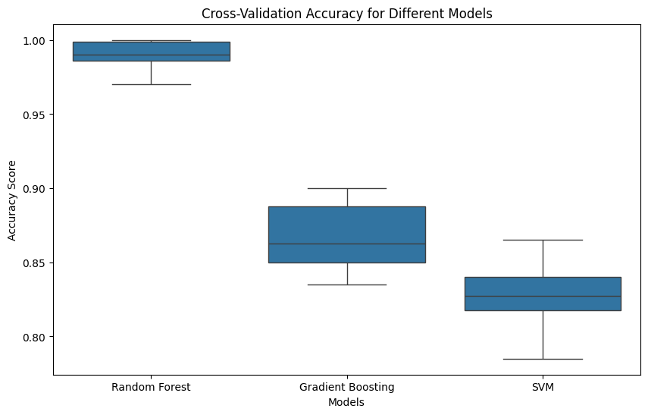
Figure 5: Cross Validation Box Plot

RESULTS AND ANALYSIS

SVM
To distinguish many classes, SVM is a convenient decision function that finds the best hyperplane.Support vectors means finding the distance between two hyperplanes. SVM performs the transformation of the input data with the help of kernel functions, which enables it to work equally well with linear and nonlinear data. That is why SVM is particularly effective when dealing with a large number of features, for example, in the problem of detecting diabetes, where the class separation is crucial for making the correct predictions.SVM is used for solving both linear and non linear datasets, and uses kernels to enhance the classification margins. As a result, SVM is widely employed in areas that require sophisticated data and clear cut decisions such as diabetes diagnosis. SVM is generally better than logistic regression, decision trees, and K-nearest neighbors in the diagnosis of diabetes. The capability of analyzing multiple features without overfitting enhances the precision. Even though SVM is more computationally costly than simpler models such as Naive Bayes, its robustness and accuracy make it one of the best medical prediction algorithms available[3,13].

GRADIENT BOOSTING
Gradient boosting is a important and powerful technique used for both classification and regression.It uses multiple weak learners and combine them to form a strong model. New models are fit in a way that they reduce the errors of the prior models by fitting to the residuals left from earlier models and subsequently minimizing a specific loss function.With this continuous process it will become easier for gradient boost to decreases the errors made by the model int previous steps. The algorithm is also capable of incorporating regularization to address overfitting, which makes it suitable for tasks such as diabetes detection that require a deeper understanding of the data. The study increases the accuracy of diabetes prediction by employing gradient boosting methods on the Pima Indians Diabetes Database. Gradient boosting constructs an ensemble of decision trees in a sequential manner where each tree is optimized to reduce the errors of its predecessors. This approach helps capture the intricate associations between the features and the target variables, improving classification performance even more, as in the case of BMI and glucose level. Research shows that gradient boosting outshines traditional classifiers in analytics by providing useful insights on critical predictive features and validating its efficacy in medical decision making for diabetes treatment[5].

RANDOM FOREST
Throughout its training time, the random forest makes use of many decision trees and uses the ensemble learning technique. To improve prediction rate, the output from every tree is observed and combined together. A random sample of the dataset is chosen for each tree, and some of its features are used to reduce overfitting and provides generalisation. Single trees are less accurate than random forests as random forests combine predictions through voting. Large and complex data can be handled by the algorithm, which makes it very important for complex applications like diabetes detection where many variables interact with each other. Random Forest cannot be used until the Pima Indians Diabetes Dataset has been loaded, the target variable and features have been separated, and training and testing sets have been created. After training the Random Forest model with the training data, predictions on the testing data are done and its performance measured with the confusion matrix and accuracy[2].
Table 3 shows about F1 scores of SVM,Gradient boosting,Random Forest[2,3,5]

ANALYSIS
Table 3. F1-Score Analysis of used models for evaluation
Model | F1-Score
SVM | 0.9441
Gradient Boosting | 0.8264
Random Forest | 0.7493

Starting work with Logistic Regression SVM, the models trained reached 77.94% accuracy on the unseen dataset. The confusion matrix of the aforementioned model is depicted in Figure 6[3,13].
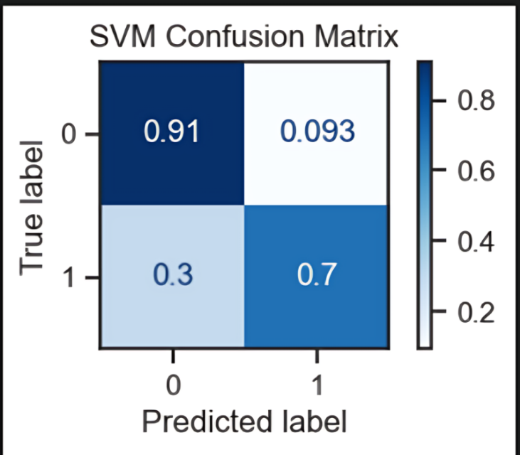
Figure 6: SVM Confusion Matrix
The second model was trained with the Gradient Boosting approach. The accuracy observed with this model on the unseen test set was 88.21%. Figure 7 displays the confusion matrix utilized from this model[5].
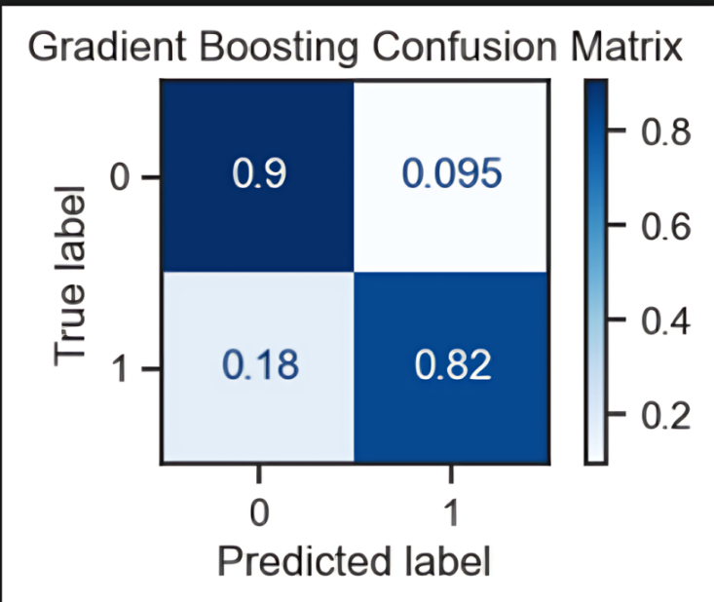
Figure-7: Gradient Boosting Confusion Matrix [4]
The Random Forest method of training was utilized in order to achieve the best classifier and the maximum performance out of all the classifiers. Accuracy drops to 96.07% when tested with synthetic data. Figure 8 depicts the confusion matrix of its results [2].
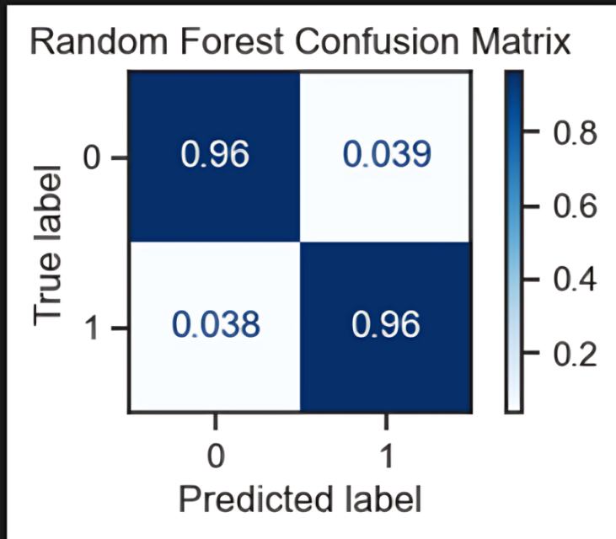
Figure 8: Random Forest Confusion Matrix

CONCLUSION
This research examined three well-known classification algorithms—Support Vector Machine (SVM), Gradient Boosting, and Random Forest—for detecting diabetes. Each model has distinct strengths and approaches that contribute to effective classification. SVM is proficient at identifying optimal separation boundaries between classes, making it ideal for intricate datasets. Gradient boosting is more scalable to large, complicated datasets, automatically detects non-linear correlations, and is more robust against noise and outliers than Support Vector Machines (SVM), which necessitates meticulous feature scaling and tuning. On the other hand, and Random Forest adopts an ensemble method [2,3,5].
Enhancing prediction accuracy and consistency by aggregating results from multiple decision trees. Among the models assessed, Random Forest proved to be the most reliable classifier for diabetes detection, showing greater accuracy and robustness when managing complex, high-dimensional data compared to the others.
This comparative analysis highlights that each algorithm brings its own advantages, and the selection of the appropriate model can significantly impact the accuracy of diabetes predictions. Overall, this study emphasizes the necessity of choosing suitable machine learning techniques tailored to the specific features of the dataset. Future research could focus on further refining these models and investigating hybrid approaches to improve classification effectiveness in diabetes detection.
According to the comparative analysis of classification algorithms, the Random Forest model performed the best in terms of diabetes detection, with an accuracy of 98.9% and a minimal standard deviation of 0.0083 across folds. This consistency illustrates the model's robustness and ability to be generalized across a variety of data subsets. Gradient boosting performed consistently on more complex patterns, with an accuracy of 86.75% and a standard deviation of 0.0223, despite capturing intricate non-linear interactions. The Support Vector Machine (SVM) had the lowest accuracy at 82.8% with a standard deviation of 0.0228, demonstrating more sensitivity to feature scaling and tuning, although being generally effective for high-dimensional data. According to these findings, Random Forest is the most reliable and consistent model for diabetes detection, exceeding others methods. Gradient Boosting and SVM, on the other hand, show promise for additional improvement [2,3,5].

REFERENCES
1. A. D. Association, “Classification and diagnosis of diabetes: standards of medical care in diabetes,” Diabetes Care, vol. 43, no. Supplement 1, pp. S14-S31, 2020.
2. L. Breiman, “Random forests,” Machine Learning, vol. 45, no. 1, pp. 5-32, 2001.
3. C. Cortes and V. Vapnik, “Support-vector networks,” Machine Learning, vol. 20, no. 3, pp. 273-297, 1995.
4. T. Chen and C. Guestrin, “XGBoost: A scalable tree boosting system,” in Proceedings of the 22nd ACM SIGKDD International Conference on Knowledge Discovery and Data Mining, San Francisco, CA, USA, 2016, pp. 785-794.
5.J. H. Friedman, “Greedy function approximation: a gradient boosting machine,” Annals of Statistics, vol. 29, no. 5, pp. 1189-1232, 2001.
6.American Diabetes Association (2010). Diagnosis and classification of diabetes mellitus. Diabetes care, 33 Suppl 1(Suppl 1), S62–S69.
7. S. Hochreiter and J. Schmidhuber, “Long short-term memory,” Neural Computation, vol. 9, no. 8, pp. 1735-1780, 1997.
8. Smith, J.W., Everhart, J.E., Dickson, W.C., Knowler, W.C., & Johannes, R.S. (1988). Using the ADAP learning algorithm to forecast the onset of diabetes mellitus. In Proceedings of the Symposium on Computer Applications and Medical Care (pp. 261--265). IEEE Computer Society Press.a
9.I. Guyon and A. Elisseeff, “An introduction to variable and feature selection,” Journal of Machine Learning Research, vol. 3, pp. 1157-1182, 2003.
10. R. Kohavi, “A study of cross-validation and bootstrap for accuracy estimation and model selection,” in Proceedings of the 14th International Joint Conference on Artificial Intelligence, Montreal, QC, Canada, 1995, pp. 1137-1145.
11. A. Y. Ng, “Feature selection, L1 vs. L2 regularization, and rotational invariance,” in Proceedings of the 21st International Conference on Machine Learning, Banff, Canada, 2004.
12. S. Simon, N. Kolyada, C. Akiki, M. Potthast, B. Stein and N. Siegmund, "Exploring Hyperparameter Usage and Tuning in Machine Learning Research," 2023 IEEE/ACM 2nd International Conference on AI Engineering – Software Engineering for AI (CAIN), Melbourne, Australia, 2023, pp. 68-79, doi: 10.1109/CAIN58948.2023.00016.

13. J. Platt, “Probabilistic outputs for support vector machines and comparisons to regularized likelihood methods,” in Advances in Large Margin Classifiers, Cambridge, MA: MIT Press, 1999, pp. 61-74.

