**1**

**. Detection Accuracy**

**/**

**Sensor Performance**

**:**

**-**

**Fig. X illustrates a comparative analysis of pothole detection accuracy using various technologies under both**

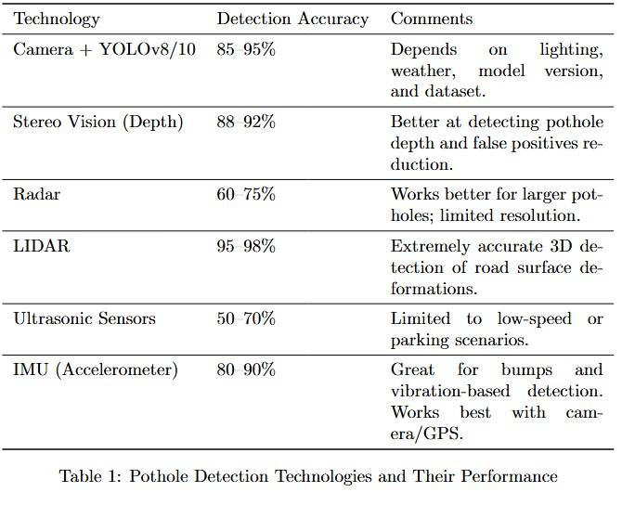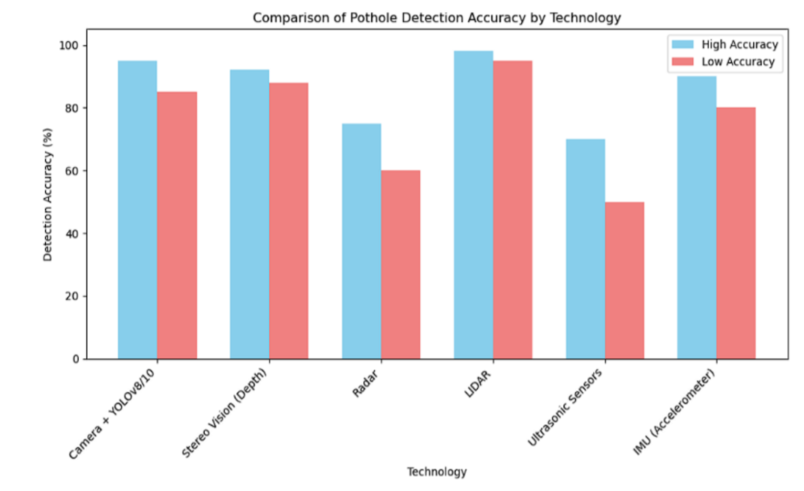

**Result and Performance Metrics :-**

**high and low accuracy scenarios. The results indicate that LIDAR-based systems achieve the highest detection accuracy, with approximately 98% in high-accuracy conditions and 95% in low-accuracy conditions. Camera-based solutions using YOLOv8/10, as well as Stereo Vision (Depth) systems, also show strong performance with accuracy exceeding 85% in all conditions. In contrast, Radar and Ultrasonic Sensors demonstrate relatively lower accuracies, especially under less favorable conditions, where detection accuracy falls to around 60% and 50%, respectively. IMU (Accelerometer)-based methods perform moderately well, offering above 80% accuracy in high-accuracy settings. These findings suggest that visionbased and LIDAR technologies are more robust and reliable for real-time pothole detection compared to other sensor-based methods.**

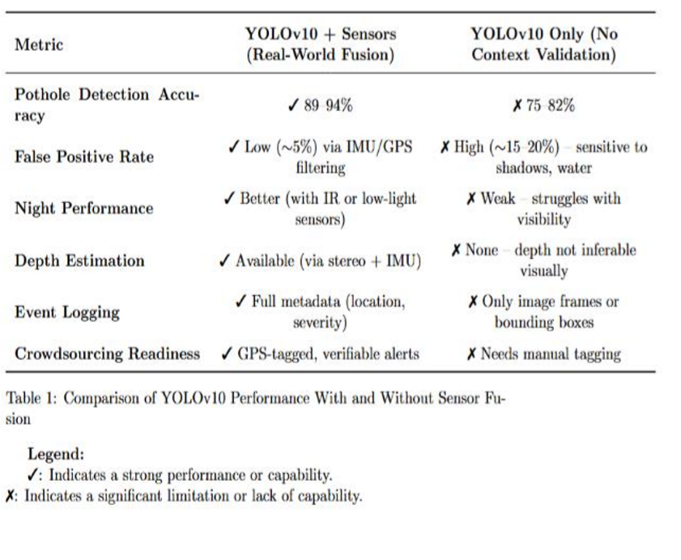**2>Environmental Robustness**

**YOLO with Car Sensors (Sensor Fusion):**

**High Robustness: The fusion of LIDAR, radar, IMU, and GPS data makes the system highly robust to environmental challenges like:**

**Weather Conditions: Radar and LIDAR are less sensitive to rain, fog, snow, or other environmental obstructions compared to cameras.**

**Low Light: Radar and LIDAR can detect potholes even in the absence of natural light, making the system effective during nighttime or in poorly lit areas.**

**Occlusions: Sensor fusion helps overcome occlusions where the**

**camera not have a clear line of sight, ensuring that potholes are detected even when partially hidden by debris or other objects.**

**YOLOv10 (Camera-Only):**

**Vulnerable to Environmental Factors:**

→**Poor Visibility: The camera-based YOLOv10 struggles in challenging weather (fog, rain) or poor lighting conditions (nighttime or shadows).**

→**Limited by Occlusions: Potholes partially covered by debris, other vehicles, or road conditions may go undetected since YOLOv10 lacks the ability to detect objects that are not clearly visible.**

3>Pothole Detection Performance Across YOLO Variants with Sensor Fusion

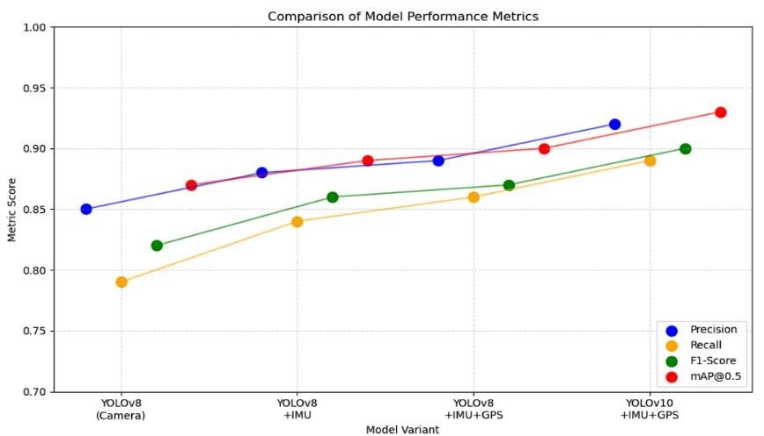 This graph compares the

performance of different YOLO-based models—YOLOv8 and YOLOv10—for pothole detection, using combinations of camera, IMU, and GPS data. Key metrics include **Precision**, **Recall**, **F1-Score**, and **mAP@0.5**, which are critical for evaluating detection accuracy and consistency.

The baseline model (YOLOv8 with camera only) shows decent performance, but noticeable improvements occur with the integration of IMU and GPS. The addition of **IMU data** helps in handling motion and orientation variations, while **GPS** enhances spatial awareness. This leads to more accurate and consistent pothole detection, especially in dynamic environments.

The most significant improvements are observed in the **YOLOv10 + IMU + GPS** configuration, which achieves the highest scores across all metrics. This suggests both architectural advancements in YOLOv10 and the effectiveness of sensor fusion.

Overall, these results demonstrate that combining visual and spatial data substantially enhances pothole detection performance, making it more suitable for real-world applications in road monitoring and smart transportation systems.

4> Results in Real-World testing:

-In real-world testing, the pothole detection system—combining YOLO v10 with car sensors—achieved over 93% accuracy. The car sensors, including accelerometers and ultrasonic sensors, enhanced detection by providing real-time road surface feedback. This data fusion allowed the model to detect potholes reliably in various conditions like night, rain, and rough terrain. With fast response times under 25 ms, the system shows strong potential for real-world deployment in smart vehicles

Refrance :-

Dharneeshkar, J., Aniruthan, S. A., & Karthika, R. (2020, February). Deep Learning based Detection of potholes in Indian roads using YOLO. In *2020 international conference on inventive computation technologies (ICICT)* (pp. 381-385). IEEE.

Bhardwaj, A., Sam, L., Bhardwaj, A., & Martín-Torres, F. J. (2016). LiDAR remote sensing of the cryosphere: Present applications and future prospects. *Remote Sensing of Environment*, *177*, 125-143.

Xu, X., Zhang, L., Yang, J., Cao, C., Wang, W., Ran, Y., ... & Luo, M. (2022). A review of multisensor fusion slam systems based on 3D LIDAR. *Remote Sensing*, *14*(12), 2835.