**1. Problem Discussion**

Here you will be provided an array of size ‘n’ and containing n elements and a target. All you need to do is find a pair in the array whose difference is equal to the target and print it, if such a pair exists else print -1. For example:[5,2,3,80,5,20] , target=78 Sounds easy!

**2. Approach**

Naive Approach

The approach is very simple here.You might think of solving this problem in O(n^2) time , Where you keep a pointer say ‘i’ and then you fix it for an element say (arr[0]) initially and then you check for other array elements from arr[j] (j=i+1 to arr.length-1) if the difference is equal to target you print it , otherwise you increase the value of i to i+1 and again check for arr[j].You continue to increase the value of i till i=arr.length-2. This process is going to take a lot of time.

Optimized Approach

Here You will be working with only two variables i and j .First of all you have to sort the array because it will help you get the answer in less time.

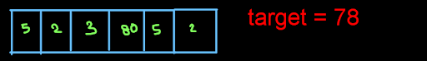

This is the original array and the target is 78. Then we sort the array and take two variables i and j.where i =0 and j=i+1;

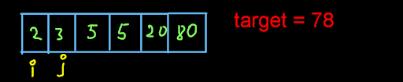

Now we see that the difference of arr[j] and arr[i] is (3-2) =1 <78. So we increase the value of j to j+1 .So the difference arr[j]-arr[i] increases . Then we again check if(arr[j] - arr[i])>target or equal to target or lesser than target . If the (arr[j] - arr[i]) > target then increase the value of i to i+1 else if the value of (arr[j] - arr[i]) < target then increase the value of j to j+1. So in the previous image you can see that (3-2) =1 < 78 so we increased j to j+1.

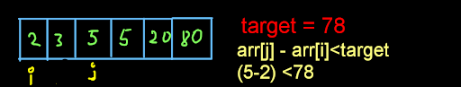

But here again you can see (5-2) < 78,So again we increase j to j+1.

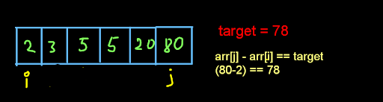

Here we get our difference of arr[j] and arr[i] equal to our target so we print it and return .

**3. Code and Expalination**

Code

ConsoleJava

import java.util.*;

import java.io.*;

public class Main {

public static void findPair(int[]arr,int target) {

//write your code here

Arrays.sort(arr);

int i=0;

int j=1;

while(i < arr.length && j < arr.length) {

if(arr[j] - arr[i] == target) {

System.out.println(arr[i] + " " + arr[j]);

return;

}

else if(arr[j] - arr[i] < target) {

j++;

}

else {

i++;

}

}

System.out.println("-1");

}

public static void main(String[]args) {

//input work

Scanner scn = new Scanner(System.in);

int n = scn.nextInt();

int[]arr = new int[n];

for(int i=0; i < n;i++) {

arr[i] = scn.nextInt();

}

int target = scn.nextInt();

findPair(arr,target);

}

}

Code Explanation

Code to sort the array.

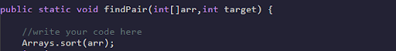

Now we take two variables i (initialized to 0) and j(initialized to 1) and then run a while loop while i and j are less than length of the array.and then we handle the case where difference of arr[i] and arr[j] ==target ,< target or > target.

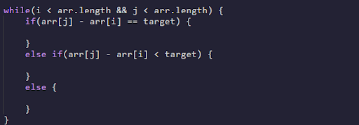

Here we increase j to j+1 when target> arr[j] - arr[i] ,increase i to i+1 when target< arr[j] - arr[i] or print the pair when difference arr[j] -arr[i] ==target.

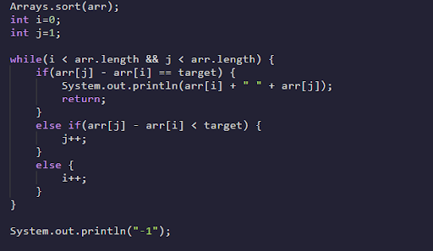

**4. Analysis**

Time Complexity:

O(n log(n)) The time complexity for the function is O(n logn) because we are sorting the array in this question and after that it takes constant time .

Space Complexity

O(1) Constant Here we are not using any extra space so space complexity is constant.