**1. Problem Discussion :**

You are given an array “arr” of N integers. Where, the only operation allowed is to rotate(clockwise or counter clockwise) the array any number of times. Your task is to find the maximum value of sum of arr[i]*i, where i = 0,1,2,...,n-1.

Example) For N = 4, arr[]={8,3,1,2}

The output is 29.

If we rotate the array by 3 as {3,1,2,8}.

Sum of arr[i]*i = 3*0 + 1*1 + 2*2 + 8*3 = 29, which is maximum.

**2. Approach :**

Naive Approach :

One basic approach to solve this problem is to generate all possible rotations of given array and calculate the value of sum of arr[i]*i for each rotation and then return the maximum value.

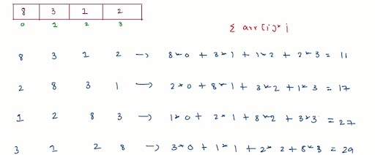

But using this approach will consume too much time and will have time complexity of O(n^2).

Optimized Approach :

Our optimized approach will improve over the naive approach. In the naive approach sum of arr[i]*i was calculated for every rotation. If we are able to calculate sum of arr[i]*i in constant time then we will be able to reduce the time complexity of naive approach.

So, our basic idea is to somehow calculate the sum of arr[i]*i of new rotation using the sum of arr[i]*i of previous rotation. If we observe the coefficients of all elements in the sum of arr[i]*i , only the coefficients of the first and last element change drastically and the coefficient of every other element increases or decreases by 1.

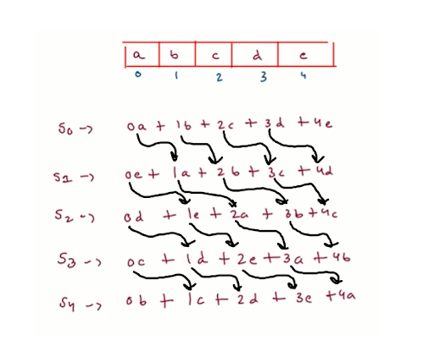

Now, we will try to find sum of arr[i]*i for 1st rotation in terms of 0 rotations.

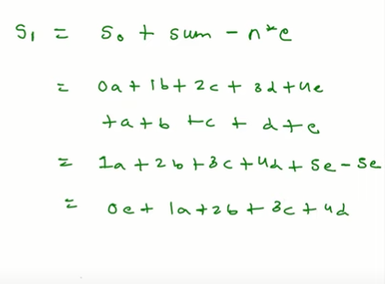

Now, we are able to see how we can calculate the sum of arr[i]*i of new rotation using the sum of arr[i]*i of previous rotation.

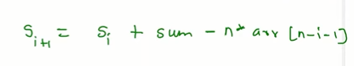

Using this formula we can calculate the sum of arr[i]*i of new rotation using the sum of arr[i]*i of previous rotation.

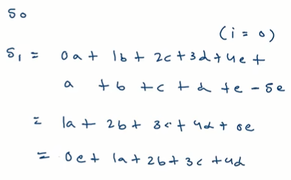

Now, we just need to calculate the sum of arr[i]*i for all rotations using the derived formula and then return the maximum value.

**3. Code :**

ConsoleCpp

#include<bits/stdc++.h>

using namespace std;

int maximise(vector<int>& arr)

{

int n = arr.size();

int sum = 0;

int S0 = 0;

for(int i=0; i < n;i++) {

sum += arr[i];

S0 += arr[i]*i;

}

int max = S0;

int Si = S0;

for(int i=0; i < n-1 ;i++) {

int temp = Si + sum - n*arr[n-i-1];

Si = temp;

if(temp > max) {

max = temp;

}

}

return max;

}

int main()

{

int n;

cin>>n;

vector<int> arr(n,0);

for(int i =0;i<n;i++)

{

cin>>arr[i];

}

int ans = maximise(arr);

cout<<ans;

}

**4. Code Discussion**

1• First we need variables to store sum of all elements of array, the sum of arr[i]*i for 0 rotation, also we stored the length of array for easier access.

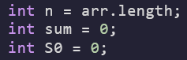

2• Here, we calculate the sum of all elements of array and the sum of arr[i]*i for 0 rotation as a prerequisite for the formula we derived.

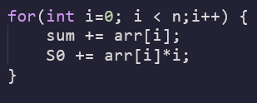

3• Max variable is declared for storing maximum sum of arr[i]*i and Si variable is declared for storing the sum of arr[i]*i for i number of rotation.



4• Here, we are calculating the sum of arr[i]*i for each number of rotation and checking if have maximum sum of arr[i]*i.

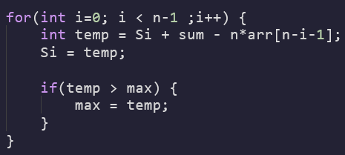

5• Now, we just need to return the maximum sum of arr[i]*i that we calculated.



**5. Analysis :**

Time Complexity : O(n)

We only need to check the sum for all the rotations and find the maximum sum which takes O(n) time as the number of rotations for any array is from 0 to n-1 and since, the sum of the present rotation is calculated from the previous rotations in constant(O(1)) time, the overall time complexity of the function becomes O(n).

SPACE COMPLEXITY : O(1)

Since, no extra spaces are used to store numbers, therefore the space complexity is constant.