**1. PROBLEM DISCUSSION**

In this problem we will be given an array of strings where each string represents a date. We have to sort these dates in increasing order.

**2. APPROACH**

We will be using radix sort to sort the array. First we will be sorting the array on the basis of day then month then year. This is because the precedence of year is greater than month and precedence of month is greater than day. We will call count sort 3 times; first to sort the given array on the basis of dates, second on the basis of month and third on the basis of year.

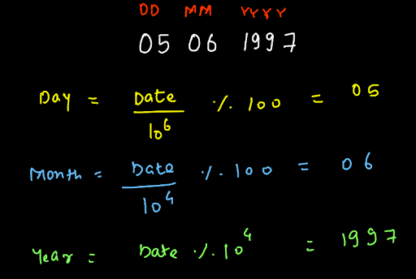

In the above figure you can see to calculate the date, we first divided the data (05061997) with 10^6. Doing this we lose the initial 6 digits of the data. And then we take the modulus of 100. This way we get 05 as the date. Similarly, to calculate the month, we first divide the data (05061997) with 10^4. Doing this we lose the initial 4 digits of the data. And then we take the modulus of 100. This way we get 06 as the month. Finally to get a year, we first divide the data (05061997) with 10^0. And then we take the modulus of 10000. This way we get 1997 as the year.