Game Design Document

Fill up the Following document

1. Write the title of your project.

CLIMB UP

1. What is the goal of the game?

To defeat the dragon

1. Write a brief story of your game?

We need to defeat the dragon and reach the top by using ladders. Mario needs to collect coins on his way.We need to avoid fireballs and obstacles. We will get hammer to destroy the obstacles. If Mario hits the obstacle with hammer , he gets 150 points. If Mario jumps over the obstacles , he gets 100 points. If Mario avoids the fireball , he gets 200 points. If Mario jumps defeats the dragon, he gets 500 points.

______________________________________________________________________________________________________________________

1. Which are the playing characters of this game?

* Playing characters are the ones which respond to the user based on the input from the user
* Cars, monkeys, dinos, wizards etc, are the playing characters in the game.

|  |  |  |
| --- | --- | --- |
| Number | Character Name | What can this character do? |
| 1 | MARIO | Main character |
| 2 |  |  |
| 3 |  |  |
| 4 |  |  |
| 5 |  |  |
| 6 |  |  |
| 7 |  |  |
| 8 |  |  |

1. Which are the Non Playing Characters of this game?

* Non Playing characters are the ones which don't have an action or a behaviour when the user interacts with the game.
* Hurdles, stones, bananas, coins, etc are non playing characters in the game.

|  |  |  |
| --- | --- | --- |
| Number | Character Name | What can this character do? |
| 1 | fireball | Make player lose |
| 2 | stones | Make player lose |
| 3 | coins | Increase point randomly(50,200) |
| 4 | yladders | To grow on upper level of floor |
| 5 | dragon | Throws fireball |
| 6 | scoreboard | Calculate points |
| 7 | xladder | Ground for different floors |
| 8 | hammer | Destroys obstacle |

Draw your imagination of this game. What does this game look like?

* Draw the game either on your computer or on paper,
* Add images of scenes of the game to show each of the playing and non-playing characters at least once.

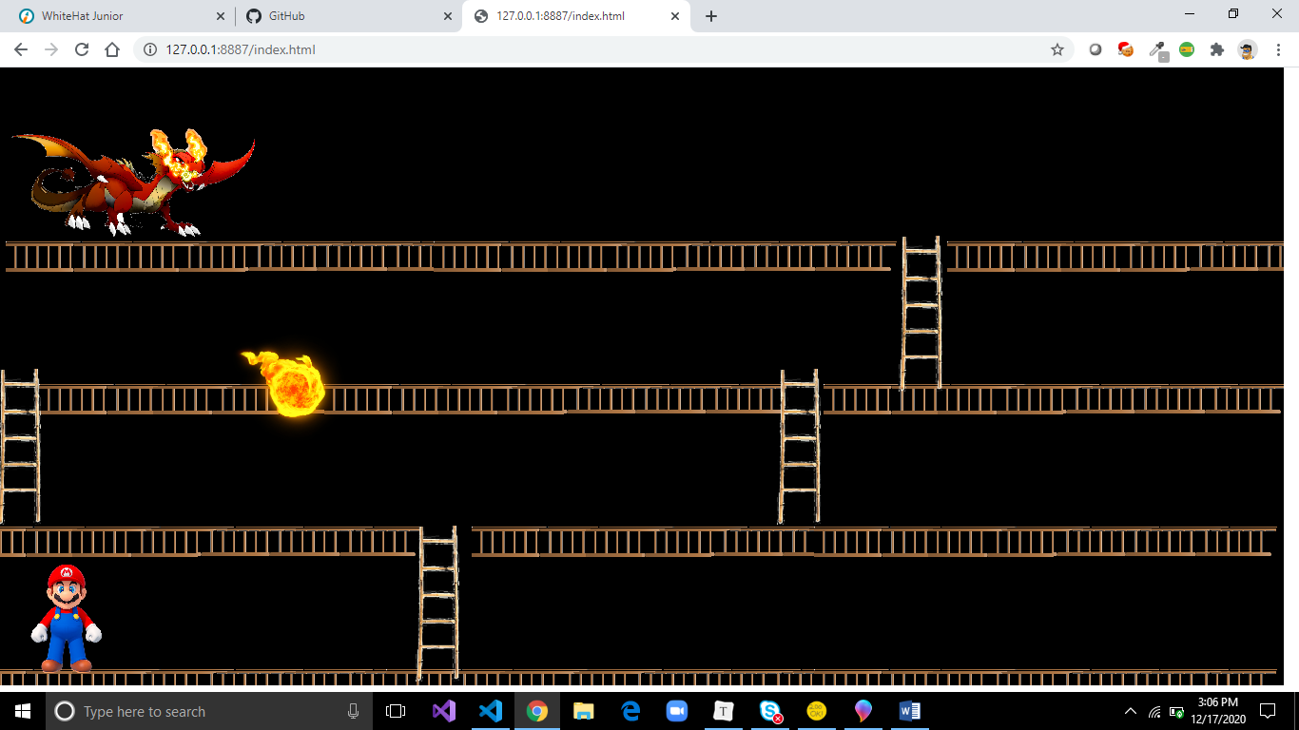

How do you plan to make your game engaging?

After completing each level game the game becomes harder.