***MINI PROJECT***

***AI GAME***

***Reinforcement Learning Game Suite***

TEAM LEADER NAME – PRIYANSHI AGRAWAL

ROLL NO – 2301CS90

MEMBER 2 NAME – MANVITHA REDDY

ROLL NO – 2301CS29

MEMBER 3 NAME – SHIKSHA RAGINEE

ROLL NO – 2301AI13

MEMBER 4 NAME – GOMPA VASAVI

ROLL NO – 2301AI43

MEMBER 5 NAME – PREETI KUMARI

ROLL NO – 2301AI17

MEMBER 6 NAME – GURU SAI BHASKARI

ROLL NO – 2301AI19

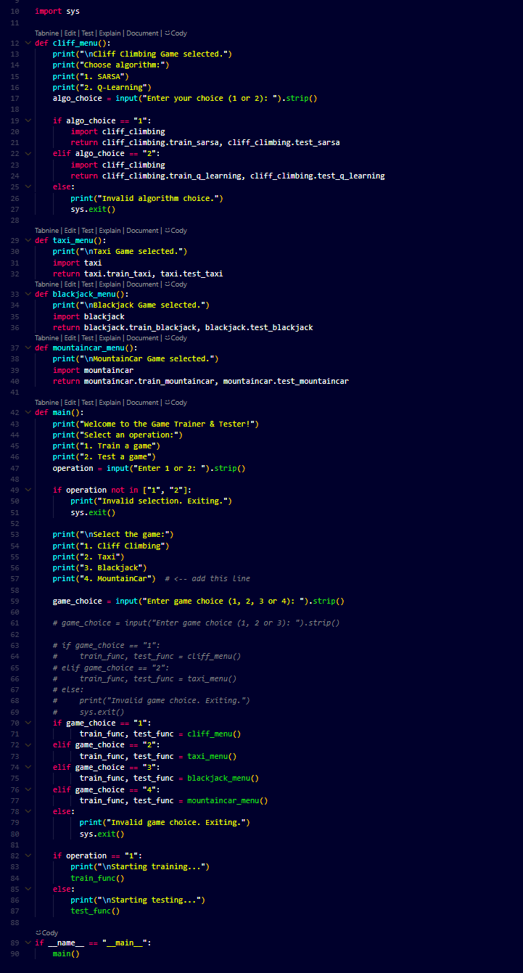Main.py

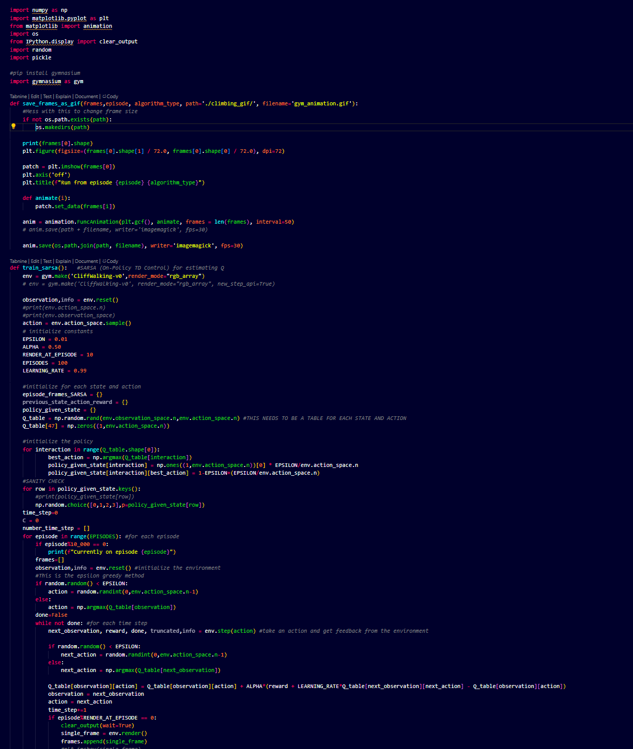Cliff_climbing.py

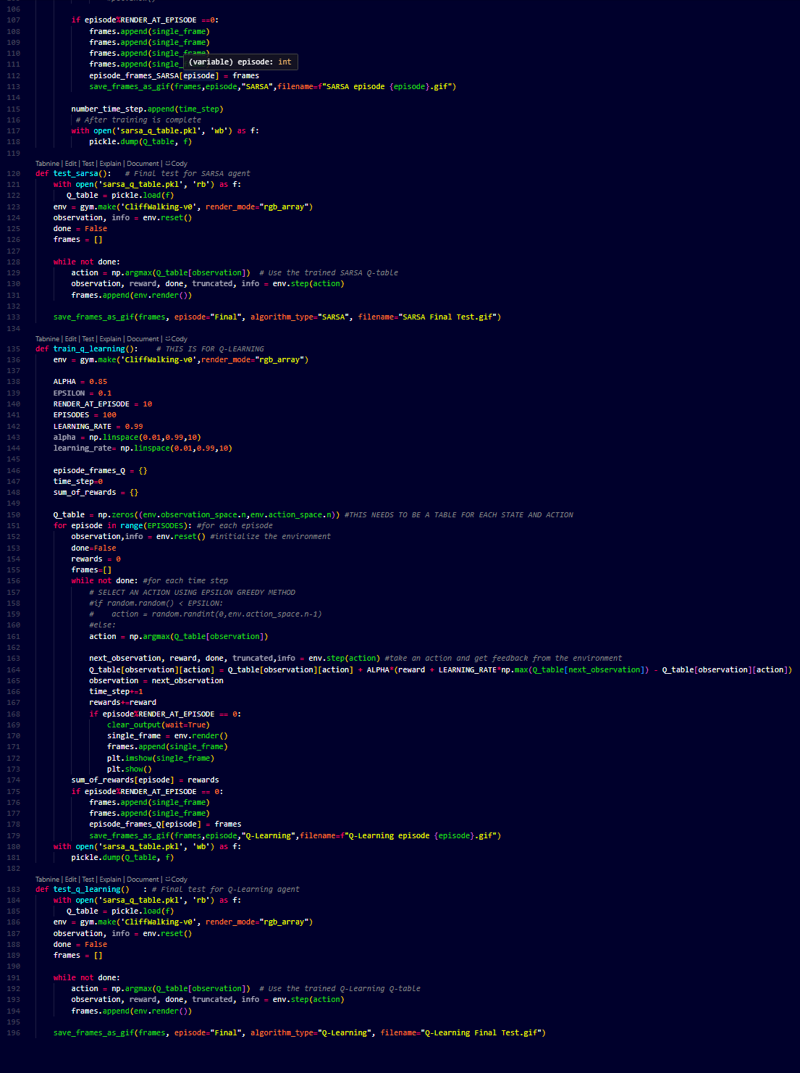

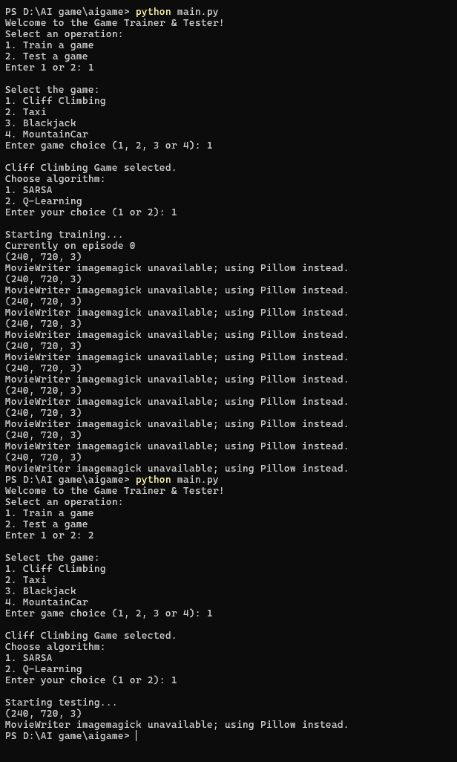GAME 1 – cliff climbing—sarsa algorithm

Result --







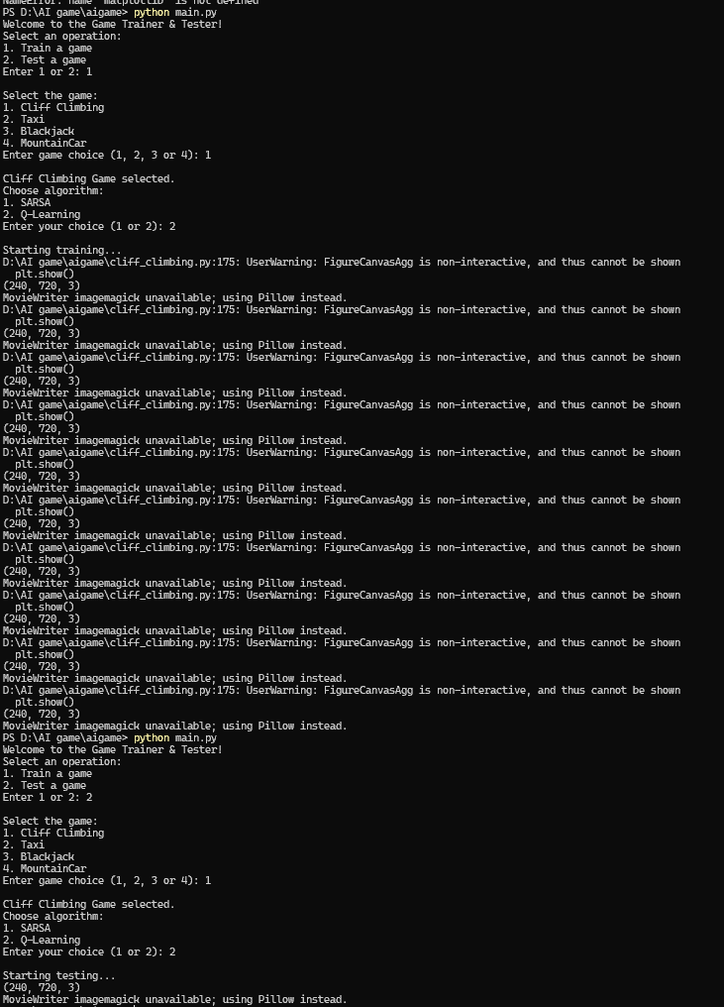GA E 1 – cliff climbing—Q learning algorithm

RESULT—



taxi.py-

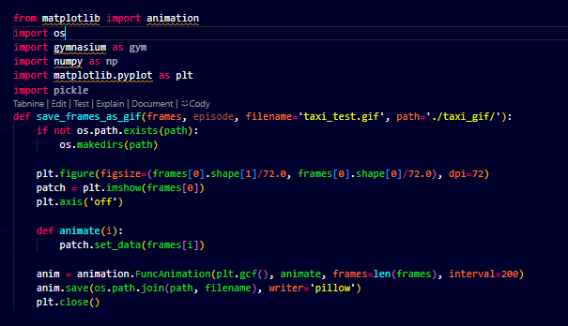

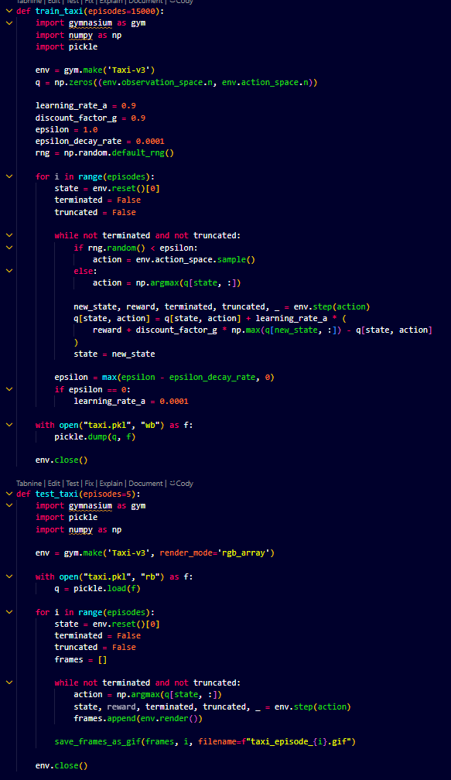

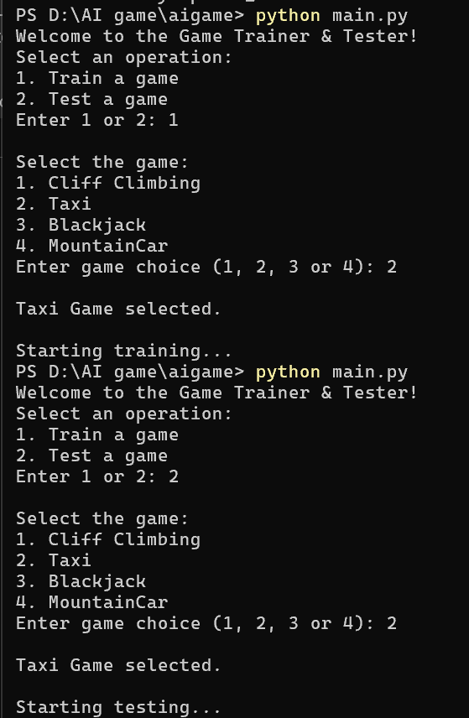GAME 2 – TAXI-

RESULT--

 EPISODE = 2

EPISODE=3

EPISODE=4

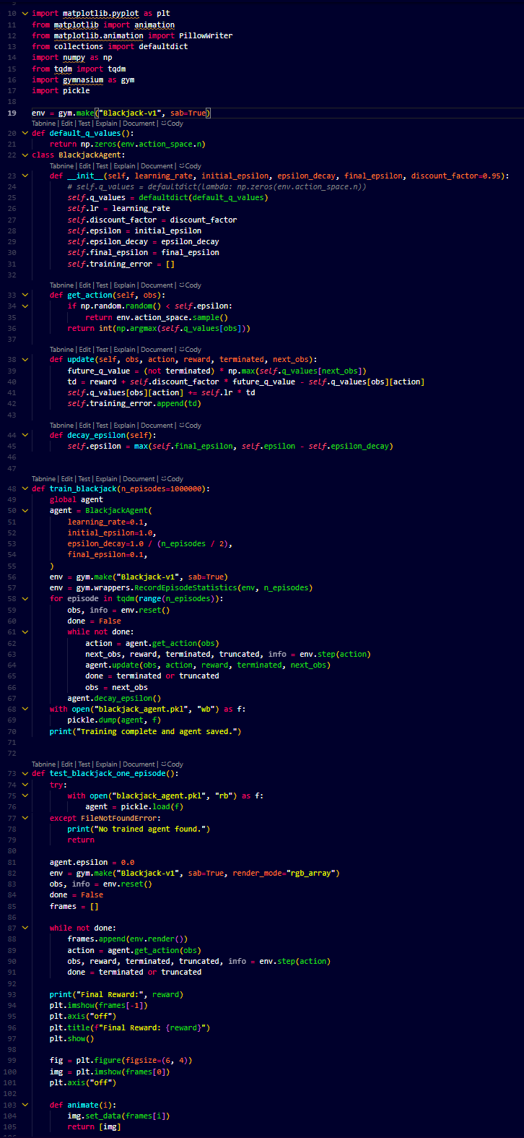blackjack.py—

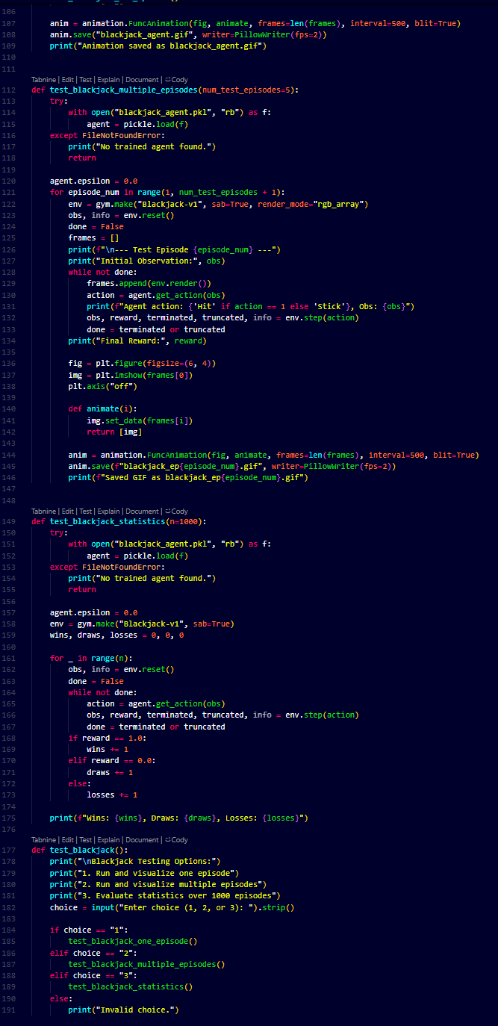

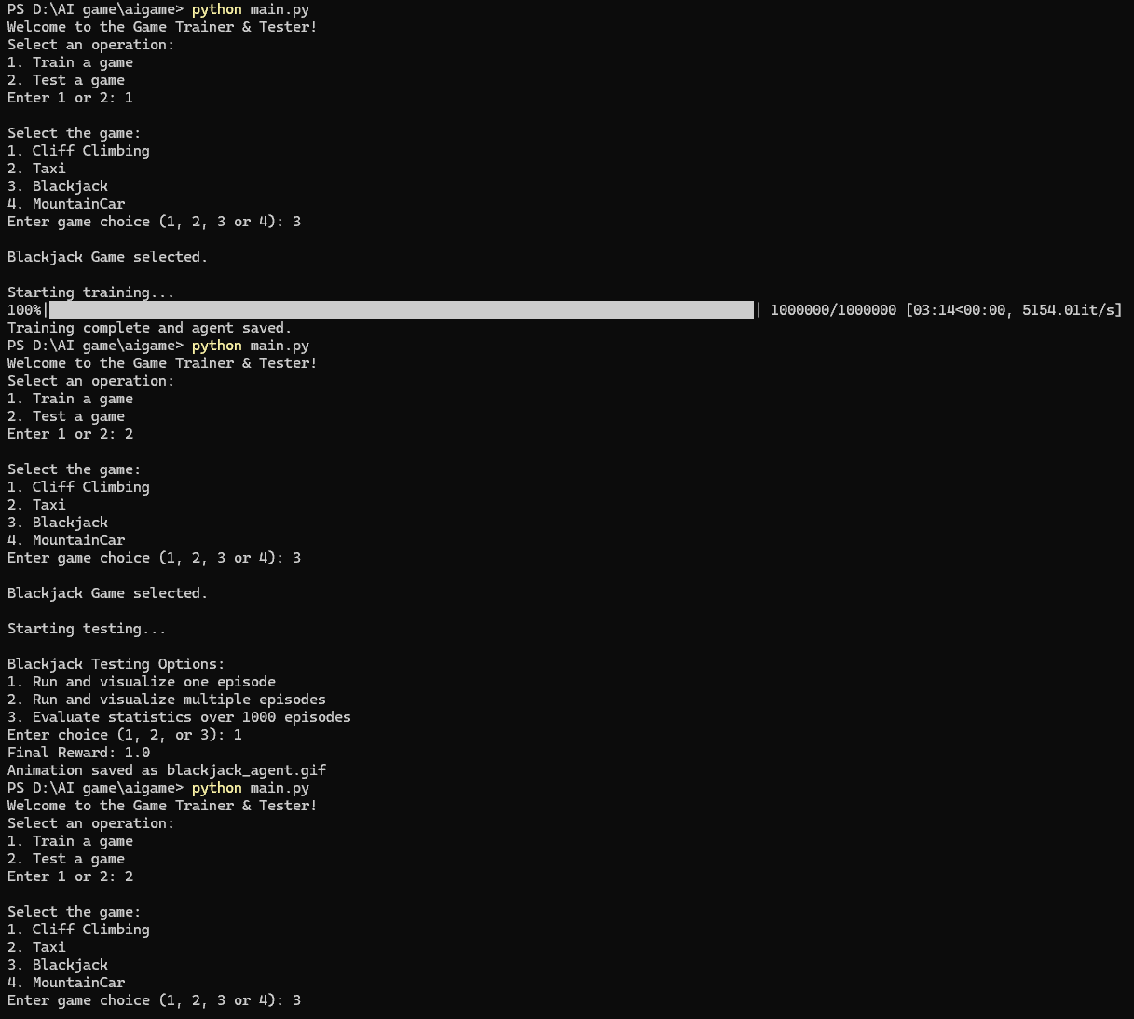GAME 3-- BLACKJACK –

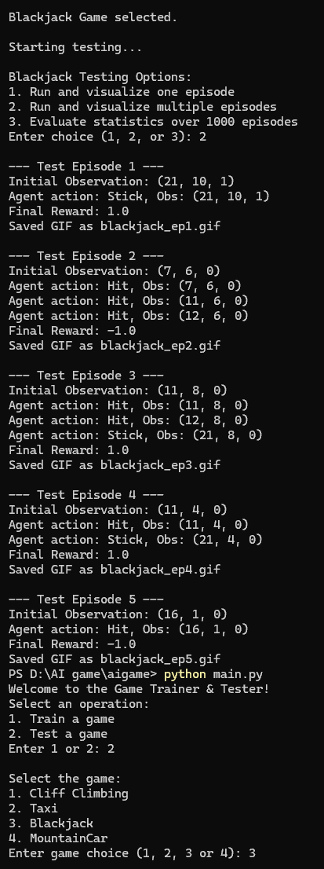

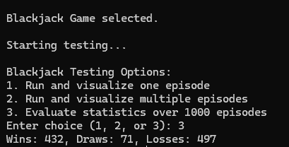

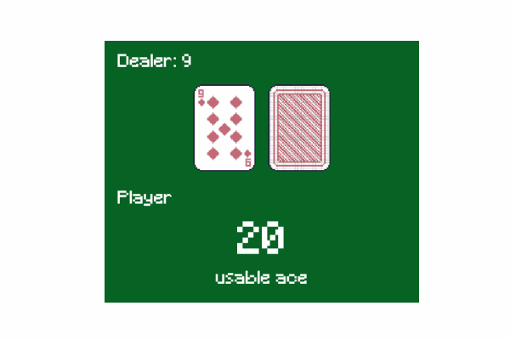RESULT-- FOR 1 EPISODE



FOR MORE EPISODE—

EPISODE 4

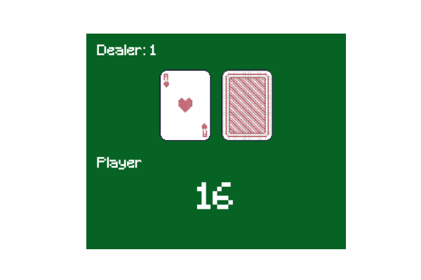

EPISODE 5

mountaincar.py---

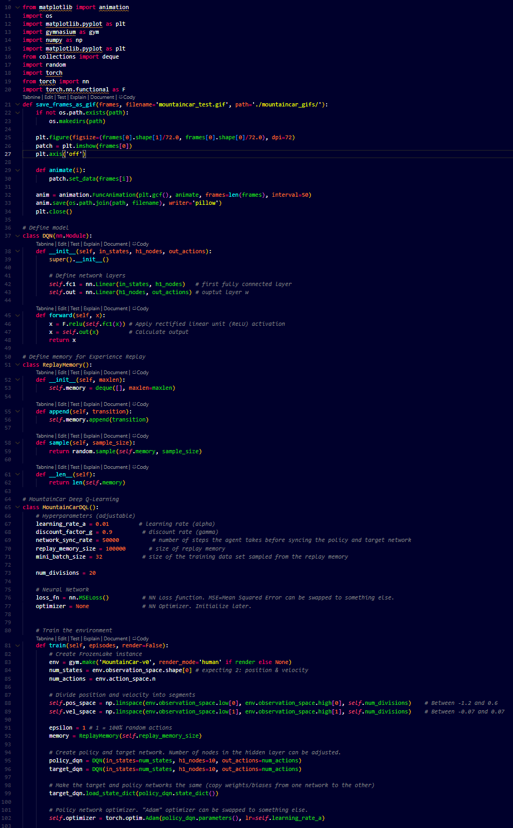

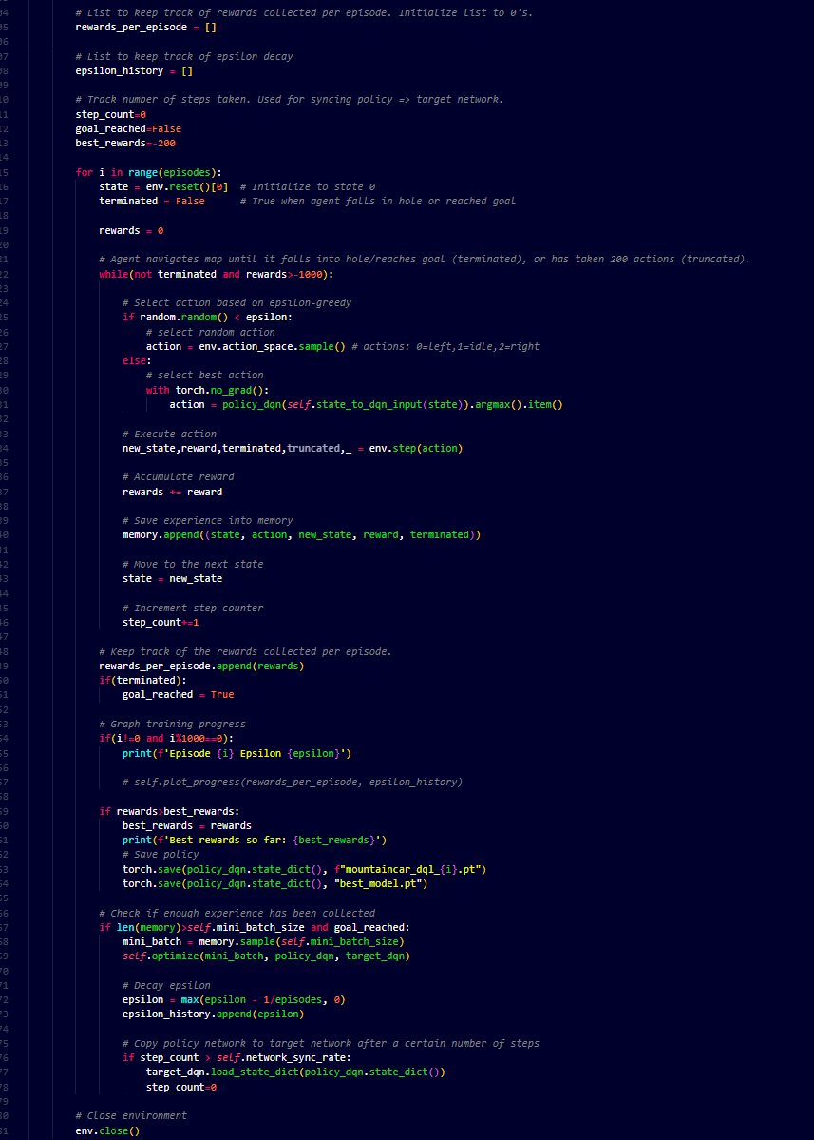

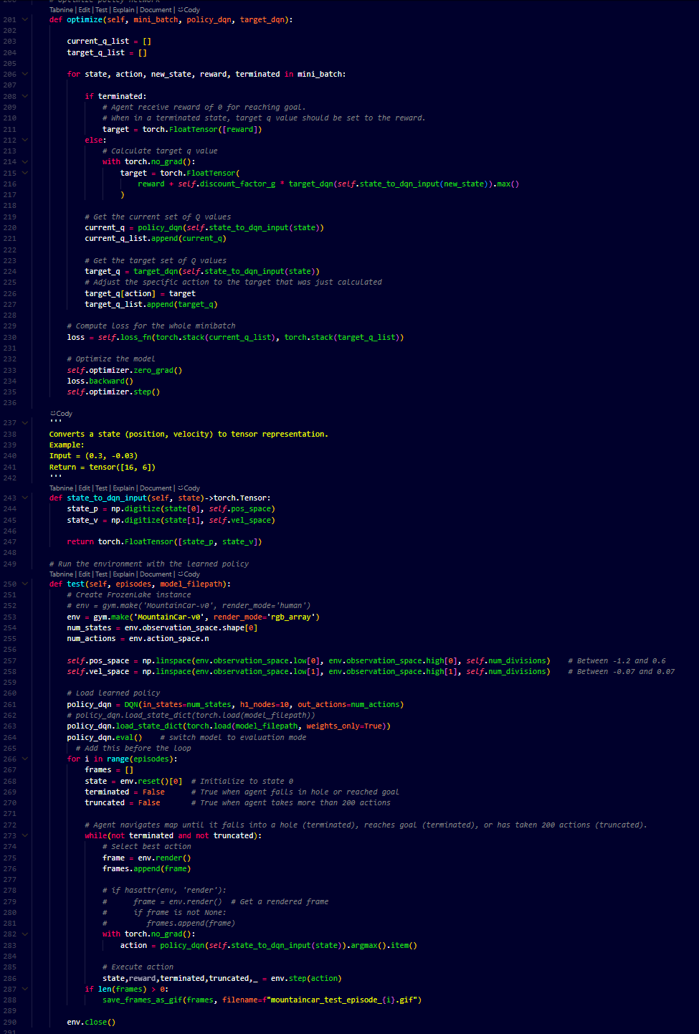

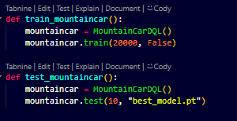

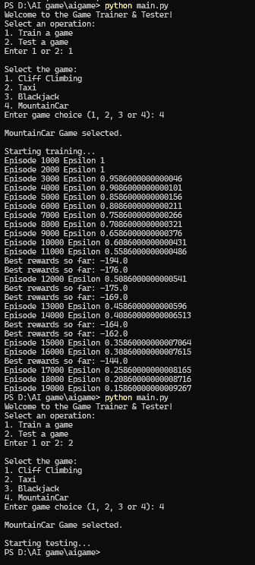GAME 3-- MOUNTAIN CAR–

RESULT-

EPOSODE -8

EPISODE - 9