IoT Lab Report
LoRa-Based Environmental Monitoring System
Using LoRa (Long Range Radio) Communication
IIT Patna – IoT Research Laboratory

1. Objective
Design, implement, and validate a wireless sensor network for real-time environmental monitoring using LoRa at 433.5 MHz. A transmitter node equipped with a BME680 and MQ-135 sensor encodes multi-parameter data into a 24-byte binary packet and transmits it to a receiver node, which decodes readings and logs link quality metrics (RSSI and SNR).

2. Hardware Used
Component | Role | Qty
Heltec WiFi LoRa 32 (V3) | Transmitter & Receiver node (ESP32 + SX1262) | 2
BME680 Sensor | Temperature, Humidity, Pressure, Gas Resistance | 1
MQ-135 Gas Sensor | CO2 / Air Quality Index estimation | 1
USB Cable | Power and programming | 2

3. Circuit Diagram & Pin Configuration
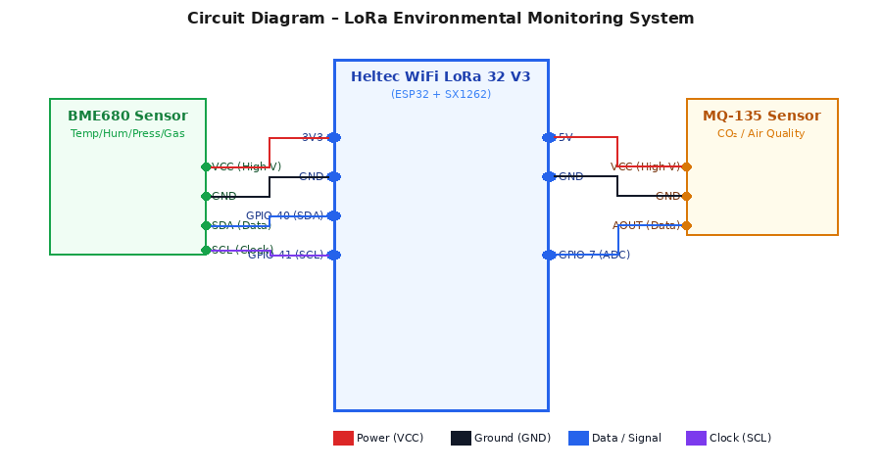

Figure 1: Wiring connections for BME680 and MQ-135 sensors to Heltec V3
Heltec V3 Pin | Sensor Pin | Description
GPIO 40 (SDA) | BME680 SDA | Data wire – I2C
GPIO 41 (SCL) | BME680 SCL | Clock wire – I2C
3V3 | BME680 VCC | High voltage (power)
GND | BME680 GND | Ground
GPIO 7 (ADC) | MQ-135 AOUT | Analog data wire
5V | MQ-135 VCC | High voltage (power)
GND | MQ-135 GND | Ground

4. LoRa Configuration
The SX1262 radio chip is configured for maximum range using SF12 over 433.5 MHz ISM band with hardware CRC. A 24-byte packed binary struct carries all sensor fields with no ASCII overhead.

Parameter | Value | Remarks
RF Frequency | 433.5 MHz | ISM sub-GHz band (Asia)
Spreading Factor | SF12 | Maximum range, longer air time
Bandwidth | 125 kHz | Better sensitivity, lower data rate
Coding Rate | 4/8 | Maximum forward error correction
TX Output Power | 14 dBm (~25 mW) | Sufficient for lab/outdoor range

5. Sensor Working Principles

BME680
Four-in-one Bosch sensor communicating via I2C (address 0x77). Measures temperature (±1 °C), humidity (±3 %), pressure (0.18 Pa resolution), and VOC gas resistance. Gas heater runs at 320 °C / 150 ms. Oversampling: 8×T, 4×P, 2×H with IIR filter of size 3.

MQ-135 CO2 Estimation
Semiconductor sensor whose SnO2 layer changes resistance with target gas concentration. CO2 ppm is estimated via the power-law:
PPM = 110.47 × (Rs / Ro)^(−2.86)
Rs = sensor resistance derived from 12-bit ADC reading; Ro = 2.7 kΩ calibrated in clean air. Note: MQ-135 is cross-sensitive to multiple gases — values represent relative air quality, not absolute CO2.

6. Observations & Results
Parameter | Typical Value | Sensor
Temperature | 25–35 °C | BME680
Relative Humidity | 40–70 % | BME680
Pressure | 1000–1013 hPa | BME680
CO2 (estimated) | 400–1000 ppm | MQ-135
RSSI (lab range) | -30 to -60 dBm | SX1262 report
SNR | > 10 dB | SX1262 report

In the lab at close range (< 10 m), RSSI was typically −30 to −60 dBm with SNR > 10 dB — well above the SF12 sensitivity floor of −137 dBm. Binary struct memcpy() ensured bit-perfect float reconstruction. CRC at hardware level discarded any corrupted packets.

7. Conclusion & Future Enhancements
The experiment demonstrated a complete IoT pipeline: sensor acquisition → 24-byte binary LoRa transmission → receiver decoding with RSSI/SNR logging. Key takeaways:
- SF12 + BW 125 kHz provides ~+20 dB link budget vs SF7 at the cost of ~2 s air time per packet.
- Packed binary encoding is 3–5× more efficient than ASCII CSV for LoRa payloads.
- BME680 gas resistance and MQ-135 CO2 together give a complementary VOC + air quality picture.

Planned enhancements include: cloud upload via HTTP POST (code stub already present), LoRaWAN OTAA integration, deep-sleep duty cycling, AES-128 payload encryption, GPS tagging, and migration to a dedicated NDIR CO2 sensor (SCD41) for absolute accuracy.

8. References
- Semtech SX1262 Datasheet – Long Range LoRa Modem, Rev 2.1
- Bosch BME680 Datasheet – Environmental Sensor, Rev 1.6
- Winsen MQ-135 Gas Sensor Datasheet
- Heltec WiFi LoRa 32 V3 Schematic – heltec.org
- LoRa Alliance LoRaWAN Specification v1.0.4

