Arima Model in R

Krishna P Koirala

6/21/2018

We will learn here how to use ARIMA() model for Non-seasonal univariate time series. Although, ARIMA() model can be used to multivariate, seasonal time series.

rm(list = ls())  
library(forecast)

lynx

## Time Series:  
## Start = 1821   
## End = 1934   
## Frequency = 1   
## [1] 269 321 585 871 1475 2821 3928 5943 4950 2577 523 98 184 279  
## [15] 409 2285 2685 3409 1824 409 151 45 68 213 546 1033 2129 2536  
## [29] 957 361 377 225 360 731 1638 2725 2871 2119 684 299 236 245  
## [43] 552 1623 3311 6721 4254 687 255 473 358 784 1594 1676 2251 1426  
## [57] 756 299 201 229 469 736 2042 2811 4431 2511 389 73 39 49  
## [71] 59 188 377 1292 4031 3495 587 105 153 387 758 1307 3465 6991  
## [85] 6313 3794 1836 345 382 808 1388 2713 3800 3091 2985 3790 674 81  
## [99] 80 108 229 399 1132 2432 3574 2935 1537 529 485 662 1000 1590  
## [113] 2657 3396

plot(lynx)

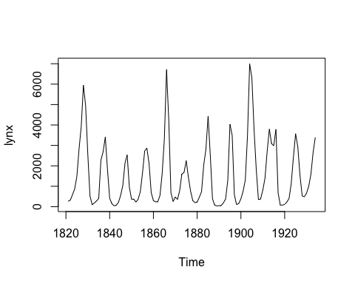

# Check for the stationary

library(tseries)  
adf.test(lynx)

## Warning in adf.test(lynx): p-value smaller than printed p-value

##   
## Augmented Dickey-Fuller Test  
##   
## data: lynx  
## Dickey-Fuller = -6.3068, Lag order = 4, p-value = 0.01  
## alternative hypothesis: stationary

Shows that lynx is stationary time series. Now we find p, q values from acf and pacf plots

# Acf and Pacf plots

acf(lynx)

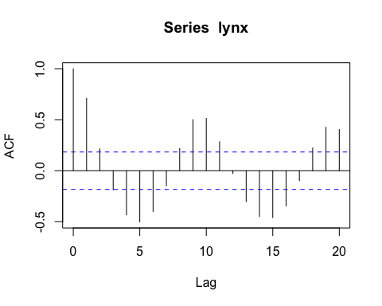

pacf(lynx)

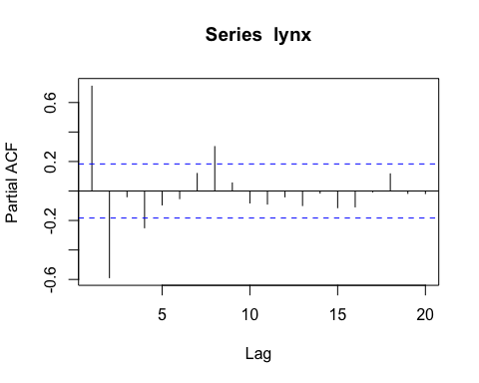

# Show ACF and PACF plot together

tsdisplay(lynx)

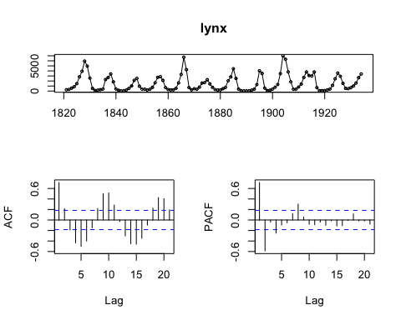

Above acf plot shows that several bars are above the threshold line. Which confirms that the ts is autocorrelated. The Pacf plot shows that mainly two lines are above threshold line which indicates that it is atleast AR(2) model.

# Automated way to calculate ARIMA(p, d, q) using auto.arima().

We will also manually find value of p q later

auto.arima(lynx)

## Series: lynx   
## ARIMA(2,0,2) with non-zero mean   
##   
## Coefficients:  
## ar1 ar2 ma1 ma2 mean  
## 1.3421 -0.6738 -0.2027 -0.2564 1544.4039  
## s.e. 0.0984 0.0801 0.1261 0.1097 131.9242  
##   
## sigma^2 estimated as 761965: log likelihood=-932.08  
## AIC=1876.17 AICc=1876.95 BIC=1892.58

auto.arima() function has lots of options to consider while creating model.

# List of Possible models using auto.arima()

# Its giving us models with values of AIC. Choose the model  
# with least AICc  
auto.arima(lynx, trace = TRUE)

##   
## ARIMA(2,0,2) with non-zero mean : 1876.952  
## ARIMA(0,0,0) with non-zero mean : 2006.724  
## ARIMA(1,0,0) with non-zero mean : 1927.209  
## ARIMA(0,0,1) with non-zero mean : 1918.165  
## ARIMA(0,0,0) with zero mean : 2080.721  
## ARIMA(1,0,2) with non-zero mean : 1888.757  
## ARIMA(3,0,2) with non-zero mean : 1878.603  
## ARIMA(2,0,1) with non-zero mean : 1880.014  
## ARIMA(2,0,3) with non-zero mean : Inf  
## ARIMA(1,0,1) with non-zero mean : 1891.442  
## ARIMA(3,0,3) with non-zero mean : 1881.515  
## ARIMA(2,0,2) with zero mean : 1905.595  
##   
## Best model: ARIMA(2,0,2) with non-zero mean

## Series: lynx   
## ARIMA(2,0,2) with non-zero mean   
##   
## Coefficients:  
## ar1 ar2 ma1 ma2 mean  
## 1.3421 -0.6738 -0.2027 -0.2564 1544.4039  
## s.e. 0.0984 0.0801 0.1261 0.1097 131.9242  
##   
## sigma^2 estimated as 761965: log likelihood=-932.08  
## AIC=1876.17 AICc=1876.95 BIC=1892.58

# Using other options in auto.arima() function

auto.arima(lynx, trace = TRUE,   
 stepwise = FALSE,   
 approximation = FALSE)

##   
## ARIMA(0,0,0) with zero mean : 2080.721  
## ARIMA(0,0,0) with non-zero mean : 2006.724  
## ARIMA(0,0,1) with zero mean : 1972.791  
## ARIMA(0,0,1) with non-zero mean : 1918.165  
## ARIMA(0,0,2) with zero mean : 1925.15  
## ARIMA(0,0,2) with non-zero mean : 1890.428  
## ARIMA(0,0,3) with zero mean : 1913.118  
## ARIMA(0,0,3) with non-zero mean : 1888.326  
## ARIMA(0,0,4) with zero mean : 1906.524  
## ARIMA(0,0,4) with non-zero mean : 1889.064  
## ARIMA(0,0,5) with zero mean : 1908.619  
## ARIMA(0,0,5) with non-zero mean : 1886.754  
## ARIMA(1,0,0) with zero mean : 1934.647  
## ARIMA(1,0,0) with non-zero mean : 1927.209  
## ARIMA(1,0,1) with zero mean : 1903.345  
## ARIMA(1,0,1) with non-zero mean : 1891.442  
## ARIMA(1,0,2) with zero mean : 1903.567  
## ARIMA(1,0,2) with non-zero mean : 1888.757  
## ARIMA(1,0,3) with zero mean : 1905.59  
## ARIMA(1,0,3) with non-zero mean : 1890.03  
## ARIMA(1,0,4) with zero mean : 1907.578  
## ARIMA(1,0,4) with non-zero mean : Inf  
## ARIMA(2,0,0) with zero mean : 1906.685  
## ARIMA(2,0,0) with non-zero mean : 1878.399  
## ARIMA(2,0,1) with zero mean : 1903.412  
## ARIMA(2,0,1) with non-zero mean : 1880.014  
## ARIMA(2,0,2) with zero mean : 1905.595  
## ARIMA(2,0,2) with non-zero mean : 1876.952  
## ARIMA(2,0,3) with zero mean : 1907.963  
## ARIMA(2,0,3) with non-zero mean : Inf  
## ARIMA(3,0,0) with zero mean : 1903.728  
## ARIMA(3,0,0) with non-zero mean : 1880.512  
## ARIMA(3,0,1) with zero mean : 1905.587  
## ARIMA(3,0,1) with non-zero mean : 1881.962  
## ARIMA(3,0,2) with zero mean : Inf  
## ARIMA(3,0,2) with non-zero mean : 1878.603  
## ARIMA(4,0,0) with zero mean : 1905.899  
## ARIMA(4,0,0) with non-zero mean : 1875.007  
## ARIMA(4,0,1) with zero mean : Inf  
## ARIMA(4,0,1) with non-zero mean : 1876.407  
## ARIMA(5,0,0) with zero mean : 1904.543  
## ARIMA(5,0,0) with non-zero mean : 1876.332

## Series: lynx   
## ARIMA(4,0,0) with non-zero mean   
##   
## Coefficients:  
## ar1 ar2 ar3 ar4 mean  
## 1.1246 -0.7174 0.2634 -0.2543 1547.3859  
## s.e. 0.0903 0.1367 0.1361 0.0897 136.8501  
##   
## sigma^2 estimated as 748457: log likelihood=-931.11  
## AIC=1874.22 AICc=1875.01 BIC=1890.64

It gave us AR(4) model with lowes AICc. which is good. Above steps are to choose arima parameters. Below are steps creating model.

# Creating model

We supposed that 2, 0, 0 are best parameters for now

myarima <- arima(lynx, order = c(2, 0, 0))  
myarima

##   
## Call:  
## arima(x = lynx, order = c(2, 0, 0))  
##   
## Coefficients:  
## ar1 ar2 intercept  
## 1.1474 -0.5997 1545.4458  
## s.e. 0.0742 0.0740 181.6736  
##   
## sigma^2 estimated as 768159: log likelihood = -935.02, aic = 1878.03

The model equation is Yt = C + phi1*Yt-1 + phi2*Yt-2 + et

tail(lynx)

## Time Series:  
## Start = 1929   
## End = 1934   
## Frequency = 1   
## [1] 485 662 1000 1590 2657 3396

From above Yt = 3396 Yt-1 = 2657, Yt-2 = 1590, phi1 = 1.1474, phi2 = -0.5997

We need C and et. From above the mean of the model is = 1545.4458 which is not C value. So we have to modify the model equation to solve this problem.

In reality the modified equation looks like this. where m = mean

Yt- m = phi1(Yt-1 -m) + phi2(Yt-2 -m) + et

Now what is et?

et is error term. actual-predicted

residuals(myarima)

## Time Series:  
## Start = 1821   
## End = 1934   
## Frequency = 1   
## [1] -711.715800 -247.179068 -321.014839 -306.751202 127.414827  
## [6] 951.890591 876.687792 2428.733153 -212.432514 -237.541926  
## [11] -164.223204 344.415030 -313.801319 -572.372533 -499.800869  
## [16] 1284.008241 -390.614888 999.532714 -1176.312892 -338.411239  
## [21] 76.614594 -581.986383 -592.092428 -537.056449 -356.640535  
## [26] -164.773680 572.140125 13.626146 -1375.059569 84.838236  
## [31] -162.287575 -690.094698 -371.088497 -246.153634 316.113199  
## [36] 584.894187 27.600121 -240.002495 -724.567794 85.994521  
## [41] -395.876984 -545.490420 -286.601293 437.533551 1080.751334  
## [46] 3196.206424 -2171.180547 -862.324669 1319.008240 -106.590562  
## [51] -730.821550 -42.121950 210.099599 -381.832131 584.871735  
## [56] -850.724879 -229.236651 -412.244306 -387.695328 -521.330158  
## [61] -372.233398 -363.825181 779.748247 210.328753 1731.217687  
## [66] -1586.424626 -533.760190 433.588275 -510.481277 -650.987938  
## [71] -672.853636 -549.330544 -502.352341 273.149380 2075.597251  
## [76] -1054.463188 -1704.735336 828.545228 -314.449678 -424.603800  
## [81] -293.316062 -29.674453 1720.888636 3099.981788 -329.627515  
## [86] 44.035737 569.799862 -185.278565 388.247443 -122.427802  
## [91] -9.044981 905.933577 820.433050 -341.167517 1018.287679  
## [96] 1519.696544 -2583.562459 881.643131 -307.733379 -634.234854  
## [101] -545.962808 -498.009703 112.495341 673.381411 763.327803  
## [106] -406.375377 -386.254717 -173.376326 100.795394 -276.260594  
## [111] -167.745563 140.575959 733.302579 601.838001

from above et is = 601.838001 (the last value in residuals)

# modified equation values are  
RHS = (2657-1545.45)*1.147 - (1590-1545.45)*0.6 + 601.84  
LHS = 3396-1545.45  
RHS;LHS

## [1] 1850.058

## [1] 1850.55

Yes they are equal, it means the equation works.

# How would the model looks like if it is MA(0, 0, 2) model?

MA(0, 0, 2) is MA(2).

myarima = arima(lynx, order = c(0, 0, 2))  
myarima

##   
## Call:  
## arima(x = lynx, order = c(0, 0, 2))  
##   
## Coefficients:  
## ma1 ma2 intercept  
## 1.1407 0.4697 1545.3670  
## s.e. 0.0776 0.0721 224.5215  
##   
## sigma^2 estimated as 855092: log likelihood = -941.03, aic = 1890.06

residuals(myarima)

## Time Series:  
## Start = 1821   
## End = 1934   
## Frequency = 1   
## [1] -803.732851 -316.819775 -339.796973 -153.575542 256.164758  
## [6] 1051.017490 1062.665677 2690.592373 -162.936784 -44.605977  
## [11] -894.921151 -405.552321 -478.418368 -530.135762 -306.914693  
## [16] 1338.739662 -243.365541 1512.454318 -1332.377780 -326.856600  
## [21] -395.701695 -895.452231 -270.030612 -603.745610 -183.818830  
## [26] -19.103090 691.762826 210.483679 -1153.389638 32.488716  
## [31] -663.690549 -578.528068 -213.686644 -298.876138 533.939929  
## [36] 710.925757 263.863961 -61.283359 -915.393384 -173.356483  
## [41] -681.659497 -441.346353 -169.735507 478.553892 1299.450551  
## [46] 3468.524287 -1858.394332 -367.558957 1.794961 -901.775190  
## [51] -159.518680 -155.841195 301.331932 -139.911234 723.702215  
## [56] -879.208277 -126.335608 -689.293961 -498.722732 -423.698105  
## [61] -358.791482 -201.071547 894.524832 339.653953 2078.024947  
## [66] -1564.386859 -347.838999 -340.793301 -954.233203 -247.766795  
## [71] -755.533899 -379.124919 -381.015812 359.344984 2254.673608  
## [76] -791.145850 -1114.876734 203.012693 -1100.303344 1.440094  
## [81] -272.206328 71.473327 1965.953529 3169.419791 228.755266  
## [86] 499.031993 -386.077507 -994.344061 152.258905 -444.019657  
## [91] 277.629380 1059.482295 915.638387 3.497027 1005.575888  
## [96] 1095.889333 -2593.803120 979.758850 -1364.729473 -340.749646  
## [101] -286.657856 -659.317506 473.383962 656.300763 1057.619544  
## [106] -125.095552 -362.420744 -544.182680 -269.369783 -320.487877  
## [111] -53.252771 255.911083 844.717221 766.830502

The MA(2) model equation is Yt = C + theta1*et-1 + theta2*et-2 + et

The modified equation is Yt-m = theta1*et-1 + theta2*et-2 + et

e are error terms

# For arima always use later equations for ar() and ma() model  
RHS = 1.141*844.72 + 255.91*0.47 + 766.83  
LHS = 3396-1545.37  
RHS;LHS

## [1] 1850.933

## [1] 1850.63

Yes, Our model works

# Simulate ARIMA model in R

We can create sample arima model by simulating in R

set.seed(123)  
# simulate at least n of 1000  
# Here 0.3, 0.4 are ar and ma coefficients, 10 is mean as a   
#pseudo constant for the model  
asim <- arima.sim(model = list(order = c(1, 0, 1),   
 ar = c(0.4),   
 ma =c(0.3)),   
 n = 1000) + 10

plot(asim)

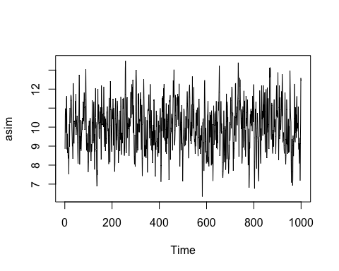

# Lets see our data with moving average, 50 days moving average first  
library(zoo)

##   
## Attaching package: 'zoo'

## The following objects are masked from 'package:base':  
##   
## as.Date, as.Date.numeric

plot(rollmean(asim, 50))

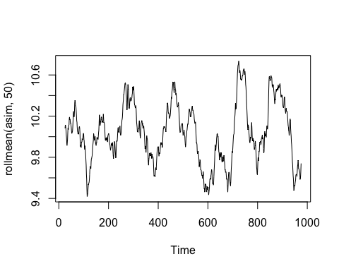

lets use moving average of days 25

plot(rollmean(asim, 25))

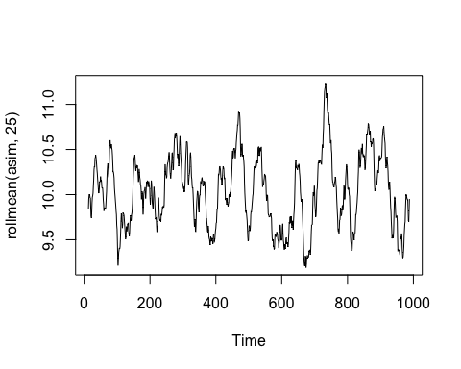

# Lets check the stationary

library(tseries)  
adf.test(asim)

## Warning in adf.test(asim): p-value smaller than printed p-value

##   
## Augmented Dickey-Fuller Test  
##   
## data: asim  
## Dickey-Fuller = -9.0113, Lag order = 9, p-value = 0.01  
## alternative hypothesis: stationary

Shows stationary

# Lets see ADF and PACF plots for autocorrelation

library(forecast)  
tsdisplay(asim)

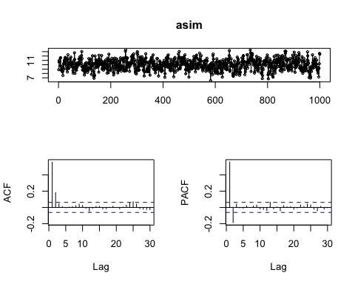

# Lets check with auto.arima()

Lets see if this gives us the value we used to simulate the arima ts or not.Just for checking

auto.arima(asim, trace = T, stepwise = F, approximation = F)

##   
## ARIMA(0,0,0) with zero mean : 7465.459  
## ARIMA(0,0,0) with non-zero mean : 3241.528  
## ARIMA(0,0,1) with zero mean : 6218.948  
## ARIMA(0,0,1) with non-zero mean : 2878.74  
## ARIMA(0,0,2) with zero mean : 5341.968  
## ARIMA(0,0,2) with non-zero mean : 2836.895  
## ARIMA(0,0,3) with zero mean : 4809.724  
## ARIMA(0,0,3) with non-zero mean : 2837.534  
## ARIMA(0,0,4) with zero mean : 4450.32  
## ARIMA(0,0,4) with non-zero mean : 2838.689  
## ARIMA(0,0,5) with zero mean : 4219.275  
## ARIMA(0,0,5) with non-zero mean : 2840.557  
## ARIMA(1,0,0) with zero mean : Inf  
## ARIMA(1,0,0) with non-zero mean : 2870.637  
## ARIMA(1,0,1) with zero mean : Inf  
## ARIMA(1,0,1) with non-zero mean : 2836.047  
## ARIMA(1,0,2) with zero mean : Inf  
## ARIMA(1,0,2) with non-zero mean : 2837.165  
## ARIMA(1,0,3) with zero mean : Inf  
## ARIMA(1,0,3) with non-zero mean : 2839.088  
## ARIMA(1,0,4) with zero mean : Inf  
## ARIMA(1,0,4) with non-zero mean : 2840.615  
## ARIMA(2,0,0) with zero mean : Inf  
## ARIMA(2,0,0) with non-zero mean : 2836.945  
## ARIMA(2,0,1) with zero mean : Inf  
## ARIMA(2,0,1) with non-zero mean : 2837.319  
## ARIMA(2,0,2) with zero mean : Inf  
## ARIMA(2,0,2) with non-zero mean : 2838.849  
## ARIMA(2,0,3) with zero mean : Inf  
## ARIMA(2,0,3) with non-zero mean : 2840.867  
## ARIMA(3,0,0) with zero mean : Inf  
## ARIMA(3,0,0) with non-zero mean : 2837.297  
## ARIMA(3,0,1) with zero mean : Inf  
## ARIMA(3,0,1) with non-zero mean : 2839.296  
## ARIMA(3,0,2) with zero mean : Inf  
## ARIMA(3,0,2) with non-zero mean : 2840.86  
## ARIMA(4,0,0) with zero mean : Inf  
## ARIMA(4,0,0) with non-zero mean : 2839.279  
## ARIMA(4,0,1) with zero mean : Inf  
## ARIMA(4,0,1) with non-zero mean : 2841.309  
## ARIMA(5,0,0) with zero mean : Inf  
## ARIMA(5,0,0) with non-zero mean : 2841.162

## Series: asim   
## ARIMA(1,0,1) with non-zero mean   
##   
## Coefficients:  
## ar1 ma1 mean  
## 0.3494 0.3183 10.0288  
## s.e. 0.0478 0.0473 0.0637  
##   
## sigma^2 estimated as 0.9927: log likelihood=-1414  
## AIC=2836.01 AICc=2836.05 BIC=2855.64

Yes the out put confirms the 1, 0, 1 model as in simulation. But the ar and ma part not so similar as in simulation. But close enough.

# How to manually calculate p, d, q values?

The best idea is to use auto.arima() function to get idea around p, d, q values. after that play around these values to manually choose best p, q values for the model. Keep in mind we choose the model with less AICc value.

Sometime auto.arima() alone is not good for parameter selection.

# Problem with R-base arima() function

This function can not calculate constant value if the TS requ ires the differencing. So the option is Arima() function of ‘forecast’ package.

# Again we use lynx data set to choose p,q values manually  
library(forecast)  
tsdisplay(lynx)



The Pacf plot shows that it probably the (2, 0, 0), it could be different but lets check this vlaues first. We know this data set has stationary. So d = 0

# Model building  
library(forecast)  
myarima <- Arima(lynx, order = c(2, 0, 0))  
summary(myarima)

## Series: lynx   
## ARIMA(2,0,0) with non-zero mean   
##   
## Coefficients:  
## ar1 ar2 mean  
## 1.1474 -0.5997 1545.4458  
## s.e. 0.0742 0.0740 181.6736  
##   
## sigma^2 estimated as 788920: log likelihood=-935.02  
## AIC=1878.03 AICc=1878.4 BIC=1888.98  
##   
## Training set error measures:  
## ME RMSE MAE MPE MAPE MASE  
## Training set 0.3615075 876.4468 631.7405 -74.99125 153.9046 0.7603467  
## ACF1  
## Training set -0.008188618

# Residual checking of model

library(forecast)  
checkresiduals(myarima)

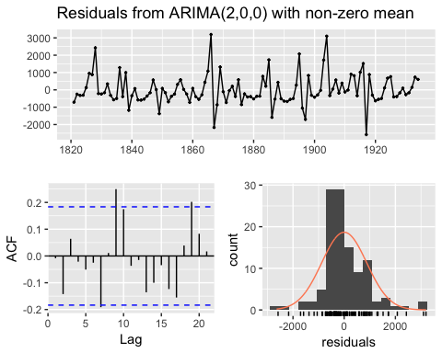

##   
## Ljung-Box test  
##   
## data: Residuals from ARIMA(2,0,0) with non-zero mean  
## Q* = 19.603, df = 7, p-value = 0.006494  
##   
## Model df: 3. Total lags used: 10

The acf plot of residual shows that there is still the autocorrelation. Lets play with p value to address this condition.

myarima <- Arima(lynx, order = c(3, 0, 0))  
summary(myarima)

## Series: lynx   
## ARIMA(3,0,0) with non-zero mean   
##   
## Coefficients:  
## ar1 ar2 ar3 mean  
## 1.1318 -0.5702 -0.0256 1545.5884  
## s.e. 0.0935 0.1306 0.0934 177.1506  
##   
## sigma^2 estimated as 795560: log likelihood=-934.98  
## AIC=1879.96 AICc=1880.51 BIC=1893.64  
##   
## Training set error measures:  
## ME RMSE MAE MPE MAPE MASE  
## Training set 0.05901059 876.1538 630.2967 -73.17528 152.8511 0.7586091  
## ACF1  
## Training set 0.0005592603

checkresiduals(myarima)

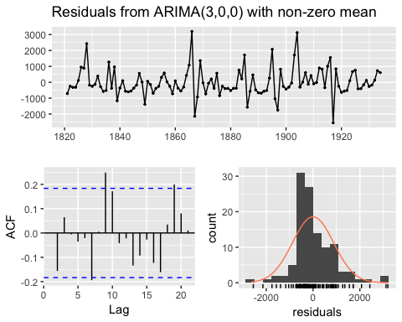

##   
## Ljung-Box test  
##   
## data: Residuals from ARIMA(3,0,0) with non-zero mean  
## Q* = 19.786, df = 6, p-value = 0.003023  
##   
## Model df: 4. Total lags used: 10

Among two models the first one (2, 0, 0) has low AICc so that is the best among two.

Lets see the Arima(4, 0, 0)

myarima <- Arima(lynx, order = c(4, 0, 0))  
summary(myarima)

## Series: lynx   
## ARIMA(4,0,0) with non-zero mean   
##   
## Coefficients:  
## ar1 ar2 ar3 ar4 mean  
## 1.1246 -0.7174 0.2634 -0.2543 1547.3859  
## s.e. 0.0903 0.1367 0.1361 0.0897 136.8501  
##   
## sigma^2 estimated as 748457: log likelihood=-931.11  
## AIC=1874.22 AICc=1875.01 BIC=1890.64  
##   
## Training set error measures:  
## ME RMSE MAE MPE MAPE MASE  
## Training set -3.075395 845.949 595.9818 -55.59226 128.7656 0.7173084  
## ACF1  
## Training set -0.01587225

checkresiduals(myarima)

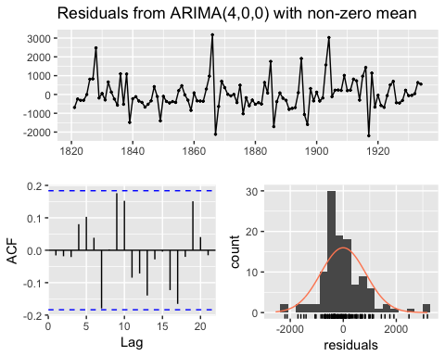

##   
## Ljung-Box test  
##   
## data: Residuals from ARIMA(4,0,0) with non-zero mean  
## Q* = 13.201, df = 5, p-value = 0.02157  
##   
## Model df: 5. Total lags used: 10

It has lowest AICc among three so this one is the best until now. It has also no lines above threshold in ACF plot. Although the plot seems not so normal than others, it is close enough.

Similarly we can test other values of p. But now we leave here

# Prediction on ARIMA model

Lets use the lynx data, make model with auto.arima() and forecast. This model is choosed just for understanding the forecasting.

# Model building  
myarima <- auto.arima(lynx,  
 stepwise = F,   
 approximation = F)

# This is yearly data set, h = 10 means, lets forecast the next 10 years  
library(forecast)  
arimafore <- forecast(myarima, h = 10)

plot(arimafore)

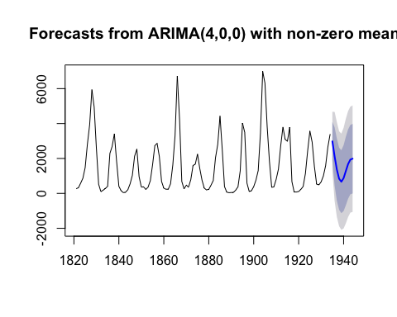

summary(arimafore)

##   
## Forecast method: ARIMA(4,0,0) with non-zero mean  
##   
## Model Information:  
## Series: lynx   
## ARIMA(4,0,0) with non-zero mean   
##   
## Coefficients:  
## ar1 ar2 ar3 ar4 mean  
## 1.1246 -0.7174 0.2634 -0.2543 1547.3859  
## s.e. 0.0903 0.1367 0.1361 0.0897 136.8501  
##   
## sigma^2 estimated as 748457: log likelihood=-931.11  
## AIC=1874.22 AICc=1875.01 BIC=1890.64  
##   
## Error measures:  
## ME RMSE MAE MPE MAPE MASE  
## Training set -3.075395 845.949 595.9818 -55.59226 128.7656 0.7173084  
## ACF1  
## Training set -0.01587225  
##   
## Forecasts:  
## Point Forecast Lo 80 Hi 80 Lo 95 Hi 95  
## 1935 2980.7782 1872.064458 4089.492 1285.1469 4676.410  
## 1936 2114.6447 446.136392 3783.153 -437.1186 4666.408  
## 1937 1361.7211 -413.725499 3137.168 -1353.5901 4077.032  
## 1938 839.0137 -938.235509 2616.263 -1879.0544 3557.082  
## 1939 668.7873 -1133.427818 2471.002 -2087.4629 3425.038  
## 1940 874.3079 -1010.219757 2758.835 -2007.8284 3756.444  
## 1941 1281.3753 -678.535018 3241.286 -1716.0489 4278.799  
## 1942 1679.8363 -304.332085 3664.005 -1354.6874 4714.360  
## 1943 1933.3503 -51.056008 3917.757 -1101.5373 4968.238  
## 1944 1987.5494 -5.522913 3980.622 -1060.5917 5035.690

# See the 10 forecasted values

arimafore$mean

## Time Series:  
## Start = 1935   
## End = 1944   
## Frequency = 1   
## [1] 2980.7782 2114.6447 1361.7211 839.0137 668.7873 874.3079 1281.3753  
## [8] 1679.8363 1933.3503 1987.5494

# Plot last observationas and the forcasted values

plot(arimafore, xlim = c(1930, 1944))

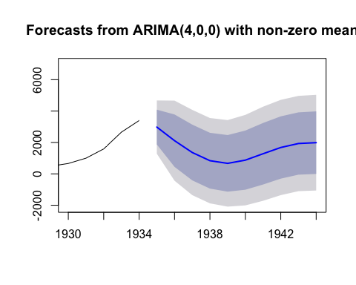

# Lets See how exponential smoothing model works for us

# Create ets model  
myets <- ets(lynx)

# Forecasting  
etsfore <- forecast(myets, h = 10)

# Lets compare two forecasted models with ggplot

library(ggplot2)  
autoplot(lynx) + forecast::autolayer(etsfore$mean, series = 'ETS model') +   
 forecast::autolayer(arimafore$mean, series = "ARIMA model") +   
 xlab('year') + ylab('Lynx Trappings') +  
 guides(  
 colour = guide_legend(title = "Forecast Method")) + theme(legend.position = c(0.8, 0.8))

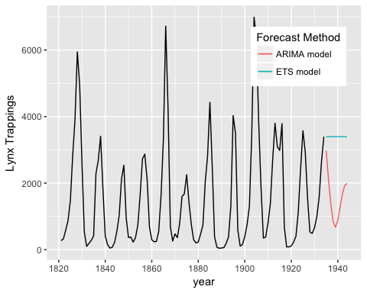

ETS model is not working good here. ARIMA model is best here Visualization is im;portant

# Dealing with explanatory variable in ARIMA

fish <- read.csv("~/Desktop/cyprinidae.csv")

head(fish)

## X concentration predator_presence  
## 1 1 11.240482 FALSE  
## 2 2 10.294277 FALSE  
## 3 3 232.000000 TRUE  
## 4 4 10.626500 FALSE  
## 5 5 10.323206 FALSE  
## 6 6 8.514967 FALSE

library(ggplot2)  
ggplot(aes(X, concentration), data = fish) + geom_point() +   
 aes(colour = predator_presence)

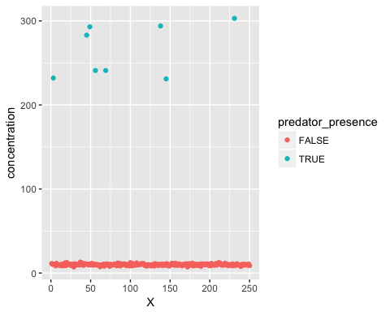

# Convert to time series

class(fish)

## [1] "data.frame"

# Since fish is data frame, change it to time series  
x = ts(fish$concentration)  
y = fish$predator_presence  
class(x)

## [1] "ts"

# Model creation of this fish data with explanatory variable

The xreg function allows us to use explanatory variable while model building

library(forecast)  
mymodel <- auto.arima(x, xreg = y,   
 stepwise = F,   
 approximation = F)  
mymodel

## Series: x   
## Regression with ARIMA(0,0,0) errors   
##   
## Coefficients:  
## intercept xreg  
## 9.9765 254.7735  
## s.e. 0.3409 1.9059  
##   
## sigma^2 estimated as 28.36: log likelihood=-771.84  
## AIC=1549.68 AICc=1549.77 BIC=1560.24

# Check the model residual

From this we can check if the autocorrelation is still present or not. If present go back and choose right p, q values.

checkresiduals(mymodel)

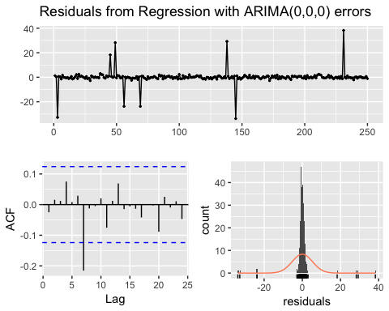

##   
## Ljung-Box test  
##   
## data: Residuals from Regression with ARIMA(0,0,0) errors  
## Q* = 14.122, df = 8, p-value = 0.07865  
##   
## Model df: 2. Total lags used: 10

# Forecasting with explanatory variable

# We want to predict the model based on below explanatory variable. For forcasting next 10 steps  
y1 <- c(T, T, F, F, F, F, T, F, T, F)

plot(forecast(mymodel, xreg = y1))

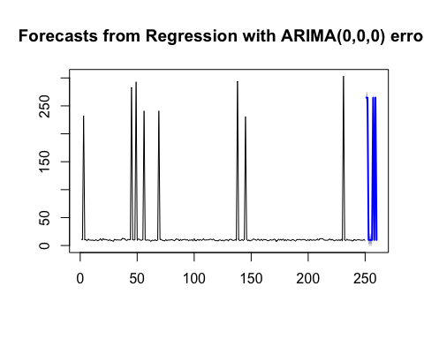

# Only forcasted part is below  
plot(forecast(mymodel, xreg = y1), xlim = c(230, 260))

