Prompt Library for Content Generation
Mini Project – Generative AI
Name: Kritika Gahlawat

Introduction
This is my prompt library for common content generation tasks. I have used different prompt engineering techniques such as role prompting, few-shot prompting, RTCF and constraints. I have also used placeholders so that the prompts can be reused.

1. LinkedIn Post for a Student Project
Use Case: To write a LinkedIn post about a college project.
Techniques: Role Prompting + Few-Shot + Constraints
Template:
You are a LinkedIn content writer. Write a LinkedIn post about my project Library Management System, made using Java and MySQL. The audience is college students and recruiters. Mention what I learned: database connectivity, CRUD operations and problem-solving. Keep it around 100–120 words. Use a simple and positive student tone. Start with a short opening and end with a question.
Sample Output:
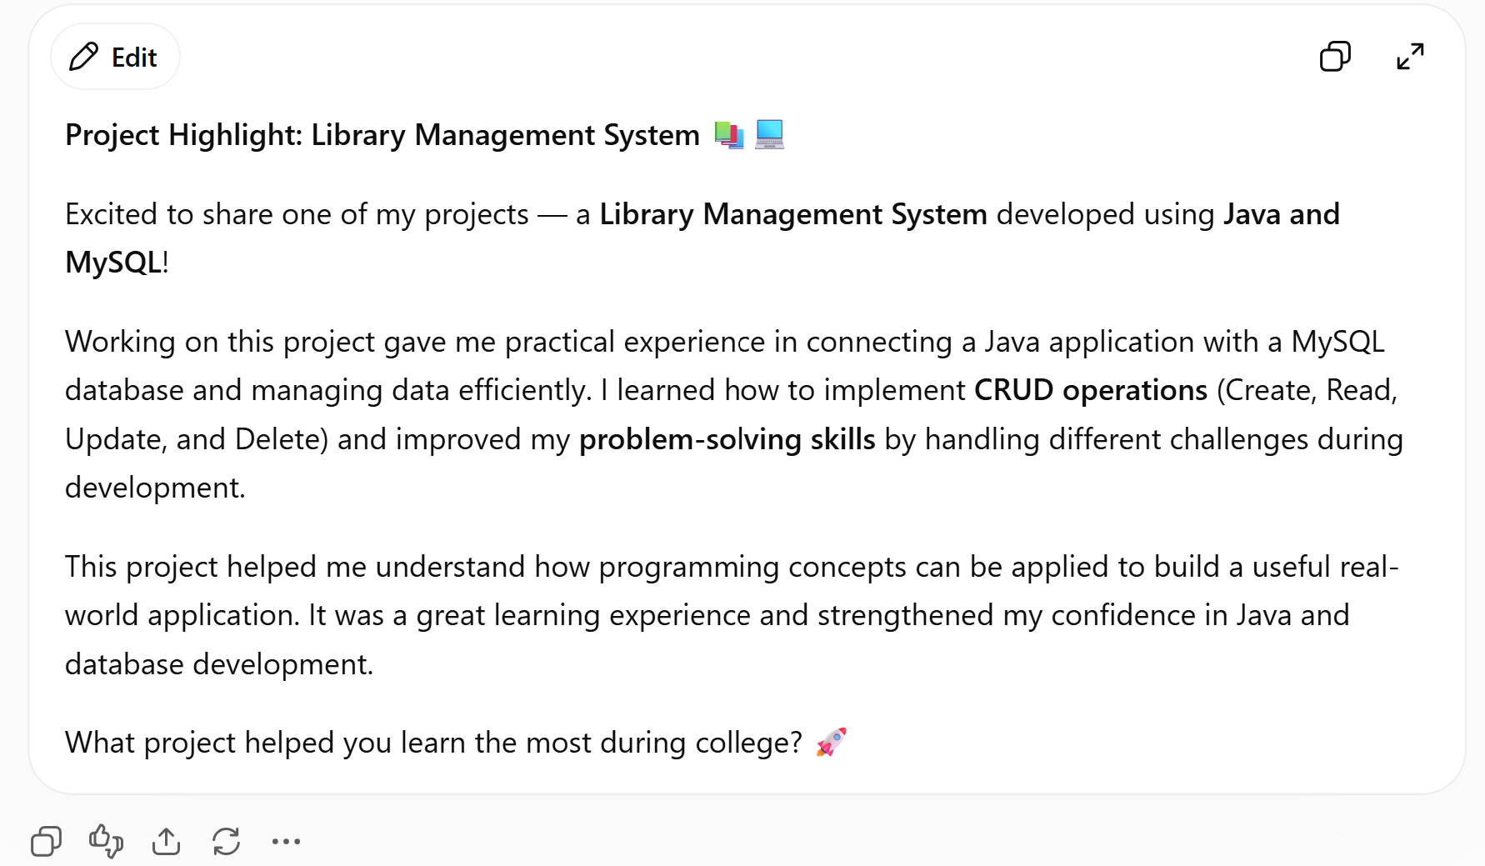Iteration: V1 → V2: In V1 I only asked for a LinkedIn post. In V2 I added the audience, tone, word limit and an example. This made the result more focused.

2. Blog Introduction
Use Case: To write the first paragraph of a student blog.
Techniques: Role Prompting + RTCF + Constraints
Template:
You are a blog writer. Write an introduction for a blog about How Beginners Can Start Learning Python. The readers are college students. The purpose of the blog is to help beginners understand how to start learning Python. Start with a question or common problem. Explain why the topic is useful and briefly say what the blog will cover. Write 120–150 words in simple language.
Sample Output:
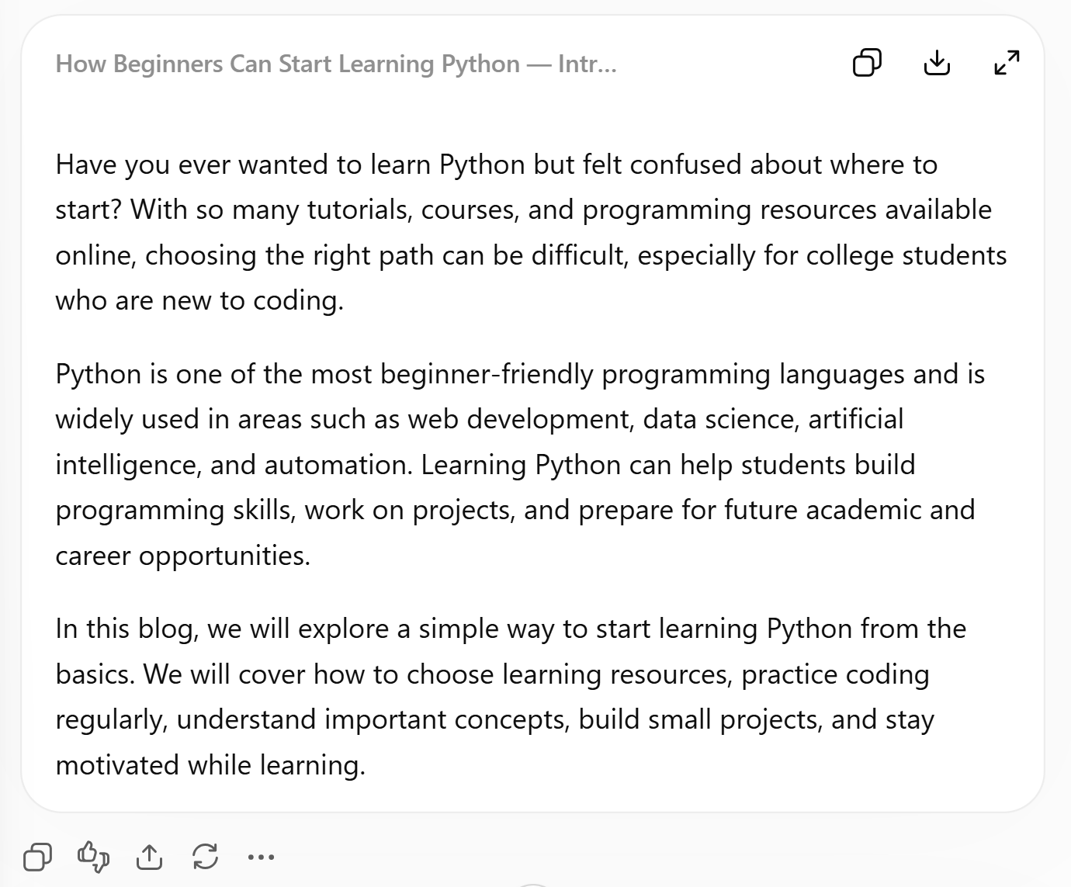
Iteration: V1 → V2: I added the target readers, purpose, structure and word limit. The second version gave a more useful introduction.

3. Cold Outreach Email
Use Case: To contact a company or professional for an opportunity or advice.
Techniques: Role Prompting + Constraints + RTCF
Template:
You are a career mentor. Write a short email to Ms. Sharma, who is an HR Manager at ABC Technologies. I am a final-year M.Tech student and my skills are Python, SQL and Machine Learning. I am contacting her because I am interested in internship opportunities. Mention my project Machine Learning Project. I want to ask about internship opportunities and advice for students. Keep it under 120 words. Be polite and confident, not desperate.
Sample Output:
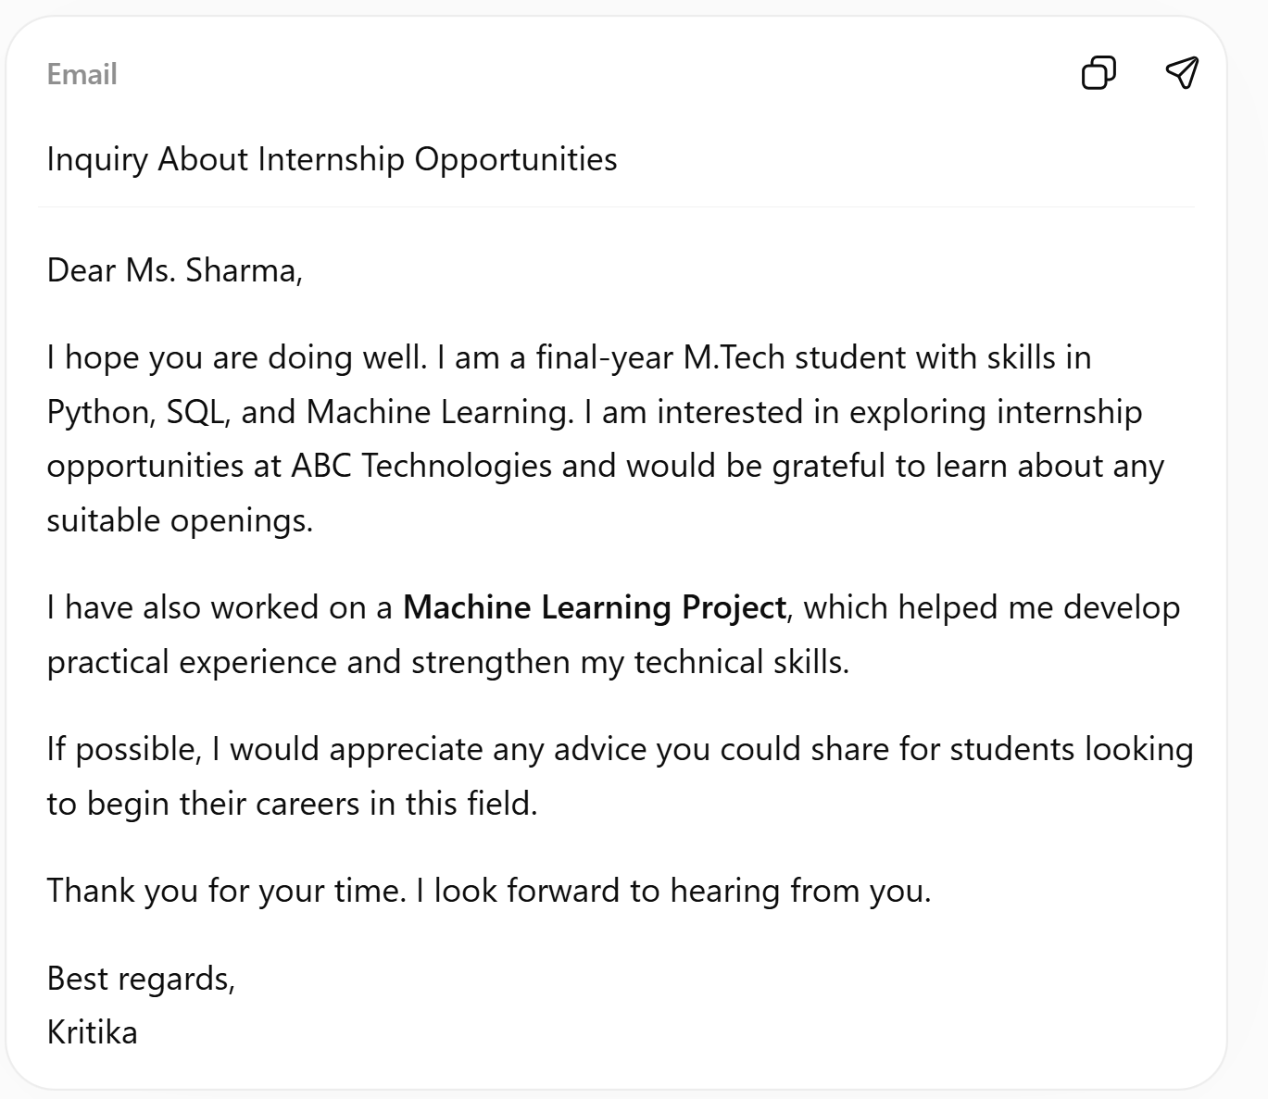Iteration: V1 → V2: The first prompt was just “write a cold email for a job”. I added my background, reason, project, request and word limit, so the email sounded more natural.

