PROJECT AND TEAM INFORMATION

Project Title

GasGrid - Gas Supply Network & Resource Allocation System

Student / Team Information
Team Name: | kritikadhiman1492006
Team member 1 (Team Lead)  Kritika Dhiman  2418611  240122194  kritikadhiman1492006@gmail.com | 
Team member 2  Garvit Jain  2418499  24011847  jgarvit40@gmail.com | 
Team member 3  Aryan  2418351  24031732  aryanbidhuri3@gmail.com | 
Team member 4  Tanishi Pande  2419054  24012855  pandetanishi@gmail.com | 

PROPOSAL DESCRIPTION (10 pts)

Motivation (1 pt)

LPG is an essential energy resource used by households, commercial establishments, and industries. Its distribution involves managing a large number of requests while dealing with limited resources such as LPG cylinders, warehouse inventory, delivery vehicles, delivery agents, and available delivery slots. During periods of high demand or emergency requirements, inefficient allocation of these resources can result in long waiting times, delayed deliveries, resource conflicts, and inventory shortages.
A conventional LPG booking system mainly focuses on recording customer requests and processing deliveries. However, it does not adequately address the underlying problem of how multiple competing requests should be scheduled and how limited resources should be safely and efficiently allocated.
GasGrid is motivated by the need to model this problem as a resource-constrained system. Each LPG request is treated as a process, while cylinders, vehicles, delivery agents, and warehouse capacity are treated as system resources. Operating System concepts such as process scheduling, synchronization, resource allocation, deadlock detection, and starvation prevention can therefore be applied to real distribution scenarios.
At the same time, reliable resource management requires a strong database layer. Oracle DBMS is used to maintain inventory, requests, resource allocations, deliveries, and transaction history while ensuring consistency during concurrent operations. Advanced SQL, PL/SQL, triggers, transactions, and analytical queries further support decision-making and inventory planning.
Thus, GasGrid aims to bridge the gap between theoretical OS and DBMS concepts and their practical application in a real-world LPG supply network.

State of the Art / Current solution (1 pt)

Current LPG distribution systems primarily use digital platforms for customer registration, cylinder booking, order tracking, inventory management, delivery scheduling, and payment processing. Customers can place requests through websites, mobile applications, or other digital channels, while distributors manage orders, available stock, deliveries, and customer information through centralized systems.
In a typical workflow, a booking is recorded in the database, inventory availability is checked, and the request is assigned for delivery based on operational availability. Large-scale distribution networks may also use centralized inventory and logistics systems to coordinate warehouses, vehicles, and delivery operations.
However, conventional booking-oriented systems mainly focus on order processing and record management. When several requests compete simultaneously for limited cylinders, vehicles, delivery agents, or delivery slots, the deeper resource-allocation problem becomes more complex. Emergency requests may require immediate attention, while continuously prioritizing them can delay normal requests. Concurrent requests can also create resource conflicts, and combinations of allocated resources may lead to deadlock-like situations.
Therefore, there is scope for a system that goes beyond booking and database management by explicitly modelling LPG requests as processes and distribution resources as system resources. GasGrid addresses this gap by integrating OS-based scheduling, synchronization, resource allocation, deadlock handling, and starvation prevention with advanced DBMS-based inventory, transaction, and analytical management.

Project Goals and Milestones (2 pts).
Project Goals
The primary goal of GasGrid is to develop an integrated OS + DBMS based LPG supply network and resource allocation system that can efficiently manage competing LPG requests under limited resources.
The project aims to:
- Model LPG requests as processes and cylinders, vehicles, delivery agents, and warehouse capacity as system resources.
- Implement and compare process scheduling techniques such as FCFS, SJF/SRTF, Priority Scheduling, Round Robin, and MLFQ.
- Implement synchronization mechanisms to handle concurrent requests and prevent race conditions during resource allocation.
- Apply resource-allocation techniques, including Banker’s Algorithm, along with deadlock detection and recovery.
- Address starvation using priority aging and evaluate scheduling performance using waiting, turnaround, and response times.
- Develop an Oracle-based database for LPG types, inventory, requests, resources, deliveries, and transaction history.
- Implement advanced DBMS features including transactions, PL/SQL procedures/functions, triggers, constraints, views, indexing, auditing, and analytical queries.
- Integrate the OS engine, Oracle DBMS, Flask backend, and web interface into a single working system.
Initial Milestones
- Milestone 1: Finalize problem definition, LPG types, system assumptions, actors, and resource model.
- Milestone 2: Design system architecture, process model, workflow, DFD, and ER diagram.
- Milestone 3: Design Oracle schema and populate realistic sample data.
- Milestone 4: Implement OS process management and scheduling algorithms in C.
- Milestone 5: Implement synchronization, resource allocation, Banker’s Algorithm, deadlock handling, starvation, and aging.
- Milestone 6: Implement advanced SQL, PL/SQL, triggers, transactions, auditing, and analytics.
- Milestone 7: Integrate the C OS engine with Flask and Oracle.
- Milestone 8: Develop the dashboard and visualize scheduling, resources, inventory, deadlocks, and analytics.
- Milestone 9: Test normal, high-demand, emergency, concurrent-booking, deadlock, starvation, insufficient-inventory, and transaction-failure scenarios.
- Milestone 10: Evaluate results, document findings, and finalize the project.

Project Approach (3 pts)

GasGrid will be developed as an integrated Operating System and Database Management System application using a modular architecture. The solution will model LPG distribution as a resource-constrained system in which customer requests compete for limited cylinders, vehicles, delivery agents, warehouse capacity, and delivery slots.
The project will be divided into four major layers:
- OS Engine: The OS component will be implemented in C. LPG requests will be represented as processes, and process states, ready queues, scheduling, synchronization, resource allocation, deadlock detection/recovery, starvation, and aging will be implemented. Scheduling algorithms will be evaluated using waiting time, turnaround time, response time, and completion time.
- Database Layer: Oracle Database will store customers, LPG and cylinder types, warehouses, inventory, vehicles, delivery agents, requests, process information, resource allocations, and delivery records. SQL and PL/SQL will be used for complex queries, procedures, functions, triggers, transactions, auditing, and analytics. Inventory transactions will maintain a reliable history of stock movement.
- Backend and Integration Layer: Python Flask will act as the application and integration layer between the frontend, Oracle database, and C-based OS engine. It will handle requests, invoke OS operations, retrieve database information, and return scheduling and resource-allocation results.
- Frontend Layer: HTML, CSS, and JavaScript will provide interfaces for booking, inventory, scheduling, resource monitoring, delivery management, and analytics. A dashboard will visualize ready/waiting processes, resource availability, scheduling results, deadlocks, inventory alerts, and system performance.
The complete system will be tested using realistic scenarios such as high demand, emergency requests, concurrent bookings, insufficient inventory, deadlock, starvation, and transaction failure. The final implementation will demonstrate how OS resource-management techniques and DBMS consistency mechanisms can work together in an LPG distribution environment.

System Architecture (High Level Diagram)(2 pts)

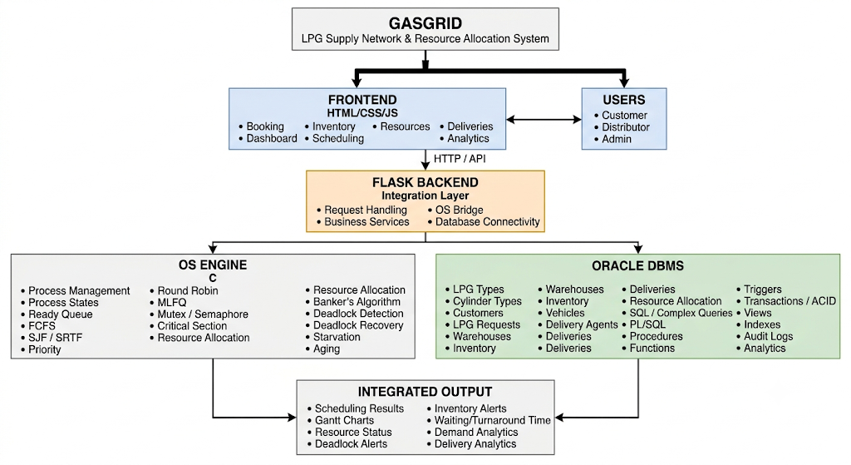

GASGRID
│
├── 1. SYSTEM ARCHITECTURE
│ ├── High-Level Architecture
│ ├── Overall Workflow
│ ├── DFD Level 0
│ └── DFD Level 1
│
├── 2. OS DESIGN
│ ├── Process Model
│ ├── Process State Diagram
│ ├── Scheduling Flow
│ ├── Gantt Chart
│ ├── Resource Allocation Graph
│ ├── Synchronization
│ ├── Banker's Algorithm
│ ├── Deadlock
│ └── Starvation & Aging
│
├── 3. DBMS DESIGN
│ ├── ER Diagram
│ ├── Relational Schema
│ ├── Normalization
│ ├── Database Architecture
│ ├── Transaction Flow
│ ├── Inventory Lifecycle
│ ├── PL/SQL Flow
│ └── Trigger Flow
│
├── 4. INTEGRATION
│ ├── OS ↔ DBMS Integration
│ ├── Sequence Diagram
│ └── Complete Request Flow
│
└── 5. RESULTS
├── Dashboard
├── Scheduling Results
├── Gantt Charts
├── Resource Utilization
├── Deadlock Detection
├── Inventory Analytics
└── Performance Analysis

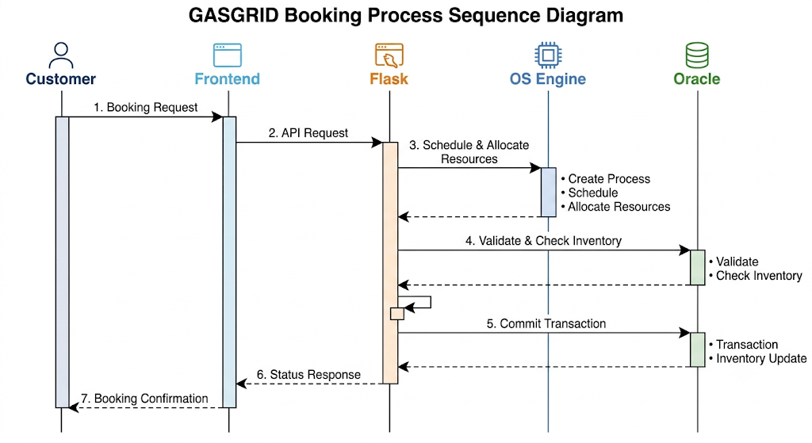

Project Outcome / Deliverables (1 pts)

The project will deliver a functional prototype of an integrated OS + DBMS based LPG Supply Network and Resource Allocation System. The major outcomes of the project will include:
- A web-based interface for LPG request management, inventory monitoring, scheduling, resource allocation, delivery management, and analytics.
- A C-based OS engine implementing process management, process scheduling, synchronization, resource allocation, Banker’s Algorithm, deadlock detection and recovery, starvation prevention, and aging.
- An Oracle database for managing LPG types, cylinder types, customers, requests, warehouses, inventory, vehicles, delivery agents, resource allocations, and deliveries.
- A properly designed ER model, relational schema, normalized database, primary/foreign key constraints, and integrity constraints.
- Advanced SQL and PL/SQL implementation including joins, subqueries, views, procedures, functions, triggers, transactions, auditing, and analytical queries.
- Integration of the OS engine, Flask backend, and Oracle DBMS for coordinated request processing and resource management.
- Scenario-based demonstrations covering high demand, emergency requests, concurrent bookings, insufficient inventory, deadlock, starvation, and transaction failure.
- A dashboard displaying scheduling results, Gantt charts, resource utilization, inventory alerts, deadlock status, and demand/delivery analytics.

- Complete testing, performance evaluation, documentation, and demonstration of the interaction between OS resource management and DBMS consistency mechanisms.

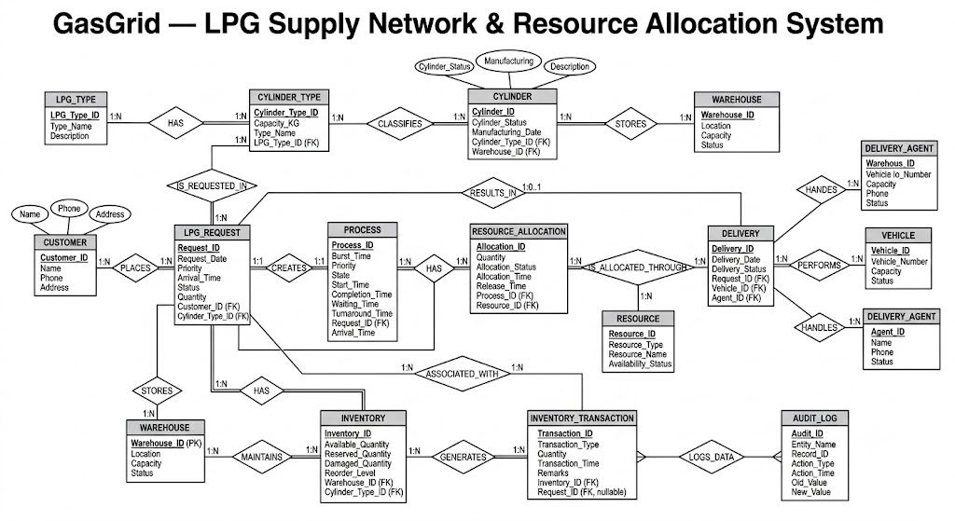

Assumptions

The following assumptions are made for developing GasGrid:
- LPG is categorized into domestic and commercial types with defined cylinder capacities.
- Warehouses have limited LPG inventory and storage capacity.
- Vehicles and delivery agents have limited availability and capacity.
- Each LPG request is treated as an independent process with arrival time, priority, and resource requirements.
- Multiple requests may arrive concurrently and compete for the same resources.
- Emergency requests may receive higher priority.
- Network communication and sensor-based real-time tracking are outside the project scope.
- Sample/simulated data is used for testing scheduling, resource allocation, and database operations.

References

- Abraham Silberschatz, Peter B. Galvin, and Greg Gagne, Operating System Concepts, Wiley.
- Ramez Elmasri and Shamkant B. Navathe, Fundamentals of Database Systems, Pearson.
- Oracle Database 11g Documentation — SQL, PL/SQL, Transactions, Triggers and Database Concepts.
- Oracle SQL Language Reference — SQL statements, joins, subqueries, views and analytical functions.
- Oracle PL/SQL Language Reference — Procedures, functions, cursors and exception handling.
- Oracle Database Concepts — Transactions, concurrency control, locking and data consistency.
- Ministry of Petroleum and Natural Gas, Government of India — LPG distribution and consumer-related information.
- Indian Oil Corporation Limited — LPG services, domestic and commercial LPG information.
- Bharat Petroleum Corporation Limited — LPG distribution and cylinder-related information.
- Hindustan Petroleum Corporation Limited — LPG services and distribution information.
- Flask Documentation — Python web application development and routing.
- Python Documentation — subprocess, database connectivity and application development.

