## Kleurschema website

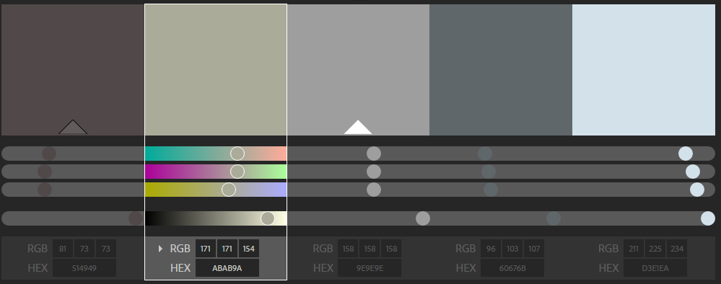

#514949  
#ABAB9A  
#9E9E9E  
#60676B  
#D3E1EA