Patient: SMITH, SYLVIA | Date: 07 Oct 2013 1139 EDT | Appt Type: OPAC
Treatment Facility: JAMES A LOVELL FED HEALTH CARE CENTER | Clinic: FAMILY PRACTICE CLINIC | Provider:
Patient Status: Outpatient

AutoCites Refreshed by BHIE,USERONE @ 07 Oct 2013 1145 EDT
Problems  Chronic:  •Upper back pain is not worse with coughing/sneezing  •Flank pain relieved by sneezing or coughing  •No vomiting preceded by vigorous coughing  •Coughing up broncholiths  •No cough  •Visit for: screening for whooping cough | Family History  •No family history of hematologic symptoms (General FHx)  •Pulmonary symptoms (General FHx)  •No family history of eye symptoms (General FHx)  •Systemic symptoms (General FHx) | Allergies  •NUT TX IMP.DIG.FXN,SOY LACFREE Ingredient: Skin irritation, Skin Lesion (testing by BHIEONE)  •PEANUT BUTTER FLAVOR (FLAVORING AGENT): Nausea (testing by Provider BHIEONE)  •Aspirin: Cough, Cough after exercise, Cough at rest
Active Medications
No Active Medications Found.

Reason for Appointment:Written by BHIE,USERONE @ 07 Oct 2013 1139 EDT
Cough

Vitals
Vitals Written by BHIE,USERONE @ 07 Oct 2013 1150 EDT
BP: 120/99, HR: 55, RR: 32, T: 99 °F, HT: 66 in, WT: 140 lbs, SpO₂: 99%, PF: 99, Uncorr OD: 20/20,
Uncorr OS: 20/20, Uncorr OU: 20/20, BMI: 22.6, BSA: 1.719 square meters, Tobacco Use: Yes, Alcohol Use: Yes, Pain Scale: 9/10 Severe,
Pain Scale Comments: testing for Pain
Comments: Comments added by BHIEONE

Drawing/Image Written by BHIE,USERONE @ 07 Oct 2013 1152 EDT
1. comments one
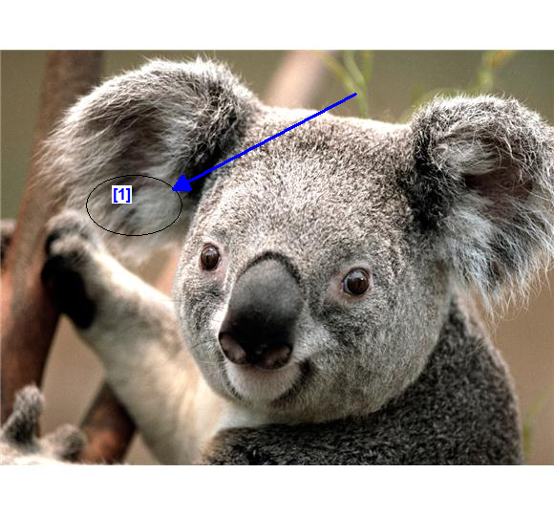

A/P Written by BHIE,USERONE @ 07 Oct 2013 1154 EDT
1. COUGH WITH HEMORRHAGE
Procedure(s): | -Pulmonary Function Tests Peak Expiratory Flow x 1 - Created by entry in Vitals Module

Disposition Written by BHIE,USERONE @ 07 Oct 2013 1154 EDT
Released w/o Limitations

Signed By BHIE, USERONE (Physician/Workstation) @ 07 Oct 2013 1156

