Patient: VICKERS, CURTIS | Date: 09 Oct 2013 1309 EDT | Appt Type: SPEC$
Treatment Facility: JAMES A LOVELL FED HEALTH CARE CENTER | Clinic: FAMILY PRACTICE CLINIC | Provider: BHIEONE
Patient Status: Outpatient

AutoCites Refreshed by BHIE,USERONE @ 09 Oct 2013 1310 EDT
Problems  No Problems Found. | Family History  No Family History Found. | Allergies  No Allergies Found.
Active Medications
No Active Medications Found.

Reason for Appointment:Written by BHIE,USERONE @ 09 Oct 2013 1309 EDT
testing drawing module

Drawing/Image Written by BHIE,USERONE @ 09 Oct 2013 1323 EDT
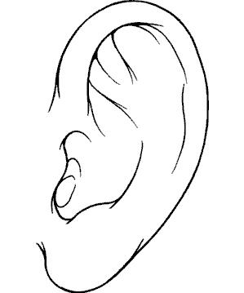

Drawing/Image Written by BHIE,USERONE @ 09 Oct 2013 1324 EDT
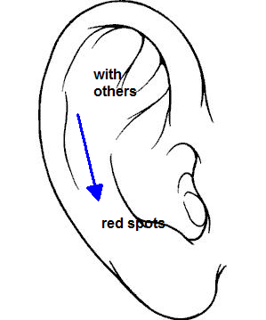

Drawing/Image Written by BHIE,USERONE @ 09 Oct 2013 1323 EDT
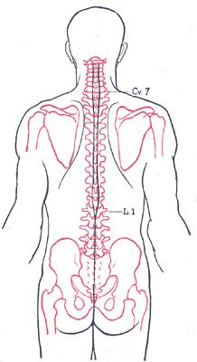

A/P Last Updated by BHIE,USERONE @ 09 Oct 2013 1310 EDT
1. EYE DISORDERS
Procedure(s): | -Home Care Visit Administration Of Aerosolized Pentamidine x 1

Disposition Last Updated by BHIE,USERONE @ 09 Oct 2013 1320 EDT
Released w/o Limitations

Signed By BHIE, USERONE (Physician/Workstation) @ 09 Oct 2013 1325
_________________________________________________________________________________________________________
CHANGE HISTORY
The following Drawing Tool Was Overwritten by BHIE,USERONE @ 09 Oct 2013 1324 EDT:
The DrawingTool section was last updated by BHIE,USERONE @ 09 Oct 2013 1324 EDT - see above.Previous Version of DrawingTool section was entered/updated by BHIE,USERONE @ 09 Oct 2013 1320 EDT.
Drawing/Image Written by BHIE,USERONE @ 09 Oct 2013 1320 EDT

The following Signature(s) No Longer Applies because this Encounter Was Opened for Amendment by BHIE,USERONE @ 09 Oct 2013 1322 EDT:
Signed BHIEONE (Physician/Workstation) @ 09 Oct 2013 1320

