Patient: DANIELS, PEDRO ROBERT | Date: 09 Oct 2013 1339 EDT | Appt Type: OPAC
Treatment Facility: JAMES A LOVELL FED HEALTH CARE CENTER | Clinic: Family Practice Clinic | Provider: BHIE, USERONE
Patient Status: Outpatient

AutoCites Refreshed by BHIE, USERONE @ 09 Oct 2013 1341 EDT
Problems  No Problems Found. | Family History  No Family History Found. | Allergies  No Allergies Found.
Active Medications
No Active Medications Found.

Drawing/Image Written by BHIE,USERONE @ 09 Oct 2013 1342 EDT


A/P Last Updated by BHIE, USERONE @ 09 Oct 2013 1342 EDT
1. EYE DISORDERS
Procedure(s): | -Home Care Visit For Assistance With ADLs / Personal Care x 1

Disposition Last Updated by BHIE, USERONE @ 09 Oct 2013 1343 EDT
Released w/o Limitations

Note Written by BHIE, USERONE @ 17 Oct 2013 1246 EDT
Update encounter for 09 Oct 2013
Testing Updated Encounters
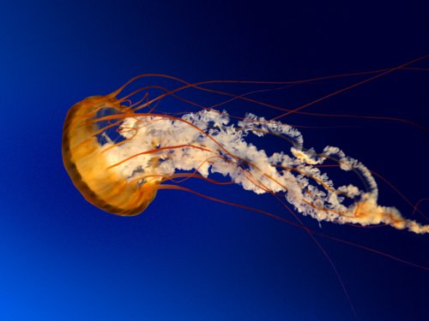

Signed By BHIE, USERONE (Physician/Workstation) @ 17 Oct 2013 1248
_________________________________________________________________________________________________________
CHANGE HISTORY
The following Signature(s) No Longer Applies because this Encounter Was Opened for Amendment by BHIE, USERONE @ 17 Oct 2013 1246 EDT:
Signed BHIE, USERONE (Physician/Workstation) @ 09 Oct 2013 1343

