Patient: VICKERS, CURTIS | Date: 02 Dec 2013 1600 EST | Appt Type: ACUT
Treatment Facility: JAMES A LOVELL FED HEALTH CARE CENTER | Clinic: FAMILY PRACTICE CLINIC | Provider: BHIEONE
Patient Status: Outpatient

AutoCites Refreshed by BHIE,USERONE @ 02 Dec 2013 1600 EST
Problems  Chronic:  •Previous history of sinus pressure  •Previous history of pain over the nose  •Ankle joint pain  •History of gastroduodenal artery aneurysm  •History of malignant neoplasm of the gastrointestinal tract  •Previous history of gastrointestinal symptoms  •Previous history of visit for: preoperative gastrointestinal exam  •Cough variant asthma  Acute:  •Appendix disorders | Family History  No Family History Found. | Allergies  •Iodine Containing Agents: Nausea (test)
Active Medications
No Active Medications Found.
Expired Medications
No Expired Medications Found.

Appointment Comments: Written by BHIE,USERONE @ 02 Dec 2013 1600 EST
test

Vitals
Vitals Written by BHIE,USERONE @ 02 Dec 2013 1601 EST
BP: 110/80, HR: 40, RR: 40, T: 98 °F, HT: 5' 3'', WT: 120 lbs, BMI: 21.26, BSA: 1.556 square meters, Tobacco Use: No, Alcohol Use: No
Comments: test

Questionnaire AutoCites Refreshed by BHIE,USERONE @ 02 Dec 2013 1600 EST
Questionnaires

SO Note Written by BHIEONE @ 02 Dec 2013 1620 EST
History of present illness
• Headache.
• Neck pain radiating up the back of the head.

Drawing/Image Written by BHIE,USERONE @ 02 Dec 2013 1615 EST
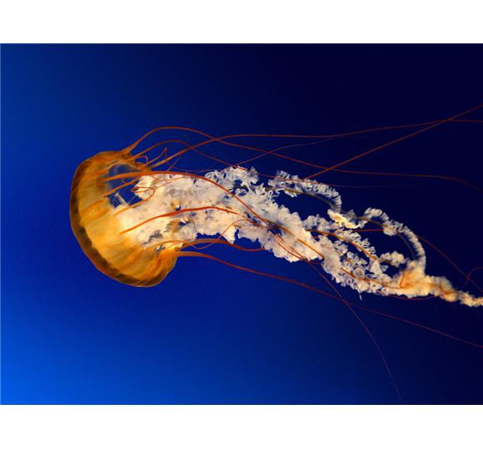

A/P Written by BHIE,USERONE @ 02 Dec 2013 1639 EST
1. CYSTITIS ACUTE VIRAL
Procedure(s): | -Hepatitis B Vaccine (Active); 20 Years and Above x 1 - Hep B - Adult; Series #: 3; .1 mL; IM; Right Thigh; Mfg: Abbott; Lot: 15b.
 | -Immunization Administration One Vaccine x 1
 | -Anesthesia Neck For Procedures On Skin / Subcutaneous Tissue x 1

Disposition Written by BHIE,USERONE @ 02 Dec 2013 1639 EST
Released w/ Work/Duty Limitations
Discussed: Diagnosis, Medication(s)/Treatment(s), Alternatives, Potential Side Effects with Patient who indicated understanding.

Signed By BHIE, USERONE (Physician/Workstation) @ 02 Dec 2013 1640
_________________________________________________________________________________________________________
CHANGE HISTORY
The following Allergy was Added: <CHCS IEN|DESC>:7000|Tetracyclines by BHIE,USERONE @ 02 Dec 2013 1637 EST:

