RAPIDO · MEMO TO THE HEAD OF SUPPLY
Onboarding leak and overnight airport · Ramanathan K R · 10 Sep 2026 · extract 30 Jun 2026, 23:59 IST
~180 more approved captains a month — two photo fixes, not a hiring push
The ask. Ship Insurance camera UX this week, then a 10-day RC grace after Legal. Do not hire the airport catchment. Stop scaling CAMP_WA_002. Medium confidence on 180; the campaign call is a hard no. These approvals are not hollow: 98.7% of mature approved captains already take a first trip (3,895 / 3,946).
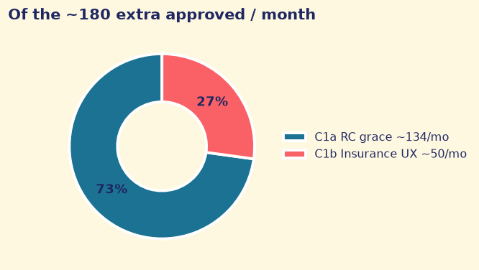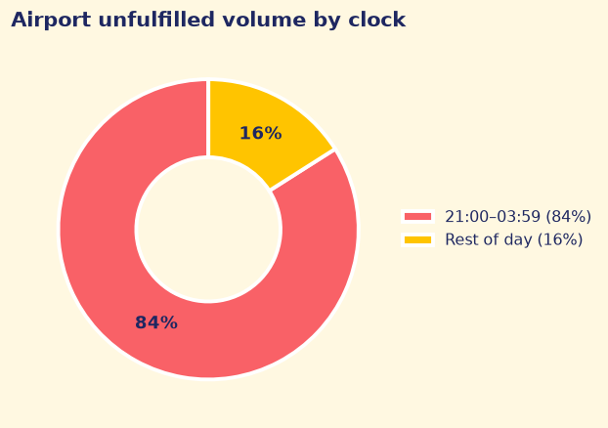
What to do this week
# | Do this | Impact | Watch
1 | C1b Insurance camera this week (411), then C1a 10-day RC grace after Legal (1,637). Same camera on other docs is a free rider — not in the 180. | ~180/mo (~50 + ~134). C1a ops ~1 FTE ₹40–60k assumed. | Approved by cohort
2 | Airport Return Assurance at ₹35.4 per unpaid night-suburban leg. Do not hire the catchment. | Sample ~₹69–103k/mo. Rest-suburban, not city-core. | Return-in-20m, cancels, falling 4-week run-rate
3 | Stop CAMP_WA_002 5×. Send/no-send RCT on RC-cleared app/paid captains only. | 0 pp click lift. Cost avoided + answer in 4–6 weeks. | Aadhaar pass and approved
Airport: ~40% unfulfilled vs ~3% elsewhere; 84% in 21:00–03:59. Mix does not shift overnight (χ² p=0.12). CAMP_WA_002 clicked vs not is −1.5pp (CI −3.6 to +0.6) → 0 pp. Do not fund 5×.
Why these two stages — leftover queue — ARA maths
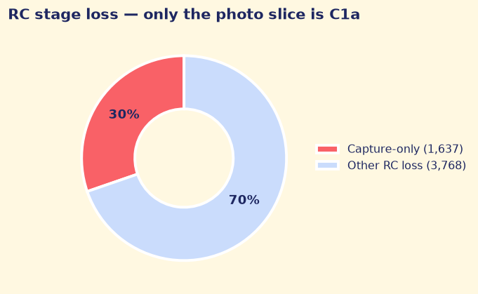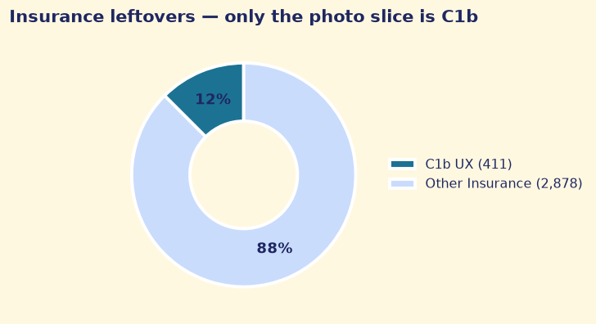
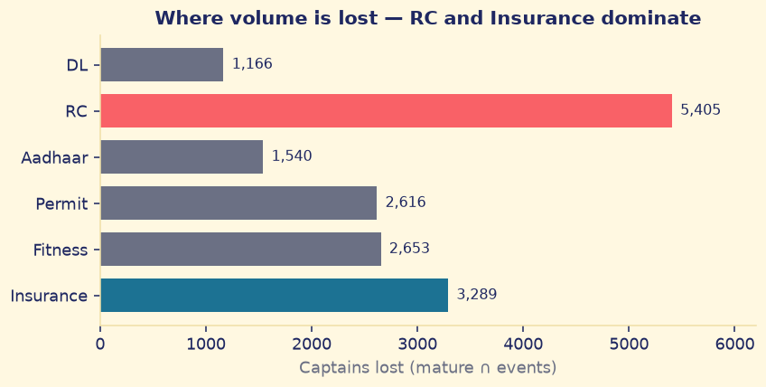
RC loses 5,405; only 1,637 are capture-only (C1a). Insurance loses 3,289 but ~2,530 never uploaded after Fitness — C1b is the 411 photo fails. C1a: ~300/mo × 60% show-up × 74% pass ≈ 134. C1b: 67→76% × 91% approved-if-cleared ≈ 46–52. If remaining docs bind, C1a shrinks toward ~36/month. ARA: gap ₹31.6 ÷ 0.8931 ≈ ₹35.4/leg. 30% of fare (₹105) overpays. Do not add field 128–256 (overlaps 726 C1a captains).
What I assumed, and what would change my answer. ~15.6-day cutoff; doc_events not approvals.docs_cleared; field gap not banked; ARA vs rest-suburban not city-core; C1a FTE ₹40–60k assumed; trips file is sampled so ₹/month is not a city P&L.

