Experiment No. 4
Course Name: | Reinforcement Learning | Semester: | VII
Date of Performance: | ___ / ___ / ______ | DIV/ Batch No:
Student Name: |  | Roll No:

Title: Implementation of Monte Carlo Prediction and Monte Carlo Control with ε-Greedy Policy
Objective: To implement Monte Carlo Prediction and Monte Carlo Control algorithms using an ε-Greedy policy for estimating value functions and learning an optimal policy through episodic interaction with the environment.
Expected Outcome of Experiment
CO2: Apply various Dynamic Programming and Monte Carlo methods.
Books / Journals / Websites Referred
- Richard S. Sutton and Andrew G. Barto, Reinforcement Learning: An Introduction, MIT Press, 2nd Edition, 2018.
- David Silver, Reinforcement Learning Course Notes, University College London.
- Gymnasium Documentation (https://gymnasium.farama.org/).
Pre Lab / Prior Concepts
Unlike Dynamic Programming methods, Monte Carlo (MC) methods do not require complete knowledge of the environment model. Instead, they learn directly from sampled episodes generated by interacting with the environment. Monte Carlo methods estimate value functions based on the average return observed after visiting states or state-action pairs.
These methods are applicable to episodic tasks where each episode eventually terminates.
1. Monte Carlo Prediction
Monte Carlo Prediction estimates the value function of a given policy by averaging the returns obtained after visiting each state over multiple episodes.
For every state (s),
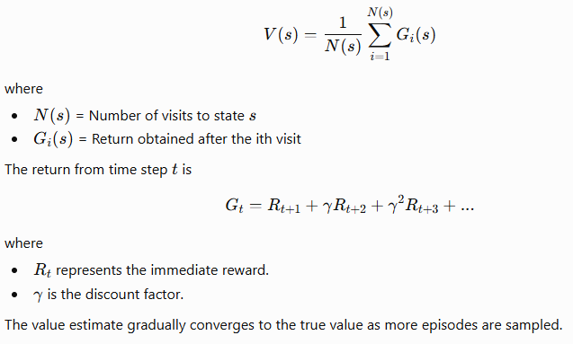

2. First-Visit and Every-Visit Monte Carlo
First-Visit Monte Carlo
Only the first occurrence of a state within an episode is considered while updating its value estimate.
Advantages
- Lower correlation among samples
- Simpler convergence analysis
Every-Visit Monte Carlo
Every occurrence of a state within an episode contributes to the value estimate.
Advantages
- Uses more information from each episode
- Faster learning in many practical problems
3. Monte Carlo Control
Monte Carlo Control extends prediction by learning the optimal policy.
Instead of estimating only state values, it estimates the action-value function
Q(s,a)
using sampled returns.
The policy is continuously improved by selecting actions having larger estimated action values.
The learning cycle consists of
- Generate an episode.
- Compute returns.
- Update Q-values.
- Improve policy.
- Repeat until convergence.

4. ε-Greedy Policy
A purely greedy policy always selects the action having the highest estimated value.
However, such a policy may fail to explore unknown actions.
The ε-Greedy policy balances exploration and exploitation.
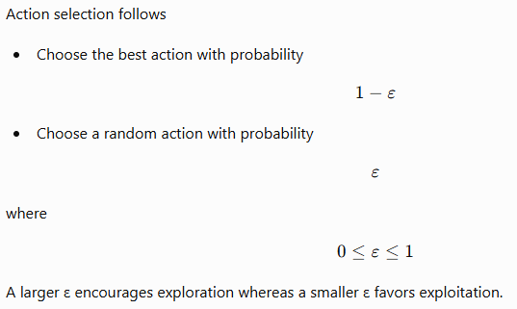
5. Monte Carlo Control using ε-Greedy Policy
The complete learning procedure consists of
- Initialize Q-values.
- Generate an episode using ε-Greedy action selection.
- Compute discounted returns.
- Update Q-values using sample averages.
- Improve the policy.
- Repeat until convergence.
This algorithm guarantees continual exploration of all state-action pairs while gradually improving the policy.
6. Environment
The experiment may be performed using
- Grid World
- Blackjack
- FrozenLake
- Custom Episodic Environment
Each episode terminates when the agent reaches a terminal state or the maximum episode length is exceeded.
Implementation Details
In this experiment, a Gymnasium or custom episodic environment is initialized in Python.
The Monte Carlo Prediction algorithm estimates the state-value function by averaging the returns obtained from multiple episodes generated using a fixed policy.
Monte Carlo Control is then implemented using an ε-Greedy policy to estimate optimal action-value functions and derive an improved policy.
The implementation should include the following components:
- Initialize the environment.
- Generate complete episodes using the current policy.
- Store state, action, and reward sequences.
- Compute discounted returns for each episode.
- Implement First-Visit Monte Carlo Prediction.
- Estimate state-value function.
- Implement Monte Carlo Control using ε-Greedy policy.
- Update action-value function using sample averages.
- Improve the policy after each episode.
- Plot episode rewards and learning progress.
- Display the learned optimal policy and value function.
Code
(Space for student code implementation)

Output
(Space for episode reward plots, learned value function, optimal policy, convergence graphs, screenshots, and observations)
Conclusion
Thus, we have successfully implemented Monte Carlo Prediction and Monte Carlo Control using an ε-Greedy policy. The experiment demonstrated how value functions and optimal policies can be learned directly from sampled episodes without requiring knowledge of the environment's transition probabilities. It was observed that the ε-Greedy strategy effectively balances exploration and exploitation, enabling the agent to converge toward an optimal policy through repeated interactions with the environment.
Post Lab Descriptive Questions
1. Differentiate between Monte Carlo Prediction and Monte Carlo Control. Why is Monte Carlo Control capable of learning an optimal policy?
2. Explain the role of the ε-Greedy policy in balancing exploration and exploitation. What would happen if ε is chosen as 0 or 1?

