M.Tech AI–ML

Hindi Character-Level Transliteration
Using RNN, LSTM, GRU, Attention and Transformer
Deep Learning Laboratory Assignment Report
Submitted by: ______________________________
Roll Number: ______________________________
Course/Batch: M.Tech AI–ML 2026–27
Date: ______________________________

Abstract
This project investigates character-level transliteration from Romanized Hindi into Devanagari. A sequence-to-sequence learning setup was implemented and compared using vanilla recurrent neural networks (RNN), Long Short-Term Memory (LSTM), Gated Recurrent Unit (GRU), an attention-based encoder–decoder, and a manually assembled Transformer encoder–decoder. Models were trained and evaluated on a small, reproducible sample of 5,000 word examples obtained from the IB-Emper/hinglish-translit-sarvam Hugging Face dataset. The sample was divided into 4,000 training, 500 validation, and 500 test examples. In the saved experiment, attention-based Seq2Seq achieved the highest exact-match test accuracy of 18.60%, followed by the manual Transformer at 16.20% and vanilla GRU at 15.60%. These results are preliminary because the assignment's prescribed Aksharantar splits and Weights & Biases hyperparameter sweeps have not yet been used.

1. Introduction
Transliteration converts text written in one script into a corresponding form in another script without translating its meaning. In this project, the input is a Romanized Hindi word and the output is its Devanagari representation. For example, an input such as “ghar” should produce “घर”. The task is challenging because Romanized Hindi spelling is not always standardized, and multiple character sequences can represent similar sounds.
Sequence-to-sequence neural networks are suitable for this task because they process an input character sequence and generate an output sequence one character at a time. This report compares recurrent cells, an attention mechanism, and a Transformer architecture.

2. Objectives
- Implement a character-level sequence-to-sequence model for Romanized Hindi to Devanagari transliteration.
- Compare vanilla RNN, LSTM, and GRU encoder–decoder models.
- Add attention to the encoder–decoder model and evaluate its effect.
- Implement a Transformer encoder and decoder manually using lower-level PyTorch modules.
- Measure exact-match accuracy, inspect errors, and save model predictions for further analysis.

3. Dataset and Preprocessing
The saved notebook streams examples from the Hugging Face dataset IB-Emper/hinglish-translit-sarvam, filters records marked as words, removes empty and duplicate pairs, and samples 5,000 examples. This is an alternative dataset used for a prototype experiment; it is not the official Aksharantar Hindi train/dev/test benchmark required by the assignment.
Subset | Number of examples | Share
Training | 4,000 | 80%
Validation | 500 | 10%
Test | 500 | 10%
Total | 5,000 | 100%

The split was created with a fixed random seed (42) using an 80/10/10 split. The notebook builds separate character vocabularies for Romanized input and Devanagari output. Special tokens are used for padding, start-of-sequence, end-of-sequence, and unknown characters. The saved run reports an input vocabulary size of 30 and an output vocabulary size of 66.

4. Methodology and Model Architectures

4.1 Vanilla Seq2Seq
The vanilla model contains source and target character embeddings, an encoder recurrent layer, a decoder recurrent layer, and a linear output layer. The encoder reads the Romanized sequence and passes its final state to the decoder. The decoder predicts Devanagari characters autoregressively. The same overall design was tested with RNN, LSTM, and GRU cells.

4.2 Attention-based Seq2Seq
The attention model computes a relevance score between the decoder state and each encoder output. The scores are normalized to attention weights, which are used to calculate a context vector. The decoder combines this context with its current input to predict the next character. This gives the decoder access to the encoder sequence rather than relying only on a single final state.

4.3 Manual Transformer
The Transformer implementation uses positional encodings, multi-head attention, feed-forward networks, residual connections, layer normalization, and batch normalization. It contains one encoder block and one decoder block. The configuration uses embedding size 64, four attention heads, feed-forward size 256, and dropout 0.1. PyTorch MultiheadAttention is used, but the high-level nn.Transformer and its encoder/decoder wrapper classes are not used.

5. Training Configuration
Model | Epochs | Learning rate | Main configuration
Vanilla RNN | 15 | 0.001 | Embedding 64; hidden size 128
Vanilla LSTM | 15 | 0.001 | Embedding 64; hidden size 128
Vanilla GRU | 15 | 0.001 | Embedding 64; hidden size 128
Attention Seq2Seq | 20 | 0.001 | Embedding 64; hidden size 128; dropout 0.2
Manual Transformer | 20 | 0.0005 | Embedding 64; 4 heads; FFN 256; dropout 0.1

The notebook output indicates that training ran on CPU. Training loss generally decreased over the recorded epochs. These runs are baseline experiments rather than the result of a formal hyperparameter sweep.

6. Evaluation Metric
The primary metric is exact-match accuracy. A prediction is counted as correct only when the entire generated Devanagari string exactly matches the reference string. The metric is calculated as:
Exact-match accuracy = (number of exactly correct predictions / total test examples) × 100%
All reported test results below are based on the saved notebook output for 500 test examples per model.

7. Results
Model | Exact matches | Test samples | Exact-match accuracy
Vanilla RNN | 1 | 500 | 0.20%
Vanilla LSTM | 73 | 500 | 14.60%
Vanilla GRU | 78 | 500 | 15.60%
Attention Seq2Seq | 93 | 500 | 18.60%
Manual Transformer | 81 | 500 | 16.20%

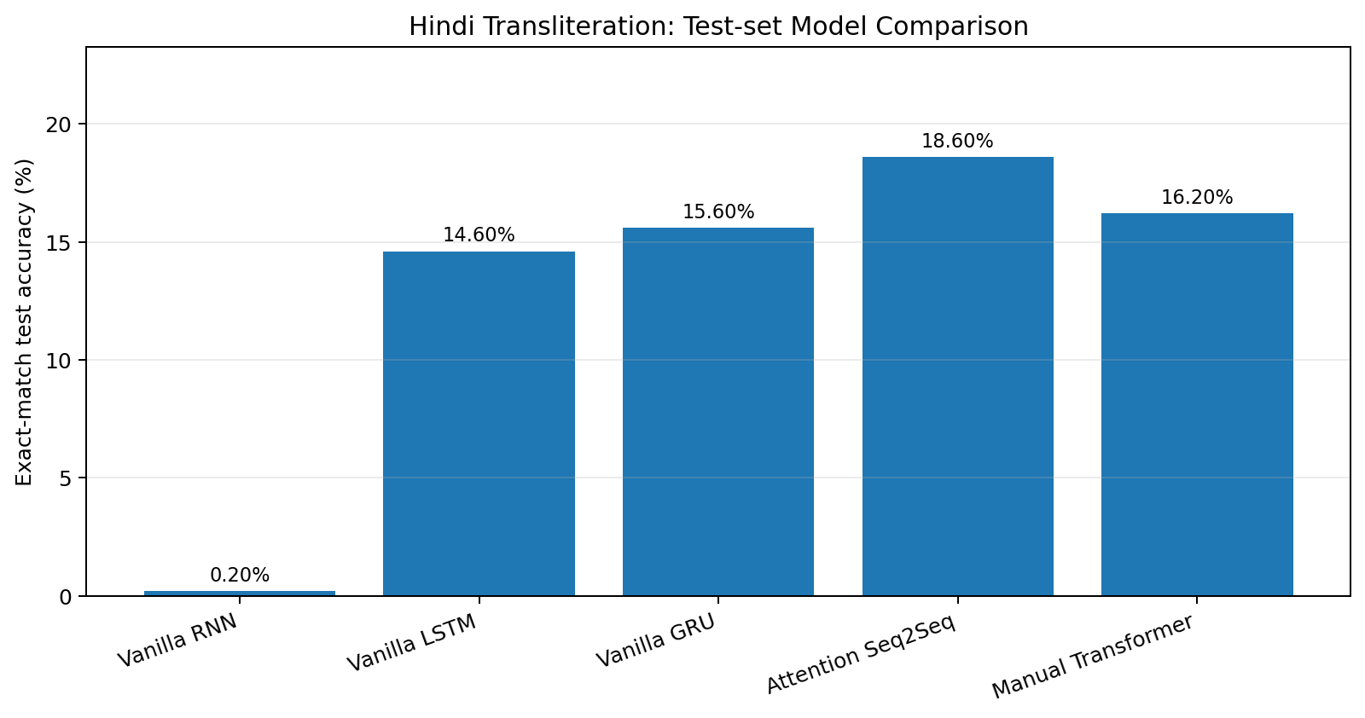

8. Discussion and Observations
- Attention Seq2Seq achieved the highest saved test accuracy (18.60%), which is 3.00 percentage points higher than the vanilla GRU result (15.60%).
- The manual Transformer achieved 16.20%, slightly above the vanilla GRU and below the attention model in this particular run.
- The vanilla RNN performed poorly at 0.20% exact-match accuracy. Its training loss decreased, but this did not translate into reliable whole-word predictions within the limited training setup.
- The LSTM and GRU substantially outperformed the vanilla RNN. The gated recurrent units may help preserve useful sequence information during training; however, the present experiment is too small to establish a general conclusion.
- The Attention model's validation exact-match accuracy reached 19.60% in its saved training history. The Transformer validation accuracy reached 13.40% at its final recorded epoch.
- The results should be interpreted as a small prototype comparison. The dataset source, sample size, CPU training, and lack of systematic hyperparameter sweeps limit generalization.

9. Computation and Parameter Count
For a one-layer, unidirectional encoder–decoder with input embedding size m, hidden size k, sequence length T, and vocabulary size V, a rough multiply–accumulate (MAC) estimate for a vanilla RNN is 2T(mk + k²) + T(kV). This approximation counts the encoder and decoder recurrent matrix operations and the output projection, while omitting elementwise operations, bias additions, softmax, and embedding lookups. For GRU and LSTM, recurrent computation is larger because they use three and four gates respectively; a rough gated-cell estimate multiplies the recurrent terms by three for GRU and four for LSTM.
For a vanilla RNN using separate source and target embeddings and PyTorch's two bias vectors per recurrent layer, the trainable parameter count is approximately: 2Vm + 2km + 2k² + 4k + Vk + V. The actual parameter count depends on vocabulary sizes, hidden size, embedding size, cell type, and the exact implementation. The notebook includes a parameter-count cell that computes the trainable parameter count directly from each instantiated model. Run that cell and include its generated table if your submission requires numerical counts for each model.

10. Error Analysis
The notebook exports predictions containing the Romanized input, reference Hindi word, predicted Hindi word, and a Boolean correctness flag. Examples visible in the saved outputs include cases where the prediction differs by repeated or substituted characters. Such errors can arise from ambiguous Romanized spellings, insufficient examples for particular character combinations, early stopping of decoding, or limited model capacity/training time.
A stronger error analysis should group errors by input length, character or sound pattern, and whether the attention model corrected an error made by the best vanilla model. The current report does not claim these patterns were statistically established.

11. Generated Files and Reproducibility
The notebook creates prediction CSV files under predictions_vanilla, predictions_attention, and predictions_transformers. It also includes cells for model parameter counts, a combined comparison table, combined predictions, and attention heatmaps for ten test examples. These files are generated inside the Colab runtime and should be downloaded or committed to the project repository before the runtime is disconnected.

12. Limitations and Remaining Assignment Work
- The assignment specifies the official Aksharantar Hindi train/dev/test splits. The reported results instead use a 5,000-example sample from IB-Emper/hinglish-translit-sarvam, so the reported scores are not official Aksharantar benchmark results.
- Weights & Biases sweeps and the requested accuracy-versus-run plot, parallel-coordinates plot, and hyperparameter correlation table are not included in the saved experiment.
- The vanilla Seq2Seq implementation in this notebook uses one encoder and one decoder layer and does not expose all requested layer-count and bidirectionality settings.
- The current inference code uses greedy decoding. Beam search with multiple beam sizes has not been evaluated.
- The theoretical computation estimate is provided, but the model-specific parameter-count table must be generated from the notebook cell before numerical parameter counts can be inserted into this report.
- The results are based on a single small split and training run. More runs and a larger prescribed dataset would be needed for stronger conclusions.

13. Conclusion
This experiment implemented and compared recurrent, attention-based, and Transformer approaches for Romanized Hindi to Devanagari transliteration. Among the saved runs, Attention Seq2Seq obtained the highest exact-match test accuracy at 18.60%, followed by the manual Transformer at 16.20% and GRU at 15.60%. The results demonstrate that model architecture affects character-level sequence generation, but the low absolute accuracies and limited dataset indicate that substantial improvement is needed. For full compliance with the assignment, the next steps are to use the official Aksharantar splits, run and document Weights & Biases sweeps, evaluate beam search, and include the generated parameter count and attention visualizations.

References
- PyTorch Documentation. Recurrent neural network modules, nn.MultiheadAttention, embeddings, and optimization utilities. https://pytorch.org/docs/stable/
- Hugging Face Datasets. IB-Emper/hinglish-translit-sarvam dataset card. https://huggingface.co/datasets/IB-Emper/hinglish-translit-sarvam
- Vaswani, A., et al. (2017). Attention Is All You Need. Advances in Neural Information Processing Systems.
- Bahdanau, D., Cho, K., and Bengio, Y. (2015). Neural Machine Translation by Jointly Learning to Align and Translate. ICLR.

Submission Note
This report reflects the experiment outputs saved in the uploaded notebook. Before submission, fill in the student name and roll number, run the parameter-count cell, verify the prediction CSV exports, and complete any mandatory dataset and W&B requirements specified by the instructor. Do not present the alternative-dataset results as official Aksharantar results.

