SuperSet Id:6383982

Ex1:

package com.library.repository;  
public class BookRepository {  
 public void saveBook(String title) {  
 System.*out*.println("Book saved: " + title);  
 }  
}

package com.library.service;  
  
import com.library.repository.BookRepository;  
  
public class BookService {  
  
 private BookRepository bookRepository;  
  
 // Setter for Spring injection  
 public void setBookRepository(BookRepository bookRepository) {  
 this.bookRepository = bookRepository;  
 }  
  
 public void addBook(String title) {  
 bookRepository.saveBook(title);  
 }  
}

package com.library;  
  
import com.library.service.BookService;  
import org.springframework.context.ApplicationContext;  
import org.springframework.context.support.ClassPathXmlApplicationContext;  
  
public class Main {  
 public static void main(String[] args) {  
 ApplicationContext context =  
 new ClassPathXmlApplicationContext("applicationContext.xml");  
  
 BookService bookService = context.getBean("bookService", BookService.class);  
 bookService.addBook("The Alchemist");  
 }  
}

<?xml version="1.0" encoding="UTF-8"?>  
<beans xmlns="http://www.springframework.org/schema/beans"  
 xmlns:xsi="http://www.w3.org/2001/XMLSchema-instance"  
 xsi:schemaLocation="http://www.springframework.org/schema/beans  
 http://www.springframework.org/schema/beans/spring-beans.xsd">  
  
 <!-- Define BookRepository bean -->  
 <bean id="bookRepository" class="com.library.repository.BookRepository" />  
  
 <!-- Define BookService bean with dependency injection -->  
 <bean id="bookService" class="com.library.service.BookService">  
 <property name="bookRepository" ref="bookRepository" />  
 </bean>  
  
</beans>

O/P  
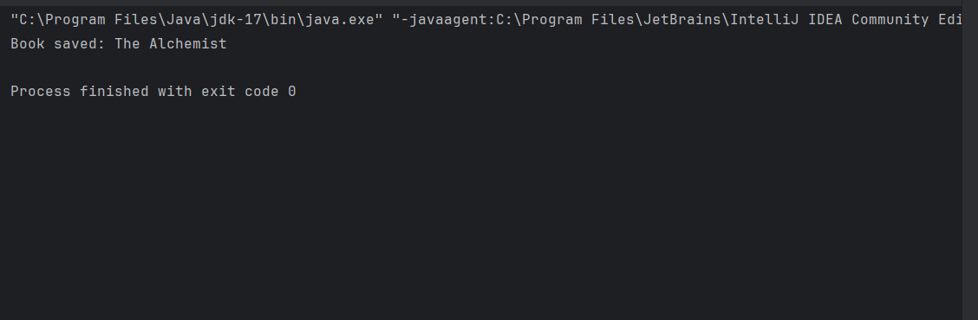

Ex:2

package com.library.repository;  
public class BookRepository {  
 public void saveBook(String title) {  
 System.*out*.println("Book saved: " + title);  
 }  
}

package com.library.service;  
  
import com.library.repository.BookRepository;  
  
public class BookService {  
 private BookRepository bookRepository;  
  
 // Setter for Spring DI  
 public void setBookRepository(BookRepository bookRepository) {  
 this.bookRepository = bookRepository;  
 }  
  
 public void addBook(String title) {  
 System.*out*.println("BookService: Adding book - " + title);  
 bookRepository.saveBook(title);  
  
 }  
}

package com.library;  
  
import com.library.service.BookService;  
import org.springframework.context.ApplicationContext;  
import org.springframework.context.support.ClassPathXmlApplicationContext;  
  
public class Main {  
 public static void main(String[] args) {  
 ApplicationContext context = new ClassPathXmlApplicationContext("applicationContext.xml");  
  
 // Get BookService bean  
 BookService bookService = context.getBean("bookService", BookService.class);  
  
 // Use the service  
 bookService.addBook("Wings of Fire");  
 }  
 }

<beans xmlns="http://www.springframework.org/schema/beans"  
 xmlns:xsi="http://www.w3.org/2001/XMLSchema-instance"  
 xsi:schemaLocation="http://www.springframework.org/schema/beans  
 http://www.springframework.org/schema/beans/spring-beans.xsd">  
  
 <!-- Repository Bean -->  
 <bean id="bookRepository" class="com.library.repository.BookRepository"/>  
  
 <!-- Service Bean with Dependency Injection -->  
 <bean id="bookService" class="com.library.service.BookService">  
 <property name="bookRepository" ref="bookRepository"/>  
 </bean>  
  
</beans>

