ASSIGNMENT-1

NAME:K.R.Vishnu Chaithanya

REG_NO:192372057

SUB_CODE:CSA0674

SUB:DESIGN AND ANALYSIS OF ALGORITHM FOFR SIMPLIFICATION

1.Two Sum Given an array of integers nums and an integer target, return indices of the two numbers such that they add up to target. You may assume that each input would have exactly one solution, and you may not use the same element twice. You can return the answer in any order. Example 1: Input: nums = [2,7,11,15], target = 9 Output: [0,1] Explanation: Because nums[0] + nums[1] == 9, we return [0, 1]. Example 2: Input: nums = [3,2,4], target = 6 Output: [1,2] Example 3: Input: nums = [3,3], target = 6 Output: [0,1] Constraints: ● 2 <= nums.length <= 104 ● -109 <= nums[i] <= 109 ● -109 <= target <= 109 ● Only one valid answer exists

Code:

def two_sum(nums, target):

num_to_index = {}

for index, num in enumerate(nums):

complement = target - num

if complement in num_to_index:

return [num_to_index[complement], index]

num_to_index[num] = index

print(two_sum([2, 7, 11, 15], 9))

print(two_sum([3, 2, 4], 6))

print(two_sum([3, 3], 6))

output:

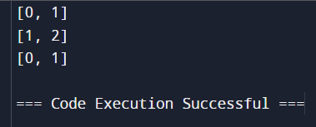

1. Add Two Numbers You are given two non-empty linked lists representing two non-negative integers. The digits are stored in reverse order, and each of their nodes contains a single digit. Add the two numbers and return the sum as a linked list. You may assume the two numbers do not contain any leading zero, except the number 0 itself. Example 1: Input: l1 = [2,4,3], l2 = [5,6,4] Output: [7,0,8] Explanation: 342 + 465 = 807. Example 2: Input: l1 = [0], l2 = [0] Output: [0] Example 3: Input: l1 = [9,9,9,9,9,9,9], l2 = [9,9,9,9] Output: [8,9,9,9,0,0,0,1] Constraints: ● The number of nodes in each linked list is in the range [1, 100]. ● 0 <= Node.val <= 9 ● It is guaranteed that the list represents a number that does not have leading zeros.

Code:

class ListNode:

def __init__(self, val=0, next=None):

self.val = val

self.next = next

def add_two_numbers(l1, l2):

dummy_head = ListNode()

current = dummy_head

carry = 0

while l1 or l2 or carry:

val1 = l1.val if l1 else 0

val2 = l2.val if l2 else 0

total = val1 + val2 + carry

carry = total // 10

new_digit = total % 10

current.next = ListNode(new_digit)

current = current.next

if l1:

l1 = l1.next

if l2:

l2 = l2.next

return dummy_head.next

def create_linked_list(nums):

dummy_head = ListNode()

current = dummy_head

for num in nums:

current.next = ListNode(num)

current = current.next

return dummy_head.next

def print_linked_list(node):

while node:

print(node.val, end=" -> " if node.next else "\n")

node = node.next

l1 = create_linked_list([2, 4, 3])

l2 = create_linked_list([5, 6, 4])

result = add_two_numbers(l1, l2)

print_linked_list(result)

l1 = create_linked_list([0])

l2 = create_linked_list([0])

result = add_two_numbers(l1, l2)

print_linked_list(result)

l1 = create_linked_list([9, 9, 9, 9, 9, 9, 9])

l2 = create_linked_list([9, 9, 9, 9])

result = add_two_numbers(l1, l2)

print_linked_list(result)

output:

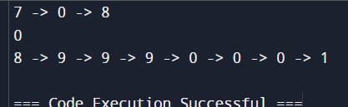

1. Longest Substring without Repeating Characters Given a string s, find the length of the longest substring without repeating characters. Example 1: Input: s = "abcabcbb" Output: 3 Explanation: The answer is "abc", with the length of 3. Example 2: Input: s = "bbbbb" Output: 1 Explanation: The answer is "b", with the length of 1. Example 3: Input: s = "pwwkew" Output: 3 Explanation: The answer is "wke", with the length of 3. Notice that the answer must be a substring, "pwke" is a subsequence and not a substring. Constraints: ● 0 <= s.length <= 5 * 104 ● s consists of English letters, digits, symbols and spaces.

Code:

def length_of_longest_substring(s):

char_index = {}

max_length = 0

left = 0

for right, char in enumerate(s):

if char in char_index and char_index[char] >= left:

left = char_index[char] + 1

char_index[char] = right

max_length = max(max_length, right - left + 1)

return max_length

print(length_of_longest_substring("abcabcbb"))

print(length_of_longest_substring("bbbbb"))

print(length_of_longest_substring("pwwkew"))

output:

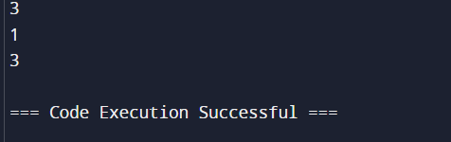

1. Median of Two Sorted Arrays Given two sorted arrays nums1 and nums2 of size m and n respectively, return the median of the two sorted arrays. The overall run time complexity should be O(log (m+n)). Example 1: Input: nums1 = [1,3], nums2 = [2] Output: 2.00000 Explanation: merged array = [1,2,3] and median is 2. Example 2: Input: nums1 = [1,2], nums2 = [3,4] Output: 2.50000 Explanation: merged array = [1,2,3,4] and median is (2 + 3) / 2 = 2.5. Constraints: ● nums1.length == m ● nums2.length == n ● 0 <= m <= 1000 ● 0 <= n <= 1000 ● 1 <= m + n <= 2000 ● -106 <= nums1[i], nums2[i] <= 106

Code:

def find_median_sorted_arrays(nums1, nums2):

combined = nums1 + nums2

combined.sort()

length = len(combined)

if length % 2 == 1:

return combined[length // 2]

else:

mid1 = combined[length // 2 - 1]

mid2 = combined[length // 2]

return (mid1 + mid2) / 2

print(find_median_sorted_arrays([1, 3], [2]))

print(find_median_sorted_arrays([1, 2], [3, 4]))

output:

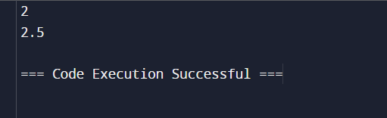

1. Longest Palindromic Substring Given a string s, return the longest palindromic substring in s. Example 1: Input: s = "babad" Output: "bab" Explanation: "aba" is also a valid answer. Example 2: Input: s = "cbbd" Output: "bb" Constraints: ● 1 <= s.length <= 1000 ● s consist of only digits and English letters.

Code:

def longest_palindromic_substring(s):

if not s:

return ""

start, end = 0, 0

for i in range(len(s)):

len1 = expand_around_center(s, i, i)

len2 = expand_around_center(s, i, i + 1)

max_len = max(len1, len2)

if max_len > end - start:

start = i - (max_len - 1) // 2

end = i + max_len // 2

return s[start:end + 1]

def expand_around_center(s, left, right):

while left >= 0 and right < len(s) and s[left] == s[right]:

left -= 1

right += 1

return right - left - 1

print(longest_palindromic_substring("babad"))

print(longest_palindromic_substring("cbbd"))

output:

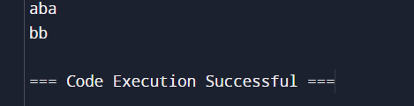

1. Zigzag Conversion The string "PAYPALISHIRING" is written in a zigzag pattern on a given number of rows like this: (you may want to display this pattern in a fixed font for better legibility) P A H N A P L S I I G Y I R And then read line by line: "PAHNAPLSIIGYIR" Write the code that will take a string and make this conversion given a number of rows: string convert(string s, int numRows); Example 1: Input: s = "PAYPALISHIRING", numRows = 3 Output: "PAHNAPLSIIGYIR" Example 2: Input: s = "PAYPALISHIRING", numRows = 4 Output: "PINALSIGYAHRPI" Explanation: P I N A L S I G Y A H R P I Example 3: Input: s = "A", numRows = 1 Output: "A" Constraints: ● 1 <= s.length <= 1000 ● s consists of English letters (lower-case and upper-case), ',' and '.'. ● 1 <= numRows <= 1000

Code:

def convert(s, numRows):

if numRows == 1 or numRows >= len(s):

return s

rows = [''] * numRows

current_row = 0

going_down = False

for char in s:

rows[current_row] += char

if current_row == 0 or current_row == numRows - 1:

going_down = not going_down

current_row += 1 if going_down else -1

return ''.join(rows)

print(convert("PAYPALISHIRING", 3))

print(convert("PAYPALISHIRING", 4))

print(convert("A", 1))

output:

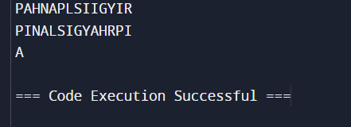

1. Reverse Integer Given a signed 32-bit integer x, return x with its digits reversed. If reversing x causes the value to go outside the signed 32-bit integer range [-231, 231 - 1], then return 0. Assume the environment does not allow you to store 64-bit integers (signed or unsigned). Example 1: Input: x = 123 Output: 321 Example 2: Input: x = -123 Output: -321 Example 3: Input: x = 120 Output: 21 Constraints: ● -231 <= x <= 231 – 1

Code:

def reverse(x):

INT_MAX = 2**31 - 1

INT_MIN = -2**31

sign = -1 if x < 0 else 1

x = abs(x)

reversed_x = 0

while x != 0:

pop = x % 10

x //= 10

if (reversed_x > INT_MAX // 10) or (reversed_x == INT_MAX // 10 and pop > INT_MAX % 10):

return 0

reversed_x = reversed_x * 10 + pop

return sign * reversed_x

print(reverse(123))

print(reverse(-123))

print(reverse(120))

print(reverse(0))

output:

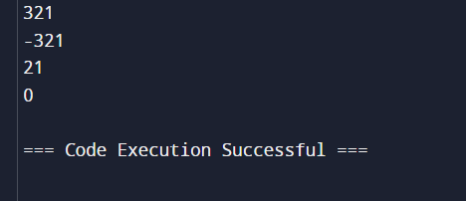

1. String to Integer (atoi) Implement the myAtoi(string s) function, which converts a string to a 32-bit signed integer (similar to C/C++'s atoi function). The algorithm for myAtoi(string s) is as follows: 1. Read in and ignore any leading whitespace. 2. Check if the next character (if not already at the end of the string) is '-' or '+'. Read this character in if it is either. This determines if the final result is negative or positive respectively. Assume the result is positive if neither is present. 3. Read in next the characters until the next non-digit character or the end of the input is reached. The rest of the string is ignored. 4. Convert these digits into an integer (i.e. "123" -> 123, "0032" -> 32). If no digits were read, then the integer is 0. Change the sign as necessary (from step 2). 5. If the integer is out of the 32-bit signed integer range [-231, 231 - 1], then clamp the integer so that it remains in the range. Specifically, integers less than -231 should be clamped to -231, and integers greater than 231 - 1 should be clamped to 231 - 1. 6. Return the integer as the final result. Note: ● Only the space character ' ' is considered a whitespace character. ● Do not ignore any characters other than the leading whitespace or the rest of the string after the digits. Example 1: Input: s = "42" Output: 42 Explanation: The underlined characters are what is read in, the caret is the current reader position. Step 1: "42" (no characters read because there is no leading whitespace) ^ Step 2: "42" (no characters read because there is neither a '-' nor '+') ^ Step 3: "42" ("42" is read in) ^ The parsed integer is 42. Since 42 is in the range [-231, 231 - 1], the final result is 42. Example 2: Input: s = " -42" Output: -42 Explanation: Step 1: " -42" (leading whitespace is read and ignored) ^ Step 2: " -42" ('-' is read, so the result should be negative) ^ Step 3: " -42" ("42" is read in) ^ The parsed integer is -42. Since -42 is in the range [-231, 231 - 1], the final result is -42. Example 3: Input: s = "4193 with words" Output: 4193 Explanation: Step 1: "4193 with words" (no characters read because there is no leading whitespace) ^ Step 2: "4193 with words" (no characters read because there is neither a '-' nor '+') ^ Step 3: "4193 with words" ("4193" is read in; reading stops because the next character is a non digit) ^ The parsed integer is 4193. Since 4193 is in the range [-231, 231 - 1], the final result is 4193. Constraints: ● 0 <= s.length <= 200 ● s consists of English letters (lower-case and upper-case), digits (0-9), ' ', '+', '-', and '.'.

Code:

def myAtoi(s):

INT_MAX = 2**31 - 1

INT_MIN = -2**31

i = 0

n = len(s)

while i < n and s[i] == ' ':

i += 1

sign = 1

if i < n and (s[i] == '+' or s[i] == '-'):

sign = -1 if s[i] == '-' else 1

i += 1

result = 0

while i < n and s[i].isdigit():

digit = int(s[i])

if result > (INT_MAX - digit) // 10:

return INT_MAX if sign == 1 else INT_MIN

result = result * 10 + digit

i += 1

return sign * result

print(myAtoi("42"))

print(myAtoi(" -42"))

print(myAtoi("4193 with words"))

output:

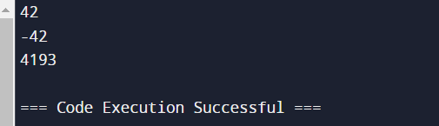

1. Palindrome Number Given an integer x, return true if x is a palindrome, and false otherwise. Example 1: Input: x = 121 Output: true Explanation: 121 reads as 121 from left to right and from right to left. Example 2: Input: x = -121 Output: false Explanation: From left to right, it reads -121. From right to left, it becomes 121-. Therefore it is not a palindrome. Example 3: Input: x = 10 Output: false Explanation: Reads 01 from right to left. Therefore it is not a palindrome. Constraints: ● -231 <= x <= 231 – 1

Code:

def isPalindrome(x):

x_str = str(x)

return x_str == x_str[::-1]

print(isPalindrome(121))

print(isPalindrome(-121))

print(isPalindrome(10))

output:

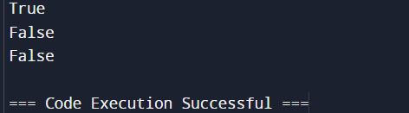

1. Regular Expression Matching Given an input string s and a pattern p, implement regular expression matching with support for '.' and '*' where: ● '.' Matches any single character. ● '*' Matches zero or more of the preceding element. The matching should cover the entire input string (not partial). Example 1: Input: s = "aa", p = "a" Output: false Explanation: "a" does not match the entire string "aa". Example 2: Input: s = "aa", p = "a*" Output: true Explanation: '*' means zero or more of the preceding element, 'a'. Therefore, by repeating 'a' once, it becomes "aa". Example 3: Input: s = "ab", p = ".*" Output: true Explanation: ".*" means "zero or more (*) of any character (.)". Constraints: ● 1 <= s.length <= 20 ● 1 <= p.length <= 30 ● s contains only lowercase English letters. ● p contains only lowercase English letters, '.', and '*'. ● It is guaranteed for each appearance of the character '*', there will be a previous valid character to match.

Code:

def isMatch(s: str, p: str) -> bool:

m, n = len(s), len(p)

dp = [[False] * (n + 1) for _ in range(m + 1)]

dp[0][0] = True

for i in range(1, n + 1):

if p[i - 1] == '*':

dp[0][i] = dp[0][i - 2]

for i in range(1, m + 1):

for j in range(1, n + 1):

if p[j - 1] == '.' or p[j - 1] == s[i - 1]:

dp[i][j] = dp[i - 1][j - 1]

elif p[j - 1] == '*':

dp[i][j] = dp[i][j - 2] or (dp[i - 1][j] and (p[j - 2] == '.' or p[j - 2] == s[i - 1]))

return dp[m][n]

print(isMatch("aa", "a"))

print(isMatch("aa", "a*"))

print(isMatch("ab", ".*"))

output:

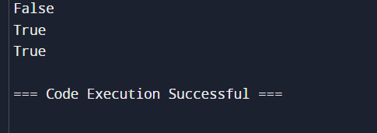

1. Regular Expression Matching Given an input string s and a pattern p, implement regular expression matching with support for '.' and '*' where: ● '.' Matches any single character. ● '*' Matches zero or more of the preceding element. The matching should cover the entire input string (not partial). Example 1: Input: s = "aa", p = "a" Output: false Explanation: "a" does not match the entire string "aa". Example 2: Input: s = "aa", p = "a*" Output: true Explanation: '*' means zero or more of the preceding element, 'a'. Therefore, by repeating 'a' once, it becomes "aa". Example 3: Input: s = "ab", p = ".*" Output: true Explanation: ".*" means "zero or more (*) of any character (.)". Constraints: ● 1 <= s.length <= 20 ● 1 <= p.length <= 30 ● s contains only lowercase English letters. ● p contains only lowercase English letters, '.', and '*'. ● It is guaranteed for each appearance of the character '*', there will be a previous valid character to match.

Code:

def isMatch(s: str, p: str) -> bool:

dp = [[False] * (len(p) + 1) for _ in range(len(s) + 1)]

dp[0][0] = True

for j in range(1, len(p) + 1):

if p[j - 1] == '*':

dp[0][j] = dp[0][j - 2]

for i in range(1, len(s) + 1):

for j in range(1, len(p) + 1):

if p[j - 1] == '.' or p[j - 1] == s[i - 1]:

dp[i][j] = dp[i - 1][j - 1]

elif p[j - 1] == '*':

dp[i][j] = dp[i][j - 2] or (dp[i - 1][j] and (s[i - 1] == p[j - 2] or p[j - 2] == '.'))

return dp[len(s)][len(p)]

print(isMatch("aa", "a"))

print(isMatch("aa", "a*"))

print(isMatch("ab", ".*"))

output:

