Wildfire Incident Export Script (Raftis Update)

### Original Export Script Created by Paul Hoefler

# First Time Set Up

The first time you set up the script you will need to define variables for folder locations, incident information, and export settings. Best practice for inputting any variable is to copy and paste the value instead of typing it in. This reduces the likelihood of typos and script errors.

### FOLDER LOCATIONS #######################################

project_folder = r'C:\Users\Admin\FireNet\2021_ORUPF_DevilsKnob - 2021_DevilsKnob\projects'

export_folder = r'C:\Users\Admin\FireNet\2021_ORUPF_DevilsKnob - 2021_DevilsKnob\products'

###########################################################

Copy your folder locations directly from your file directory and paste it between the ‘ ‘. If you are going to be splitting up the script between multiple GISS with separate computers, each user will need to update the folder locations for their specific computer.

The incident information will be used for naming the output product files. An example product output name is ‘pilot_18x24_port_20210929_2021_DevilsKnob_ ORUPF000450_0930_geo’ where the highlighted text is derived from these variables.

### INCIDENT ################

inc_name = 'DevilsKnob'

idn = 'ORUPF000450'

inc_year = '2021'

###########################

### SETTINGS###########

beep = 'END' #Play sound file ... 'PDF': after each PDF; 'END': only at the end; no beeps: ''

date_for_override = '' # Set this to 'MMDD' to override the date for variable

#Prefix/Suffix in case you need them. Use ‘’ if not needed

print_prefix = ''

print_suffix = '_img'

georef_prefix = ''

georef_suffix = '_geo'

dpi = 150

img_qual = 'NORMAL'

compress_vect = True

image_comp = 'ADAPTIVE'

embed_fonts = True

layer_attr = 'NONE'

jpg_comp = 50

clip = False

embed_color = True

#############################

The settings variables apply to the entire script and all exports. The beep variable refers to a random sound file that can play at the end of each export, when the script finishes, or not at all. Date_for_override overrides the automatic process for assigning a date to the product output name, highlighted below. ‘pilot_18x24_port_20210929_2021_ DevilsKnob_ ORUPF000450_0930_geo’ This is useful if you are re-exporting for a previous date.

The prefix/suffix variables allow you to differentiate which product outputs are image .pdfs for printing and which are georeferenced .pdfs for Avenza use.

The export settings conform to those of the exportToPdf function from the arcpy mapping module. More info on these settings can be found [by clicking here](https://pro.arcgis.com/en/pro-app/latest/arcpy/mapping/layout-class.htm#GUID-364B5333-BBFA-48E9-B3A7-59C7DA6DC099).

# Setting Up Items to Export

Each layout that you want to export needs to be defined in the export_jobs list. Each export job is stored as a tuple, containing variables that will be referenced by the script. This part is especially important to copy and paste your values to avoid typos and script failures. If you no longer need to export a particular layout you can put a # at the beginning of the line and this will prevent it from exporting. To resume exporting simply remove the #. The export_jobs part of the script is shown below with some examples. Not that single lines have been split onto two for easier viewing.

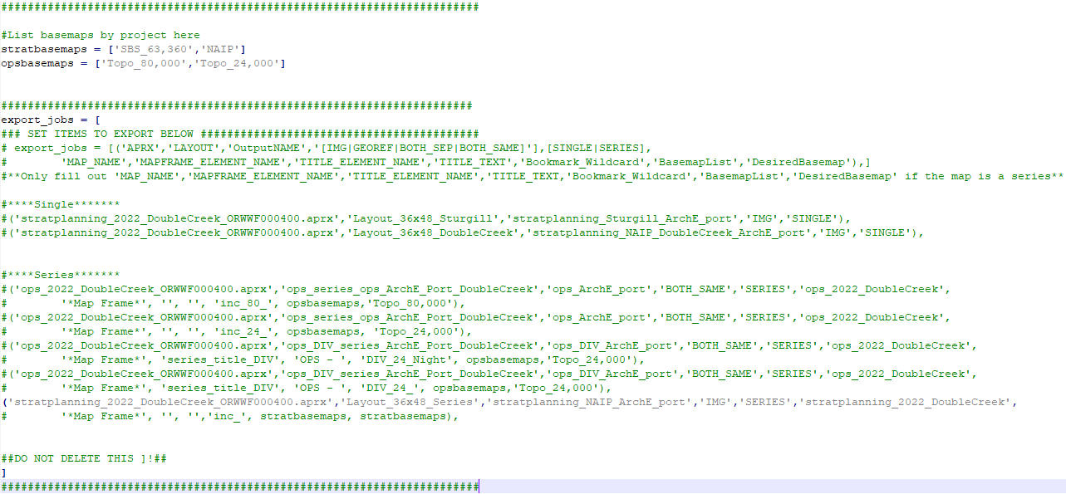

Note that map series require more variables to be filled out. The appendix has images showing where you can find each of these variables in your map project.

|  |  |  |
| --- | --- | --- |
| Variable | Description | Example |
| APRX | The name of the project file (AKA aprx). Must have the .aprx at the end for the script to run. | 'DIV_Tiles_2021_ DevilsKnob _ORUPF000450_ ArcPro_2_7.aprx' |
| LAYOUT | The name of the layout file in the project. | 'Ops_DIV_Map_Packet' |
| OutputNAME | What you want to name the product output. ‘pilot_18x24_port_20210929_2021_ DevilsKnob_ ORUPF000450_0930_geo’ | 'Ops_DIV_Map_Packet_ 18x24_land','PRINT' |
| [PRINT|GEOREF|BOTH] | Pick one of these three values. PRINT exports as an image .pdf that is not georeferenced, but is better for printing. GEOREF exports as a georeferenced .pdf for use with Avenza. BOTH exports one of each. | 'PRINT' |
| [SINGLE|SERIES] | Pick one of these two values. SINGLE is for a standard layout that is not part of a map series. SERIES is for a map series based on bookmarks, with individual .pdf exports for each bookmark. | 'SERIES' |
| MAP_NAME | The name of the map file in the project. | 'Ops_DivTiles_ 2021_DevilsKnob' |
| MAPFRAME_ELEMENT _NAME | The name of the map frame from the layout contents that contains your main map with bookmarks. | '*Main*' |
| TITLE_ELEMENT_NAME | The name of the title text element that should be updated with each bookmark name. Use ‘’ if you’re not using this feature. | 'Title' |
| TITLE_TEXT | Type the title text that you want shown on the map, it will have the bookmark name appended to the end of it. Can be left blank (like this ‘’) if you want just the bookmark name to be the title or you’re not using this feature. | 'OPS - ' |
| Bookmark_Wildcard | The wildcard used to catch the desired bookmarks for an export job. Can be used to split up bookmarks to use different basemaps when the basemap wildcard is included. | ‘DIV_24_’  ‘inc_’ |
| basemaplist | A list of all the base maps used in a map. Only need to put the group layer names in the list. Defined in the script before the export_jobs. This is a variable so doesn’t need ‘’ | opsbasemaps |
| Desiredbasemap | The single base map group layer name that you want for the export or a list of base maps that you want all bookmarks in the export to iterate through. A single base map should be a string ‘’, a list should reference a defined variable. | ‘Topo_80,000’  stratbasemaps |

# Map Series

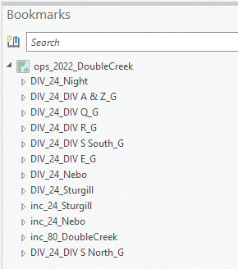 The function used to export a map series relies on more variables than the one used to export a single map. As such it is important to have your project set up correctly for the map series function to work. The first thing you will want to do is set up bookmarks for each map that you want to produce, and name them following a specific convention. The name needs to follow this format: exportgroup_basemap_uniquename.

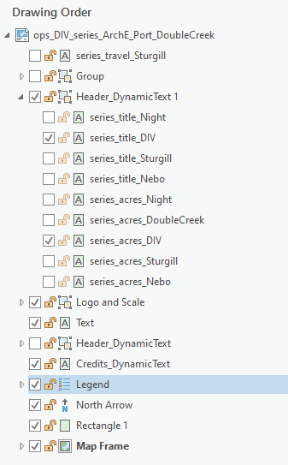Exportgroup is a wildcard used to limit the exported maps to only the bookmarks that start with the exportgroup. For example, ‘inc_’ will export inc_24_Sturgill, inc_24_Nebo, and inc_80_DoubleCreek. Whereas ‘inc_80_’ will only export inc_80_DoubleCreek. The basemap wildcard is used in conjunction with the exportgroup wildcard to limit exports based on the desired base map. As the example above shows you can narrow the export to just ‘inc_80’ bookmarks and assign a base map for use at 80k scale.

The uniquename wildcard is used to alter the title, turn layout elements on and off, and is appended to the export file name. If a title text element was defined in the export settings, the bookmark’s uniquename will be appended to the end of the title text. To turn layout elements on and off based on the uniquename they must all start with ‘series_’. The tool will then turn all series elements off and only turn on elements that end with the uniquename wildcard. An exception to this is when using _G at the end of the bookmark name. This directs the script to turn layout elements on and off based on the exportgroup name instead of the uniquename. This makes it possible to have layout elements that show up on all ‘DIV_’ maps for example. The uniquename is then added to the export file name behind the first ‘_’ in the outputname, with any spaces removed.

As an example, to the right are the bookmarks and layout elements used on a map with DIV tiles and three separate fire extents.

Appendix