Create a Jenkins “Maven Project” and name the project.

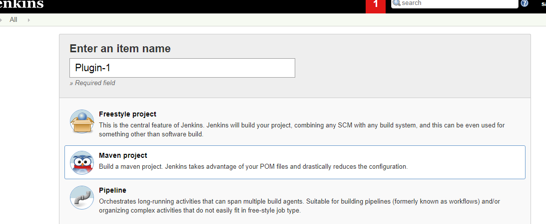

Enable “Git” in Source Code Management and Provide the repository url as:

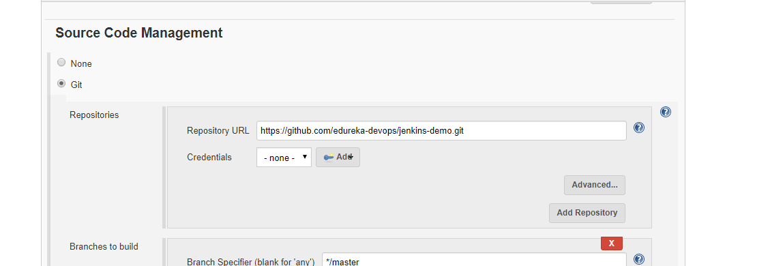

Enable the Build Environment to “Delete workspace before build starts”.

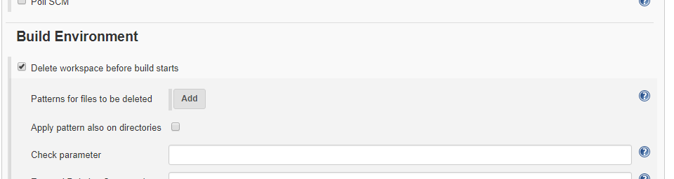

In Build select run the maven script by giving the path of pom.xml

(MavenProject/pom.xml) and set Goals and Options to “ -B DskipTestscleanpackage”

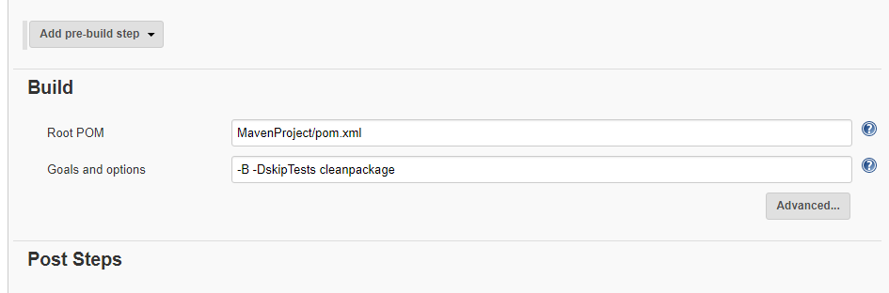

Update the Post-build Actions to archive the generated artifacts and trigger a

downstream job for deploying the archived artifacts.