SQL Commands :
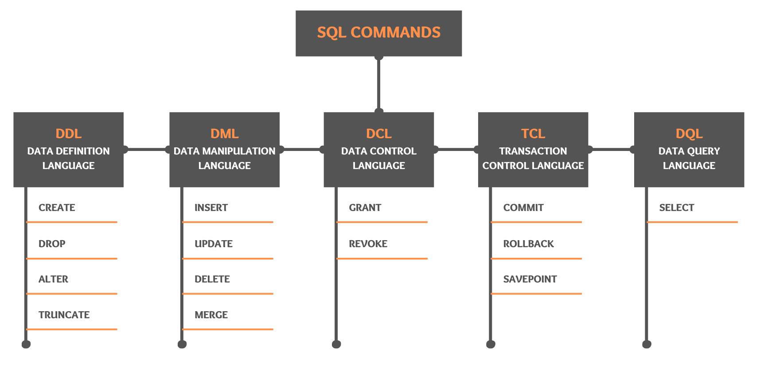
How to get all default tables information in PostgreSQL:
select * from INFORMATION_SCHEMA.TABLES;
select * from INFORMATION_SCHEMA.TABLES where table_schema='public';

Default schemas across databases:
-- Postgres --> public
-- MSSQL --> DBO
-- Oracle / MySQL --> sys

Create Database:
Using GUI:
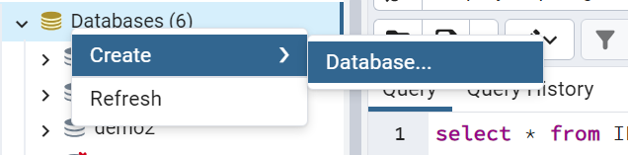

Using CLI:
CREATE DATABASE employee2;

DDL(Data Definition Language):
- Used to define the structure of a database object such as Table, Views, Procedure, Function etc.
- Commands include:
  - CREATE
  - DROP
  - ALTER
  - TRUNCATE

Create :
Create command is used create a database object in SQL.
CREATE TABLE employee (
id int,
name varchar(20),
dept_id varchar(10),
salary float
);

Most common used datatypes in SQL:
- Int / Number
- Varchar / String
- Date
- Float / Decimal
- Boolean

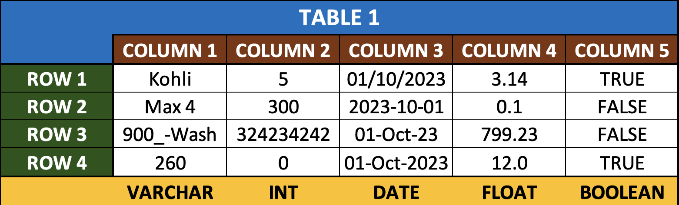

Drop:
DROP TABLE employee;

Alter:
Alter table name:
ALTER TABLE employee RENAME TO employee_new;

Adding new column:
alter table employee add column DateoOfJoining date;

Alter column name:
alter table employee RENAME COLUMN DateoOfJoining TO DOJ;

Change datatype of column:
alter table employee alter column DOJ TYPE varchar(20);

Drop column:
alter table employee drop column DOJ;

Get table information in PostgreSQL:
SELECT
table_name,
column_name,
data_type
FROM
information_schema.columns
WHERE
table_name = 'employee';

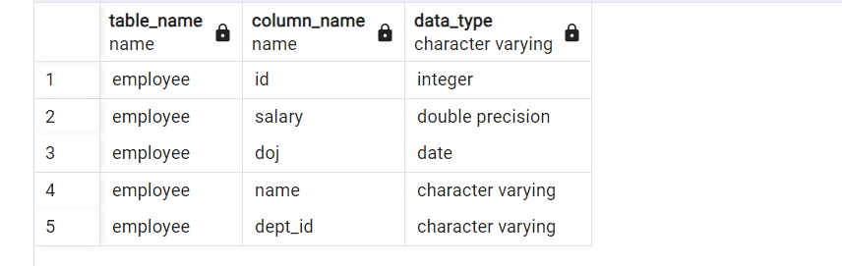

Truncate:

DML(Data Manipulation Language):
- DML commands are used to load, modify and remove data from the database.
- Commands include:
  - INSERT
  - UPDATE
  - DELETE
  - MERGE

Inset:
INSERT INTO employee(id, name, dept_id, salary,doj)
VALUES(1,'Sameer','D1',2000,to_date('2024-08-12','YYYY-MM-DD'));

INSERT INTO employee
VALUES(1,'Mohan','D2',2500,to_date('2023-06-22','YYYY-MM-DD'));

Update:
UPDATE employee set id=2 where name='Mohan';

Delete:
DELETE from employee where id=2;

Note : Recommended to use where in delete. If where is not mentioned it will delete total data.
Merge:

DQL(Data Query Language):
- Includes only the SELECT statement
- Can be used to read data from one or multiple tables.
- Contains following clauses:
  - SELECT – list of columns
  - FROM – list of tables
  - WHERE – filter conditions and join conditions
- Can also include following clauses:
  - GROUP BY – Grouping of data based on specified column(s)
  - HAVING – Filter condition for the grouped data
  - ORDER BY
  - LIMIT / TOP

select * from employee;

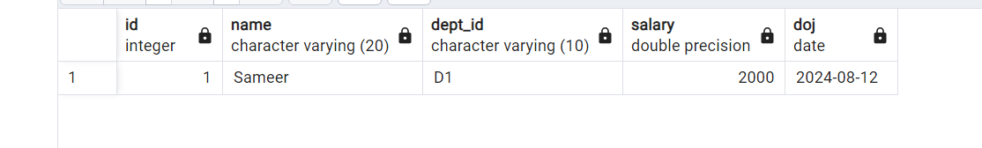

DCL(Data Control Language) :
- Includes GRANT and REVOKE statements.
- Used to provide or remove permission on a database object to a database user.

TCL(Transaction Control Language):
- Includes COMMIT, ROLLBACK and SAVEPOINT
- Used to save/unsave open transactions in a database session

Let’s create other table department and add some data in both employee and department table.
create table department (
id int,
name varchar(10));

alter table department alter column id type varchar(10);

insert into department Values('D001','HR');

insert into employee values (1, 'Raj', 'D1', 4000);
insert into employee values (1, 'Mohan', 'D2', 5000);
insert into employee values (1, 'Kumar', 'D1', 0);
insert into employee values (1, 'Raj', 'D1', 4000);

select * from employee;
select * from department;

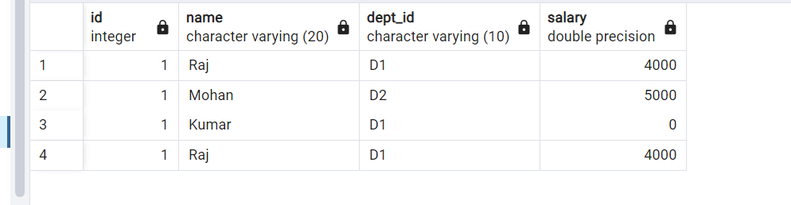
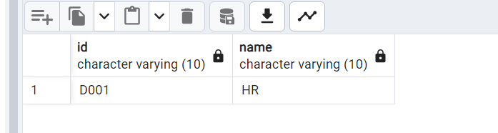

Note : We can see that below are some problems with above data.
- Like both employee and department in relation so it should match with dept id in employee with id in department.
- We know that every table or employee id should not be same for 2 employees.
- Salary should not be zero.
- Records 1 and 4th are duplicated so we don’t need these records. Any one of record is fine.
To rectify above issues, we have to apply constraints on top of table so we can restrict user to enter data with problem like above.

Constraints :
Constraints in SQL are a set of rules or restrictions defined on columns of a table in a relational database to control the data or data type that can be input or stored in a column.
In SQL, constraints are applied during the creation of the table using the CREATE TABLE command or after the creation of the table using the ALTER TABLE command.
- Not Null By default, any column can have a NULL value. but it restricts the columns in a table from having NULL values.
- Unique It ensures that the column has only unique values.
- Default It provides a default value for a column if no value is assigned
- Check Checks the values in the column is as per definition. It is similar to data validation in Excel.
- Primary key The primary Key constraint is a combination of both UNIQUE and NOT NULL constraints. Only one PRIMARY KEY can be created per table
- Foreign key It is used to relate two or more tables and prevents the operation that destroys the link between the tables. A foreign key can be a primary key if the table is connected by a one-to-one relationship, not a one-to-many relationship. Multiple foreign keys can be created per table.
- Identity An identity column is a special column that is generated automatically from an implicit sequence. It can be used to generate key values.

Now let’s add possible constraint on our tables and see how data can be inserted.
Create master/parent table :
CREATE TABLE department(
id varchar(10) PRIMARY KEY,
name varchar(20) NOT NULL
);

INSERT INTO department VALUES('D001','HR');
INSERT INTO department VALUES('D002','Finance');

SELECT * FROM department;

Create employee table with relation of department table:
CREATE TABLE employee(
id int PRIMARY KEY,
name varchar(20) NOT NULL,
dept_id varchar(10) REFERENCES department(id),
salary float CHECK(salary>0)
)

Now let’s try to insert above data:
insert into employee values (1, 'Raj', 'D001', 4000);
insert into employee values (2, 'Mohan', 'D002', 5000);
insert into employee values (3, 'Kumar', 'D002', 1);
insert into employee values (4, 'Raj', 'D001', 4000);

select * from employee;

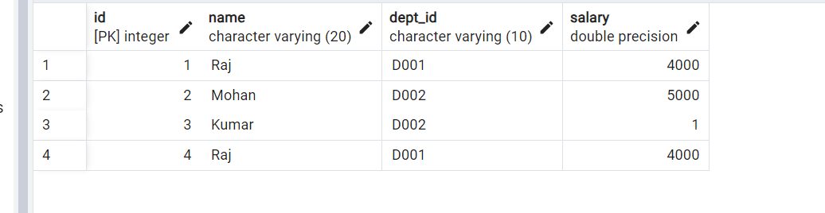
Note : Now we can see that all problems that we see before are solved.
Let’s add new column with default value:
alter table employee
add column DOJ date default to_date('2024-08-12','YYYY-MM-DD');

select * from employee;

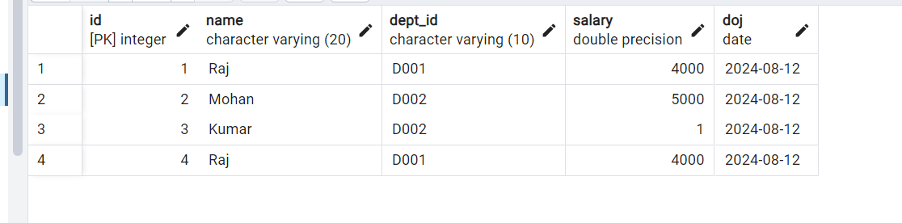

Identity :
We can create identity column by using create table command or using alter command.
To create an identity column, use the GENERATED ... AS IDENTITY clause in CREATE TABLE, for example:
CREATE TABLE people (
id bigint GENERATED ALWAYS AS IDENTITY,
...,
);

OR

CREATE TABLE people (
id bigint GENERATED BY DEFAULT AS IDENTITY,
...,
);

Use alter command to add identity our id column in employee:
alter table employee alter column id add generated always as identity (start with 50);

insert into employee values (default, 'Hanan', 'D001', 4000);
insert into employee(name,dept_id,salary) values ('Remo', 'D001', 46000);

select * from employee;

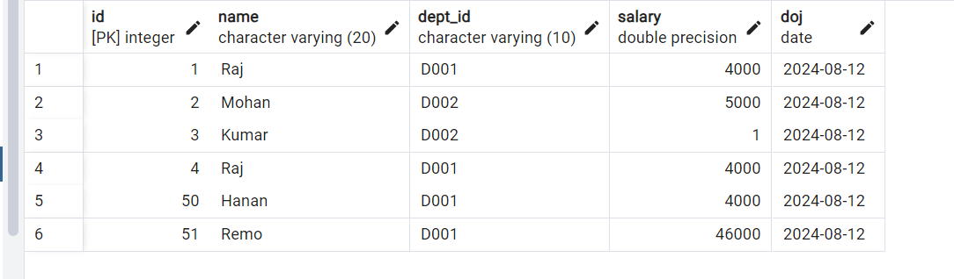

Drop constraint :
alter table employees alter column id drop identity;

Assignment:
- Choose any dataset and create new database for above dataset.
- Create minimum 4 tables which can hold meaningful data from above dataset.
- These tables should have proper constraints.
- Load sample data into these tables at least 5 records in a table.

create database amakat;

-- Product table - id,product_name,price
-- Customer table - id,name,mobile_no,email,address
-- Seller table - id,seller_name,mobile_no,email,address
-- Orders table - order_id,prod_id,quantiity,cust_id,sell_id

create table product(
product_id varchar(10) primary key,
product_name varchar(20) NOT NULL,
price float check(price>0)
);

create table customer(
customer_id varchar(10) primary key,
customer_name varchar(20) NOT NULL,
mobile_no BIGINT,
email varchar(30),
address varchar(100) NOT NULL
);

create table seller(
seller_id varchar(10) primary key,
seller_name varchar(20) NOT NULL,
mobile_no BIGINT,
email varchar(30),
address varchar(100) NOT NULL
);

create table orders(
order_id varchar(20) primary key,
prod_id varchar(10) REFERENCES product(product_id),
quantiity int NOT NULL check(quantiity>0),
cust_id varchar(10) REFERENCES customer(customer_id),
sell_id varchar(10) REFERENCES seller(seller_id)
);

INSERT INTO product VALUES('PRO1','iphone 16 pro',93000);
INSERT INTO product VALUES('PRO2','Mac m1 air',193000);
INSERT INTO product VALUES('PRO3','Iqoo z9s',19000);
INSERT INTO product VALUES('PRO4','One plus nord 4',23000);
INSERT INTO product VALUES('PRO5','Poco x6 pro',18000);
select * from product;

INSERT INTO customer VALUES('CUST1','Jhon',959146816,'Jhon@gmail.com','Newyork');
INSERT INTO customer VALUES('CUST2','Mohan',837615846,'Mohan@gmail.com','Hyderbad');
INSERT INTO customer VALUES('CUST3','Kumar',784758915,'Kumar@gmail.com','Vizag');
select * from customer;

INSERT INTO seller VALUES('SELL1','RK pvt ltd',959467816,'RK.prt.ltd@gmail.com','Delhi');
INSERT INTO seller VALUES('SELL2','Suray enterprizes',837415846,'Surayenterprizes@gmail.com','Noida');
INSERT INTO seller VALUES('SELL3','Konark shop',784258915,'Konarkshop@gmail.com','mumbai');
select * from seller;

INSERT INTO orders VALUES('ORD1','PRO1',1,'CUST2','SELL1');
INSERT INTO orders VALUES('ORD2','PRO4',2,'CUST1','SELL3');
INSERT INTO orders VALUES('ORD3','PRO2',4,'CUST3','SELL2');
INSERT INTO orders VALUES('ORD4','PRO2',3,'CUST3','SELL3');
INSERT INTO orders VALUES('ORD5','PRO1',1,'CUST2','SELL1');

select * from orders;

select orders.order_id,product.product_name,product.price,orders.quantiity,
customer.customer_name,seller.seller_name from
orders
left JOIN product on orders.prod_id=product.product_id
left JOIN customer on orders.cust_id=customer.customer_id
left JOIN seller on orders.sell_id=seller.seller_id;

