Truncate(DDL) and delete(DML) :
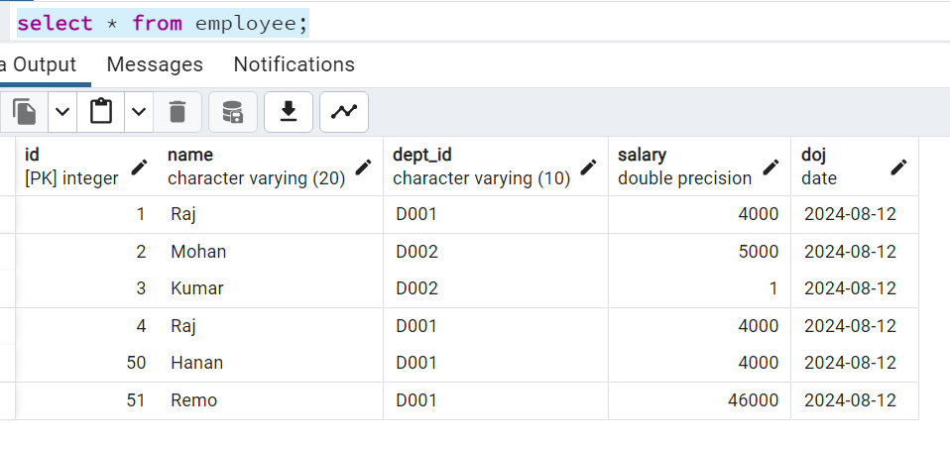

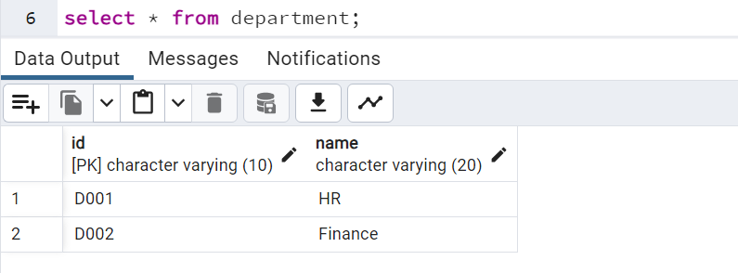

If we want to delete total table than use truncate or if you want to delete some records than use delete(We can’t delete some records using delete command)
TRUNCATE TABLE employee --where salary > 4000;
DELETE FROM employee where salary > 4000;
DELETE FROM employee;

Note : We can also delete all records in table by using delete () command but it very slow compare to truncate. Reason internally when you fired delete statement it deletes records one by one where as truncate recreates table. So truncate don’t care how many records there it’s simply recreate table structure.

Update (DML) :
Insert some records:
alter table employee alter column id add generated always as identity (start with 50);
INSERT INTO employee VALUES(DEFAULT,'Hanan','D001',4000);
INSERT INTO employee VALUES(DEFAULT,'Robert','D001',3000);
INSERT INTO employee VALUES(DEFAULT,'Arek','D001',2000);
INSERT INTO employee VALUES(DEFAULT,'Martin','D001',1000);

select * from employee;

update employee set salary = salary * 2 where salary<2000;

select * from employee;

Note : While working with update or delete always use where if where clause not used than all records in table will affected.

Merge:
We have requirement that we have employee and history_employee table. Our task is to create a SQL query that checks if both employee and history_employee have same data it won’t do nothing but if any new data added or updated in employees than that should be updated in history_employee table.
Create new table:
create table history_employee as
select * from employee where 1=2;

create table history_employee_2 as
select * from employee where 'x'='y';
Note : This creates a empty table but remember it won’t copy constrains all those.

Create merge:
merge into history_employee h
using employee e on e.id = h.id
when matched then
update set salary = e.salary
when not matched then
insert(id,name,dept_id,salary,doj)
values(e.id,e.name,e.dept_id,e.salary,e.doj);

Before execute above query:
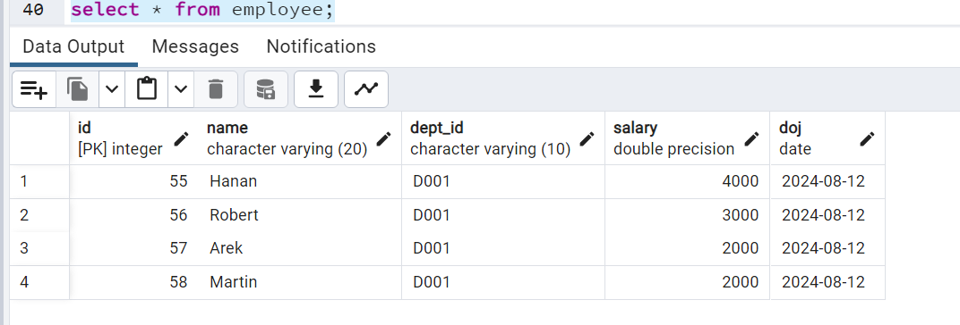

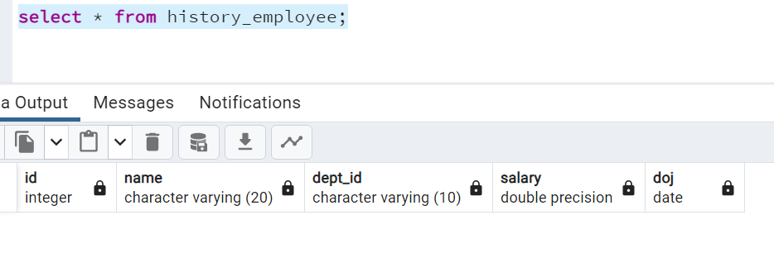

After execute above query:

DCL (Grant & Revoke) :
Scenario : Assume we have employee table and give read access to some only id,name and department columns not salary and DOJ.
First create view:
create or replace view emp_view
as
select e.id,e.name,d.name as department_name from employee e
JOIN department d on e.dept_id = d.id;

Create user and connect with that user:
create user auditor with password 'auditor123';

Now that new user not able to access view until we give grant access to him/her.
grant select on emp_view to auditor;
revoke select on emp_view from auditor;

TCL (Commit, rollback and save point) :
Note : Turn off auto commit to work with TCL.
Employee tables records:
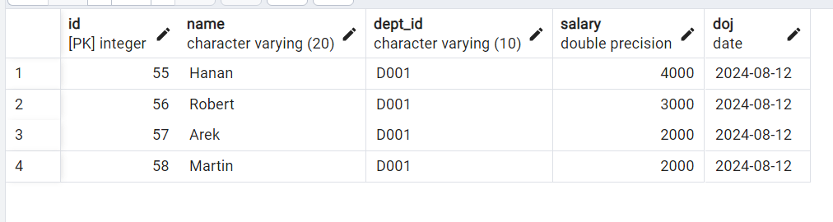

Let’s insert some records in employee:
INSERT INTO employee VALUES(DEFAULT,'Devid','D001',44000);
INSERT INTO employee VALUES(DEFAULT,'Maria','D001',10099);
INSERT INTO employee VALUES(DEFAULT,'Allen','D001',95000);

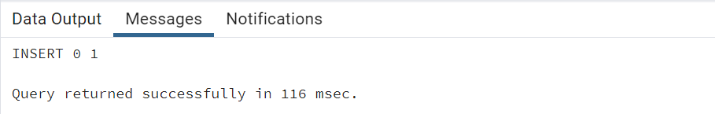

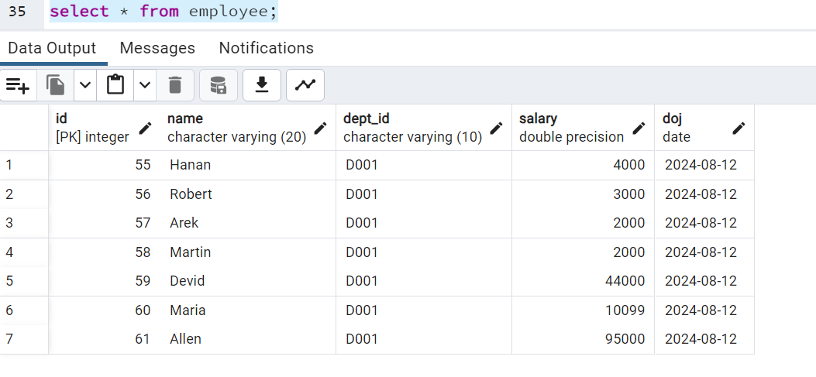

Rollback now:
Rollback;
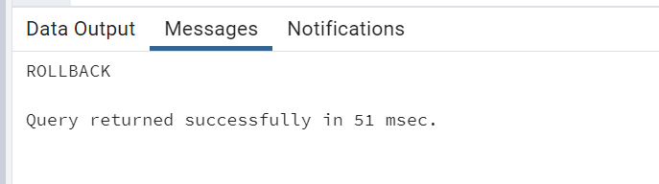

Now check employee table :
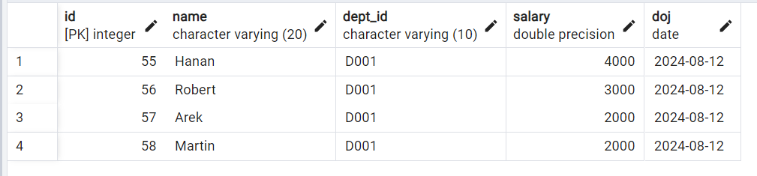

Pervious records not saved in database as we have not done commit but we have did rollback so it undo the unsaved transactions.
Rollback Removes if any unsaved transactions.
Commit Save if any unsaved transactions.
Note : Same way if we do commit manually, it saves permanently to database.

Insert more records with Save points :
INSERT INTO employee VALUES(DEFAULT,'Alex','D001',54000);
Savepoint s1;
INSERT INTO employee VALUES(DEFAULT,'Ken','D001',99099);
Savepoint s2;
INSERT INTO employee VALUES(DEFAULT,'Hang','D001',98000);
Savepoint s3;

Note : Save point is nothing but a book mark or line. Like we can rollback to up to save point.
I want to save all records before save point 2 and not after, than we execute command like below.
rollback to s2;

Employee table:
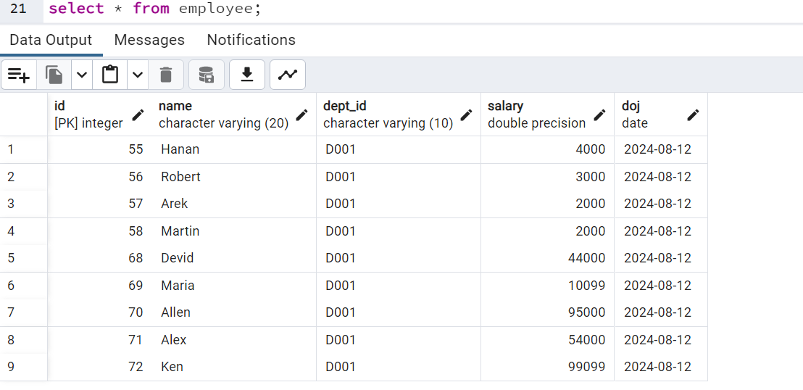

Note : If we do simple roll back, we will loss all 3 transactions but we used to save point so it not removed only last insert. (Do commit at last to save data to database)

SELECT :
Select used to fetch(read) data from database.
Below 2 clauses mainly used in select :
- SELECT List of columns (Which will returned in output)
- FROM list of tables (Data will be fetched from these databases)
- WHERE filter condition (filter data based on given condition)

Solve 16 banking questions :

