Topics :
- Joins – inner joins
- Aggregate functions sum, count, avg, max and min
- Function(in built functions) To_char ,to_date,concat and extract
- Group by

Order by 1 in order by clause:
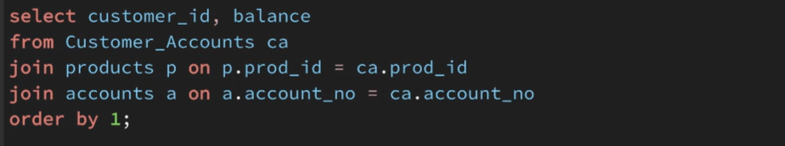
Here 1 means giving index of fetched columns means customer id.

Group by :
- Group by divide result into multiple groups of records based on given columns.
- Then we can apply aggregate function on each group separately.
- Rules need to follow while working with group by:
  - Fetch or apply aggregate function only on those columns which are grouped.

By using banking dataset, fetch sum of amount of each customer.
select customer_id,sum(balance) from customer_accounts ca
Join accounts a on ca.account_no = a.account_no
group by customer_id;

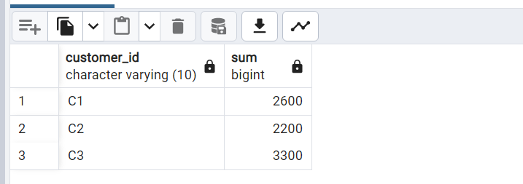
Note : Here sum executes separately for each query. If we won’t use group by then sum will apply on total table.

Working on IMDB dataset :
Create table and import IMDB data into database:
Create database IMDB

Dataset:
/*
Kaggle link to the dataset:
https://www.kaggle.com/datasets/harshitshankhdhar/imdb-dataset-of-top-1000-movies-and-tv-shows
*/

Create Table:
drop table if exists imdb_top_movies;
create table if not exists imdb_top_movies
(
Poster_Link varchar(4000),
Series_Title varchar(1000),
Released_Year varchar(10),
Certificate varchar(10),
Runtime varchar(20),
Genre varchar(50),
IMDB_Rating decimal,
Overview varchar(4000),
Meta_score int,
Director varchar(200),
Star1 varchar(200),
Star2 varchar(200),
Star3 varchar(200),
Star4 varchar(200),
No_of_Votes bigint,
Gross money
);

select * from imdb_top_movies;

Import data into table:

Solve the below problems using IMDB dataset:
- Fetch all data from IMDB table
- Fetch only the name and release year for all movies.
- Fetch the name, release year and IMDB rating of movies which are UA certified.
- Fetch the name and genre of movies which are UA certified and have a IMDB rating of over 8.
- Find out how many movies are of Drama genre.
- How many movies are directed by "Quentin Tarantino", "Steven Spielberg", "Christopher Nolan" and "Rajkumar Hirani".
- What is the highest IMDB rating given so far?
- What is the highest and lowest IMDB rating given so far?
  - Solve the above problem but display the results in different rows.
  - Solve the above problem but display the results in different rows. And have a column which indicates the value as lowest and highest.

- Find out the total business done by movies starring "Aamir Khan".
- Find out the average IMDB rating of movies which are neither directed by "Quentin Tarantino", "Steven Spielberg", "Christopher Nolan" and are not acted by any of these stars "Christian Bale", "Liam Neeson", "Heath Ledger", "Leonardo DiCaprio", "Anne Hathaway".

11. Mention the movies involving both "Steven Spielberg" and "Tom Cruise".
12. Display the movie name and watch time (in both mins and hours) which have over 9 IMDB rating.
13. What is the average IMDB rating of movies which are released in the last 10 years and have less than 2 hrs of runtime?
14. Identify the Batman movie which is not directed by "Christopher Nolan".
15. Display all the A and UA certified movies which are either directed by "Steven Spielberg", "Christopher Nolan" or which are directed by other directors but have a rating of over 8.
16. What are the different certificates given to movies?
17. Display all the movies acted by Tom Cruise in the order of their release. Consider only movies which have a meta score.
18. Segregate all the Drama and Comedy movies released in the last 10 years as per their runtime. Movies shorter than 1 hour should be termed as short film. Movies longer than 2 hrs should be termed as longer movies. All others can be termed as good watch time.
19. Write a query to display the "Christian Bale" movies which released in odd year and even year. Sort the data as per odd year at the top.
20. Re-write problem #18 without using case statement.

Extra Assignment:
21. Split the value '1234_1234' into 2 seperate columns having 1234 each.
22. We see a string value 'PG' in released_year and we hardcoaded it, can we make a query dynamic to identify string value incase if we have multiple string values in-order to ignore those string values
Write a query to identify non numeric values in a column.

Solutions of IMDB dataset questions :
- Fetch all data from IMDB table
select * from imdb_top_movies;

- Fetch only the name and release year for all movies.
select series_title, released_year
from imdb_top_movies;

- Fetch the name, release year and IMDB rating of movies which are UA certified.
select series_title, released_year,imdb_rating
from imdb_top_movies where certificate='UA';

- Fetch the name and genre of movies which are UA certified and have a IMDB rating of over 8.
select series_title, genre
from imdb_top_movies where certificate='UA' and imdb_rating>8;

- Find out how many movies are of Drama genre.
select count(*)
from imdb_top_movies
where genre like '%Drama%';

- How many movies are directed by "Quentin Tarantino", "Steven Spielberg", "Christopher Nolan" and "Rajkumar Hirani".
select count(1)
from imdb_top_movies
where director in ('Quentin Tarantino', 'Steven Spielberg', 'Christopher Nolan', 'Rajkumar Hirani');

- What is the highest IMDB rating given so far?
select max(imdb_rating)
from imdb_top_movies;
OR
select imdb_rating
from imdb_top_movies
order by imdb_rating desc limit 1;

- Find out the average IMDB rating of movies which are neither directed by "Quentin Tarantino", "Steven Spielberg", "Christopher Nolan" and are not acted by any of these stars "Christian Bale", "Liam Neeson", "Heath Ledger", "Leonardo DiCaprio", "Anne Hathaway".
select avg(imdb_rating)
from imdb_top_movies
where director not in ('Quentin Tarantino', 'Steven Spielberg', 'Christopher Nolan')
and (star1 not in ('Christian Bale', 'Liam Neeson', 'Heath Ledger', 'Leonardo DiCaprio', 'Anne Hathaway')
and star2 not in ('Christian Bale', 'Liam Neeson', 'Heath Ledger', 'Leonardo DiCaprio', 'Anne Hathaway')
and star3 not in ('Christian Bale', 'Liam Neeson', 'Heath Ledger', 'Leonardo DiCaprio', 'Anne Hathaway')
and star4 not in ('Christian Bale', 'Liam Neeson', 'Heath Ledger', 'Leonardo DiCaprio', 'Anne Hathaway')
);

11. Mention the movies involving both "Steven Spielberg" and "Tom Cruise".
select * from imdb_top_movies
where director = 'Steven Spielberg'
and (star1 = 'Tom Cruise'
or star2 = 'Tom Cruise'
or star3 = 'Tom Cruise'
or star4 = 'Tom Cruise');
OR
select * from imdb_top_movies
where director = 'Steven Spielberg'
and 'Tom Cruise' in (star1,star2,star3,star4);

14. Identify the Batman movie which is not directed by "Christopher Nolan".
select * from imdb_top_movies
where lower(series_title) like '%batman%'
and director <> 'Christopher Nolan';

15. Display all the A and UA certified movies which are either directed by "Steven Spielberg", "Christopher Nolan" or which are directed by other directors but have a rating of over 8.
select * from imdb_top_movies
where certificate in ('UA','A')
and (director in ('Steven Spielberg', 'Christopher Nolan')
or (director not in ('Steven Spielberg', 'Christopher Nolan') and imdb_rating>8));

16. What are the different certificates given to movies?
select distinct certificate
from imdb_top_movies
order by certificate;

select distinct certificate
from imdb_top_movies
order by 1;

17. Display all the movies acted by Tom Cruise in the order of their release. Consider only movies which have a meta score.
select *
from imdb_top_movies
where 'Tom Cruise' in (star1,star2,star3,star4)
and meta_score is not null
order by released_year;

Solved problems in class:
- What is the highest and lowest IMDB rating given so far?
select max(imdb_rating) as max_rating, min(imdb_rating) as min_rating
from imdb_top_movies;

Solve the above problem but display the results in different rows.
select max(imdb_rating) as max_min_rating
from imdb_top_movies
UNION ALL
select min(imdb_rating) as max_min_rating
from imdb_top_movies;

Solve the above problem but display the results in different rows. And have a column which indicates the value as lowest and highest.
select 'Maximum_rating' as status,max(imdb_rating) as value
from imdb_top_movies
UNION ALL
select 'Minimum_rating' as status,min(imdb_rating) as value
from imdb_top_movies;

- Find out the total business done by movies starring "Aamir Khan".
select sum(gross)
from imdb_top_movies
where star1='Aamir Khan' or
star2='Aamir Khan' or
star3='Aamir Khan' or
star4='Aamir Khan';

OR

select sum(gross)
from imdb_top_movies
where 'Aamir Khan' in (star1,star2,star3,star4);

- Display the movie name and watch time (in both mins and hours) which have over 9 IMDB rating.
Ways to convert a varchar into integer in PostgreSQL:

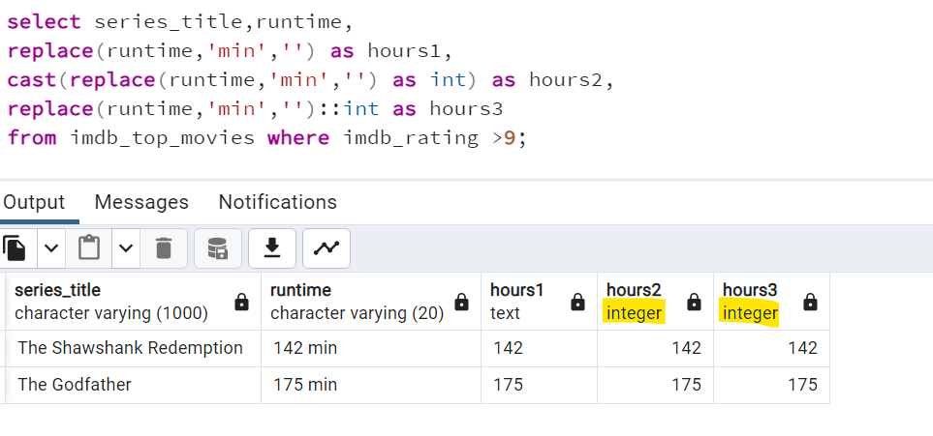

select series_title,runtime,
round(cast(replace(runtime,'min','') as decimal)/60,2) as hours
from imdb_top_movies where imdb_rating >9;

- What is the average IMDB rating of movies which are released in the last 10 years and have less than 2 hrs of runtime?
select round(avg(imdb_rating),2)
from imdb_top_movies
where released_year>'2014' and round(cast(replace(runtime,'min','') as decimal)/60,2)>2;

OR

select round(avg(imdb_rating),2)
from imdb_top_movies
where released_year>(extract(year from current_date)-10)::varchar
and round(cast(replace(runtime,'min','') as decimal)/60,2)>2;

OR

select round(avg(imdb_rating),2)
from imdb_top_movies
where released_year>(extract(year from current_date)-10)::varchar
and round(cast(replace(runtime,'min','') as int),2)>120;

18. Segregate all the Drama and Comedy movies released in the last 10 years as per their runtime. Movies shorter than 1 hour should be termed as short film. Movies longer than 2 hrs should be termed as longer movies. All others can be termed as good watch time.
select series_title,
CASE WHEN (round(cast(replace(runtime,'min','') as decimal)/60,2))<1 THEN 'short film'
WHEN (round(cast(replace(runtime,'min','') as decimal)/60,2))>2 THEN 'longer movies'
ELSE 'good watch time'
END as category
from imdb_top_movies
where (lower(genre) like '%drama%' or lower(genre) like '%comedy%')
and released_year > (extract(year from current_date)-10)::varchar;

19. Write a query to display the "Christian Bale" movies which released in odd year and even year. Sort the data as per odd year at the top.
select series_title,released_year,
CASE WHEN released_year::int%2=0 THEN 'Even Year' else 'Odd Year' end as yr_category
from imdb_top_movies
where 'Christian Bale' in (director,star1,star2,star3,star4)
order by yr_category desc;

20. Re-write problem #18 without using case statement.
select series_title,'short film' as category
from imdb_top_movies
where (lower(genre) like '%drama%' or lower(genre) like '%comedy%')
and released_year > (extract(year from current_date)-10)::varchar
and (round(cast(replace(runtime,'min','') as decimal)/60,2))<1
UNION ALL
select series_title,'longer movies' as category
from imdb_top_movies
where (lower(genre) like '%drama%' or lower(genre) like '%comedy%')
and released_year > (extract(year from current_date)-10)::varchar
and (round(cast(replace(runtime,'min','') as decimal)/60,2))>2
UNION ALL
select series_title,'good watch time' as category
from imdb_top_movies
where (lower(genre) like '%drama%' or lower(genre) like '%comedy%')
and released_year > (extract(year from current_date)-10)::varchar
and (round(cast(replace(runtime,'min','') as decimal)/60,2)) between 1 and 2 ;

21. Split the value '1234_1234' into 2 seperate columns having 1234 each.
Before solve this understand below concepts:
Substring , Position ==> Postgres
Substr , Instr ==> Oracle
Substring , Charindex ==> Mssql
Substring , Locate ==> Mysql

Working of substring and position:
SUBSTRING(Data,start index,end index)
select SUBSTRING('PostgresSQL',1,4); -->Post
select SUBSTRING('PostgresSQL',3,7); -->stgresS
select SUBSTRING('PostgresSQL',4); -->tgresSQL

POSITION:
select POSITION('P' in 'PostgresSQL'); -->1
select POSITION('g' in 'PostgresSQL'); -->5
select POSITION('s' in 'PostgresSQL'); -->3

select '1234_5678' as text,
SUBSTRING('1234_5678',1,POSITION('_' in '1234_5678')-1) as part1,
SUBSTRING('1234_5678',POSITION('_' in '1234_5678')+1) as part2;

OR

select '1234_5678' as text,
split_part('1234_5678','_',1) as part1,
split_part('1234_5678','_',2) as part2;

22. We see a string value 'PG' in released_year and we hardcoaded it, can we make a query dynamic to identify string value incase if we have multiple string values in-order to ignore those string values
Write a query to identify non numeric values in a column.
select * from imdb_top_movies
where released_year !~ '[0-9]';

Working on sales order dataset:
- Find the average sales order price based on deal size
- Identify the vehicles in the inventory which are short in number. Shortage of vehicle is considered when there are less than 10 vehicles

Answers of above questions:
- Find the average sales order price based on deal size
select deal_size,avg(sales) as average_sales
from Sales_order
group by deal_size ;

- Identify the vehicles in the inventory which are short in number. Shortage of vehicle is considered when there are less than 10 vehicles
select product_line,count(product_line)
from Products
group by product_line having count(product_line) < 10;

Diff between WHERE and HAVING:
- WHERE is used to filter data returned from a table/view/result set
- HAVING is used to filter data returned from a GROUP BY

Assessment :
- Fetch all the small shipped orders from August 2003 till the end of year 2003.
- Find all the orders which do not belong to customers from USA and are still in process.
- Find all orders for Planes, Ships and Trains which are neither Shipped nor In Process nor Resolved.
- Find customers whose phone number has either parenthesis "()" or a plus sign "+".
- Find customers whose phone number does not have any space.
- Fetch all the orders between Feb 2003 and May 2003 where the quantity ordered was an even number.
- Find orders which sold the product for price higher than its original price.
- Find the average sales order price
- Count total no of orders.
- Find the total quantity sold.
- Fetch the first order date and the last order date.

Extra question:
Identify how many cars, Motorcycles, trains and ships are available in the inventory.
Treat all type of cars as just "Cars".

